LASSO AND RIDGE FOR COMPUTER SALES DATA SET

PLOT FOR MINIMUM LAMBDA VALUE IN LASSO

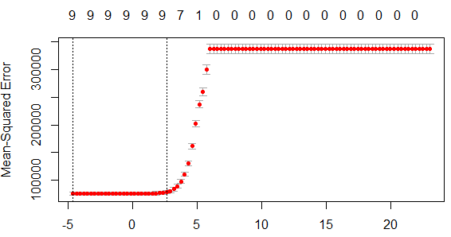

PLOT FOR MINIMUM LAMBDA VALUE IN RIDGE

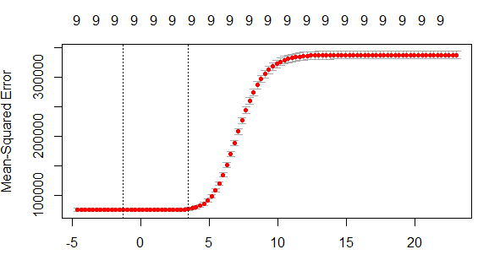

|  |  |  |
| --- | --- | --- |
| MODEL | MIN LAMDA VALUE | R-SQ VALUE |
| LASSO | 0.01 | 0.77` |
| RIDGE | 0.28 | 0.77 |

LASSO AND RIDGE 50 STARTUPS DATA SET

PLOT FOR MINIMUM LAMBDA VALUE IN LASSO

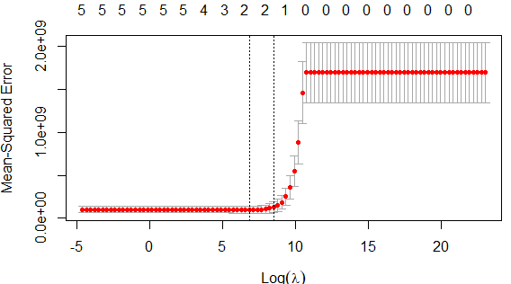

PLOT FOR MINIMUM LAMBDA VALUE IN RIDGE

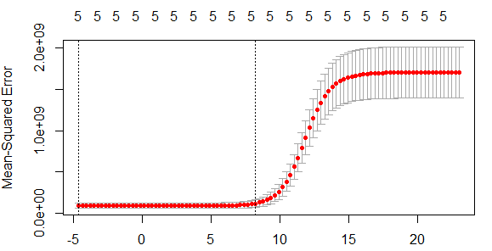

|  |  |  |
| --- | --- | --- |
| MODEL | OPTIMAL LAMDA VALUE | R-SQ VALUE |
| LASSO | 6.83 | 0.95 |
| RIDGE | 0.01 | 0.95 |

LASSO AND RIDGE TOYOTA COROLLA DATA SET

PLOT FOR MINIMUM LAMBDA VALUE IN LASSO

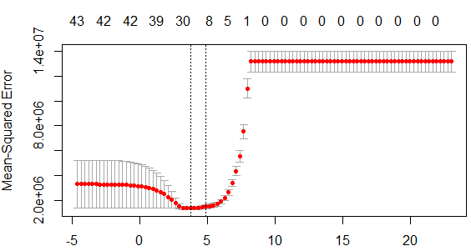

PLOT FOR MINIMUM LAMBDA VALUE IN RIDGE

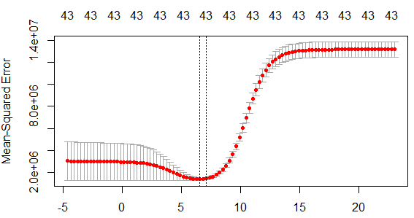

|  |  |  |
| --- | --- | --- |
| MODEL | OPTIMAL LAMDA VALUE | R-SQ VALUE |
| LASSO | 3.76 | 0.91 |
| RIDGE | 6.55 | 0.91 |