Output variable -> y

y -> Whether the client has subscribed a term deposit or not

Binomial ("yes" or "no")

BUSSINESS PROBLEM: To predict on whether the client has subscribed a term deposit or not

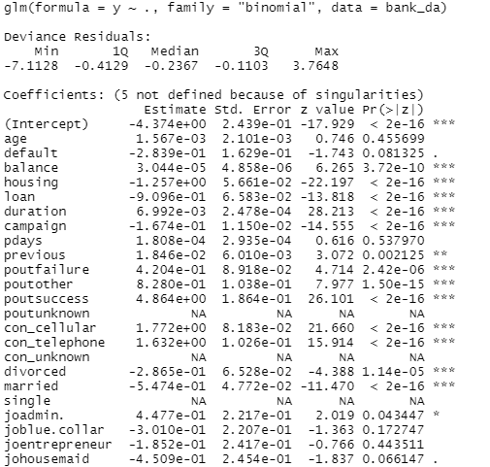

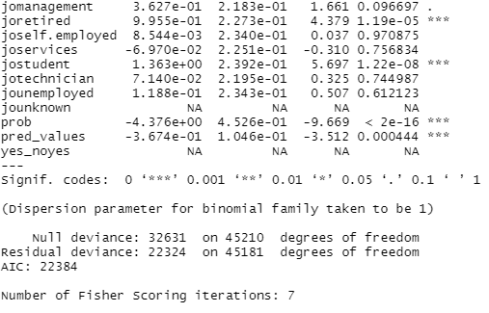

|  |
| --- |
| MODEL1-INFERENCE  Residual deviance is less than null deviance, less the residual deviance better the model.  Most of the input variables are significant  Coefficients are in log |

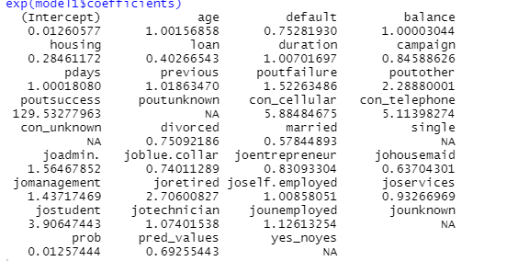

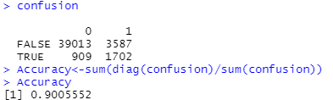

Roc curve for getting optimal cut-off value

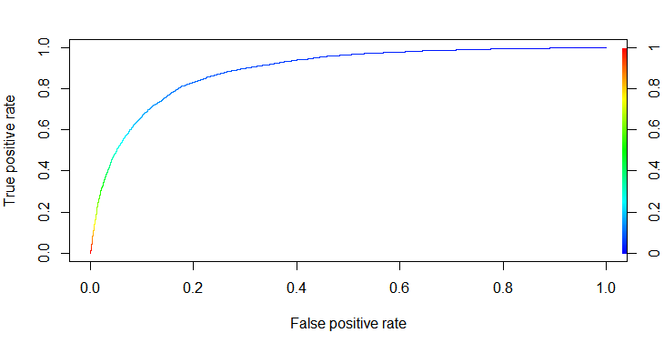

|  |  |  |
| --- | --- | --- |
| MODEL | TRAIN ACCURACY | TEST ACCURACY |
| MODEL1 | 0.90 | 0.89 |

PYTHON CODE

import pandas as pd

import numpy as np

from sklearn.linear_model import LogisticRegression

from sklearn import metrics

from sklearn.model_selection import cross_val_score

from sklearn.preprocessing import StandardScaler

bank_data=pd.read_csv("C:/Users/USER/Desktop/logistic_reg/bank_data.csv")

bank_data.info()

x=bank_data.iloc[:,0:31]

y=bank_data.iloc[:,31]

model=LogisticRegression()

model=model.fit(x,y)

model.score(x,y)#######accuracy=0.89

np.exp(model.coef_)

###train test check

from sklearn.model_selection import train_test_split

x_train,x_test,y_train,y_test = train_test_split(x,y,test_size = 0.3)

model1=LogisticRegression()

model1=model1.fit(x_train,y_train)

pred=model1.predict(x_test)

prob=model1.predict_proba(x_test)

print(metrics.confusion_matrix(y_test, pred))

print(metrics.classification_report(y_test, pred))###accuracy=0.89

###train data

pred1=model1.predict(x_train)

print(metrics.confusion_matrix(y_train, pred1))

print(metrics.classification_report(y_train, pred1))##accuracy=0.891

######checking model accuracy with cross validation

from sklearn.model_selection import cross_val_score

score=cross_val_score(LogisticRegression(),x,y,scoring='accuracy',cv=10)

print(score)

print(score.mean())

#####avg_score=0.88 hence good model