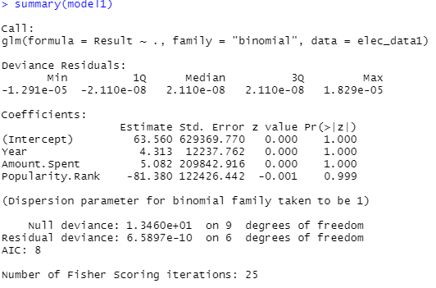

|  |
| --- |
| MODEL-INFERENCE  Residual deviance is less than null deviance and AIC value is less, hence it is the best model |



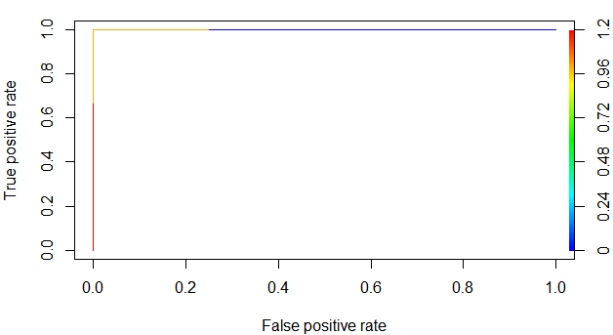

PYTHON CODE

import pandas as pd

import numpy as np

from sklearn.linear_model import LogisticRegression

from sklearn import metrics

from sklearn.model_selection import cross_val_score

from sklearn.preprocessing import StandardScaler

election_data=pd.read_csv("C:/Users/USER/Desktop/logistic_reg/election_data.csv")

election_data1=election_data.iloc[1:,[1,0,2,3,4]]

x=election_data1.iloc[:,1:]

y=election_data1.iloc[:,0]

model=LogisticRegression()

model=model.fit(x,y)

model.score(x,y) #####accu=0.9

model.coef_

np.exp(model.coef_)#####we will get coeff values