BUSSINESS PROBLEM: To Build NAÏVE BAYES model on Salary Data set

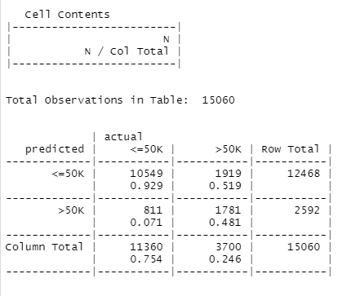

|  |
| --- |
| Accuracy=0.81 |

HISTOGRAM FOR AGE

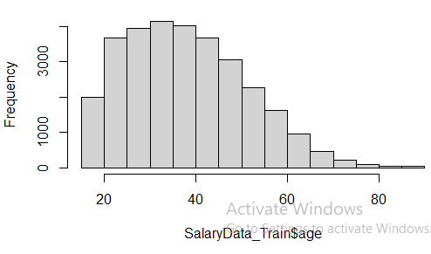

BOXPLOT FOR AGE

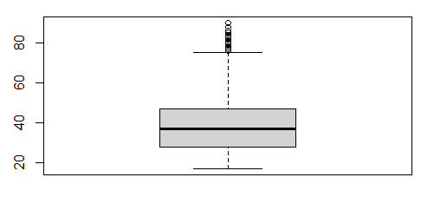

|  |
| --- |
| Shows more number of people working are from age 20-50  Shows less number of people working are from age 60-80 |