Forecast the Coca cola sales data set. Prepare a document for each model explaining

how many dummy variables you have created and RMSE value for each model. Finally which model you will use for

Forecasting.

BUSSINESS PROBLEM: TO FORCAST THE COCA COLA DATA.

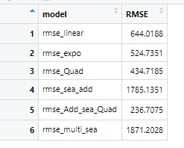

|  |
| --- |
| ADDITIVE SEASONALITY WITH QUADRATIC TREND IS GIVING LEAST RMSE VALUE |