**IoT solution accelerators** - are complete, ready-to-deploy **IoT solutions** that implement common **IoT** scenarios. The scenarios include remote monitoring, connected factory, predictive maintenance, and device simulation.

**Azure IoT Central** - is a fully managed SaaS (software-as-a-service) solution that removes the need for cloud solution expertise and makes it easy to connect, monitor and manage your IoT assets at scale.

**Azure Digital Twins -** is an IoT service that helps you create comprehensive models of physical environments. Create spatial intelligence **graphs to model the relationships and interactions between people, places and devices.** Query data from a physical space rather than disparate sensors. And, build reusable, highly scalable, spatially aware experiences that link streaming data across the physical and digital world.

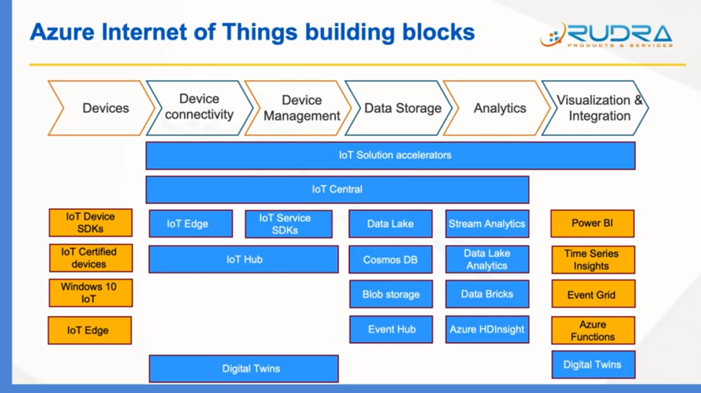

[**IoT Hub**](https://azure.microsoft.com/en-us/services/iot-hub/)— Device provisioning, management, control, and communication

[**Event Hubs**](https://azure.microsoft.com/en-us/services/event-hubs/)**— Hight velocity data ingestion service**

[**Stream Analytics**](https://azure.microsoft.com/en-us/services/stream-analytics/) — Real-time query and processing of streams

[**Blob Storage**](https://azure.microsoft.com/en-us/services/storage/blobs/)**— Unstructured data store**

[**CosmosDB**](https://azure.microsoft.com/en-us/services/cosmos-db/) — NoSQL database to store metadata

[**Time Series Insights**](https://azure.microsoft.com/en-us/services/time-series-insights/) — A Time-series database for storing and querying sensor data

[**Azure Databricks**](https://azure.microsoft.com/en-us/services/databricks/) **/** [**HDInsight**](https://azure.microsoft.com/en-us/services/hdinsight/) — Real-time stream processing (Spark) and batch processing (Hadoop)

[Functions](https://azure.microsoft.com/en-us/services/functions/) — Event-driven serverless computing model

[SQL Database](https://azure.microsoft.com/en-us/services/sql-database/) — RDBMS to store structured data

[ML Studio](https://studio.azureml.net/) — Web-based IDE to build and deploy ML models

[Power BI](https://powerbi.microsoft.com/en-us/) — Rich dashboard and visualization tool

How IOT hub connect with Edge device

There are three broad steps involved in this tutorial:

1. Creating cloud resources in Azure IoT

* We will then create a resource group
* create an IoT Hub
* creates an identity for Raspberry Pi with a device id Pi1. The output will contain a device-specific connection string that we need to save. Keep the connection string safe and secure.

1. Configuring and connecting Raspberry Pi to Azure IoT

* Make sure Moby and the CLI are properly installed
* install on Raspberry Pi is Azure IoT Edge runtime, which runs as a background daemon.
* To connect Azure IoT Hub. add the device connection string that we acquired in step 1 to the configuration file.

1. Deploying modules to the edge devices

What would be telemetry/message format of the device to IoT hub?

System Properties of D2C IoT Hub messages

1. messageId

2. enqueuedTime

3. userId

4. connectionDeviceId

5. connectionModuleId

6. connectionDeviceGenerationId

7. connectionAuthMethod

System Properties of C2D IoT Hub messages

1. message-id

2. sequence-number

3. destination specified in Cloud-to-Device messages.

4. Date and time of message expiration.

5. A string property in a response message that typically contains the MessageId of the request, in request-reply patterns.

6. User-id An ID used to specify the origin of messages. When messages are generated by IoT Hub, it is set to {iot hub name}.

7. iothub-ack A feedback message generator.