**DevSecOps: Integrating Security into the DevOps Lifecycle**

Greetings, DevOps advocates! In our ever-evolving exploration of the DevOps universe, we’re now delving into an essential dimension where security takes center stage — welcome to the world of DevSecOps. As the digital landscape continues to evolve, embedding security into every phase of the development lifecycle becomes imperative. Join us as we unravel the principles and practices of DevSecOps, ensuring that security becomes an integral part of the DevOps journey.

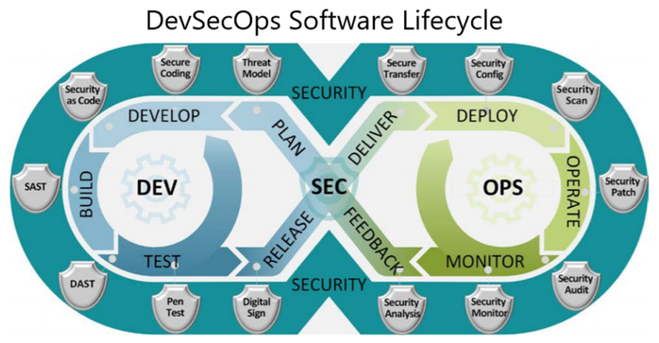

**Part 8: DevSecOps — Fusing Security and DevOps for Resilient Systems**

1. **Understanding DevSecOps: A Cultural Shift**

***Concept:***

DevSecOps extends the collaborative DevOps culture by integrating security practices seamlessly into every stage of the development lifecycle. It’s a mindset that prioritizes security as a shared responsibility rather than a separate phase.

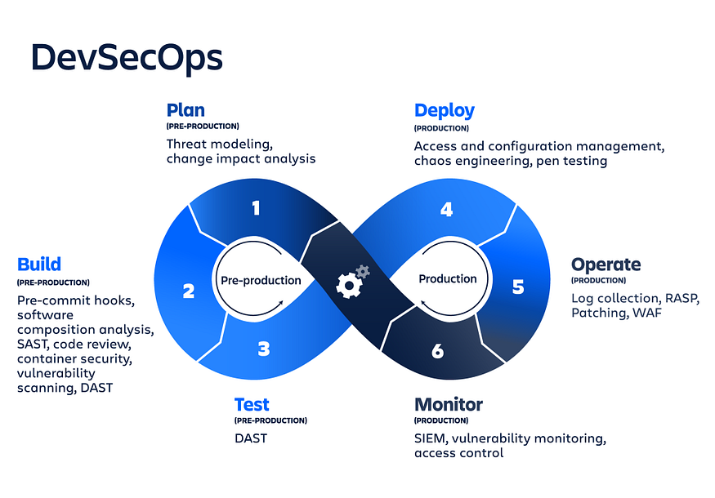

[DevSecOps: A New Paradigm in Security Integration](https://www.linkedin.com/pulse/devsecops-new-paradigm-security-integration-gitonga-bretton)

2. **Shift-Left Security: Early and Continuous Risk Mitigation**

***Concept:***

Shift-Left security in DevSecOps emphasizes addressing security concerns early in the development process. By integrating security testing and analysis into the initial stages, teams can identify and mitigate vulnerabilities before they escalate.

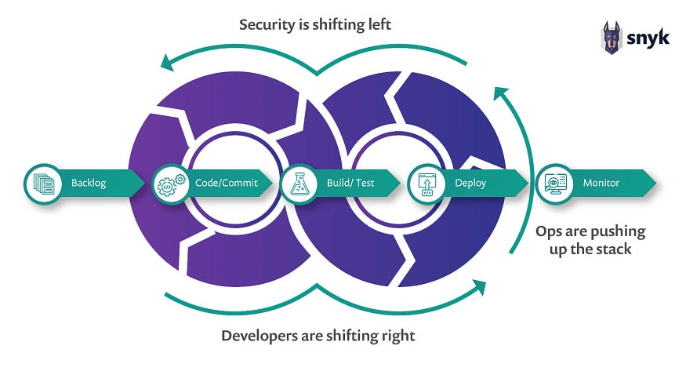

3. **Automated Security Testing: Ensuring Continuous Assurance**

***Concept:***

Automated security testing tools, such as static analysis and dynamic analysis tools, become integral in a DevSecOps pipeline. These tools automatically scan code for vulnerabilities, ensuring continuous assurance of the security posture throughout the development lifecycle.

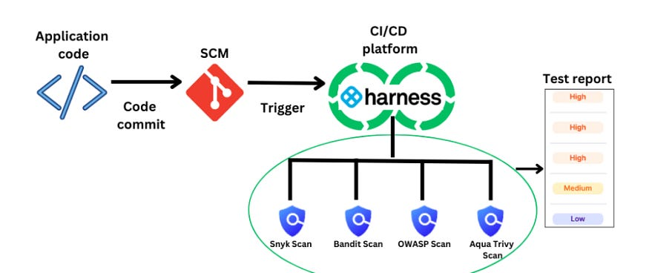

[Tools Used to Test and Detect Application Security Vulnerabilities](https://dev.to/pavanbelagatti/tools-used-to-test-and-detect-application-security-vulnerabilities-2d40)

4. **Infrastructure as Code (IaC) Security**

***Concept:***

Securing infrastructure in code is a critical aspect of DevSecOps. Applying security policies and best practices to IaC templates ensures that the provisioning of cloud resources aligns with security standards, minimizing the risk of misconfigurations.

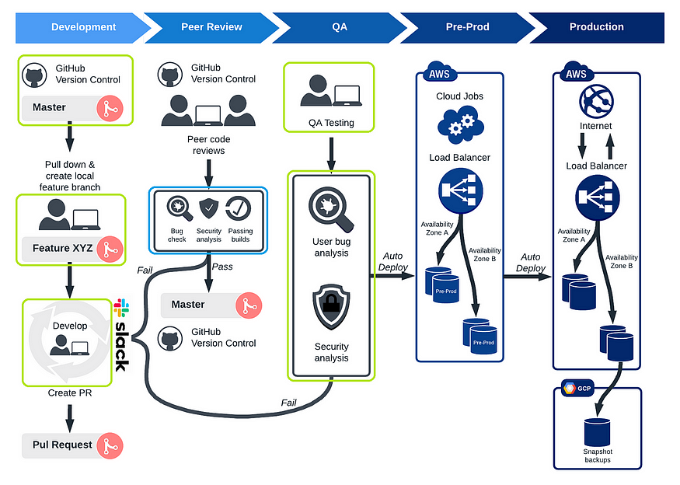

[Security Automation for IaC](https://blog.devgenius.io/security-automation-for-iac-a3256be8cd32)

5. **Continuous Monitoring and Incident Response**

***Concept:***

DevSecOps incorporates continuous monitoring of applications and infrastructure, utilizing tools like intrusion detection systems and security information and event management (SIEM) solutions. Automated incident response mechanisms are also integrated to swiftly address and remediate security incidents.

6. **Compliance as Code: Embedding Regulatory Standards**

***Concept:***

DevSecOps ensures that compliance with regulatory standards is embedded into the development process. Compliance as Code involves codifying and automating adherence to regulatory requirements, allowing organizations to maintain compliance without hindering development velocity

**Next Steps: Embracing DevSecOps for a Secure Future**

As you embrace DevSecOps, recognize that security is not a roadblock but a critical enabler of innovation. By integrating security into your DevOps practices, you fortify your systems against emerging threats and build a foundation for resilient and secure applications.

In our upcoming articles, we’ll continue to explore advanced DevSecOps topics, share insights from industry experts, and guide you in optimizing your security practices within the DevOps framework. Stay tuned as we unravel more layers of the dynamic and ever-evolving world of DevSecOps!