TRAFFIC SIMULATION ON DETER

Santosh Narayankhedkar

[santoshn@isi.edu](mailto:santoshn@isi.edu)

**Introduction:**

Today, all the traffic signals are monitored by a central controller which sends out traffic signal messages to individual traffic stations.  The central controller is at a very high risk of getting incorrect reading from the sensor as well as from attackers trying to intentionally create congestion in the network. We need a system which is capable of adapting to these attacks and hence there is a need to decentralize the traffic monitoring system.

The Idea is to design a simulation system which approximates the real world and then enforce attacks on it. The system is designed in such a way that it can adapt to these attacks and take counter measures to reduce the impact it could possibly have on the network.

**Implementation:**

**Assumptions:**

1. No Lane Changes
2. Each lane length is fixed
3. Speed of the vehicles traversing the intersection is fixed
4. Input arrival rate is 5 sec (CBR) and 2.5s on average (Poisson)
5. Traffic signal is green for 25 sec and yellow for 5 sec
6. Queues are serviced every 1.5 sec
7. Client thread services the queue in question every 1.5 sec
8. Server thread pushes the vehicle in the queue 1 sec after receiving it.
9. The control threads exchange information every 0.5 sec
10. The queue size thread takes snapshot of the queue sizes every 0.5 sec.
11. **Traffic signal thread**: which basically has four states (A = N-S Green W-E Red, B = N-S Yellow W-E Red, C = W-E Green N-S Red, D = W-E Yellow N-S Red).
12. **Queue size thread:** Takes snapshot of the queue sizes at regular interval of time.
13. **Input thread:** There exists three input thread per direction in each intersection unless it’s a common road between two intersections.
14. **Server–Client thread:** There exists two threads server and client per intersection in the direction of the common road. These threads are responsible for forwarding the cars from one intersection to the other.
15. **Control Server-Client thread:** There exits two control server and client per intersection in the direction of the common road. These threads are responsible for calculating the state of the queue’s and set the corresponding bit if the queue size exceeds the LANE_LENGTH.
16. **Service thread:** This thread checks the traffic signal state and services the queues depending on the traffic signal state. This thread only services the queues which do not have forwarding enabled.

**Scenarios:**

We would be discussing a number of scenarios for one, two and four intersection with the traffic signal synchronized and unsynchronized. We would also be giving details on how to get the intersection started.

**Scenario 1: One Intersection**

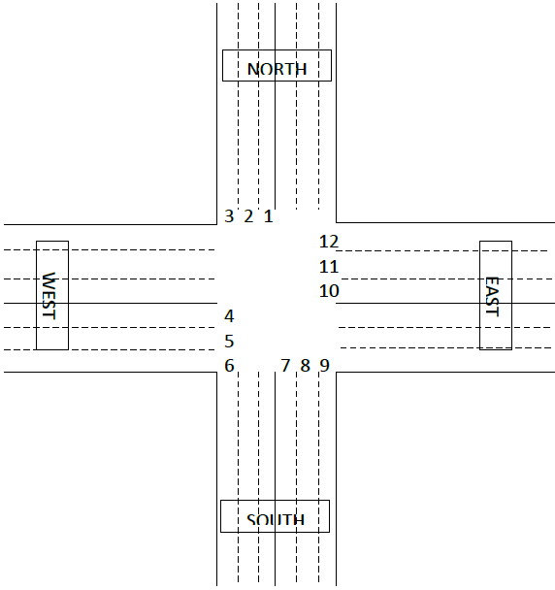

**Physical Topology**

Controller

**Experimental Topology**

There exists one controller per intersection. The physical topology shows 12 input queues Q1-12. There is only one controller corresponding to it since this is only one intersection.

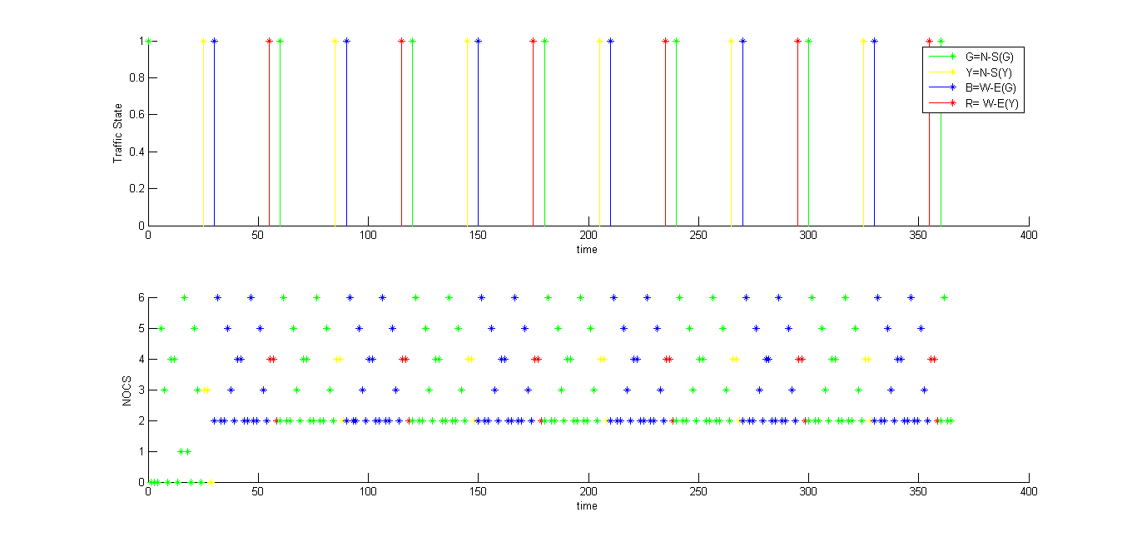

**Fig 1**

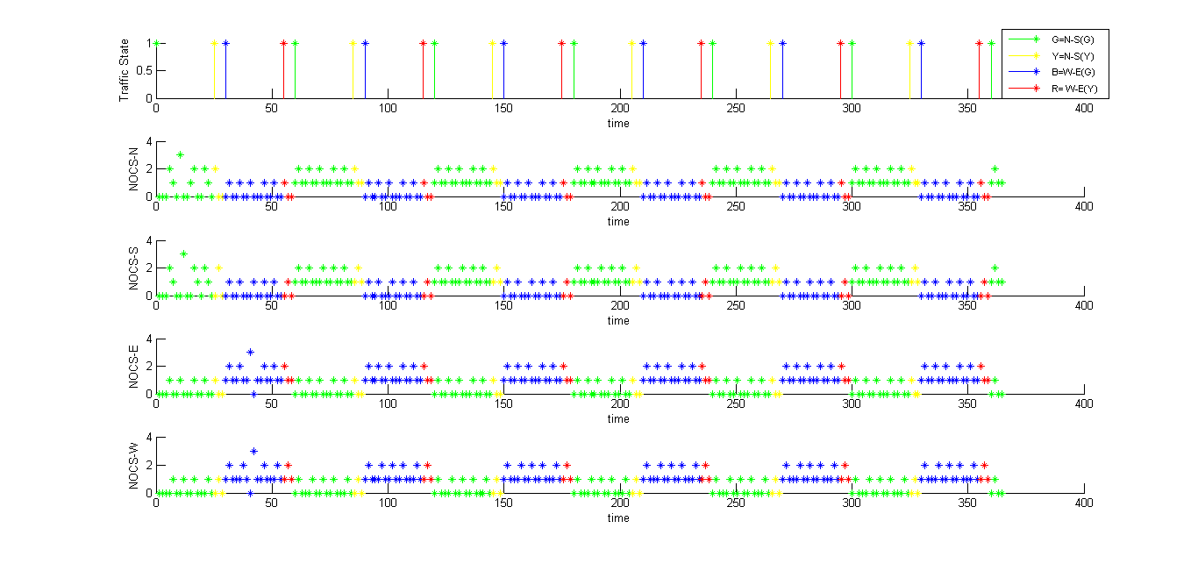

**Fig 2**

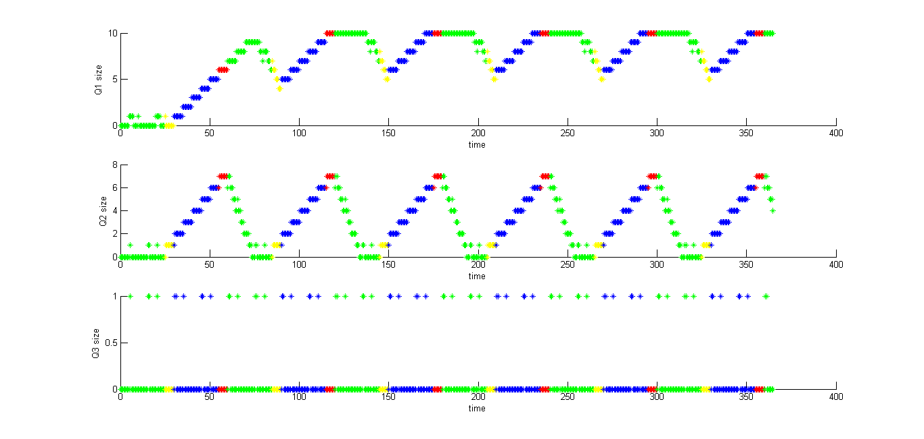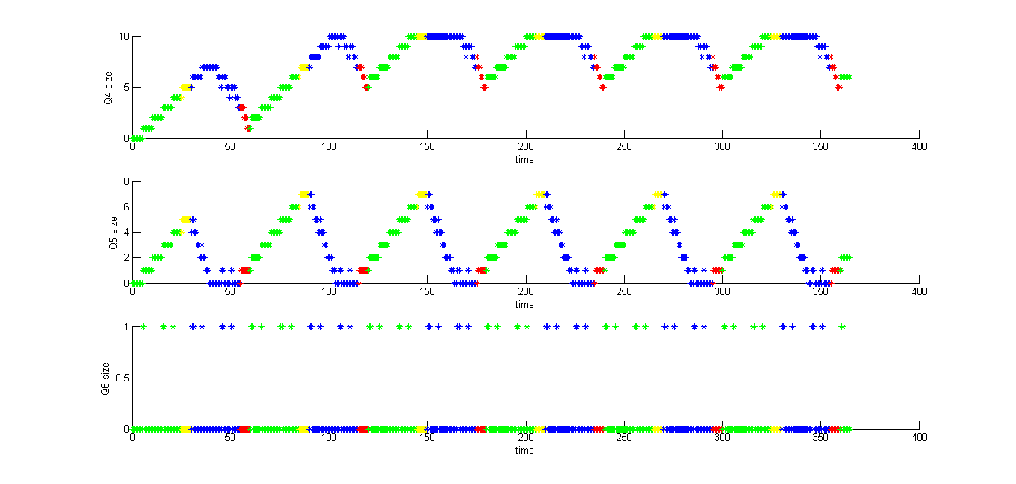

**Fig 3 Fig 4**

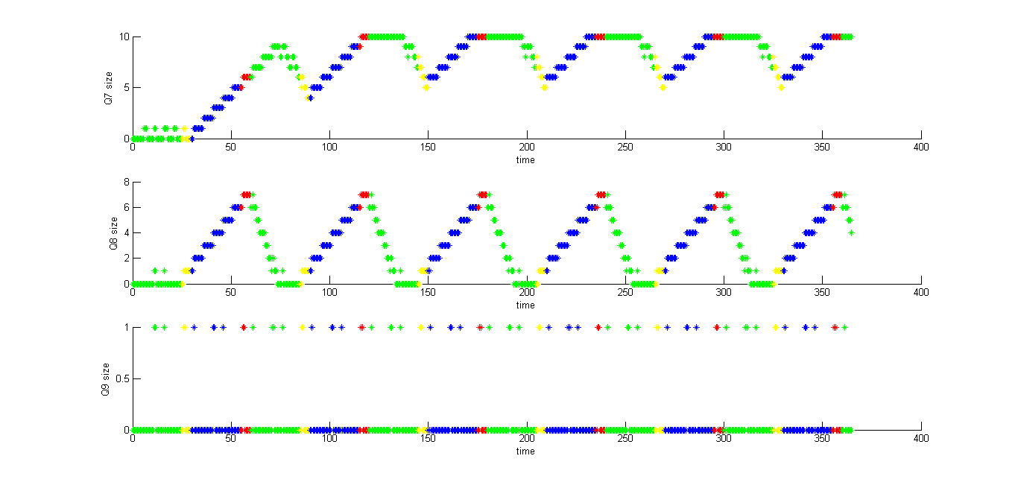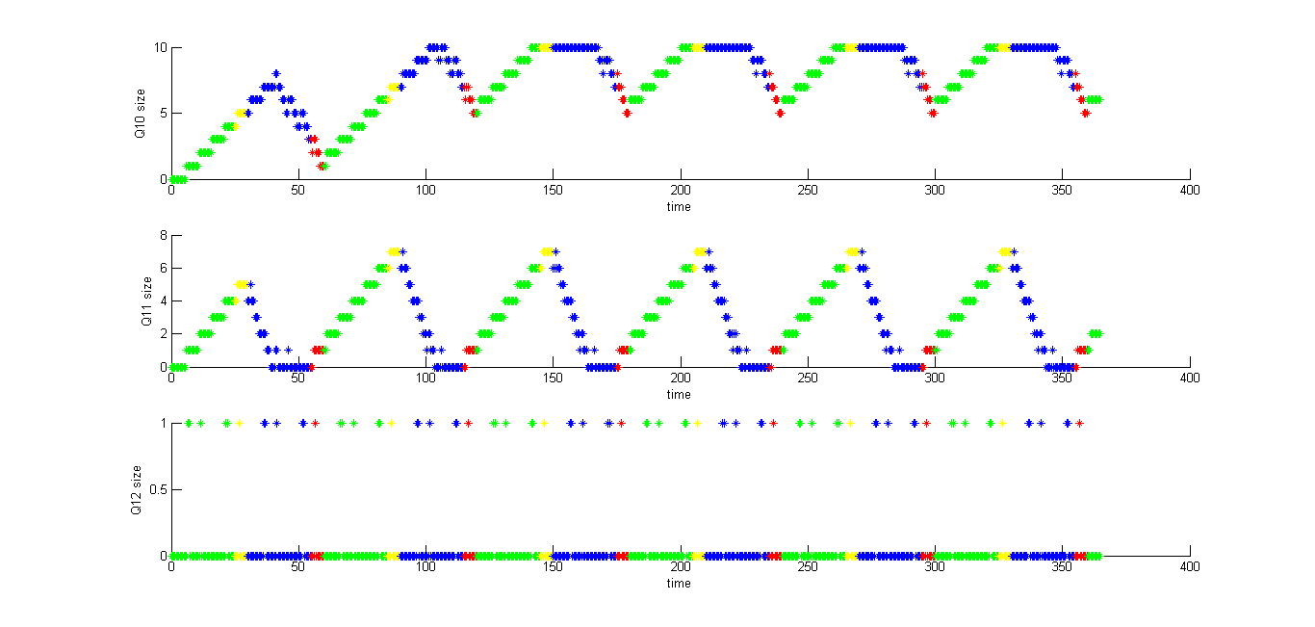

**Fig 5 Fig 6**

**Figure 1:** shows the traffic signal state vs time graph. Green = N-S Green, Yellow = N-S Yellow, Blue = W-E Green, Red = W-E Yellow. It also shows the NOCS (number of cars serviced) vs time graph. NOCS is basically the number of cars that can traverse the intersection at that instant of time.

**Figure 2:** shows the traffic signal state vs time graph (same as fig 1). It also shows the NOCS-* (number of cars serviced in the direction *) vs time.

**Figure 3-6:** shows the queue sizes with traffic signal state in north, west, south and east directions respectively.

**Explanation:**

The maximum value of NOCS graph corresponds to 6 which correspond to 4 turn lanes + (2 cars going straight or 2 cars turning at the intersection). The NOCS in each direction can be maximum 3 since there are only 3 queues. In the figure 3 – 6 shows the queue sizes in each direction. We see the queue sizes of Q4-6 and Q10-12 increasing when green which is obvious because the signal is red for them. Likewise the Q1-3 and Q7-9 sizes increase when the traffic signal state is blue. The cars can traverse the intersection only if there is no conflicting car from other queue.

**Scenario 2: Two Intersections (E-W Intersection)**



**Physical Topology**

Controller 2

Controller 1

**Experimental topology**

There exist 18 input queues, 9 per intersection. Q10-12 for controller 1 and Q4-6 for controller 2 are not input queues they are basically socket queues for this particular scenario.

The queue states are the same for controller 1 except Q10-12 and except Q4-6 for controller 2 which can be seen in the fig 7-8 for synchronized 25-5 and fig 9-10 for unsynchronized 25-5

1. Synchronized Traffic signal 25(G) – 5(Y) s.

Q10-12 for controller 1:

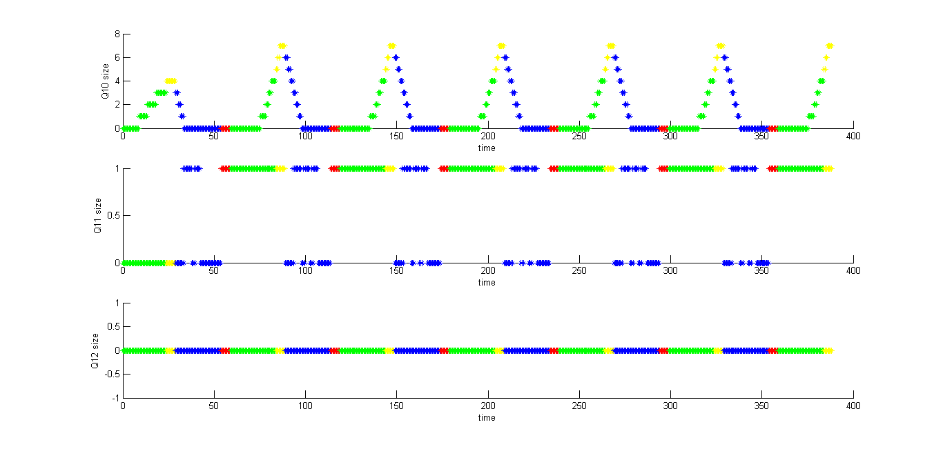

**Fig 7**

Q4-6 for controller 2:

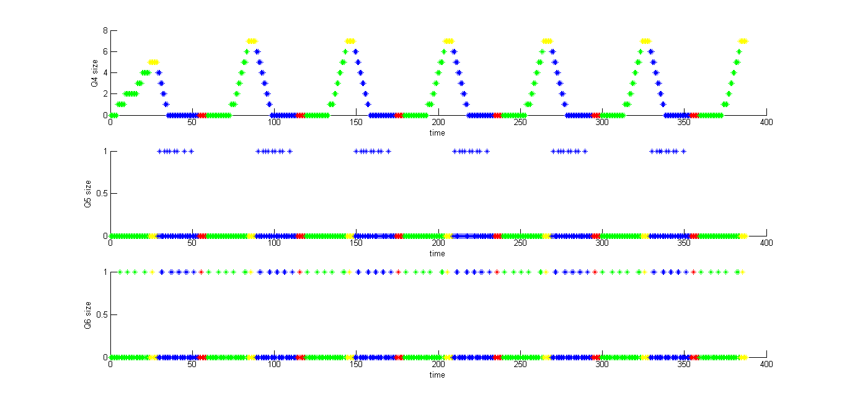

**Fig 8**

The graphs for figure 7 and 8 are pretty similar, and that is expected, since it’s the traffic signals are synchronized.

1. Unsynchronized Traffic Signal 25-5

Q10-12 for controller 1:

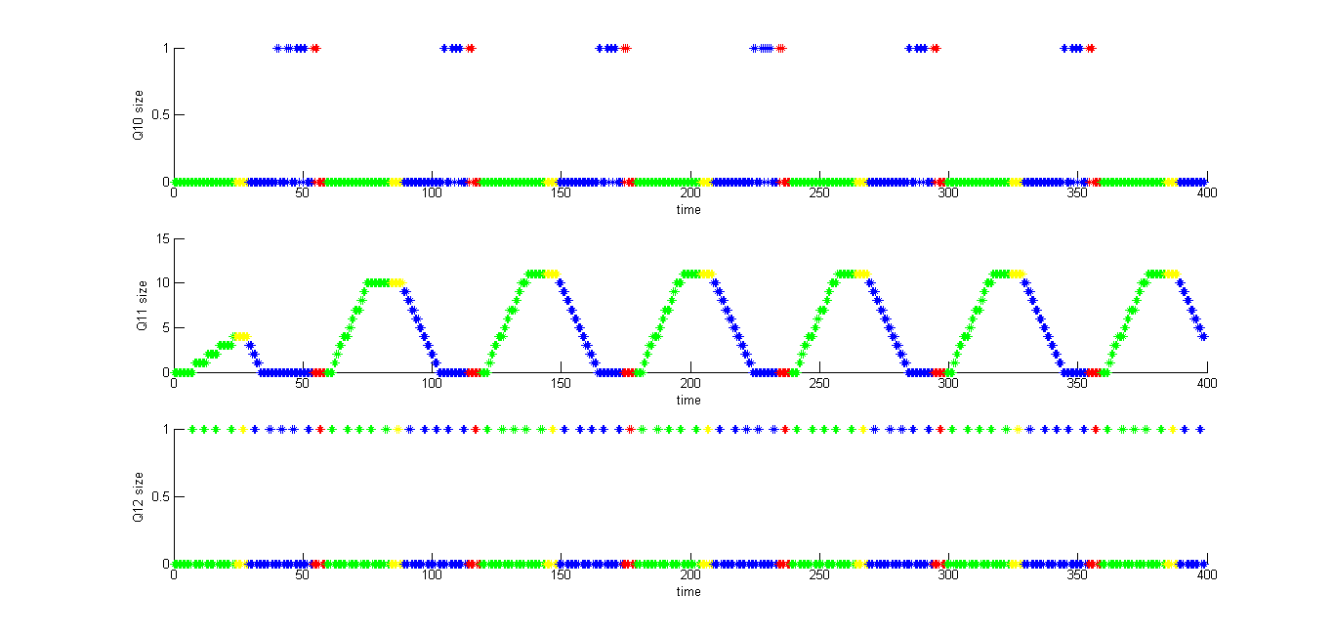

**Fig 9**

Q4-6 for controller 2:

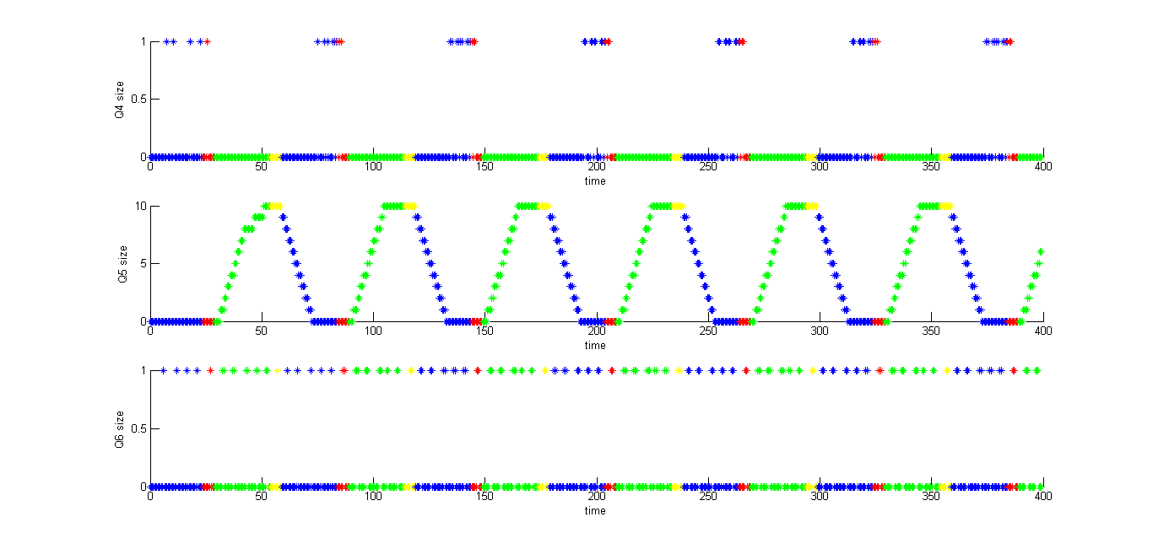

**Fig 10**

In the unsynchronized traffic signal scenario again the graphs for the fig 9 and fig 10 are pretty similar. You can see the queue sizes for the straight lane path increasing.

**Scenario 3: Four Intersections (E-W Intersection)**



**Physical Topology**

C1

C2

C3

C4

**Experimental topology**

1. Sync 25-5

Q10-12 for controller 1:

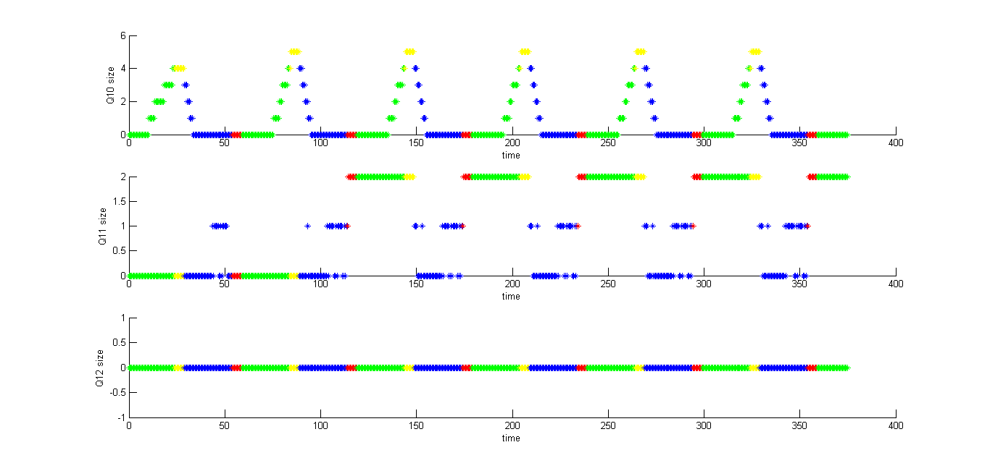

**Fig 11**

Q4-6 for controller 2:

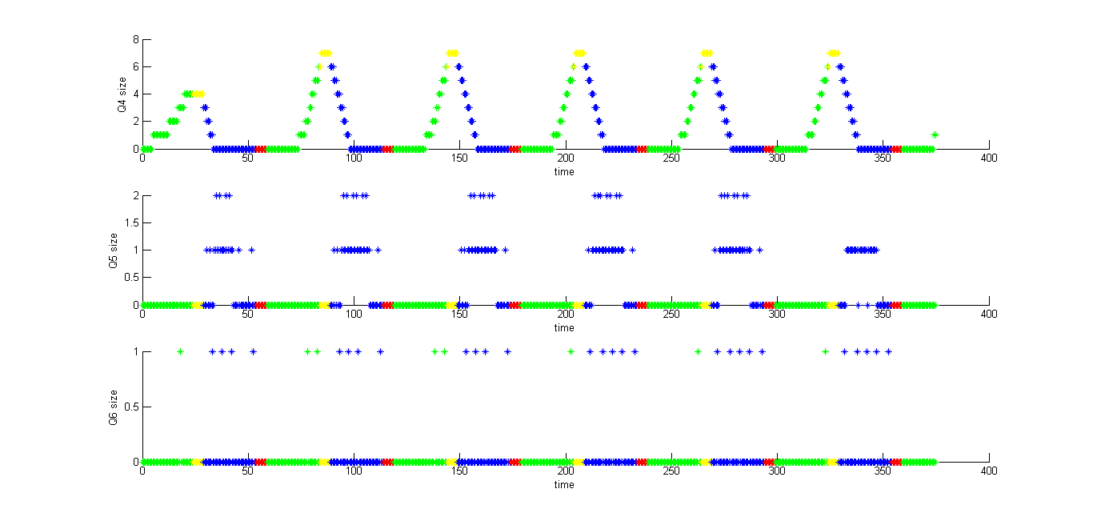

**Fig 12**

Q10-12 for controller 2:

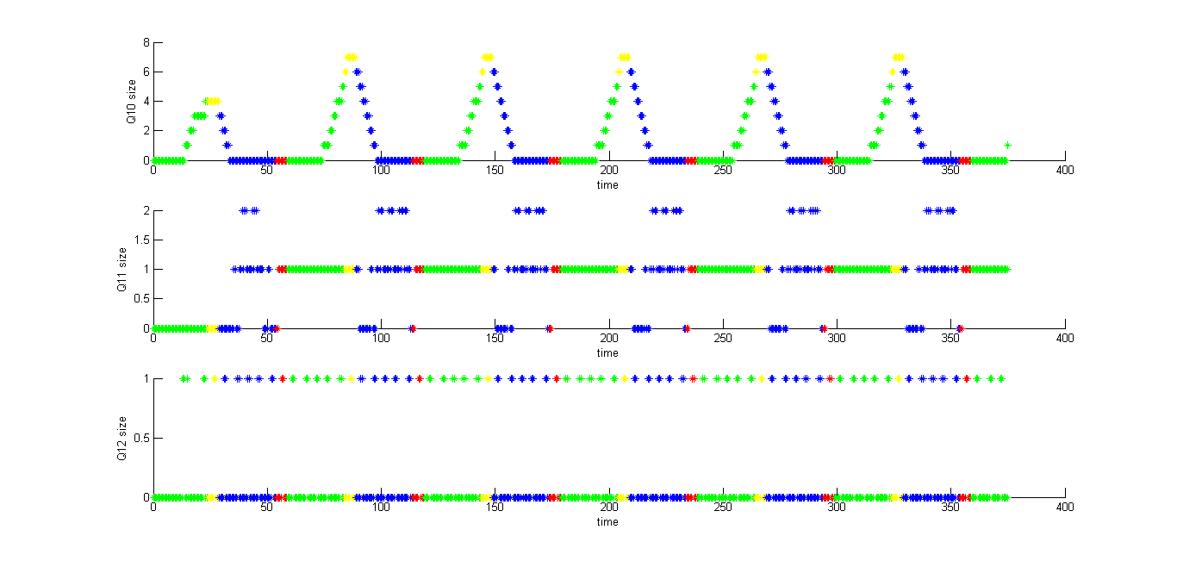

**Fig 13**

Q4-6 for controller 3:

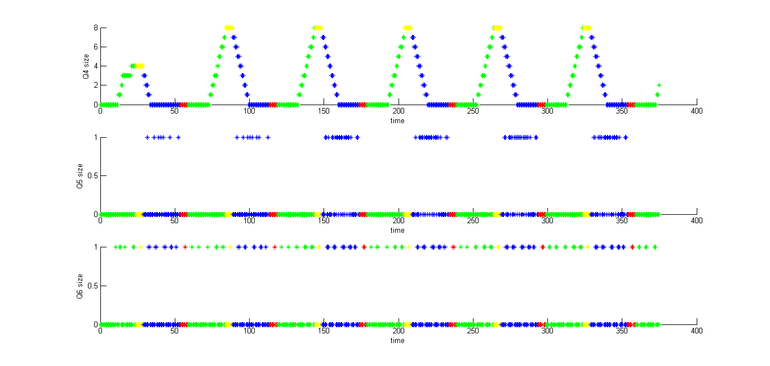

**Fig 14**

Q10-12 for controller 3:

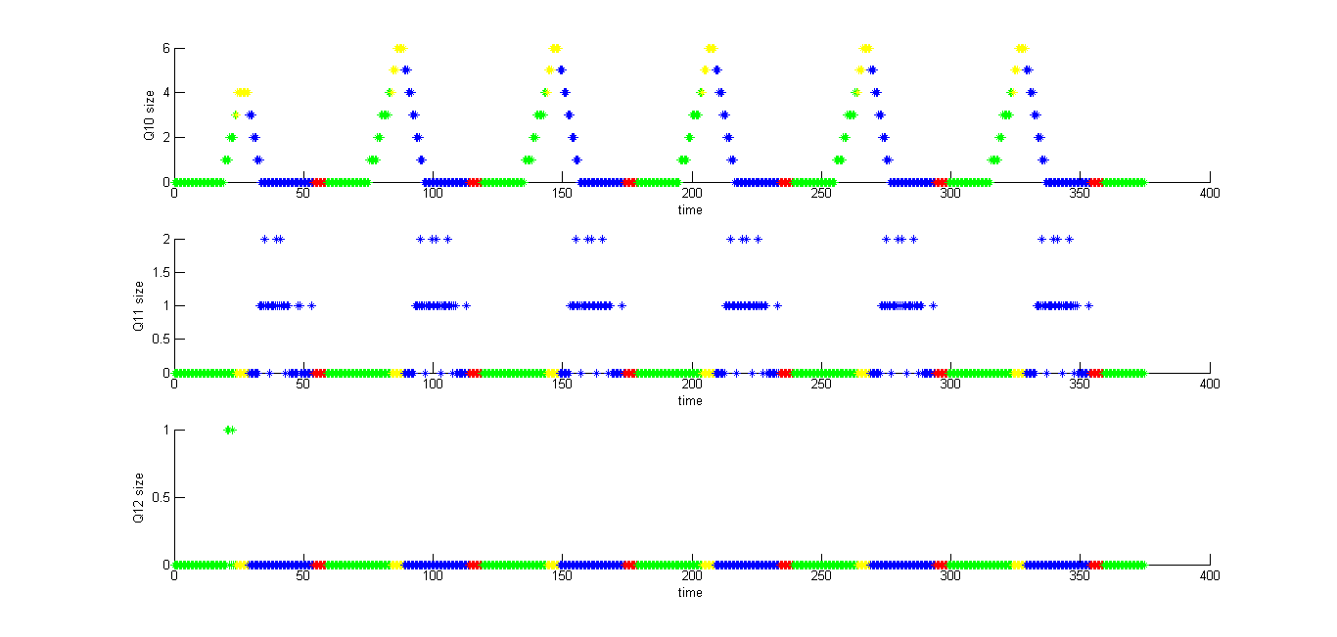

**Fig 15**

Q4-6 for controller 4:

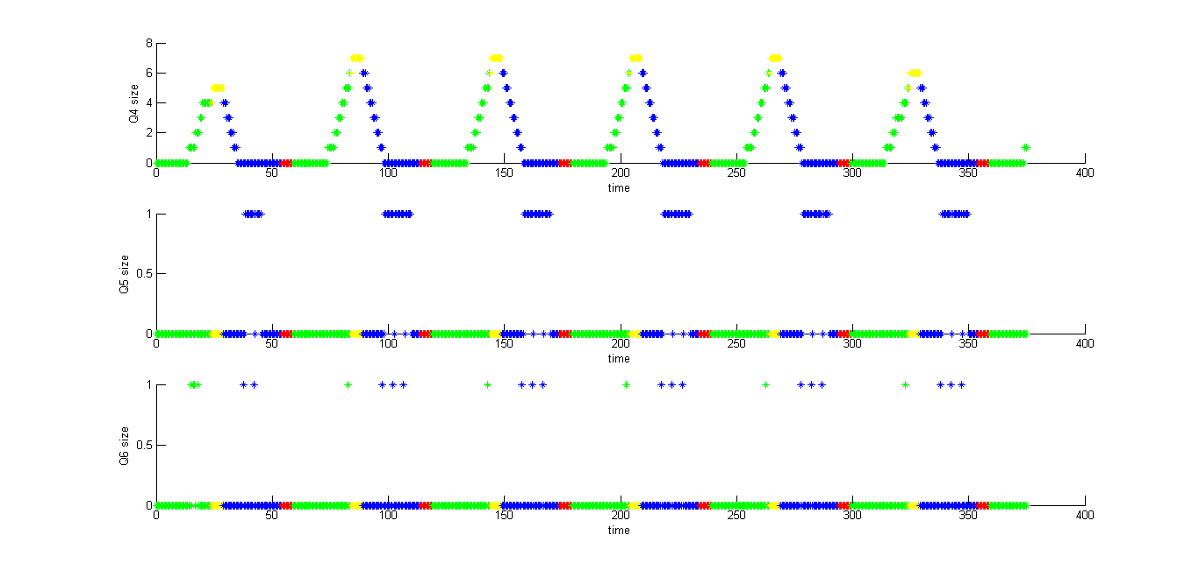

**Fig 16**

In the four intersection scenario, you can see that the signal turn lanes queue are the only queues whos size is increasing continuosly. The right turn lane and the straight lane queue sizes are is at max 2 which is again expected since the signals are synchroized.

1. Unsync 25-5

Q10-12 for controller 1:

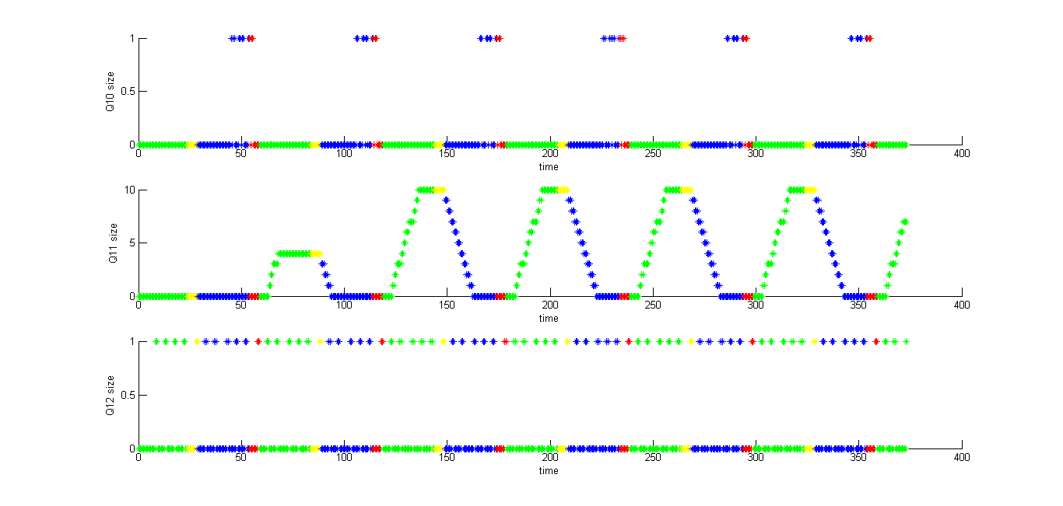

**Fig 17**

Q4-6 for controller 2:

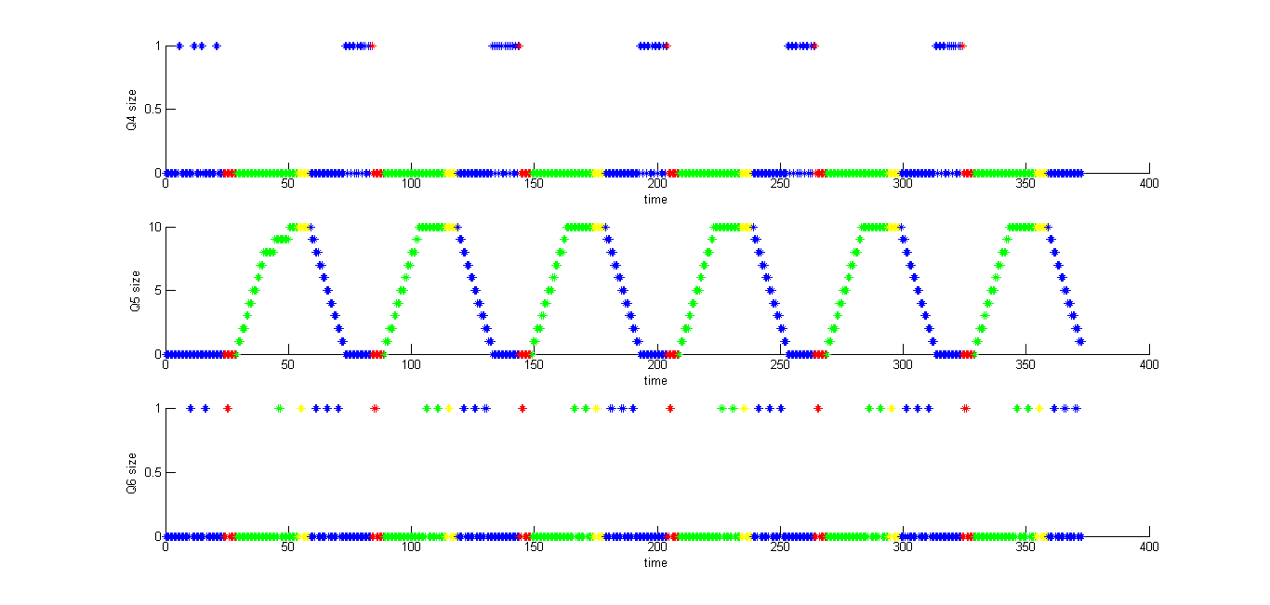

**Fig 18**

Q10-12 for controller 2:

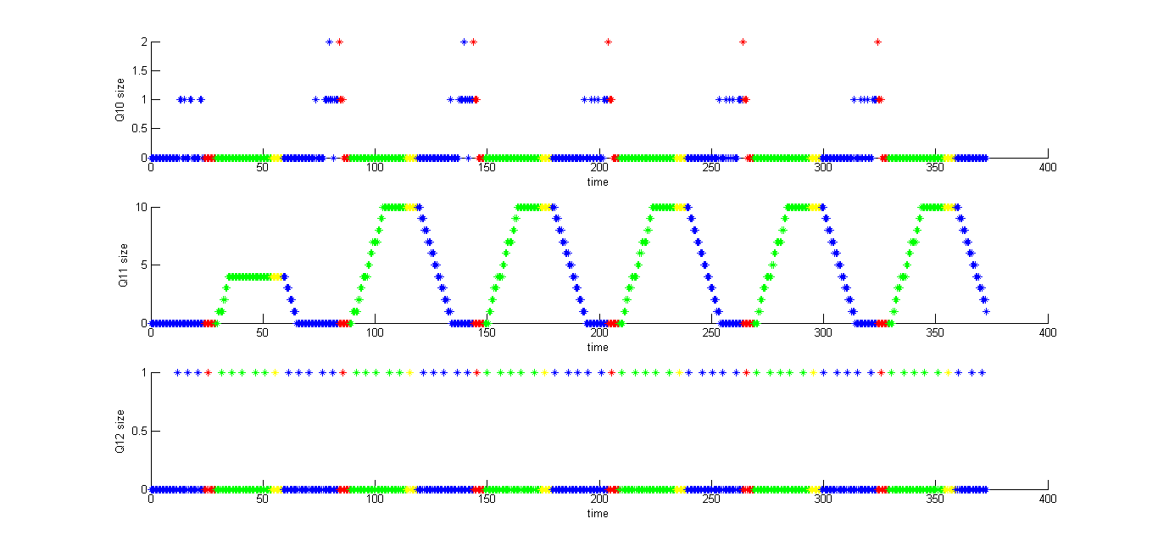

**Fig 19**

Q4-6 for controller 3:

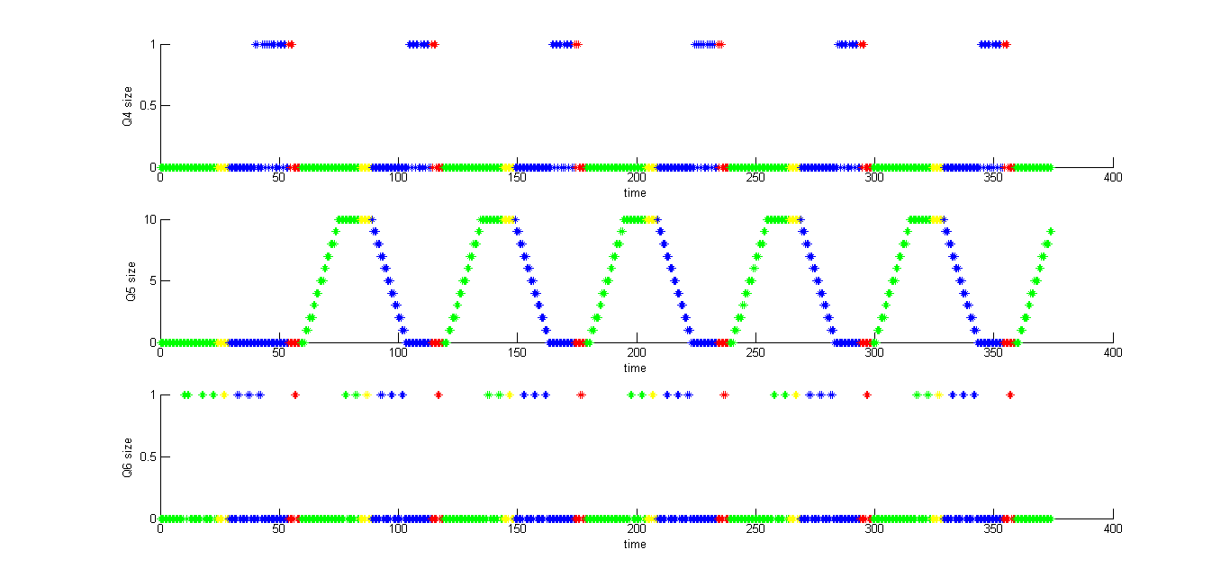

**Fig 20**

Q10-12 for controller 3:

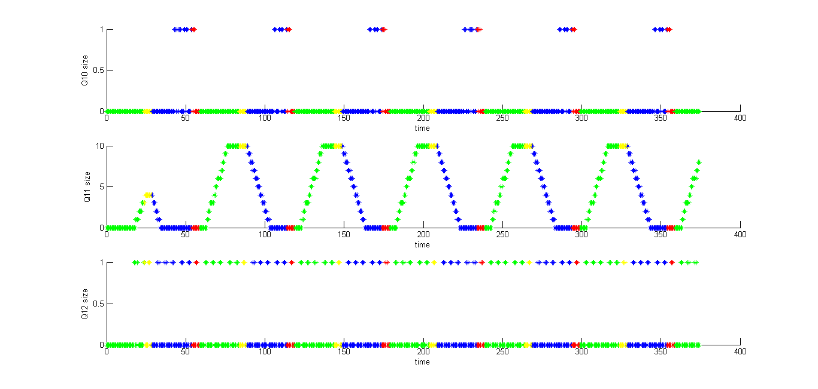

**Fig 21**

Q4-6 for controller 4:

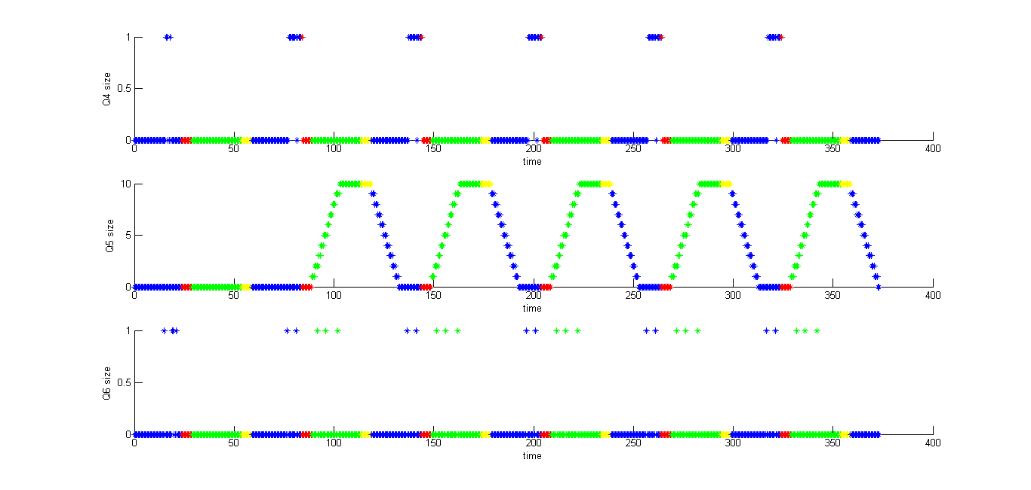

**Fig 22**

In the four intersection unsynchronized scenario, you can see that the straight lane queue sizes are increasing continuosly which is expected since the traffic signals are unsynchronized.

**Scenario 4: Four Intersections (Grid)**





**Physical Topology**

C1

C2

C3

C4

**Experimental topology**

1. Sync 25-5

Q1-3 for controller 1

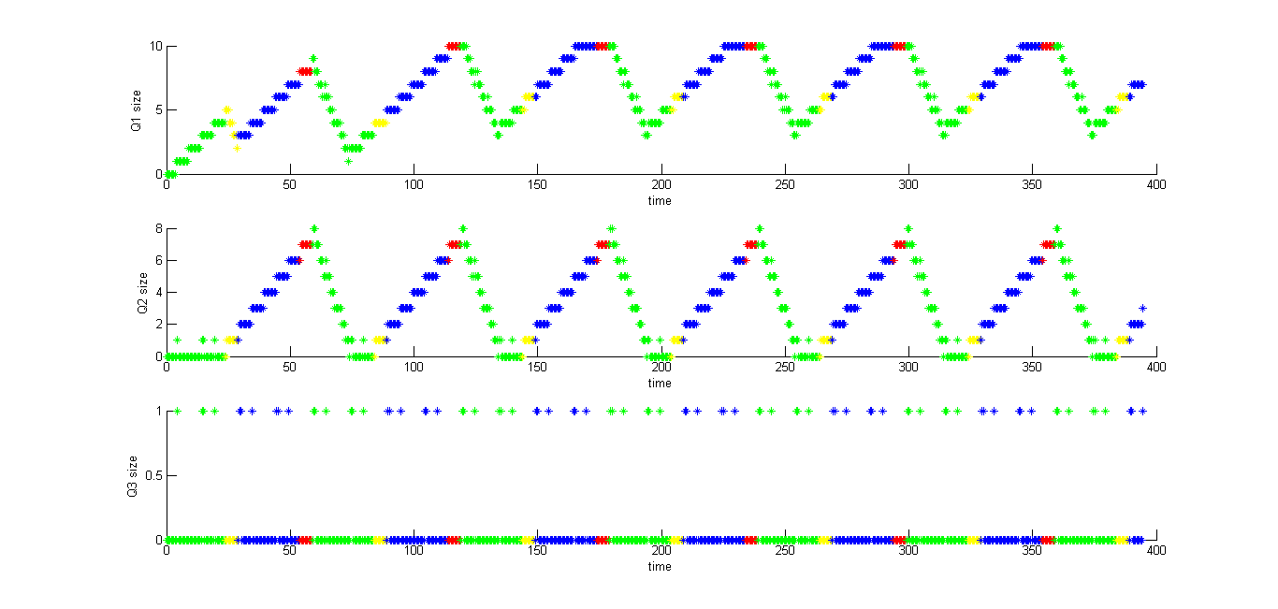

**Fig 23**

Q4-6 for controller 1

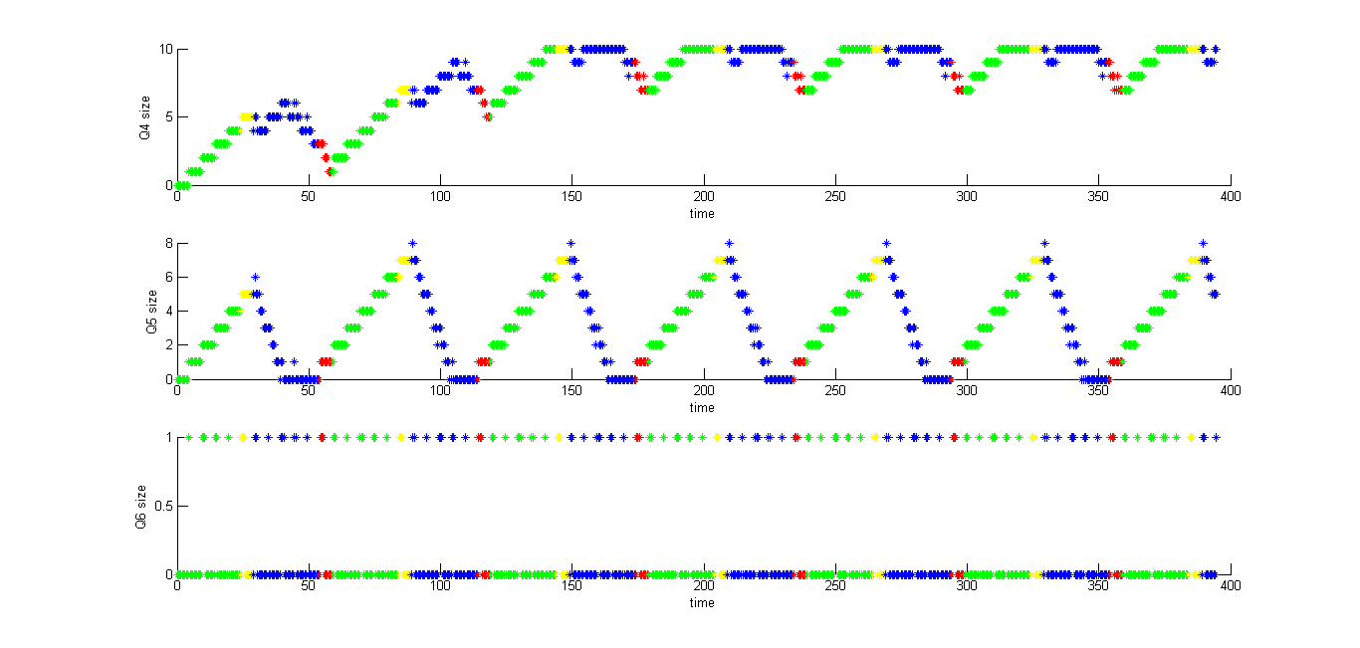

**Fig 24**

Q7-9 for controller 1

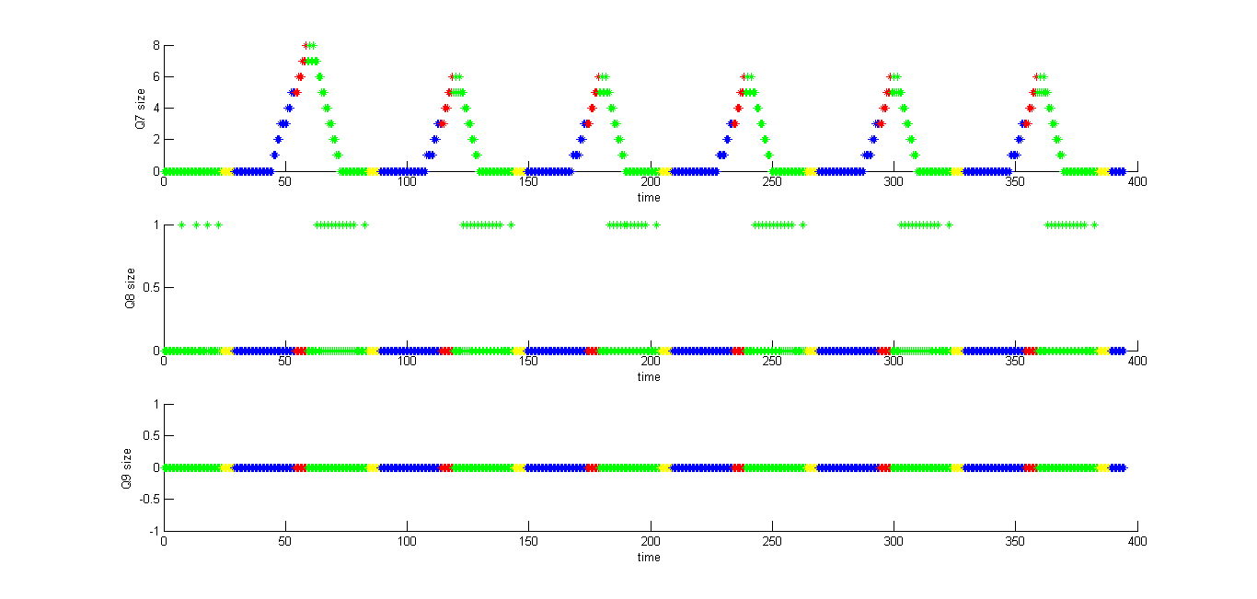

**Fig 25**

Q10-12 for controller 1

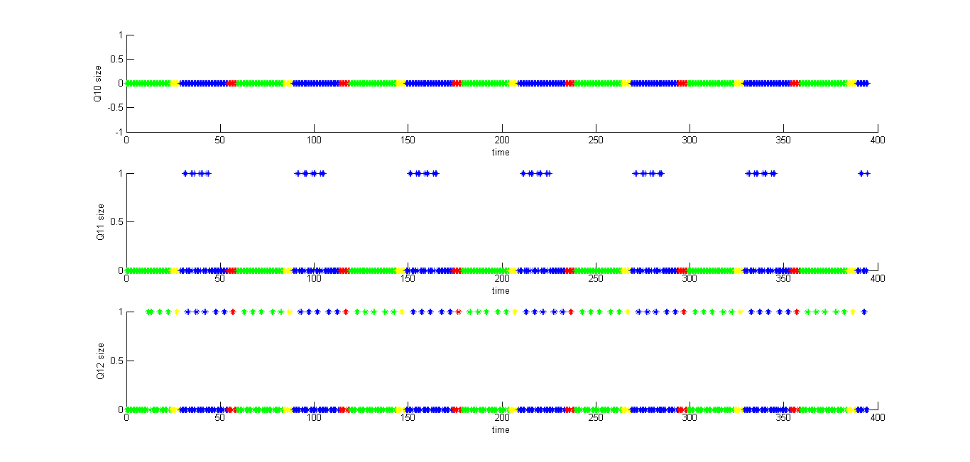

**Fig 26**

For controller 1 the most important figures are fig 25 and fig 26

Q9 and Q10 size remain always 0 which is expected since there is no input. Other queues have expected behavior in case as in case of two intersection E-W and two intersection N-S.

Q1-3 for controller 2

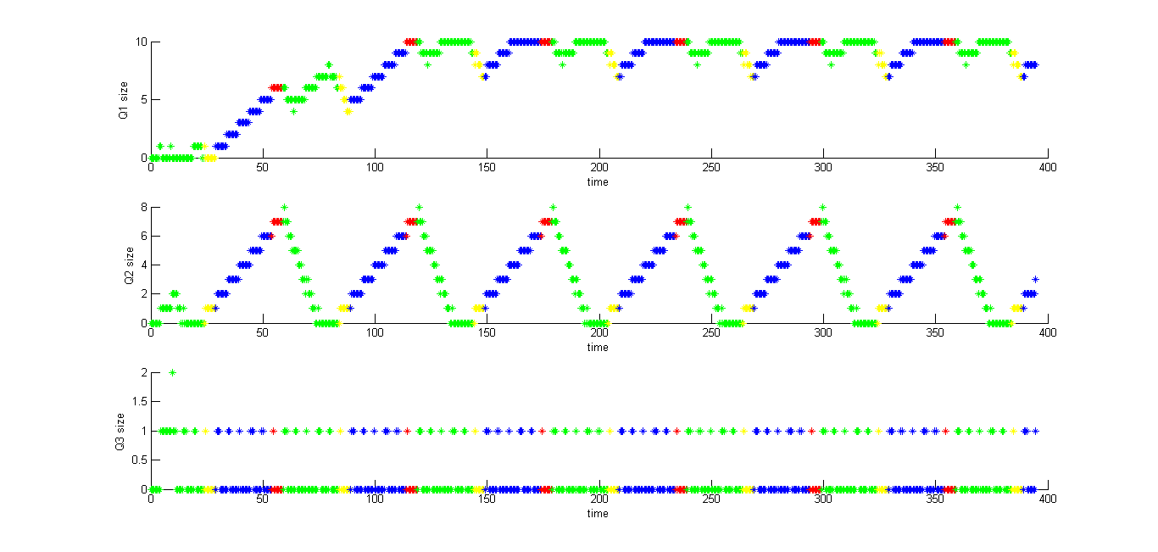

**Fig 27**

Q4-6 for controller 2

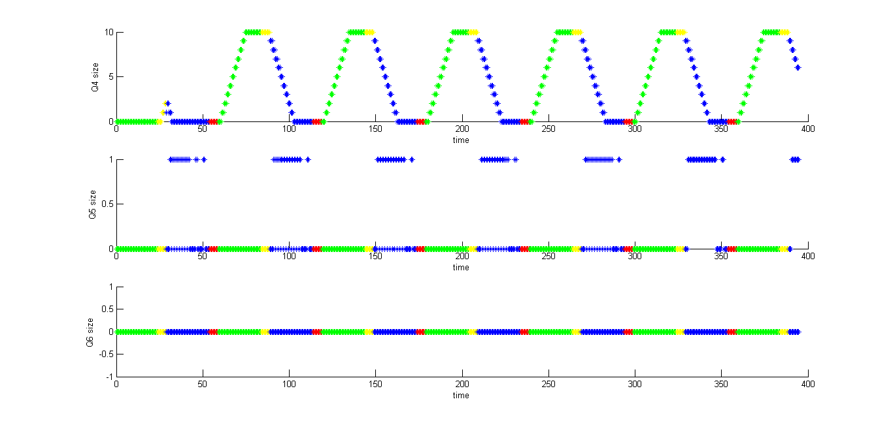

**Fig 28**

Q7-9 for controller 2

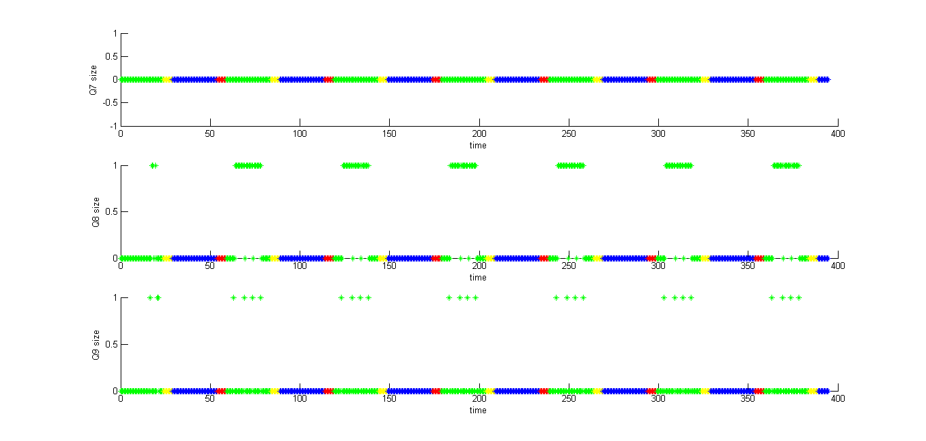

**Fig 29**

Q10-12 for controller 2

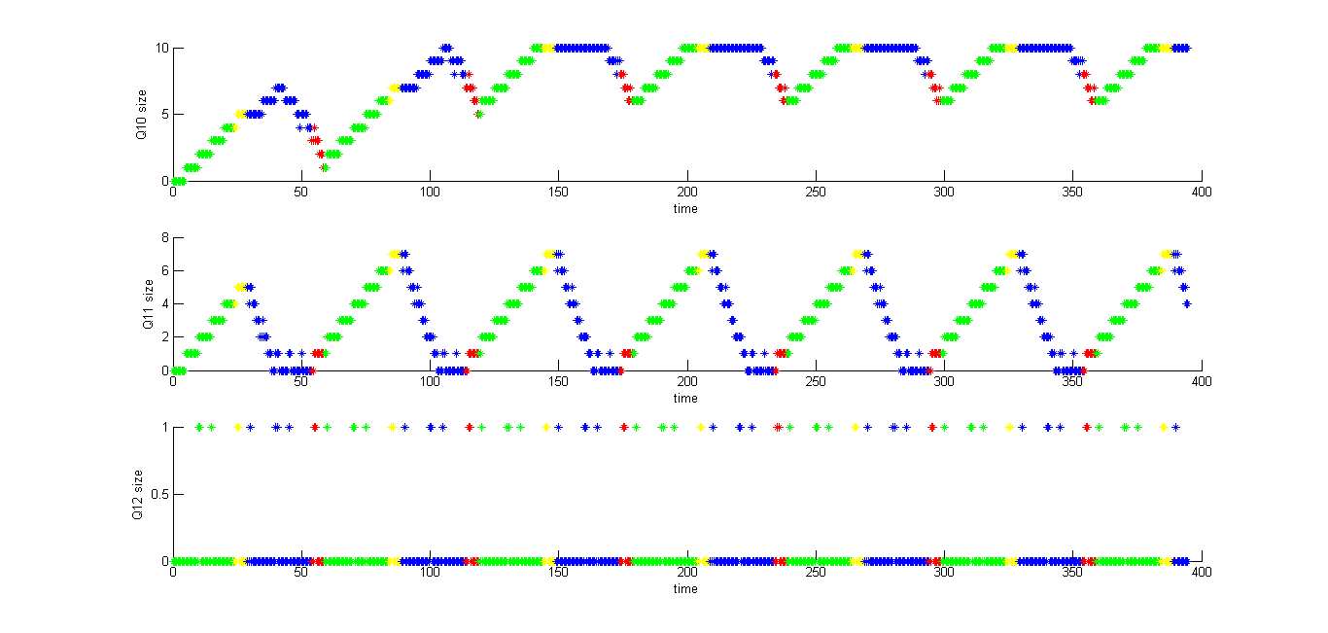

**Fig 30**

For controller 2 the most important figures are fig 28 and fig 29

Q6 and Q7 size remain always 0 which is expected since there is no input. Other queues have expected behavior in case as in case of two intersection E-W and two intersection N-S.

Q1-3 for controller 3

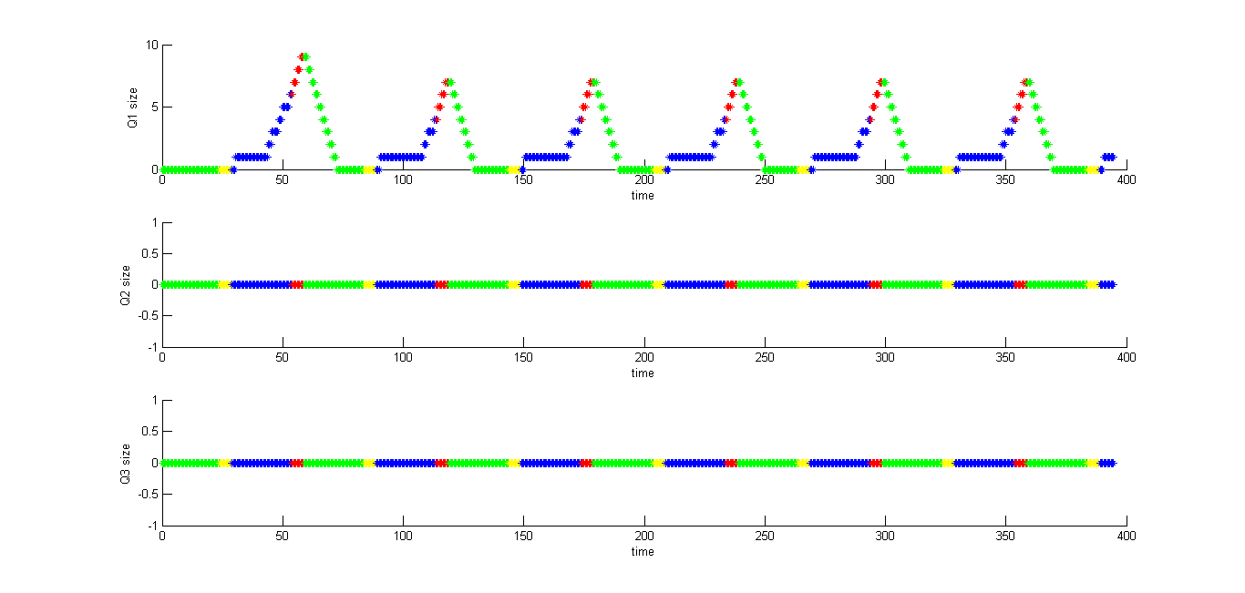

**Fig 31**

Q4-6 for controller 3

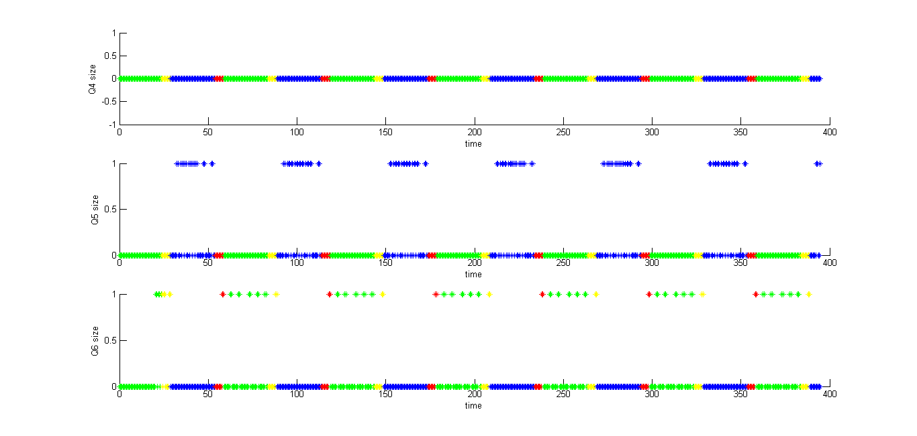

**Fig 32**

Q7-9 for controller 3

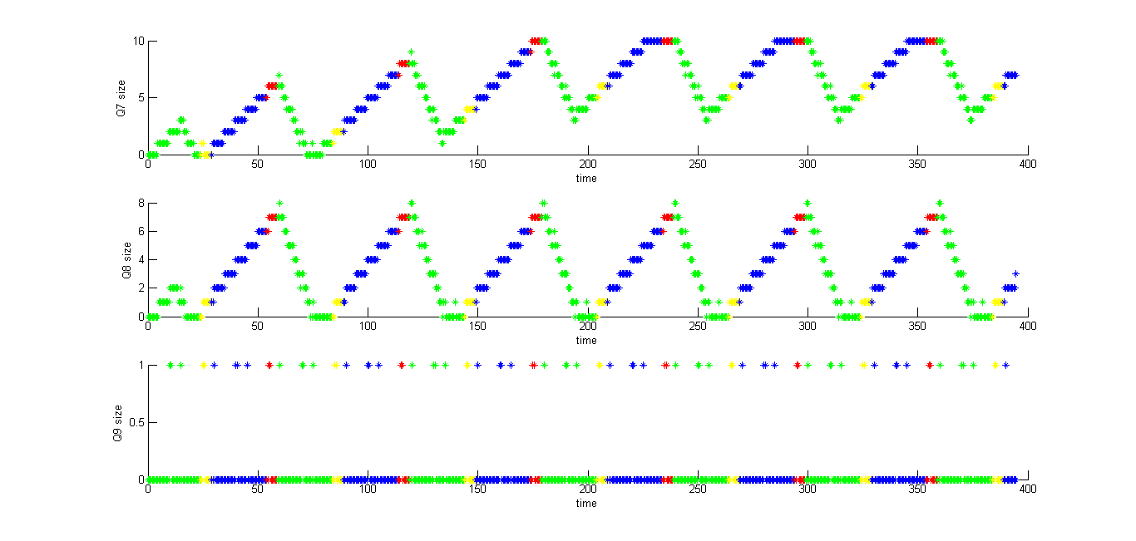

**Fig 33**

Q10-12 for controller 3

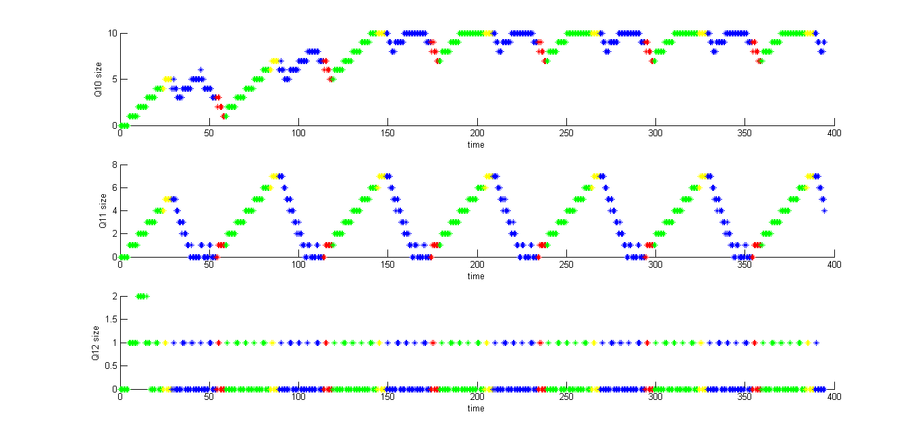

**Fig 34**

For controller 3 the most important figures are fig 31 and fig 32

Q3 and Q4 size remain always 0 which is expected since there is no input. Other queues have expected behavior in case as in case of two intersection E-W and two intersection N-S.

Q1-3 for controller 4

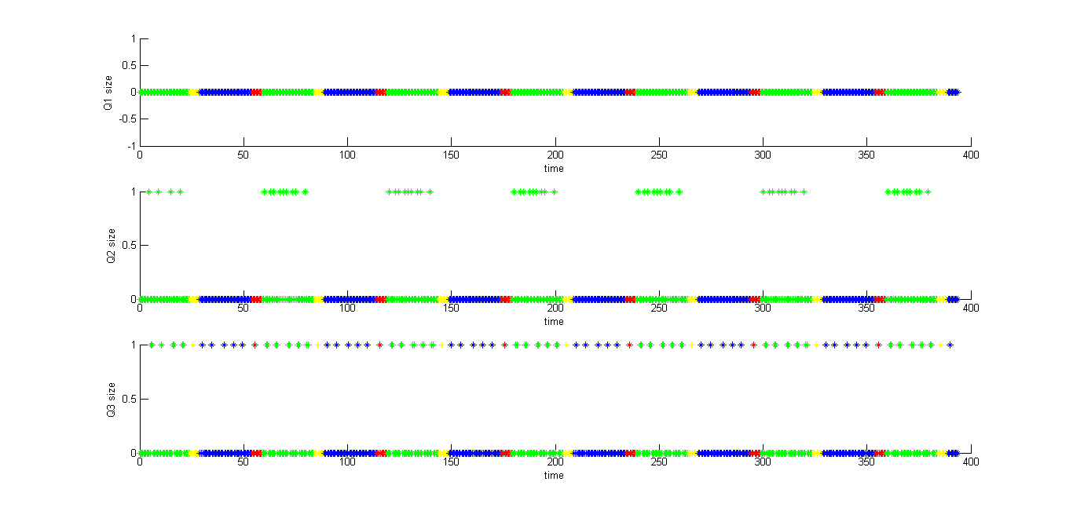

**Fig 35**

Q4-6 for controller 4

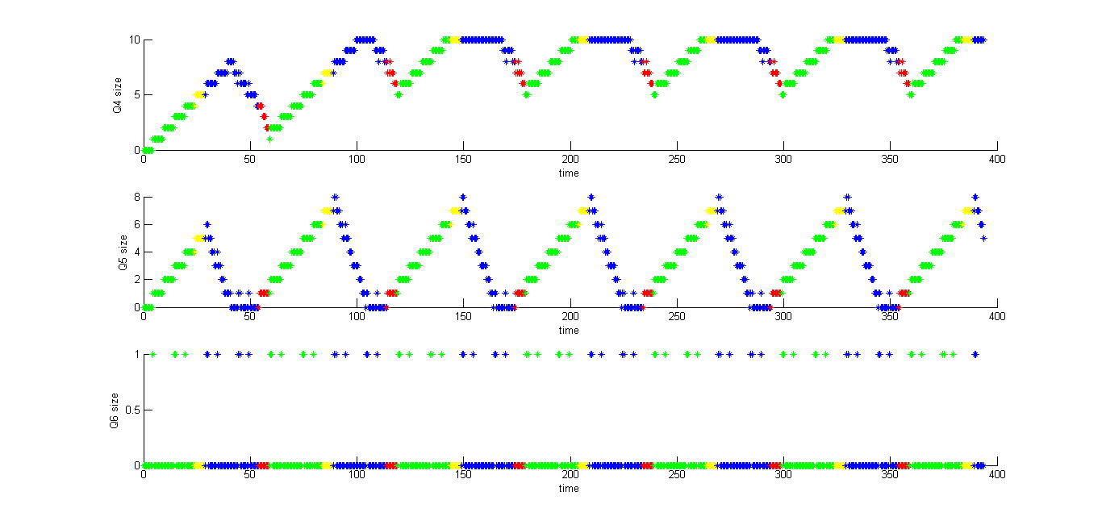

**Fig 36**

Q7-9 for controller 4

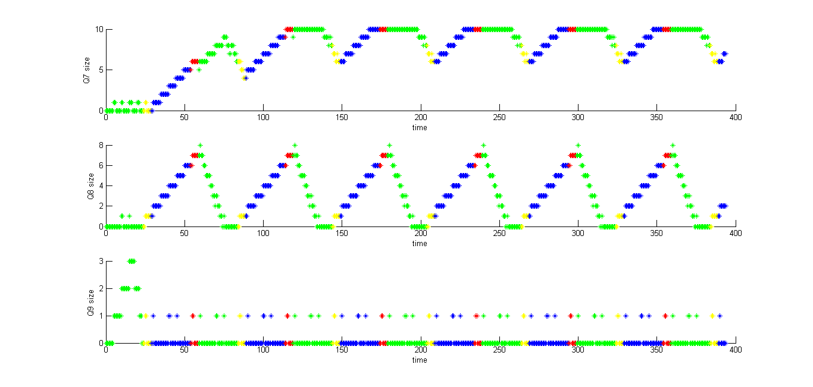

**Fig 37**

Q10-12 for controller 4

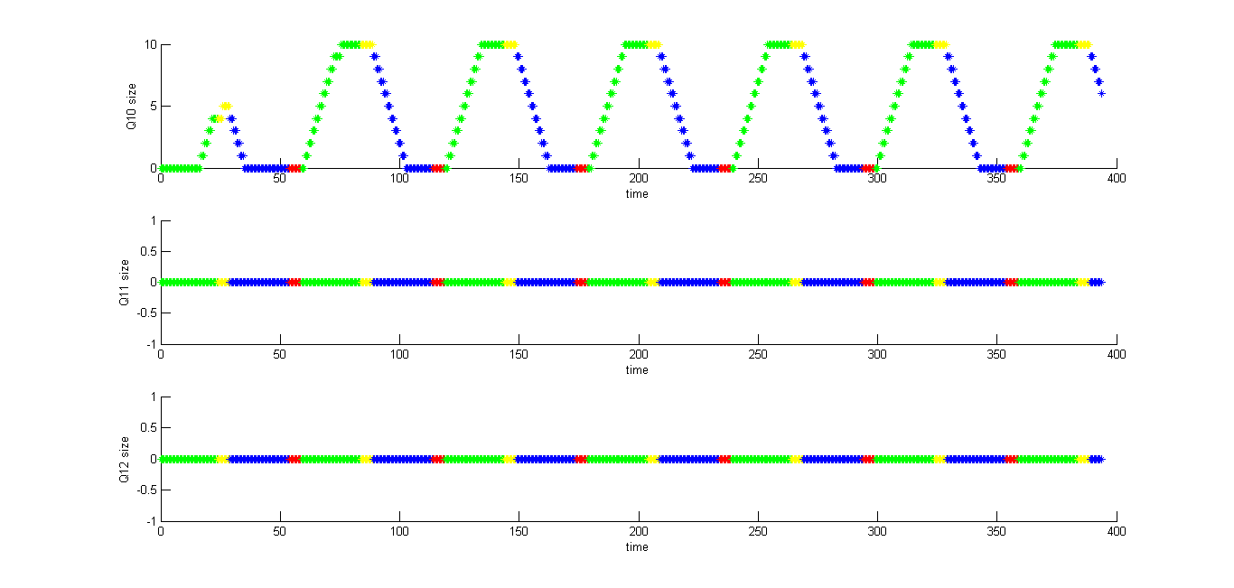

**Fig 38**

For controller 4 the most important figures are fig 35 and fig 38

Q1 and Q12 size remain always 0 which is expected since there is no input. Other queues have expected behavior in case as in case of two intersection E-W and two intersection N-S.

1. Unsync 25-5s

Q1-3 for controller 1

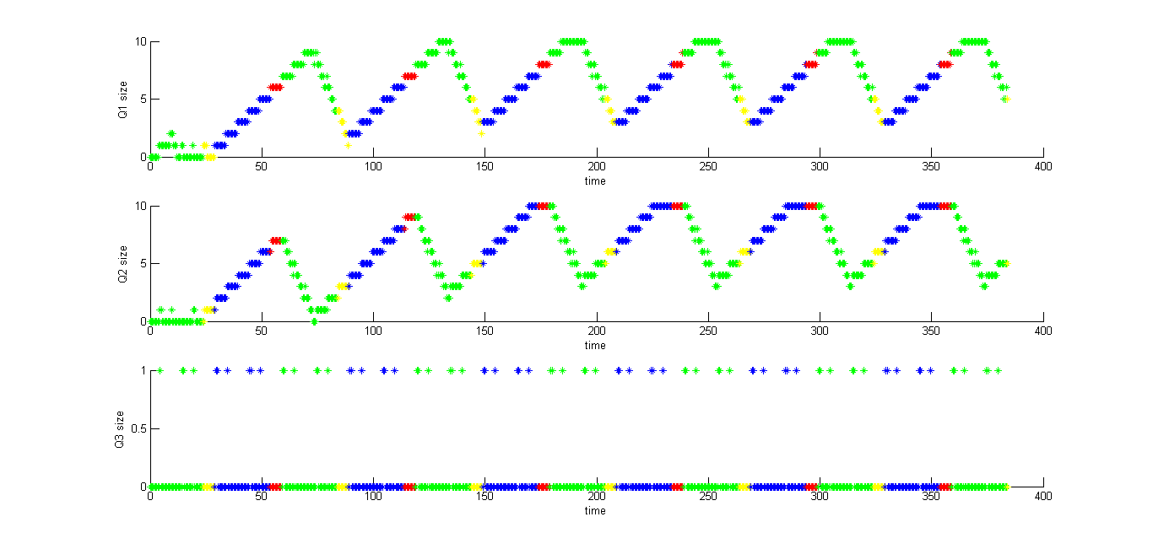

**Fig 39**

Q4-6 for controller 1

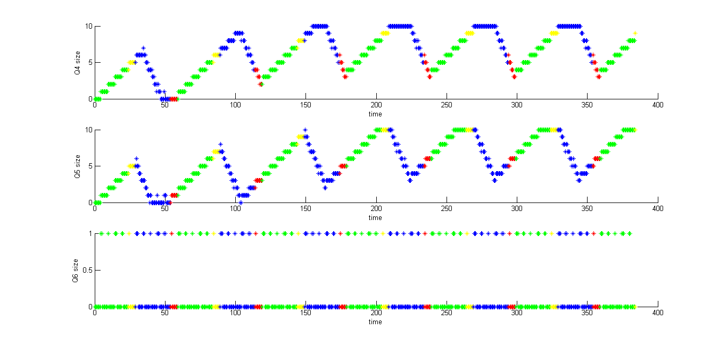

**Fig 40**

Q7-9 for controller 1

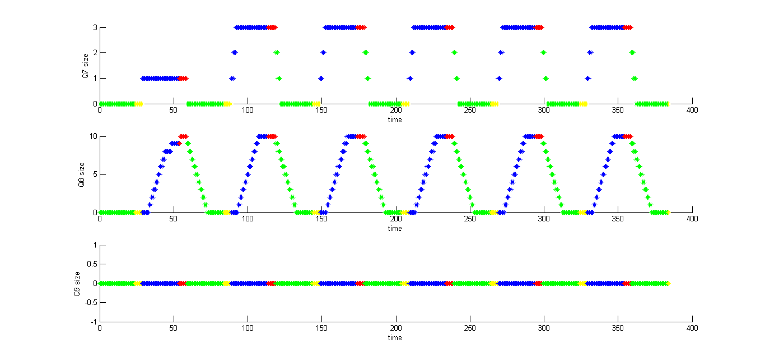

**Fig 41**

Q10-12 for controller 1

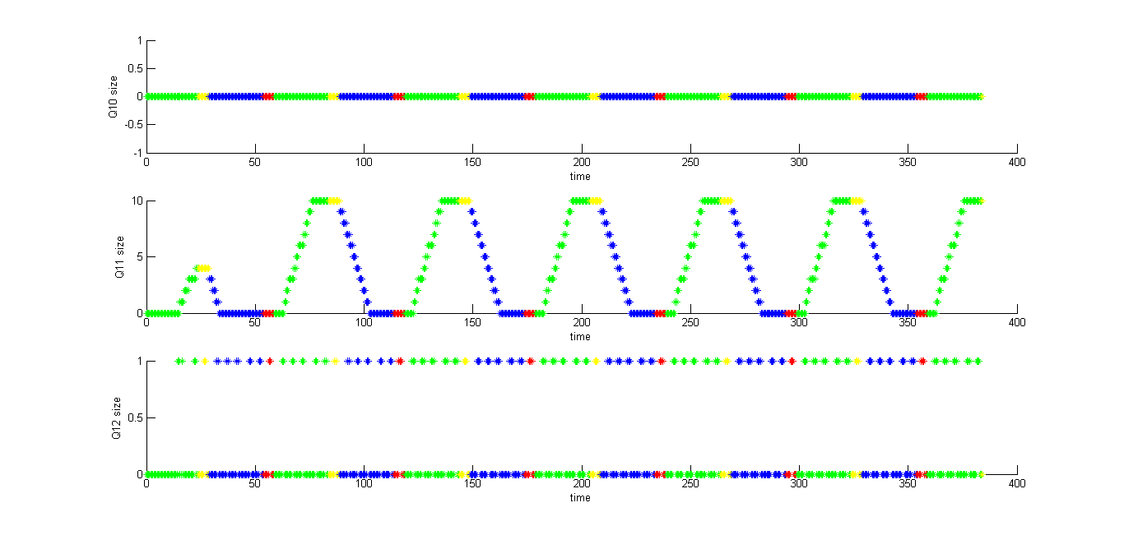

**Fig 42**

For controller 1 the most important figures are fig 41 and fig 42

Q9 and Q10 size remain always 0 which is expected since there is no input. Other queues have expected behavior in case as in case of unsynchronized two intersection E-W and two intersection N-S.

Q1-3 for controller 2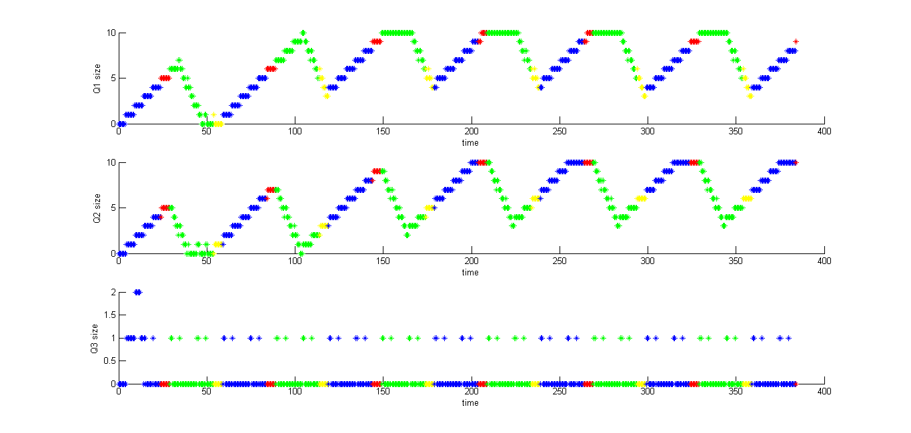

**Fig 43**

Q4-6 For controller2

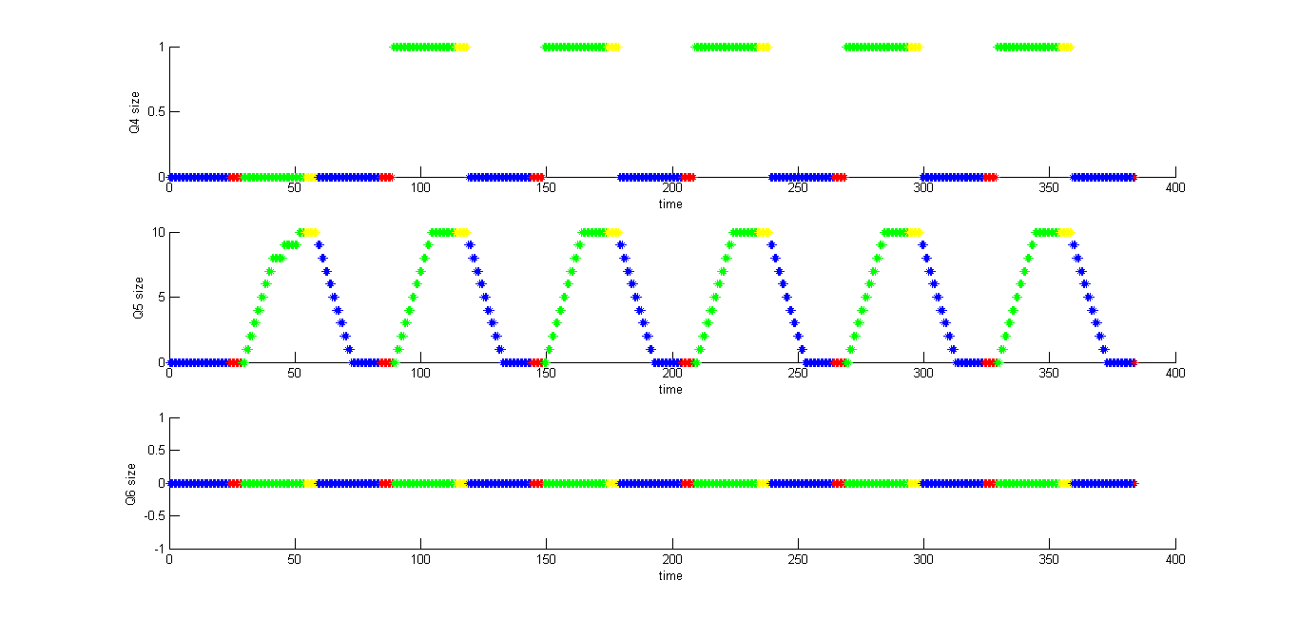

**Fig 44**

Q7-9 for controller 2

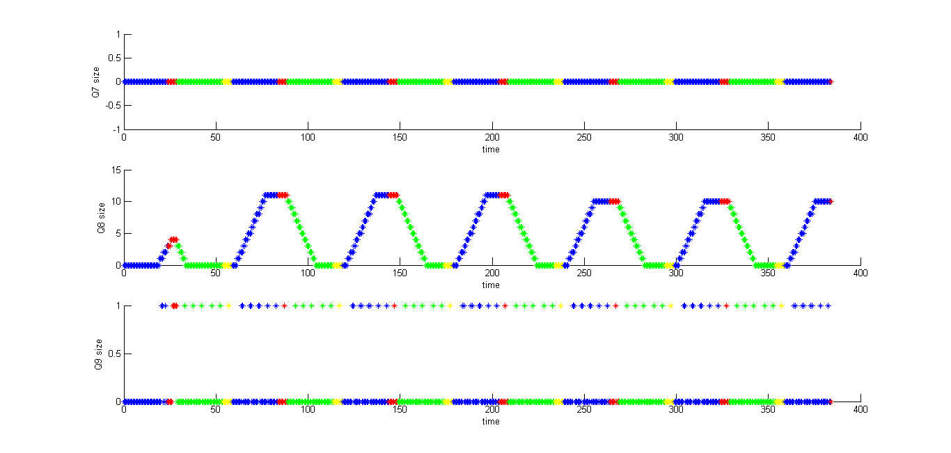

**Fig 45**

Q10-12 for controller 2

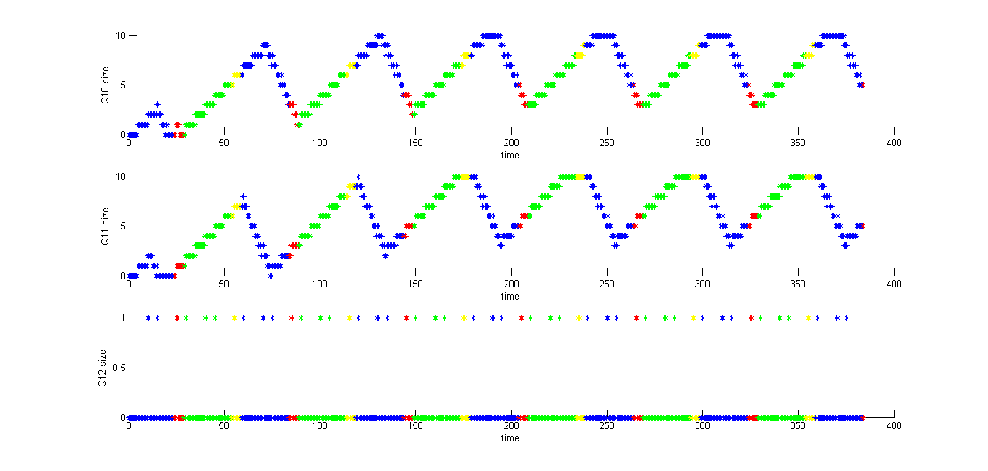

**Fig 46**

For controller 2 the most important figures are fig 44 and fig 45

Q6 and Q7 size remain always 0 which is expected since there is no input. Other queues have expected behavior in case as in case of unsynchronized two intersection E-W and two intersection N-S.

Q1-3 for controller 3

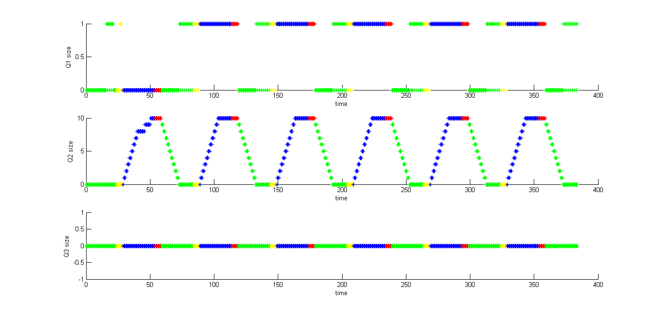

**Fig 47**

Q4-6 for controller 3

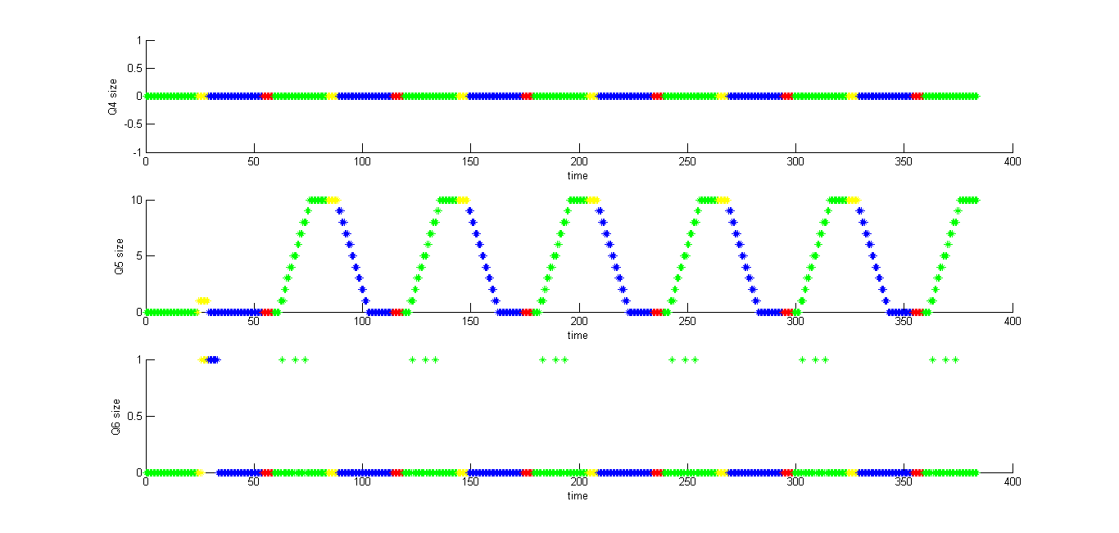

**Fig 48**

Q7-9 for controller 3

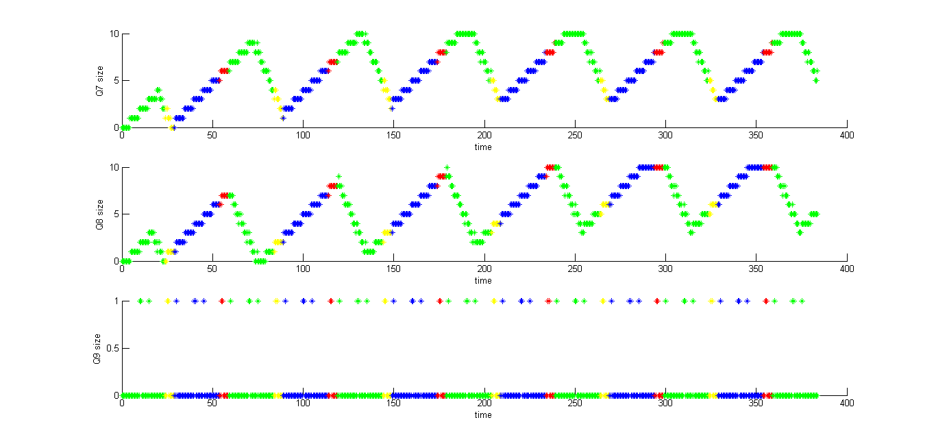

**Fig 49**

Q10-12 for controller 3

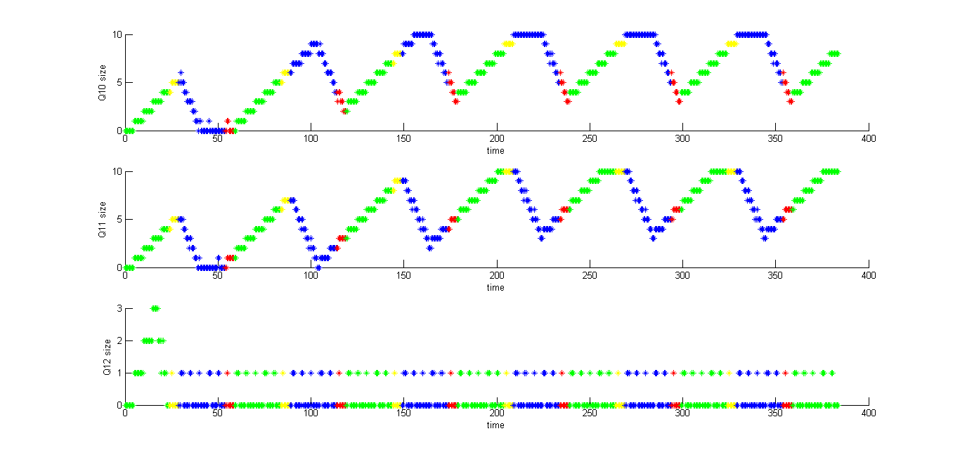

**Fig 50**

For controller 3 the most important figures are fig 47 and fig 48

Q3 and Q4 size remain always 0 which is expected since there is no input. Other queues have expected behavior in case as in case of unsynchronized two intersection E-W and two intersection N-S.

Q1-3 for controller 4

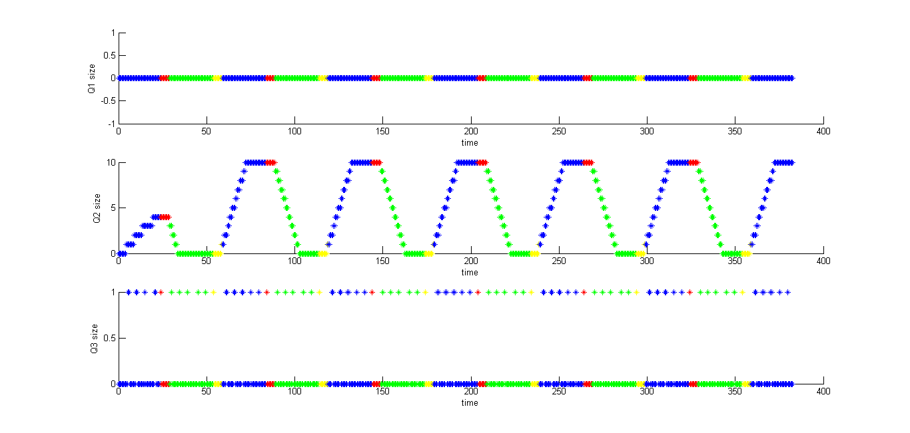

**Fig 51**

Q4-6 for controller 4

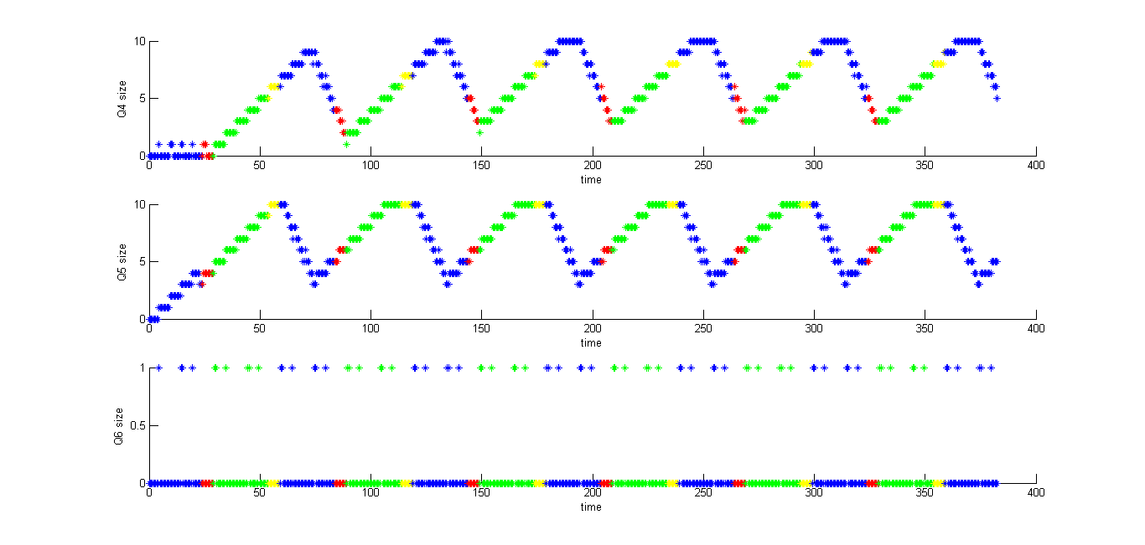

**Fig 52**

Q7-9 for controller 4

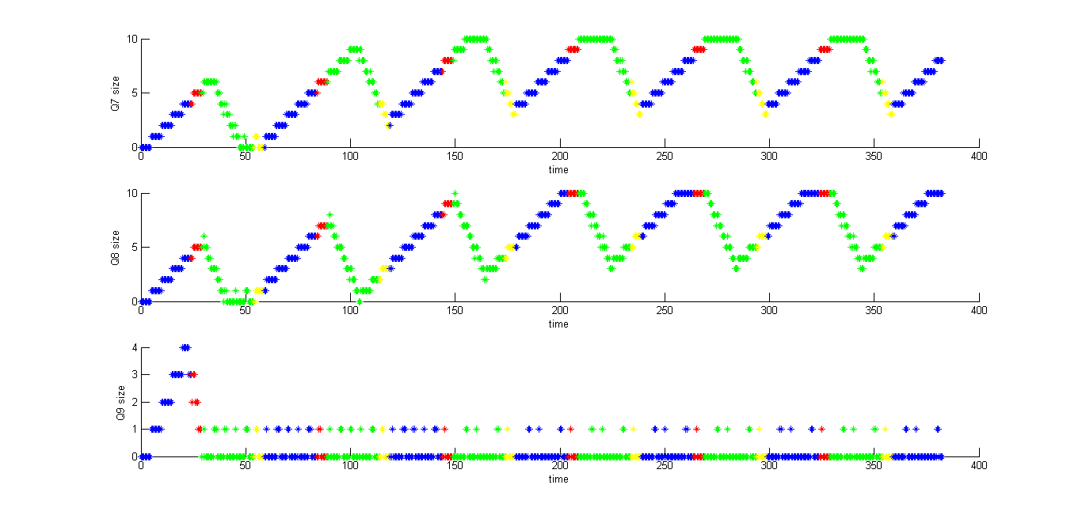

**Fig 53**

Q10-12 for controller 4

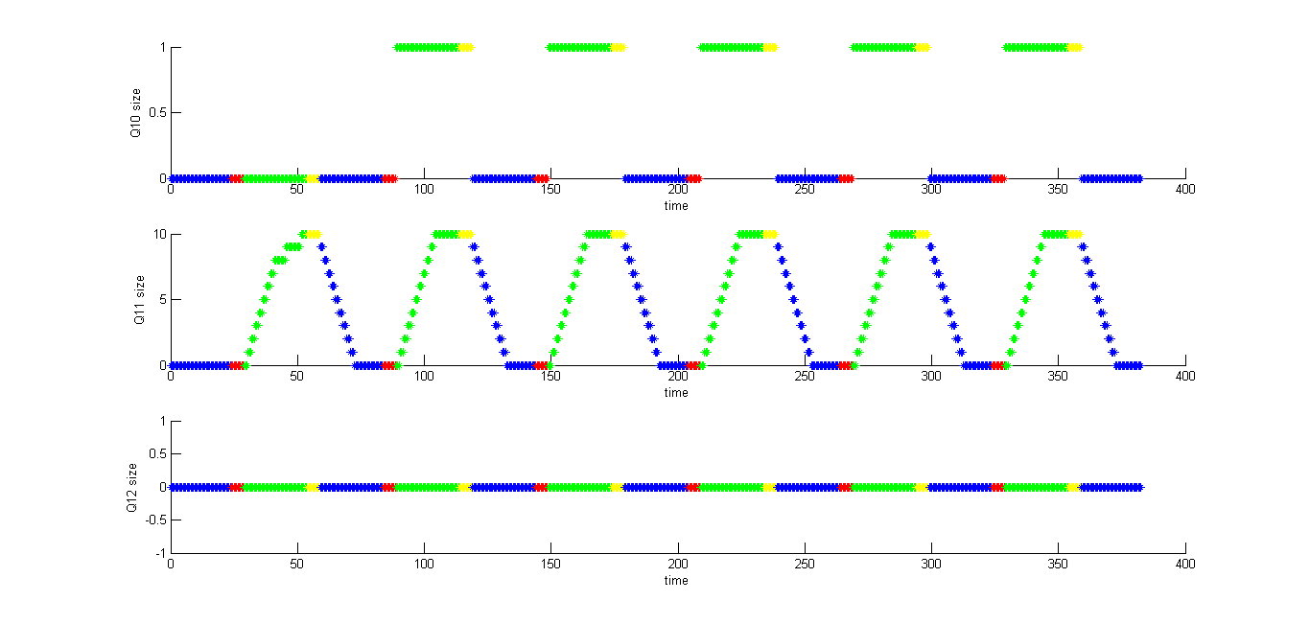

**Fig 54**

For controller 4 the most important figures are fig 51 and fig 54

Q1 and Q12 size remain always 0 which is expected since there is no input. Other queues have expected behavior in case as in case of unsynchronized two intersection E-W and two intersection N-S.