**NAME :-** Santosh Yakkala

**Mentor :-** Dr.Debi Prasad Dogra (IIT Bhubaneswar)

**Cloning YOLOv5 repository & installing the required softwares :-**

Run the following commands in a command prompt to clone yolov5:-

git clone [https://github.com/ultralytics/yolov5](https://github.com/ultralytics/yolov5%20%20)  # clone

cd yolov5

pip install -r requirements.txt # install

After running those commands we can find a folder named yolov5 in which the yolov5 repository has cloned.

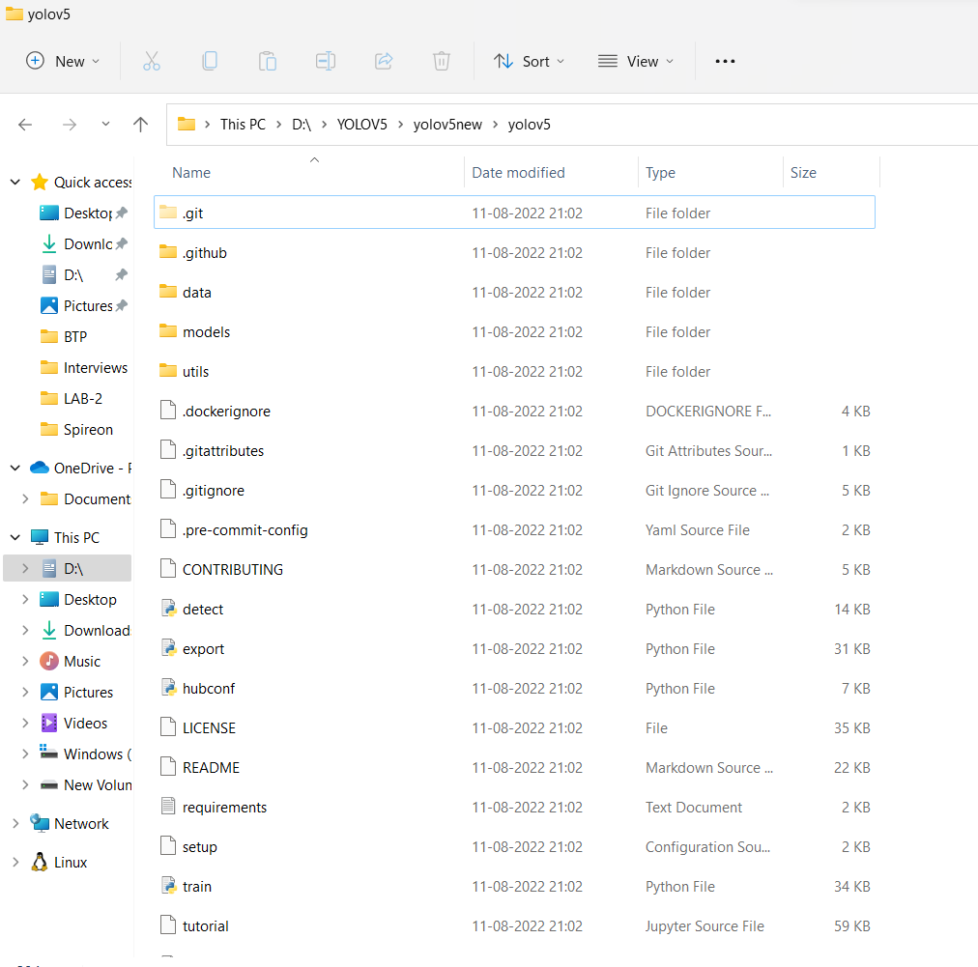

**Preparation of dataset :-**

To prepare a dataset for YOLOv5 we have to first annotate the images that we have collected. I have used **Roboflow** software for annotating the images.

Once we are done with annotating download the data set as the zip file.

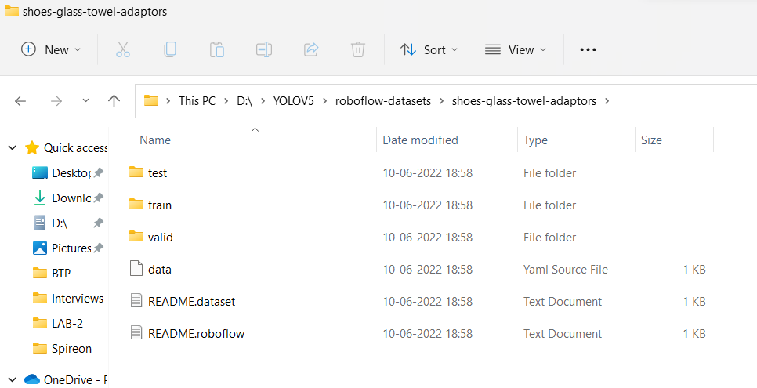

Now create a folder named **“train_data”** which contains two folders named **“images”** & **“labels”**. In each folder create two folders named **“train”** & **“val”.**

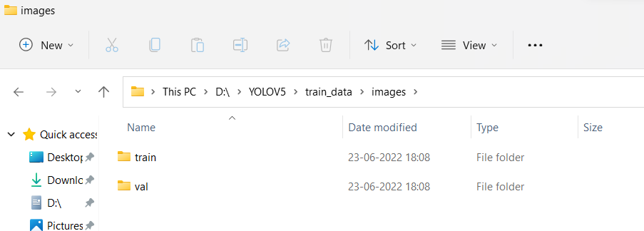

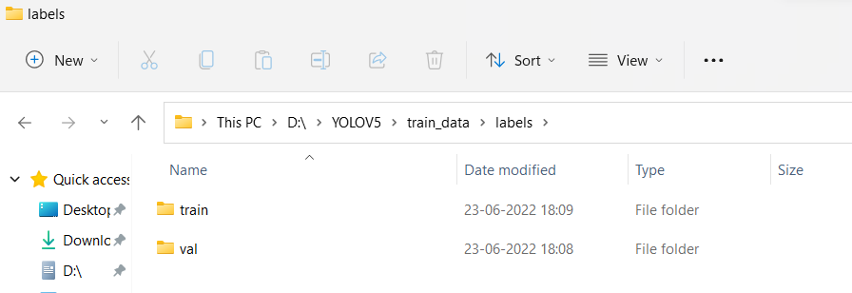

Now copy all the images and labels from the dataset downloaded to the respective folders in train_data.

**Training the model :-**

Open the command window from yolov5 folder and run the following command to train our model.

python train**.**py **--**img img_size **--**batch 8 **--**epochs 50 **--**data path to yaml data file **--**weights path for weight file.

python train**.**py **--**img 640 **--**batch 8 **--**epochs 50 **--**data **..\**custom_data**.**yaml **--**weights **..\**yolov5s**.**pt

After completion of training process we can find the training results in “yolov5/runs/train” folder which has a folder named “weights” which has two files named “best.pt” & “last.pt” which we can use to detect the objects.

**Distance estimation :-**

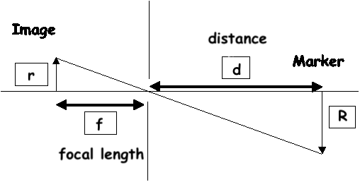

[distance-measurement](http://emaraic.com/assets/img/posts/computer-vision/distance-measurement/pinhole-camera.gif)

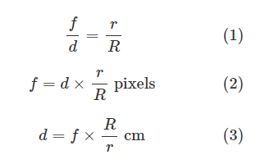

f 🡪focal length

d 🡪measured distance

R 🡪real width

R 🡪 width in pixels at camera

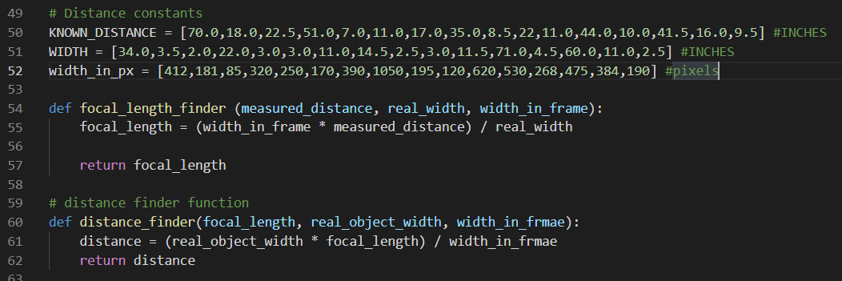

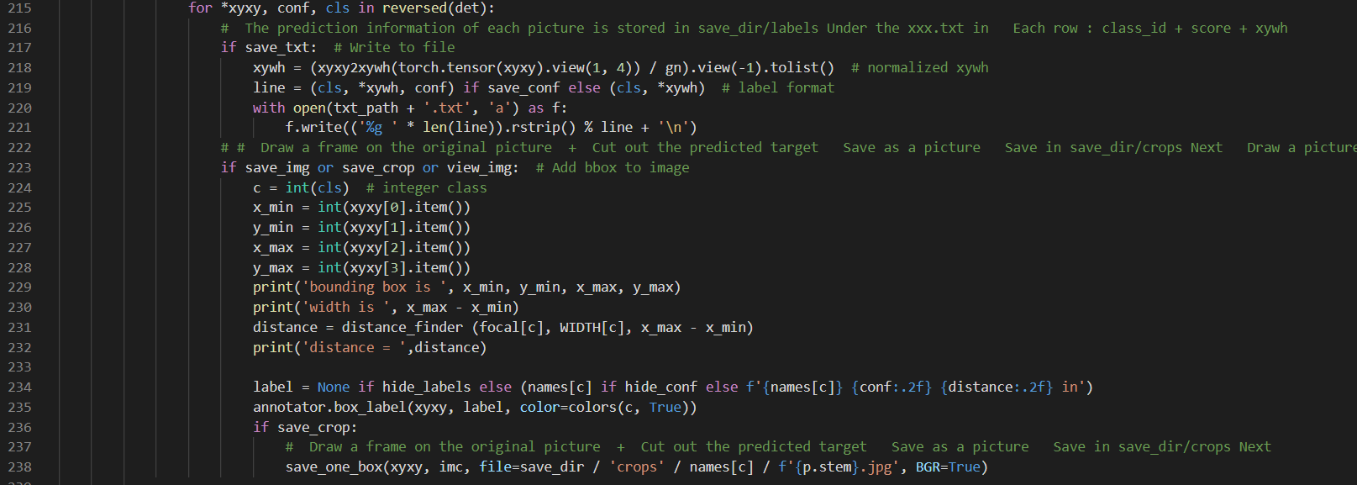

**Testing the model :-**

Open the command window from yolov5 folder and run the following command to train our model.

python ..\detect-dist**.**py --weights ..\training_results\weights\best.pt --conf 0.4 --source ..\manually-recorded\testing\t10.mp4

python path_to_detect.py --weights path_to_weights conf 0.4 --source

0 # webcam

img.jpg # image

vid.mp4 # video

path/ # directory

'path/*.jpg' # glob

'https://youtu.be/Zgi9g1ksQHc' # YouTube

'rtsp://example.com/media.mp4' # RTSP, RTMP, HTTP stream

After detecting the results are saved in “**\yolov5\runs\detect**” folder