**Air Quality Analysis and Prediction in Tamil Nadu**

|  |  |
| --- | --- |
| **Date** | **10-10-2023** |
| **Team ID** | **3886** |
| **Project Name** | **Air Quality Analysis and Prediction in Tamil Nadu** |

**Table of Contents**

|  |  |
| --- | --- |
| 1 | Introduction |
| 2 | Problem Statement |
| 3 | Design and Innovation Strategies |
| 3.1 | Data Collection and Feature Engineering |
| 3.2 | Data Pre-processing |
| 3.3 | Model Selection and Training |
| 3.4 | Geographic Analysis |
| 3.5 | Continuous Learning |
| 4 | Conclusion |

**1.Introduction:**

In today's data-driven world, predictive models play a vital role in various domains, from finance to healthcare to marketing. These models enable organizations to make informed decisions, optimize processes, and enhance customer experiences. However, the accuracy and reliability of these models can be greatly improved through the incorporation of machine learning algorithms. This project aims to enhance the predictive model's accuracy through a holistic approach that encompasses data collection, feature engineering, model selection and training, and geographic analysis.

**2.Problem Statement:**

The problem statement revolves around improving the accuracy of an existing predictive model. The existing model may have limitations in terms of prediction accuracy, especially when dealing with complex and dynamic datasets. Incorporate machine learning algorithms to enhance prediction accuracy. Optimize data collection and preprocessing techniques. Perform advanced feature engineering to extract valuable insights from the data. Select and train models that can adapt to various scenarios. Leverage geographic analysis to uncover location-specific patterns and trends.

**3.Design and Innovation Strategies:**

**3.1 Data Collection And Feature Engineering:**

**Innovation:** Advanced Data Sources, Data Augmentation, Automated Feature Engineering.

Explore innovative sources of data, such as IoT devices, social media streams, or external APIs, to enrich the dataset.

Implement data augmentation techniques, such as synthetic data generation, to increase the volume of training data for better model performance.

Utilize automated feature engineering tools to identify and generate relevant features from raw data, reducing manual efforts and increasing model accuracy.

**3.2 Data Pre-processing:**

**Innovation:** Outlier Detection, Imbalanced Data Handling, Missing Data Imputation.

Implement advanced outlier detection algorithms to identify and handle outliers more effectively.

Use innovative techniques such as Synthetic Minority Over-sampling Technique (SMOTE) to address class imbalance issues.

Employ advanced imputation methods, such as K-nearest neighbors or deep learning-based imputations, for handling missing data.

**3.3 Model Selection and Training:**

**Innovation:** Ensemble Learning, Hyperparameter Optimization, Transfer Learning**.**

Combine multiple models using ensemble techniques like stacking or bagging to harness the collective intelligence of diverse algorithms.

Use automated hyperparameter tuning methods like Bayesian optimization or grid search to fine-tune model parameters.

If relevant, explore transfer learning by pre-training models on related tasks or domains to accelerate training and improve accuracy.

**3.4 Geographic Analysis:**

**Innovation:** Geospatial Data Integration, Geospatial Visualization, Spatial Clustering.

Incorporate geospatial data sources to understand location-specific factors that may impact predictions.

Utilize advanced geospatial visualization techniques to present insights in a more understandable and actionable format.

Apply spatial clustering algorithms to discover spatial patterns and group regions with similar characteristics.

**3.5 Continuous Learning:**

**Innovation:** Model Maintenance, Feedback Loops, Model Interpretability

Regularly retraining the model with new data to adapt to changing patterns.

Incorporating feedback from users or domain experts to fine-tune the model.

Ensuring that the model's decisions are explainable, facilitating trust and accountability.

Note: In the diagram below, it visually explains about the contents of the overall design and innovation strategies provided for problem statement from 3.1 to 3.4 of air quality analysis and prediction in Tamil Nadu.

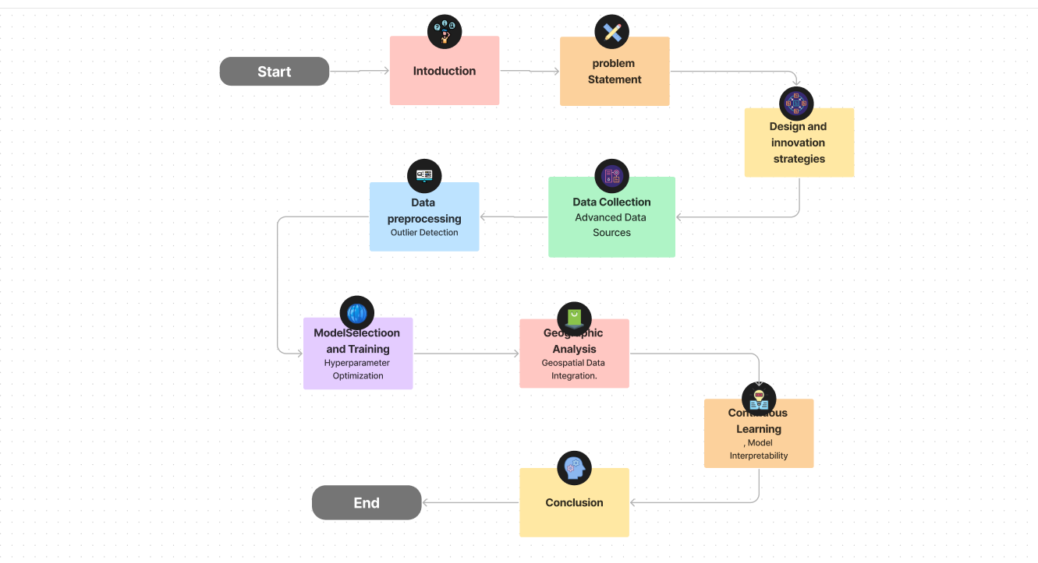

**Conclusion:**

Incorporating machine learning algorithms to improve predictive model accuracy is a multi-faceted endeavor that requires a comprehensive approach. By embracing innovative strategies in data collection, feature engineering, data preprocessing, model selection and training, and geographic analysis, organizations can not only enhance the accuracy of their predictive models but also gain deeper insights into their data. This holistic approach ensures that predictive models remain robust, adaptable, and capable of delivering more accurate predictions in dynamic environments, ultimately leading to better decision-making and improved outcomes.