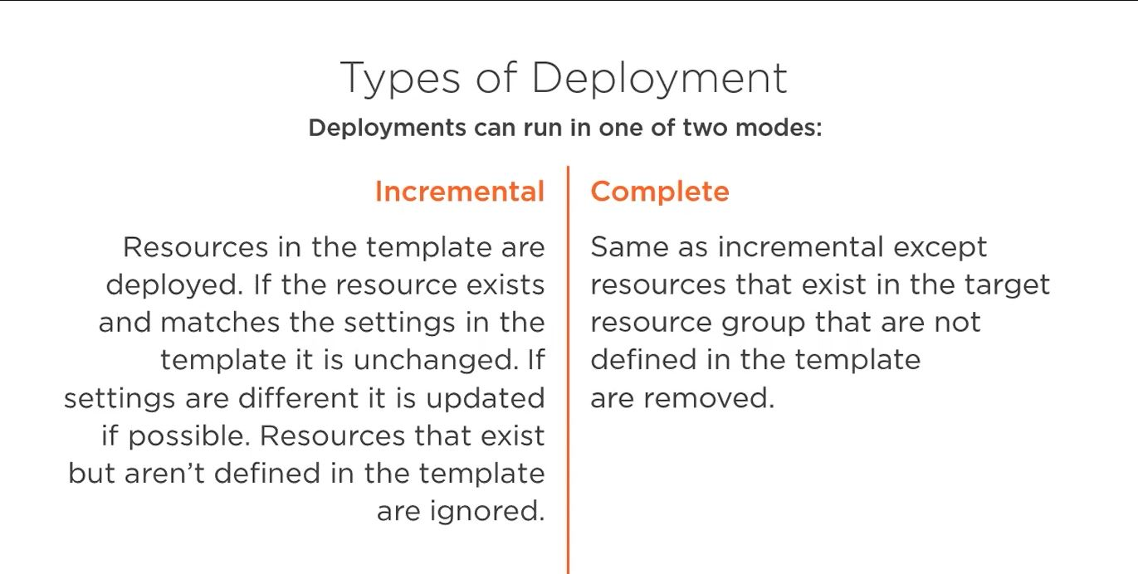

Now just to really cement that idea about the types of deployment, I have one of two modes. Incremental is the default. With incremental, resources defined in the template are deployed. If the resource already exists in my target, i.e. the resource group, and it matches the settings, the configuration in the template, it's left alone. If the settings are different, it is updated if it can. Resources that exist in that target, i.e. that resource group, but are not defined in a template, are ignored. So the first time I deployed that virtual network, it left the storage account alone. It wasn't defined in the template, but because it ran in incremental mode, it didn't touch it. In complete mode, it's the same as incremental in that if the resource already exists in the desired configuration, it's left alone. If it exists and it doesn't match, it's made to meet it. If it doesn't exist, it's created. But if there are things in the target, either resource group that are not defined in the template, they are removed. Complete is saying, make that target, i.e. the resource group, match the template. If there's stuff in the resource group that's not in the template, we need to remove it.