Phase 1 — Code Flow (Runtime Explanation)
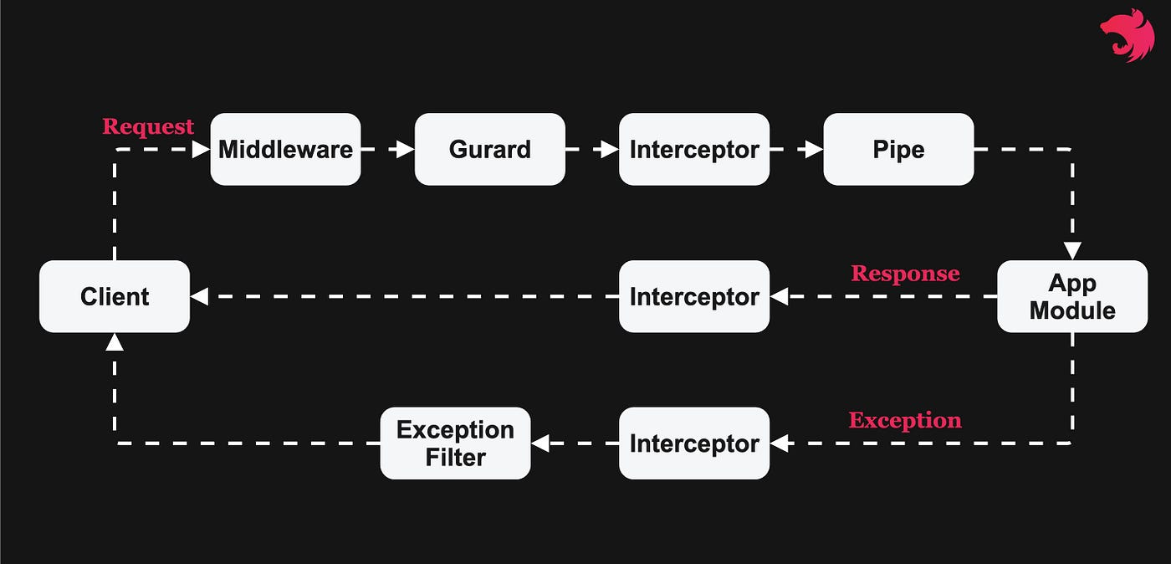

🟢 Step 1: Request hits NestJS
Client (Postman / frontend) sends:
POST /tasks
NestJS receives it in main.ts.

🟢 Step 2: Global Pipes Run
Before controller logic:
- ValidationPipe checks request body
- DTO rules applied
- Extra fields removed / rejected
If invalid ❌ → request stops here.
🟢 Step 3: Controller is Invoked
@Post()
create(@Body() dto: CreateTaskDto)
What happens:
- Body is already validated
- dto is guaranteed clean
- Controller does not check correctness again
Controller forwards data to service.
🟢 Step 4: Service Handles Business Logic
this.taskRepository.create(dto);
this.taskRepository.save(task);
Service:
- Creates entity instance
- Persists to DB
- Returns saved entity
This is where business rules belong.
🟢 Step 5: TypeORM Talks to Database
TypeORM:
- Generates SQL
- Uses Postgres driver
- Writes to Dockerized DB
You never write SQL manually.
🟢 Step 6: Response Goes Back
- Service returns Task
- Controller returns it directly
- NestJS serializes JSON
- HTTP 201 response sent

- 🔄 Same Flow for GET / DELETE
- The same lifecycle applies:
- Request
- → Validation
- → Controller
- → Service
- → Repository
- → Database
- → Response
- Only the service method changes.
------------------------------------------------------------------------------------------------------------------------------------------------------------------------------------------------------------------------------------------------------------------------------------------------------------------------------------------------
First: What problem do Pipes solve?
Imagine a backend without pipes.
Without pipes (raw flow)
Request
→ Controller
→ Service
→ Database
This means:
- Controllers must trust input
- Every controller must manually validate
- Errors leak into business logic
This works for small apps — but breaks at scale.

What a Pipe actually is (simple definition)
A Pipe is a function/class that runs before your controller method and can:
- Validate incoming data
- Transform incoming data
That’s it. Nothing more.

Pipes vs Express middleware (important)
Express | NestJS
Middleware | Pipes
Runs for all routes | Can be global or per-route
Mostly untyped | Fully typed
Manual validation | Declarative validation
Pipes are smarter middleware, aware of:
- DTOs
- Types
- Decorators
Two Types of Pipes (Conceptually)
1️⃣ Transformation Pipes
2️⃣ Validation Pipes
Validation pipe:
- Reads DTO metadata
- Applies rules
- Rejects invalid requests
Without it:
- DTO decorators are ignored
- Validation does nothing

