**Statistics Assignment**

**Problem Statement**

**Comprehension:-**

The pharmaceutical company Sun Pharma is manufacturing a new batch of painkiller drugs, which are due for testing. Around 80,000 new products are created and need to be tested for their time of effect (which is measured as the time taken for the drug to completely cure the pain), as well as the quality assurance (which tells you whether the drug was able to do a satisfactory job or not).

**Question 1:**

The quality assurance checks on the previous batches of drugs found that — it is 4 times more likely that a drug is able to produce a satisfactory result than not.

Given a small sample of 10 drugs, you are required to find the theoretical probability that at most, 3 drugs are not able to do a satisfactory job.

a.) Propose the type of probability distribution that would accurately portray the above scenario and list out the three conditions that this distribution follows.

b.) Calculate the required probability.

**Answer 01 – a):-**

1. Looking at the above scenarios , where the sample is taken 10 times.
2. It produces only two possible outcomes. The drug will either produce the satisfactory result or not.
3. All the sample results are independent to each other. It means result of previous drug testing will not impact the result of next drug.
4. Probability of getting satisfactory result is 4 time more likely than will not produce the satisfactory result. So the **P(success) = 4/5 = 0.8** and **P(Not Success) = 1- 0.8 = 0.2** (As sum to total probability of outcome is 1)

Conclusion :- From the above 3 mentioned points, it’s a type of **Binomial Distribution.**

**Answer 01 – b**)

As it is a Binomial Distribution, the probability of the binomial distribution is given as for a binomial experiment consisting of n trials and result in x number of success. If the Probability of the success on an individual trial P, Then the binomial probability would be given as :-

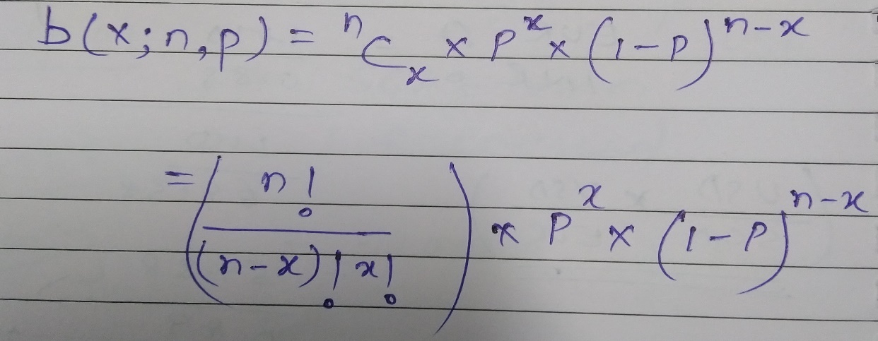

Probability (Drug will do the satisfactory) = 4 * Probability (Drug will not do the satisfactory) **--- From the question**

The sum of probability of all the possible outcomes is 1. It means

**Probability (Drug will do the satisfactory) + Probability (Drug will not do the satisfactory) = 1 (Probability Theorem)**

Let’s suppose Probability (Drug will not do the satisfactory) **= X**

**So,** Probability (Drug will do the satisfactory) = 4X

4X + X = 1 (from the probability Theorem)

X = 1/5 = 0.2

Probability (Drug will not do the satisfactory) **= 0.2**

Probability (Drug will do the satisfactory) = 4*0.2 = **0.8**

**To Find the** at most, 3 drugs are not able to do a satisfactory job.

P(X<=3) = P(X=0) + P(X=1) + P(X=2) + P(X=3) where X is the random variable of a drug will not able to do a satisfactory job.

So P(X=0), it’s probability that all trials went successful and we didn’t have any drug which failed to perform satisfactory. Number of trails (n) = 10

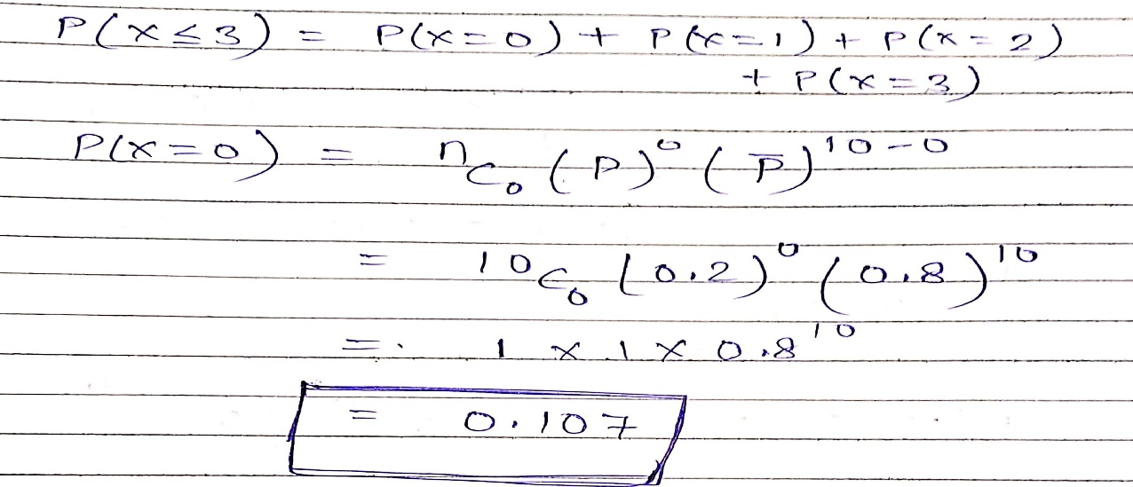

**P(X=0) = 0.107**

So P(X=1), it’s probability of getting 1 drug which not able to perform satisfactory in our sample trials. Number of trails (n) = 10

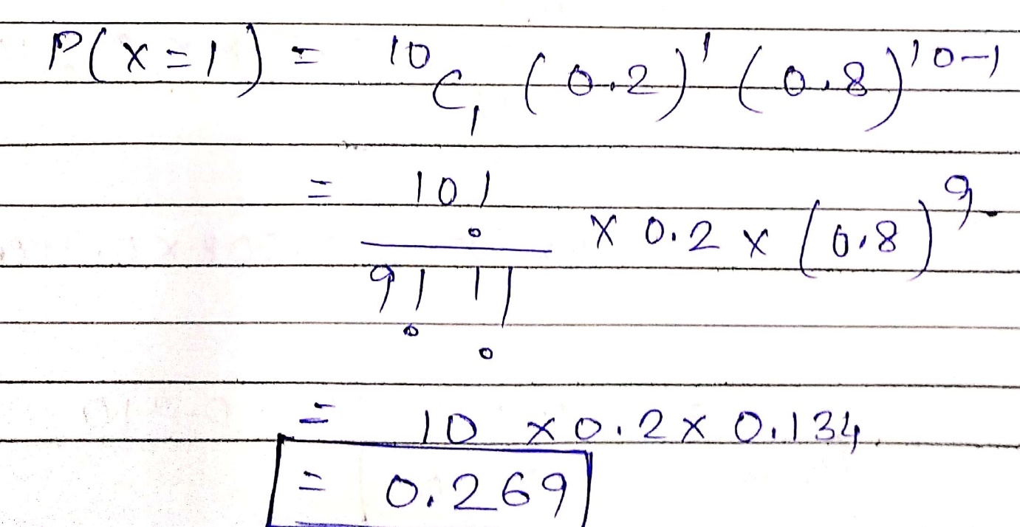

**P(X=1) = 0.269**

So P(X=2), it’s probability of getting 2 drug which not able to perform satisfactory in our sample trials. Number of trails (n) = 10

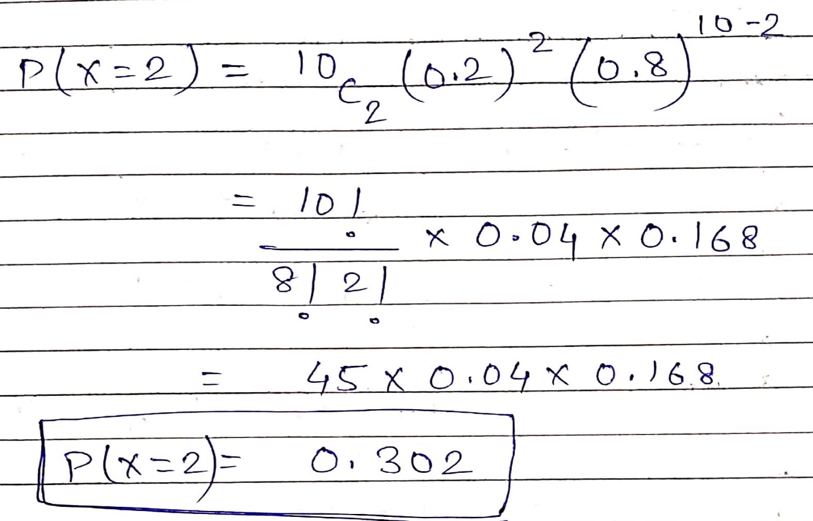

**P(X=2) = 0.302**

So P(X=3), it’s probability of getting 3 drug which not able to perform satisfactory in our sample trials. Number of trails (n) = 10

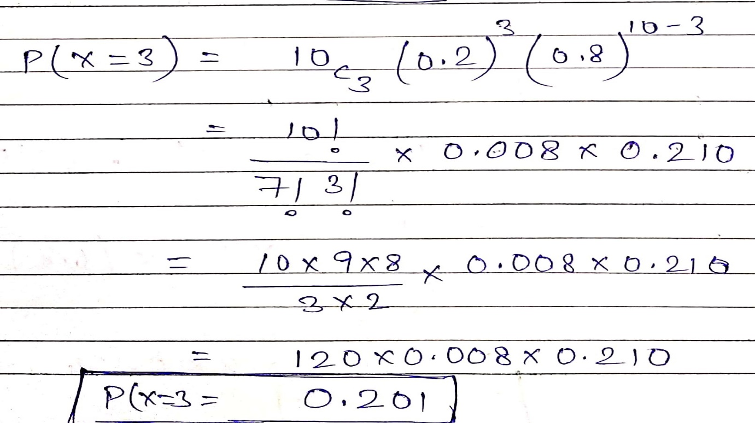

**P(X=3) = 0.201**

**Total Probability P(X<=3) = P(X=0) + P(X=1) + P(X=2) + P(X=3)**

As, we got P(X=0) = 0.107

P(X=1) = 0.269

P(X=2) = 0.302

P(X=0) = 0.201

P(X<=3) = 0.107 + 0.269 + 0.302 + 0.201

**= 0.879 (Approx. 88 %)**

**The Required Probability is 0.879 (Approx. 88 %).**