**UNIT I**

**1. BUSINESS INTELLIGENCE**

**1.1 DEFINITION OF BUSINESS INTELLIGENCE:**

Business Intelligence(BI) is an umbrella term that combines architectures,tools,databases,applications, and methodologies.Its major objectives areto enable interactiveaccess to data, enable manipulation of these data,and to provide business managers and analysts the ability to conduct appropriate analysis.

**1.2 CHANGING BUSINESS ENVIRONMENT AND COMPUTERIZED DECISION:**

The business Environment:

-Today’s environment complexity creates.

a)Opportunity on one hand and

b) Problems on the other hand for organizations.

Example: Globalization (Internet)

a) One can easily find suppliers and customers in many countries,which means buyings cheaper materials and sell more products and services.

b) More and stronger competitors.

**1.2.1 BUSINESS ENVIRONMENT:**

* The business environment today is changing and becoming more and more complex.
* Organizations are required to make frequent strategic, tactical and organizational decisions. Some of which are very complex.
* Making such decisions may require considerable data, information and knowledge.
* Processing these, must be done quickly, frequently in real-time and suing computerized support.
* To realise why Toyota embraces computerized support, including business intelligence a “business pressures-responses-support model “has been developed.

The model components are:

* The business environment(becomes complex)
* Organizational responses:-be reactive, anticipative, adaptive and proactive, so as to take advantage of opportunities available.
* Computerized support that facilities monitoring and enhance response.

**1.2.1.1 MANAGERIAL DECISION MAKING:**

A decision is selection the best alternative from two or more solutions. Management is a process by which organizational goals are achieved through the use of resources. Resources are considered to be input. Attaining goals is viewed as output. The degree of success is measured by productivity (ratio of output to input).Managers continuously make decisions to carry out their functions (planning, organizing, directing and controlling).

Managers perform 10 major roles classified into 3 categories

-Interpersonal

-Informational

-Decisional

To execute these roles, managers need information that is delivered efficiently and timely by computers. Manager is a decision maker. Organizations are filled with decision makers at different levels.

**1.2.2 COMPUTERIZED SUPPORT FOR DECISION MAKING:**

Computerized supports are now penetrating complex managerial areas:

-Design

-Management of automated factories

-Application of AI methods

-Evaluation process

Computer applications have moved from transaction processing and monitoring activities to problem analysis and solution applications. Most of the activities are done with the web-based technologies.

The following are the cornerstone of today’s modern management for decision support:

1.BI tools

2.Data warehousing

3.Data Mining

4.Online Analytical Processing (OLAP)

5.Dashboards

6.The web

Use computerized decision support system:

1. **Speedy computations:**

-Enables decision makers to perform quick computations, lowcost, timely and thousands of alternatives can be evaluated fast.

1. **Improved communication and collaboration**:

- Groups in different location can use the web-based tools to communicate.

1. **Increased productivity of group members:**

-Using web-based tools saves money and time, since group gathering in one place is no more needed. Also software helps decision makers to determine the best way to run a business in a short time.

4. **Improved data management:**

-Data stored inside and outside the organization(web).Computers transmit,search and store needed data quickly,economically,securely and transparently.

**3. A FRAME WORK FOR BNUSINESS INTELLIGENCE:**

**3.1 Business intelligence framework:**

Is this framework similar to BICC (Business Intelligence Competency Center) or a BI COE? The Business leaders in this company were able to show the investors, millions is savings with a successful business intelligence and performance management framework up to the lowest operational units.

**3.1.1 The business intelligence framework we offer consists of five key concepts:**

* Very high reusability archived by object orientation & inheritance.
* Outstanding usability.
* Device neutral-portal, desktop, smartphone, tablet.
* High flexibility and role based.
* Vendor & tool independent.

The framework connects these elements to each other .it will help you to implement your business intelligence strategy both easier and quicker.

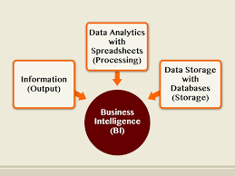

**Why do you need a BI Framework?**

A business intelligence framework can help you to structure the process of improving your business intelligence and helps you to implement your business intelligence strategy in a very cost effective way. Business intelligence projects will be more successful, cost less and deliver more value to your business users. In addition a BI-framework makes it possible that every user-once logged on to the BI-system-sees instantly the information that is relevant for them.

**What are the advantages?**

* Deliver new dashboards within an hour.
* Deliver new business intelligence applications within days.
* Create new business intelligence apps in hours.
* Less maintenance costs.
* Excellent performance(because of high reusability),
* Higher usage of Business intelligence applications and dashboards.

**3.1.2 The BI framework they have has the following components:**

1. Infrastructure to produce consistent and comparable information of performance indicators
2. Platform to evaluate, rank and collaborate best practices from the top performers
3. Institutionalize improvement program with executive sponsorship
4. Identify new performance monitoring areas and or targets.
5. Communicate and share the benefits on improvement

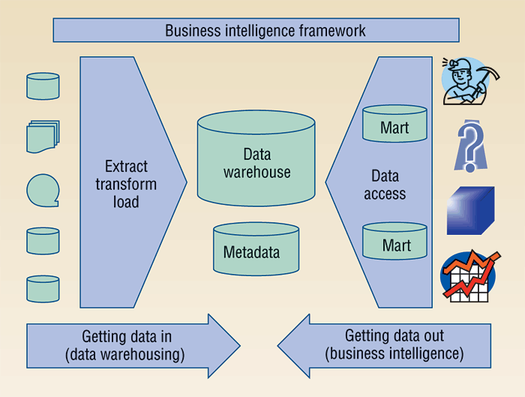

**4. Intelligence creation and use and BI Governance:**

**4.1 What is BI Governance?**

It’s the process of defining and implementing an infrastructure that will support enterprise goals. Jointly owned by IT and its business partners, the process evolves the direction and the value of BI as a strategy.

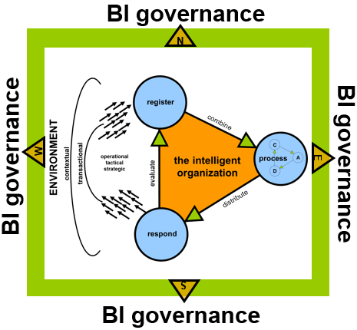

There are four components to BI Governance:

* A BI Governance committee
* A Framework for the BI lifecycle
* An end-user support structure
* A process to review Bi programs

**4.2 A BI Governance committee:**

The role of the governance is vital to the success of your Bi Strategy. The governance committee keeps you aligned with business goals. Each representative is able to bring their team’s perspective and priorities to the table. Sharing those priorities is the first step in determining which project will add the most value. Redundancies and opportunities to combine efforts will become self-evident.

**4.3The BI Lifecycle:**

When you wondered, “who will help you get to the data you need?” you might have been thinking about a specific person, with a BI lifecycle you can get data you need by developing an infrastructure to support BI needs. We are back to processes-as your environment changes, your projects can vary in scope and size from enhancements to a major corporate data.

The intention is to have a framework handle the different aspects of BI regardless of order or dependency.

**The framework has six sections:**

* Tool selection
* Data integration
* Analytics
* Custom BI tool work
* User acceptance
* Training

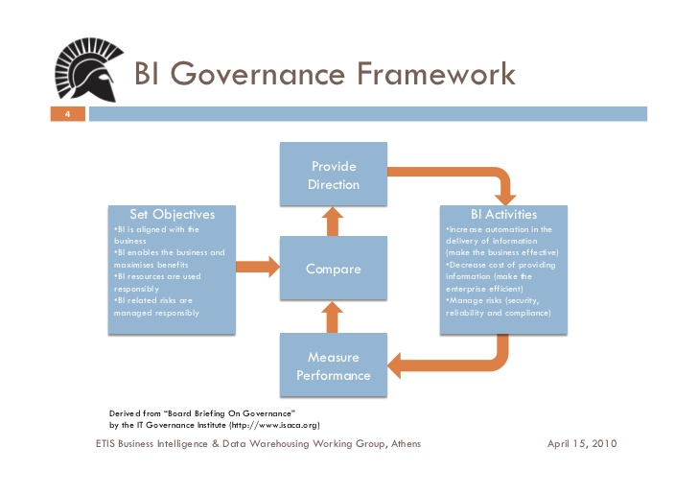

**Tool Selection**

End users often view BI as the end-user tool. This tool is the part that end users see and touch; it is their interface. With that in mind, choosing the correct BI tool for your project is a key success factor. Obviously the end-user requirements are going to drive selection, but other factors should also be considered. The end-user requirements should define how many users need to be supported, what types of users (ad hoc analysis, freehand SQL, data reviewer), data presentation needs (drill down, OLAP, MOLAP), etc. You may already have an appropriate tool or you may need to find a new one. Where possible, select a tool within your existing tool suite—it will save time and money.

Key: Determine the BI tool that is right for the job.

**Data Integration**

If you have chosen a BI tool, great! Now you need to get access to the data. Initially, you’ll need to understand the source of the data. Your BI effort can stagnate if the data is not easily identified, captured, and integrated for easy access.

A data acquisition project may be necessary to obtain the data. As part of that project (or in a separate project), you’ll want to integrate the data with whatever other data is currently  
available. If you haven’t yet created a central repository for the data, you may need to invest in the creation of a data mart or data warehouse.

Key: Ensure data is available, complete, and of value.

**Analytics**

After you have selected a tool and your data is accessible, you may need to marry the two to accomplish true BI. If a requirement exists for drill-down capabilities with certain dimensions and metrics, a star schema may be required. If this approach does not support the requirements, demoralization of the data could be needed.

Analytical structures to support  
performance or for ease of use within the BI tool could also be the answer. Aggregates and the joins of multiple data sources may be required. Views to correctly present the data may also be  
needed.

The essence of analytics revolves around ensuring data presentation and easy access, thereby increasing the value of the project. Your BI strategy loses credibility when the data is accessible but not in a workable format.

Key: Ensure data presentation and access.

**Custom BI Tool Work**

Now you have the basics-tool, data, and analytics—you’ll find that BI tools often need customization. A view of the data specifically developed for the tool will allow your end users to easily access the data that is meaningful to them. Other custom work might include cube structures for OLAP capabilities or a suite of canned reports/queries that an end user could easily reproduce on demand. End-user communities have different skill levels and needs which will determine the level of customization needed.

Key: Ensure the BI tool provides the correct functionality and capabilities.

**User Acceptance**

End-user acceptance of the finished BI product is an iterative process. You’ll want to engage the end users early in the process, gathering requirements and assessing skill levels. Involve the end users in each step of the process, explaining challenges and negotiating solutions.

Key: Ensure the end users test and approve the final BI product.

**Training**

There are multiple levels of training within a solid BI lifecycle. Ongoing training for the governance committee SMEs is essential to increasing the speed and effectiveness of each new effort. Even more importantly, the end users will need training on both the data and the tool to provide meaningful results. Approaches vary depending on your environment—just remember to consider each individual’s expertise and intent. A training session that incorporates the why behind the skill is more beneficial than rote learning.

Key: Ensure that the end user is able to utilize the BI tool to provide value.

**End-User Support Structure**

You might be thinking, “Who will focus the effort to support the enterprise goals?” End-user support focuses on providing assistance and education from a technical, functional, and data  
standpoint, always keeping the enterprise goals in mind. Part of the challenge in providing valuable end-user support relates to the combination of technical expertise with business acumen. Here is another opportunity for IT to partner with business SMEs. If the end users don’t understand the data, they cannot gain business intelligence.

**BI End-User Support**

What does good end-user support look like? It’s composed of three key elements supported individually and collectively: data, tools, and business expertise. Having an end-user support structure that focuses on these three areas guarantees a knowledgeable and empowered BI community.

**Data**

Supporting data education is necessary to help your end users derive value from the BI environment. As data is introduced into the BI environment, training sessions, data forums, and metadata need to be made available to the BI community. Provide assistance to make use of the new data. Be sure to offer good metadata (a data dictionary, including definitions and data sources), business logic (tie the data back to the original business goal), key dimensions and metrics (including how to use them for best results), and data availability (where and when new data can be found).

**Tools**

BI tool support should focus on the functionality of the selected tool as it relates to the project. This is one of the easiest areas in which to quickly yield positive results. When the BI  
governance committee recommends a tool for a specific project, one of the factors in making that recommendation may have been how knowledgeable and comfortable the end users are with the tool

.

**Business Expertise**

An effective BI strategy utilizes business expertise about the data, the tools, and the business goals. If an end user executes a query successfully but the result set is not meaningful, no value is realized. An end user who understands the data but is unable to present it in a form that will enable complete analysis also adds no value.

In this area of end-user support, the focus is on BI mentorship. BI mentorship involves super users—financial, marketing, or operational analysts who understand the data and the BI tool and have been successful in using BI to provide value. Data stewards and architects could also assist here.

**BI Program Review**

Now that your BI strategy and lifecycle are in place, how will you measure success? One of the most challenging parts of BI implementation is the review—measuring success and understanding value. BI is not always quantifiable and its role as an enabler does not easily fit into an ROI calculation. Even when you do have quantifiable metrics, your next step may not be clear.

The BI review can help you to determine your BI maturity level, identify meaningful metrics, and capture opportunities.

If you go back to the initial process stage, assessing your BI maturity level is the best place to start. Can you identify the ROI of BI initiatives? Do you know the capabilities of the BI  
environment? Is there a clear focus on BI enterprise wide? What has BI enabled—a better business understanding, a clearer direction, optimized relationships, or something else?

The best BI reviews periodically revisit the initial assessment. Use them as your baseline to determine if your BI environment is maturing and headed in the right direction.

BI measurements or metrics can be established before and after project implementations. One important project metric is ROI. The projected ROI establishes whether the project is worth initiating, the actual ROI determines if real value was derived. ROI on BI efforts is ambiguous if not specifically weighted in the projected ROI calculation.

**Risks and Challenges**

BI governance is about process and alignment. Process can be cumbersome, inflexible, and perceived as additional bureaucracy. Alignment can be difficult to achieve due to organizational structure or politics.

A framework is a guideline that is comprehensive enough to cover an area end to end, but sufficiently flexible to be applied where it makes sense. For example, consider one section of the BI governance framework (such as the BI lifecycle) and use it as a starting point. You may be able to generate enthusiasm to begin with because a process for supporting IT projects is widely accepted as being valuable. Remember that getting started will require a specific focus. Change in any environment is required but not always easy. You can improve your chance of success by gaining consensus from all functional groups. Each business unit needs to share its authority and compromise on priorities

**5. TRANSACTION PROCESSING VS ANALYTICAL PROCESSING**

**5.1 Transaction processing:**

Transaction processing is a style of computing that divides work into individual operations, called transaction. A transaction processing system(TPS) or transaction server is a software system, or software/hardware combination, that supports transaction processing.

**5.1.1Processing Types:**

Transaction processing is distinct from other computer processing models:

* Batch processing
* Time-sharing

**5.1.1.1 Batch Processing System:**

In a batch processing system, transaction are accumulated over a period of time and processed as a single unit, or batch. For e.g., a store may update its sales records every day after the store closes. Or a payroll system may process all the time cards every two weeks to determine employee earnings and produce paychecks. Whatever the time period in a batch system, there is some time delay between the actual event and the processing of the transaction update the records of the organization.

**5.1.1.2 Real-Time Processing System:**

In a real-time processing system, transactions are processed immediately as they occur without any delay to accumulate transactions. Real time processing is also referred to as online transaction processing or OLTP.

A good e.g. of a real-time processing system would be airline ticket reservations. When you book a ticket and select a seat, that booking is made right away and nobody else can get that same seat even a second later. Any changes you make to your reservation are also updated in real time.

**5.2Analytical processing:**

“Online analytical processing” OLAP allows user to analyzer database information from multiple database system at one time. While relational databases are considered to be two-dimensional, OLAP data is multidimensional, meaning the information can be compared in many different ways.

For e.g. a company might compare their computer sales in June with sales in July, then compare those result with the sales from another location, which might be stored in a different database.

**5.2.1 Types:**

Multidimensional(MOLAP):

MLOP is the classic from of OLAP and is sometimes referred as just OLAP. MOLAP stores this data in optimized multi-dimensional array storage, rather than in 0a relational database.

Relational(ROLAP):

ROLAP works directly with relational database and does not require pre-computation.

**5.3 Difference:**

* OLTP stands for On-Line Transaction Processing while OLAP stands for On-line Analytical Processing.
* OLTP provides data to data warehouse while OLAP analyze this data.
* OLAP deals with operational data while OLAP deals with historical data.
* In ILTP queries are simple while in OLAP queries are relatively complex.
* Processing speed of OLTP is very fast while in OLAP processing speed depends upon the amount of data.
* OLTP requires less space for data as compare to OLAP.
* Database design of OLAP is highly normalized with many tables while in OLAP the database design is de-normalized with few tables.
* In OLTP database transaction are short while in OLAP database transaction are long.
* In OLTP volume transaction are high while in OLAP volume transaction recovery is not necessary.
* OLTP focuses on updating data while OLTP focuses on reporting and retrieval of data.

**6.SUCCESSFUL BUSINESS INTELLIGENCE IMPLEMENTATION**

**6.1 Business Intelligence Implementation:**

The cost of Business Intelligence (BI) software goes far beyond the purchase price. Time spent researching, implementing, and maintaining your BI investment can snowball quickly and mistakes are often expensive.

Your time is valuable – save it by learning from other businesses’ experiences. We’ve compiled the top ten tips on successfully implementing BI software from professionals who have already taken the plunge.

**1. Prioritize your goals**

“Know your options and match them to your business goals,” says Boris Kontsevoi, President and Founder of [Intetics](http://www.intetics.com/). “For example, some BI platforms are free, but take a longer time to properly setup (up to 4 weeks).

**2. Recognize your non-negotiable criteria**

Harold Leusink, CEO of Peritas Solutions advises, “Before you even start looking at solutions, separate out your ‘musts’ from your ‘nice-to-haves’.” Peritas Solutions, a consulting firm that has been helping companies find insight in their increasingly large data sets since 2001, finds that “your musts are non-negotiable, and so should be the first thing you talk to vendors about. Your ‘nice-to-haves’ give you a set of criteria you can use to objectively judge any solutions that passed through your musts filter.”

**3. Utilize built-in tools first**

“Opt for built-in analytics,” says Christy Delahunt, Content Lead at [PandaDoc](https://www.pandadoc.com/). “Instead of piling apps on apps on apps, try to make use of the analytics built in to the tools,” suggests Delahunt, “often, these dashboards provide the simplest peek at actionable data with the least set-up on your end.”

**4. Clean data only**

“Make sure you data is clean,” warns Jamie Lin, CEO of [Gizmo Global](http://www.gizmoglobal.com/). “This is obvious, but the biggest issue during implementation. Cleaning your data before you implement makes the entire project easier. Chandra Siv, General Manager of Data and Analytics Solutions for North America at[Mind tree](http://www.mindtree.com/), agrees that addressing data quality is a must. Siv adds that “the confidence level and trust in the data used for decision making is a critical success factor.”

**5. Identify key metrics beforehand**

“Before implementing business intelligence software, determine what data you need and what format you want it in,” adds Gina Cerami, Vice President of Marketing for[Connotate](http://www.connotate.com/). “Look for a technology solution that can deliver clean data with actionable insight. Web extraction and monitoring solutions go hand-in-hand with business intelligence and fuel informed decision-making.”

**6. Start small – choose a few goals to focus on in the beginning, and then add more**

Michael J. Smith, CEO for [Raster Media](http://www.rastermedia.com/), advises companies to “focus your BI integration on one or two business objectives initially.” In Smith’s experience, “this will speed up the integration and allow the integration team to focus their efforts rather than being overwhelmed with delivering results for dozens of business objectives. Additional goals can be added once the initial integration is complete.”

**7. Don’t ditch currently effective processes without reason**

“Evaluate which tools and functionalities will actually benefit your company and ensure your entire team is using only those that you’ve determined are valuable,” says Sam Zietz, CEO of technology company, [Touch Suite](http://www.touchsuite.com/). “Although every tool in BI software was added to that solution (because) there is a need within the industry, many businesses already has successful processes in place that make those tools obsolete. In this case, implementing those tools might actually work against your company, particularly if some team members are inputting information in one system and others within the new BI solution.”

**8. Make the technology work for you, not the other way around**

“Make sure that you align business activities with corporate strategy,” says David Reischer, Chief Operations Manager for [LegalAdvice.com](http://www.legaladvice.com/). According to Reischer, “the key is to extract useful information when needed.”

**9. Empower end users by simplifying the toolset and infrastructure**

“You’ll never be able to gather all the requirements from the users of BI so they need to be empowered to create, change, and filter reports in order to meet their BI needs,” says Craig Abramson, Marketing Director for [Third Wave Business Systems](http://www.twbs.com/). However, “if the infrastructure is too complex then data anomalies are inevitable,” Abramson warns, “complex toolsets take away the user’s ability to be self-sufficient.”

**10. Don’t just stop at a more intelligent business**

“BI is about better intelligence, but then what?” asks Stuart Easton, CEO of[TransparentChoice](http://www.transparentchoice.com/)**.** Easton says “that intelligence is fed to a group of people to make a decision and that’s where the value generated by better intelligence gets diluted by poor decision making practice. Without addressing better decision making, any investment in BI is going to have a very limited impact.”

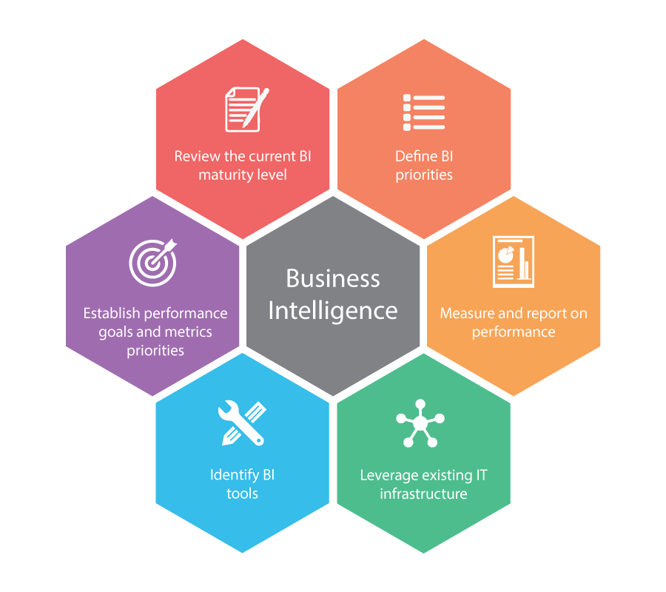

**7.TOOLS AND TECHNIQUES OF BI:**

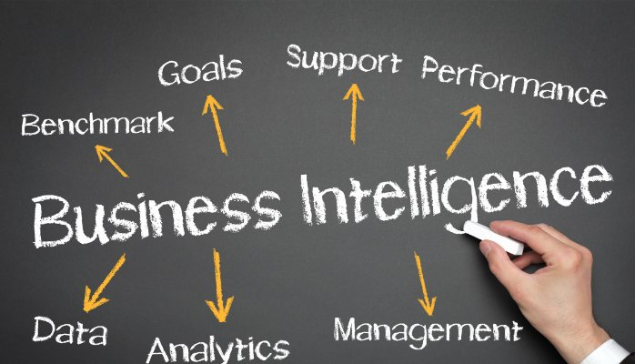

**What is BI?**

Business Intelligence (BI) includes tools and techniques, for the transformation of raw data into meaningful and actionable information for Business analysis.

**7.1 BI Techniques:**

These are techniques that can be used for BI:

**Predictive Modeling:**

* Forecasting probabilities and trends.
* Predict value for a specific data item attributes using various statistical models.

**Characterization and descriptive data mining:**

* Characterization provides a concise summarization of the given collection of data
* Descriptive data mining is based on data and analysis, define models for the database, and forecast the trend.Used in Segmentation, cluster analysis.

**Association, correlation:**

* Identifying a relationship between Attributes.

**Classification:**

* Determining the class of data item.

**OLAP (Online Analytical Processing):**

* Enable to analyze different dimensions of multidimensional data.

**Pattern Analysis:**

* Patterns & Deviations.

**Model Visualization:**

* Transforming discovered facts into charts, plots, histograms and other visual means.

**Clustering & Outlier Analysis:**

* Dividing data in chunks and grouping together items with same characteristics.

**Prescriptive Analysis:**

* Finding the best course of action for a given situation.
* Includes optimization & Simulation.

**7.2 Business intelligence tools:**

Business intelligence tools are a type of application softwaredesigned to retrieve, analyze, transform and report data for business intelligence. The tools generally read data that have been previously stored, often, though not necessarily, in a [data warehouse](https://en.wikipedia.org/wiki/Data_warehouse) or [data mart](https://en.wikipedia.org/wiki/Data_mart).

The key general categories of business intelligence tools are:

* [Spreadsheets](https://en.wikipedia.org/wiki/Spreadsheets)
* [Reporting and querying software](https://en.wikipedia.org/wiki/List_of_reporting_software): tools that extract, sort, summarize, and present selected data
* [OLAP](https://en.wikipedia.org/wiki/Online_analytical_processing): Online analytical processing
* [Digital dashboards](https://en.wikipedia.org/wiki/Dashboard_(management_information_system))
* [Data mining](https://en.wikipedia.org/wiki/Data_mining)
* [Process Visualization](https://en.wikipedia.org/wiki/Business_activity_monitoring)
* [Data warehousing](https://en.wikipedia.org/wiki/Data_warehousing)
* [Local information systems](https://en.wikipedia.org/wiki/Local_information_systems)

Except for spreadsheets, these tools are provided as standalone tools, suites of tools, components of [ERP](https://en.wikipedia.org/wiki/Enterprise_resource_planning) systems, or as components of software targeted to a specific industry. The tools are sometimes packaged into [data warehouse appliances](https://en.wikipedia.org/wiki/Data_warehouse_appliance).

