# What is Amazon EC2?

Amazon Elastic Compute Cloud (Amazon EC2) provides scalable computing capacity in the Amazon Web Services (AWS) Cloud. Using Amazon EC2 eliminates your need to invest in hardware up front, so you can develop and deploy applications faster

We can use Amazon EC2 to launch as many or as few virtual servers as you need, configure security and networking, and manage storage.

Amazon EC2 enables you to scale up or down to handle changes in requirements or spikes in popularity, reducing your need to forecast traffic.

## Features of Amazon EC2

* Virtual computing environments, known as *instances*
* Secure login information for your instances using *key pairs*
* Storage volumes for temporary data that's deleted when you stop, hibernate, or terminate your instance, known as *instance store volumes*
* *we can use ec2 to launch as many or as few virtual server as you need, configure security and networking, and manage storage.*

## Benefits of Amazon EC2

### 1. Reliability

Amazon EC2 offers 99.9% availability for each Amazon EC2 region. The services are highly reliable where replacement of instances can be done easily and rapidly.

### 2. Security

Amazon works with Amazon VPC to provide robust networking and security for the compute resources.

### 3. Flexibility

EC2 provides you with choices of multiple instance types, software packages, instance storages, and operating systems.

### 4. Cost Saving

EC2 is inexpensive as it allows the user to select plans as per the requirement

EC2 passes the benefits of Amazon’s scale as the user has to pay a very low amount compared to the services they provide.

### 5. Completely controlled

One has complete control over the instances

The user can stop instance while retaining the data on the boot partition and restart the same using web service APIs.

## How EC2 Works?

EC2 uses the AWS Management Console, the AWS Command Line Interface (CLI), or AWS Software Developer Kits (SDKs) for managing the scaling according to changing needs and makes it simple to deploy virtual servers and maintain storage.

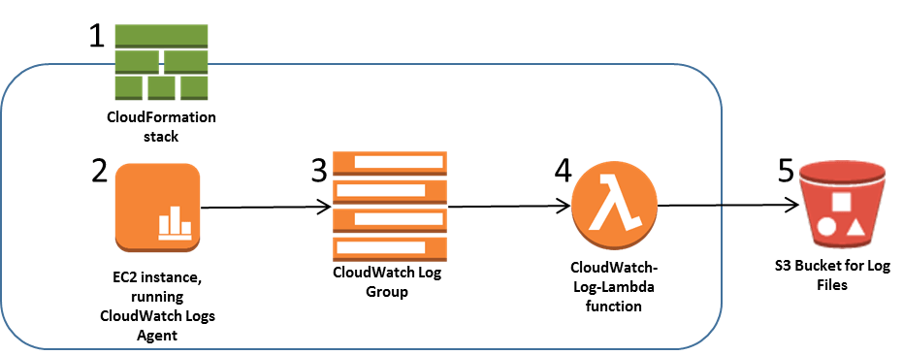

EC2 Instance Working

How to create ec2?

step 1 : open the amazon EC2 concole.

step 2 : Launch Instance

step 3: choose an Amazon Machine Image(AMI), find an Amazon Linux

2 AMI at the top of the list and choose Select.

step 4: Choose an instance type, choose NEXT: configure Instance Details

step 5 : name oyur instance and choose Next configure Security Group.

step 6: Review and launch.

step 7 : Launch

## **What is Docker?**

Docker is a software development tool and a virtualization technology that makes it easy to develop, deploy, and manage applications by using containers

## **What is a Virtual Machine?**

A virtual machine is capable of performing tasks such as running applications and programs like a separate computer making them ideal for testing other operating systems like beta releases, creating operating system backups, and running software and applications

## Docker vs Virtual Machine

| Docker | | Virtual Machines (VMs) |
| --- | --- | --- |
| **Boot-Time** | Boots in a few seconds. | It takes a few minutes for VMs to boot. |
| **Runs on** | Dockers make use of the execution engine. | VMs make use of the hypervisor. |
| **Memory Efficiency** | No space is needed to virtualize, hence less memory. | Requires entire OS to be loaded before starting the surface, so less efficient. |
| **Isolation** | Prone to adversities as no provisions for isolation systems. | Interference possibility is minimum because of the efficient isolation mechanism. |
| **Deployment** | Deploying is easy as only a single image, containerized can be used across all platforms. | Deployment is comparatively lengthy as separate instances are responsible for execution. |
| **Usage** | Docker has a complex usage mechanism consisting of both third party and docker managed tools. | Tools are easy to use and simpler to work with. |