Closing Date 04/26/17 Account Ending 4-01001



**New Balance $2,807.81**

***Membership Rewards® Points***

Available and Pending as of 03/31/17

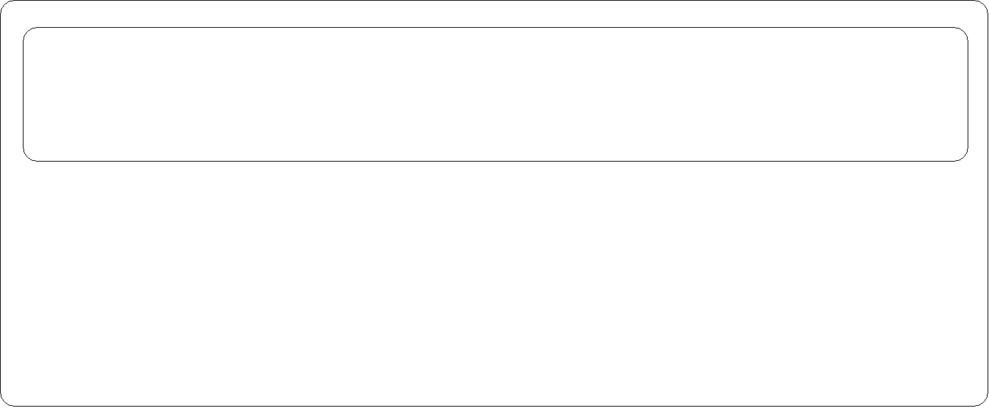

# Payment Due Date 05/11/17

***Late Payment Warning:*** *If we do not receive your payment by the Payment*

***505***

*For more details about Rewards, please visit* ***americanexpress.com/rewardsinfo***

###### Account Summary

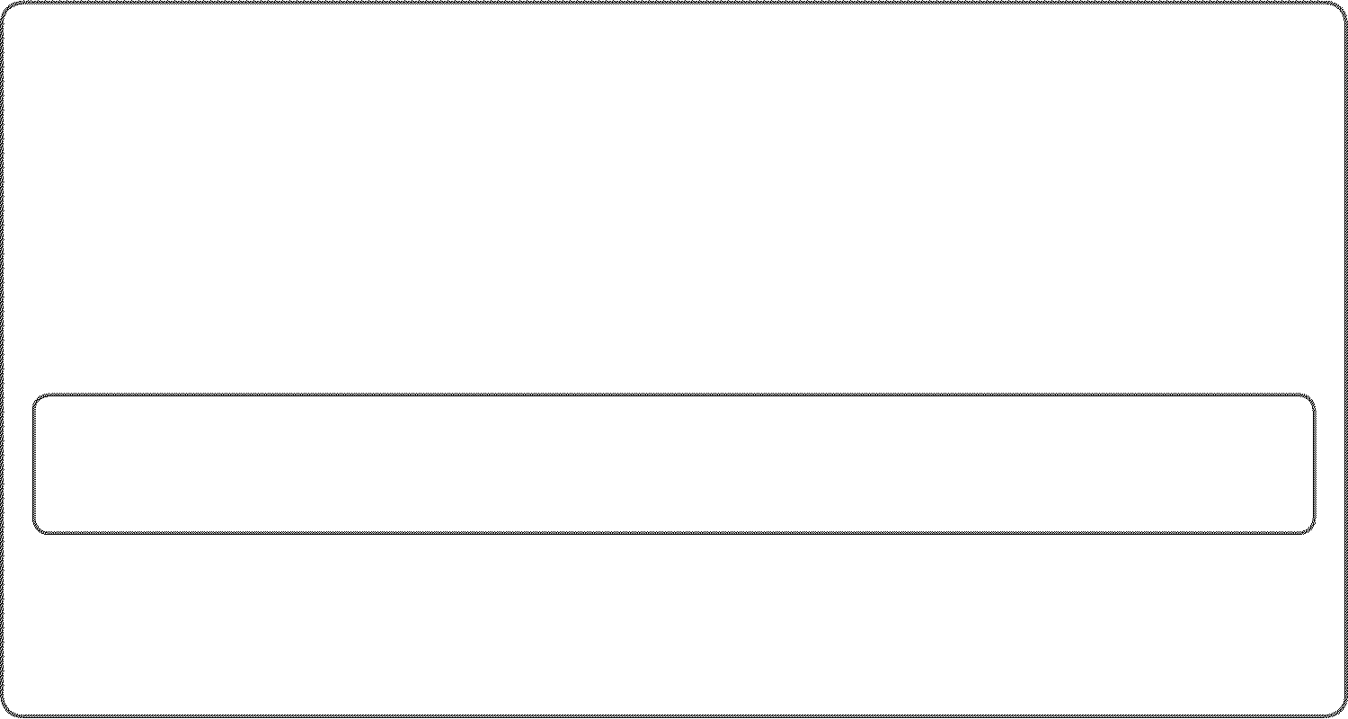

*Due Date of 05/11/17, you may have to pay a late fee of up to $38.00.*

Previous Balance

Payments/Credits New Charges Fees

$673.60

-$1,706.10

+$3,734.13

+$0.00

See page 2 for important information about your account.



***New Balance $2,701.63***

Days in Billing Period: 30

***See Page 9 for an important Privacy Notice and the following pages for important notices about Your Billing Rights, Electronic Fund***

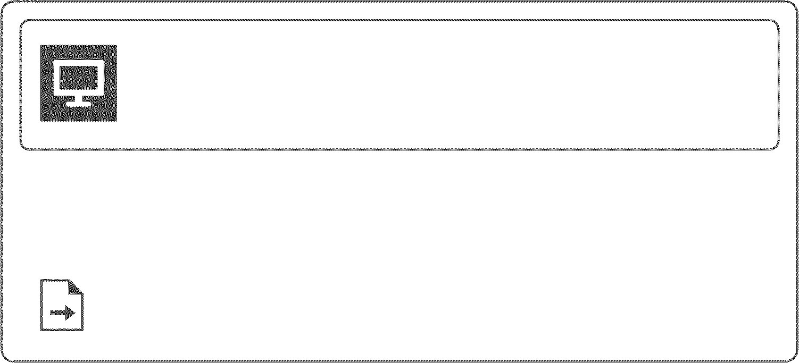

***Transfer Error Resolution and a notice for WA residents.***

*Your membership will be renewed next month. Please refer to the Renewal Notice on* ***Page 7.***



*We will debit your bank account for your payment of $2,807.81 on 05/08/17. This date may not be the same date your bank will debit your bank account. Any inquiry to American Express concerning this debit should be made by 05/06/17. If your AutoPay payment is less than your New Balance, we must receive an additional payment for at least the difference by the Payment Due Date.*



***Important Information:*** *To access the most up to date version of your Cardmember Agreement, please log in to your Account at* [***www.americanexpress.com.***](http://www.americanexpress.com/)



*As a valued Card Member we want to make you aware that, if you have a Pay Over Time feature and should variable APRs increase, the Penalty APR on your account will not exceed 29.99%. Your APRs may be increased to the Penalty APR if we do not receive your payment on time or if your payment is returned by your bank.*



###### Customer Care

***Pay by Computer***

americanexpress.com/pbc

***Customer Care Pay by Phone***

1-800-327-2177 1-800-472-9297

See Page 2 for additional information.

Continued on page 3

***Payment Coupon Pay by Computer Pay by Phone Account Ending 4-01001***



Do not staple or use paper clips americanexpress.com/pbc 1-800-472-9297

Enter 15 digit account # on all payments.

Make check payable to American Express.



*SANTOSH LAD*

*1330 VALLEY LAKE DR*

*APT 305*

*SCHAUMBURG IL 60195-3628*

Payment Due Date

***05/11/17***

AutoPay Amount

***$2,701.63***



Check here if your address or phone number has changed. Note changes on reverse side.



*AMERICAN EXPRESS BOX 0001*

*LOS ANGELES CA 90096-8000*



**Payments:** Your payment must be sent to the payment address shown on your statement and must be received by 5 p.m. local time at that address to be credited as of the day it is received. Payments we receive after 5 p.m. will not be credited to your Account until the next day. Payments must also: (1) include the remittance coupon from your statement; (2) be made with a single check drawn on a US bank and payable in US dollars, or with a negotiable instrument payable in US dollars and clearable through the US banking system; and (3) include your Account number. If your payment does not meet all of the above requirements, crediting may be delayed and you may incur late payment fees and additional interest charges. Electronic payments must be made through an electronic payment method payable in US dollars and clearable through the US banking system. If we accept payment in a foreign currency, we will convert it into US dollars at a conversion rate that is acceptable to us, unless a particular rate is required by law. Please do not send post-dated checks as they will be deposited upon receipt. Any restrictive language on a payment we accept will have no effect on us without our express prior written approval. We will re-present to your financial institution any payment that is returned unpaid. If you have a Pay Over Time balance, you may pay more than the Minimum Payment Due, up to your New Balance, at any time. If you pay in full an unpaid balance that you have been revolving, interest charged on that balance during the billing period in which you paid it will appear on your next statement.

**Permission for Electronic Withdrawal:** (1) When you send a check for payment, you give us permission to electronically withdraw your payment from your deposit or other asset account. We will process checks electronically by transmitting the amount of the check, routing number, account number and check serial number to your financial institution, unless the check is not processable electronically or a less costly process is available. When we process your check electronically, your payment may be withdrawn from your deposit or other asset account as soon as the same day we receive your check, and you will not receive that cancelled check with your financial account statement. If we cannot collect the funds electronically we may issue a draft against your deposit or other asset account for the amount of the check. (2) By using Pay By Computer, Pay By Phone or any other electronic payment service of ours, you give us permission to electronically withdraw funds from the deposit or other asset account you specify in the amount you request. Payments using such services of ours received after 8:00 p.m. MST may not be credited until the next day.

**How We Calculate Your Balance:** We use the Average Daily Balance (ADB) method (including new transactions) to calculate the balance on which we charge interest for Pay Over Time balances on your Account. Call the Customer Care number listed below for more information about this balance computation method and how resulting interest charges are determined. The method we use to figure the ADB and interest results in daily compounding of interest.

**Paying Interest:** If you have a Pay Over Time balance, your due date is at least 25 days after the close of each billing period. We will begin charging interest on transactions added to a Pay Over Time balance as of the date they are added. However, we will not charge interest on charges added to a Pay Over Time balance automatically (for example, Sign & Travel and Extended Payment Option) if you pay the Account Total New Balance by the due date each month.

**Foreign Currency Charges**: If you make a Charge in a foreign currency, we will convert it into US dollars on the date we or our agents process it. We will choose a conversion rate that is acceptable to us for that date, unless a particular rate is required by law. The conversion rate we use is no more than the highest official rate published by a government agency or the highest interbank rate we identify from customary banking sources on the conversion date or the prior business day. This rate may differ from rates in effect on the date of your charge. Charges converted by establishments will be billed at the rates such establishments use.

**Credit Balance:** A credit balance (designated CR) shown on this statement represents money owed to you. If within the six-month period following the date of the first statement indicating the credit balance you do not request a refund or charge enough to use up the credit balance, we will send you a check for the credit balance within 30 days if the amount is $1.00 or more.

**Credit Reporting:** We may report information about your Account to credit bureaus. Late payments, missed payments, or other defaults on your Account may be reflected in your credit report.

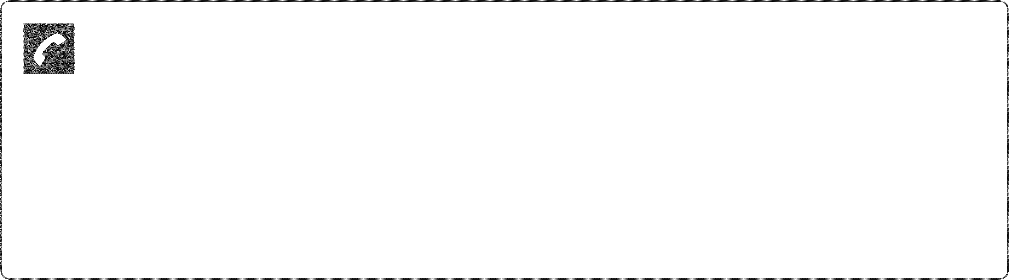

***Customer Care & Billing Inquiries International Collect***

***Large Print & Braille Statements Lost or Stolen Card***

***Express Cash***

1-800-327-2177

1-336-393-1111

1-800-327-2177

1-800-992-3404

1-800-CASH-NOW

***Hearing Impaired TTY:*** *1-800-221-9950*

***FAX:****1-800-695-9090*

***In NY:*** *1-800-522-1897*

***Website:*** *americanexpress.com*

***Customer Care***

***& Billing Inquiries Payments***

P.O. BOX 981535

EL PASO, TX

79998-1535

BOX 0001

LOS ANGELES CA

90096-8000

***Change of Address***

*If correct on front, do not use.*

*To change your address online, visit* [*www.americanexpress.com/updatecontactinfo*](http://www.americanexpress.com/updatecontactinfo)



*For Name, Company Name, and Foreign Address or Phone changes, please call Customer Care. Please print clearly in blue or black ink only in the boxes provided.*



*Street Address*

|  |  |  |  |  |  |  |  |  |  |  |  |  |  |  |  |  |
| --- | --- | --- | --- | --- | --- | --- | --- | --- | --- | --- | --- | --- | --- | --- | --- | --- |
|  |  |  |  |  |  |  |  |  |  |  |  |  |  |  |  |  |
|  |  |  |  |  |  |  |  |  |  |  |  |  |  |  |  |  |
|  |  |  |  |  |  |  |  |  |  |  |  |  |  |  |  |  |
|  |  |  |  |  |  |  |  |  |  |  |  |  |  |  |  |  |
|  |  |  |  |  |  |  |  |  |  | | | | | | | |
|  | | |  |  |  |  |  |  |
|  |  |  |  |  |  |  |  |  |  |  | | | |
|  |  |  |  |  |  |  | | | | | | | |
|  |  |  |  |  |  |  |  |  |  |  | | | |

*City, State Zip Code*

*Area Code and*

*Home Phone*

*Area Code and Work Phone*

*Email*

***Pay Your Bill with AutoPay***

* Avoid late fees
* Save time

Deduct your payment from your bank account automatically each month

*Visit* ***americanexpress.com/autopay***

today to enroll.

*For information on how we protect your privacy and to set your communication and privacy choices, please visit* [***www.americanexpress.com/privacy.***](http://www.americanexpress.com/privacy)

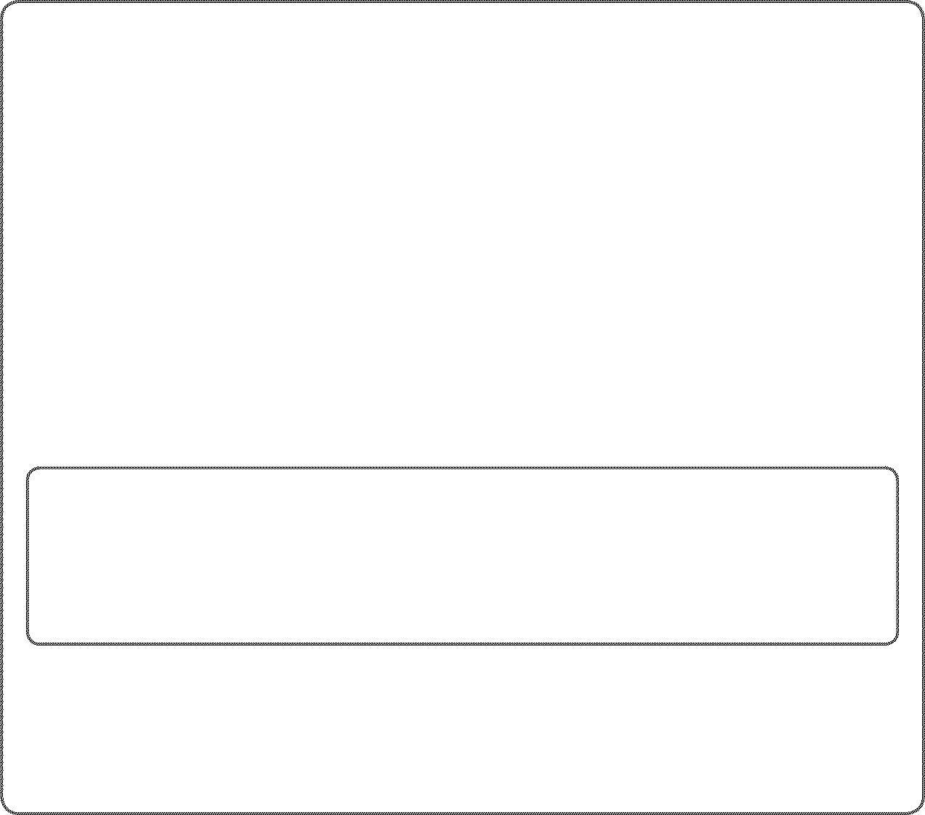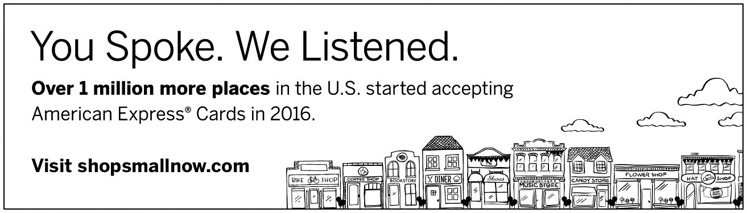

# Payments and Credits

###### Summary

***Payments Credits***

***Total***

-$1,002.44



-$703.66

***Total Payments and Credits -$1,706.10***

**Detail**

*\*Indicates posting date*

***Payments Amount***



03/19/17* ONLINE PAYMENT - THANK YOU -$376.24

03/24/17* ONLINE PAYMENT - THANK YOU -$297.36

03/28/17* ONLINE PAYMENT - THANK YOU -$328.84

***Credits Amount***

03/23/17* POINTS FOR YOUR CHARGES CREDIT -$39.69

03/23/17* POINTS FOR YOUR CHARGES CREDIT -$12.02

03/30/17 MEN'S WEARHOUSE

SCHAUMBURG IL

-$5.50

8008516744

04/03/17 SOLSTICE SUNGLASS 10

SCHAUMBURG IL

-$218.90

MISC/SPECIALTY RETAIL

04/06/17 MEN'S WEARHOUSE

SCHAUMBURG IL

-$24.19

8008516744

04/11/17 ESURANCE CAR INSURAN

800-378-7262 CA

-$298.98

INSURANCE SALES

04/13/17 GEICO AUTO

(800)841-3000 DC

-$104.38

INSURANCE SALES

# New Charges

###### Summary

***Total***



***Total New Charges $3,734.13***

3

**Detail**

***SANTOSH LAD***



Card Ending 4-01001

***Amount***

03/27/17 ALLSTATE-WLLW RD NORTHBROOK IL

847-6670250

$7.40

FOOD/BEVERAGE $7.40

03/27/17 CHIPOTLE GLENVIEW IL

303-595-4000

Description

$7.13

FAST FOOD RESTAURAN

03/28/17 ALLSTATE-WLLW RD NORTHBROOK IL

847-6670250

$6.20

FOOD/BEVERAGE $6.20

03/28/17 ALLSTATE-WLLW RD NORTHBROOK IL

847-6670250

$3.27

FOOD/BEVERAGE $3.27

03/29/17 ALLSTATE-WLLW RD NORTHBROOK IL

847-6670250

$5.01

FOOD/BEVERAGE $5.01

03/29/17 NAF NAF GRILL 013 0036 NORTHBROOK IL

571-243-8399

Description

$8.23

FOOD/BEVERAGE

03/30/17 GOLF LIQUORS SCHAUMBURG IL

$16.89

847-882-1952

03/30/17 MEN'S WEARHOUSE SCHAUMBURG IL

4604 65158 60173

$24.19

AUT MINI UMBREL

03/31/17 ALLSTATE-WLLW RD NORTHBROOK IL

847-6670250

$0.64

FOOD/BEVERAGE $0.64

03/31/17 ALLSTATE-WLLW RD NORTHBROOK IL

847-6670250

$1.95

FOOD/BEVERAGE $1.95

03/31/17 TAVA RESTAURANT 000000001 MORTON GROVE IL

8479668282

Description

$17.00

REFER TO RECEIPT

03/31/17 STRIKE TEN LANES ROSELLE IL BOWLING ALLEY

$27.00

FOOD/BEVERAGE $27.00

###### Detail Continued

03/31/17 STRIKE TEN LANES ROSELLE IL BOWLING ALLEY



FOOD/BEVERAGE $60.00

***Amount***

$72.00

TIP $12.00

04/02/17 AT&T RECURR BILL PAYMENT DALLAS TX

800-331-0500

Description

$64.91

TELECOMMUNICATIONS

04/03/17 PATEL BROTHERS OF 542929806325767 SCHAUMBURG IL

8476754455

Description Price

$92.77

GROCERY STORES, SUP $92.77

04/06/17 Fox Valley Volkswagen Schaumburg IL

$2,000.00

630-231-9900

04/06/17 MEN'S WEARHOUSE SCHAUMBURG IL

4604 65158 60173

$5.49

JUMBO GOLF UMBR

04/06/17 ESURANCE CAR INSURAN 800-378-7262 CA

$335.41

INSURANCE

04/07/17 HOLLISTER #0127 000030127 SCHAUMBURG IL

8664261285

Description Price

$47.22

CLOTHING STORES $47.22

04/07/17 GNC SCHAUMBURG IL

MISC FOOD STORE

Description

$33.93

FOOD/BEVERAGE

04/07/17 ENTERPRISE RENTACAR SCHAUMBURG IL

Location Date

Rental: SCHAUMBURG IL 17/04/06

Return: SCHAUMBURG IL 17/04/07

Agreement Number: D581959

$35.30

Renter Name: LAD SANTOS

04/07/17 MACYS WOODFIELD 000000259 SCHAUMBURG IL

8002896229

Description Price

STBK BLENDED BEVRGE $3.95

$7.17

STBK FOOD $2.45

04/08/17 GEICO AUTO (800)841-3000 DC

$124.31

INSURANCE

04/08/17 DD/BR #336651 Q35 SCHAUMBURG IL

$1.99

847-839-0500

04/08/17 DD/BR #336651 Q35 SCHAUMBURG IL

$3.21

847-839-0500

04/09/17 TACO BELL SCHAUMBURG IL

847-885-1360

Description

$6.24

FAST FOOD RESTAURAN

04/09/17 RAJA GROCERIES 137001001043992 MADISON WI

$37.71

608-831-4642

04/10/17 ENTERPRISE RENTACAR SCHAUMBURG IL

Location Date

Rental: SCHAUMBURG IL 17/04/08

Return: SCHAUMBURG IL 17/04/10

Agreement Number: D582032

$493.37

Renter Name: LAD SANTOS

04/10/17 AMERICAN FAMILY MUTUAL IN 084870007003 608-242-4100 WI

$101.28

INSURANCE SALES

###### Detail Continued

04/10/17 CUNAMUTUALCAFE207313 93711207313 MADISON WI



952-4122859

***Amount***

$6.41

FOOD/BEVERAGE $6.41

04/10/17 IL TOLLWAY - WEB - UNPD T 000009021 DOWNERS GROVE IL

8008247277

Description

$19.70

REFER TO RECEIPT

04/11/17 CUNAMUTUALCAFE207313 93711207313 MADISON WI

952-4122859

$5.07

FOOD/BEVERAGE $5.07

04/11/17 CUNAEUREST5910283424 93718283424 MADISON WI

608-6657024

$1.99

FOOD/BEVERAGE $1.99

04/11/17 CUNA MUTUAL GR207552 93711207552 MADISON WI

952-4122859

$2.90

FOOD/BEVERAGE $2.90

04/11/17 IL TOLLWAY - WEB - UNPD T 000009021 DOWNERS GROVE IL

8008247277

Description

$9.40

REFER TO RECEIPT

04/11/17 WHOLE FOODS MARKET MADISON WI

6082339566

Description Price

$50.07

GROCERY STORES $50.07

04/12/17 CHIPOTLE 2204 0098 MADISON WI

303-595-4000

Description

$6.86

FAST FOOD RESTAURAN

04/13/17 TILTED KILT PUB & EATERY SCHAUMBURG IL

8474132000

$50.00

TIP $6.44

04/13/17 CUNAMUTUALCAFE207313 93711207313 MADISON WI

952-4122859

$2.73

FOOD/BEVERAGE $2.73

04/14/17 BP#9175258GOLF & MEACHUM 9175 SCHAUMBURG IL

847-605-0270

Description

$41.43

Unleaded Regular

04/14/17 TACO BELL SCHAUMBURG IL

847-885-1360

Description

$1.44

FAST FOOD RESTAURAN

04/14/17 SHELL OIL 57444094106 SCHAUMBURG IL

$19.99

AUTO FUEL DISPENSER

04/14/17 DD/BR #336651 Q35 SCHAUMBURG IL

$1.99

847-839-0500

# Fees

***Amount Total Fees for this Period $0.00***



**2017 Fees and Interest Totals Year-to-Date**

***Amount***

Total Fees in 2017 $0.00

Total Interest in 2017 $24.22

# Interest Charge Calculation

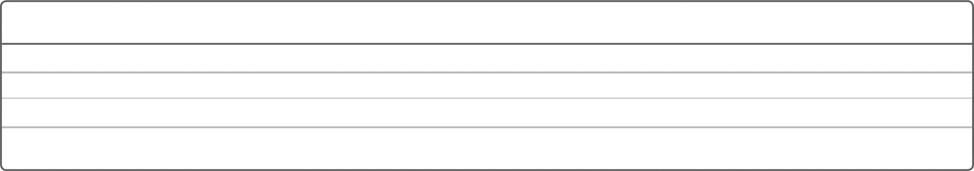

Your Annual Percentage Rate (APR) is the annual interest rate on your account.



***Transactions Dated***

***Annual Percentage***

***Balance Subject to***

***Interest Charge***

***From To Rate Interest Rate***

Select & Pay Later 10/07/2016 18.99% (v) $0.00 $0.00

***Total $0.00***

* 1. *Variable Rate*

**Information on Pay Over Time Features**

***There is no pre-set spending limit on your Card***

No pre-set spending limit does not mean unlimited spending. Purchasing power adjusts with your use of the Card,

your payment history, credit record and financial resources known to us and other factors. Unless you have been

previously notified otherwise, your Card has a no pre-set spending limit.

***There is a limit to your Pay Over Time feature balance***

Your Pay Over Time limit is $35,000.00. We may approve or decline a charge regardless of whether your Card

account balance exceeds or does not exceed your Pay Over Time limit. You must pay in full all charges that are not

placed into a Pay Over Time balance by the Payment Due Date.

###### Renewal Notice

Your Account renews next month. The following terms will be in effect when your Account renews, unless we tell you otherwise. Please refer to Page 2 for more information about your Account, including How We Calculate Your Balance, Paying Interest, and Foreign Currency Charges.

**Payment Information:** All charges made on this charge card, that are not included in a Pay Over Time balance, are due and payable by the Payment Due Date.

*Please refer to page 2 for further important information regarding your account*

**Annual Membership Fee:** The annual membership fee for your Account is $195.00. When you receive the statement in which the annual fee is billed, you can avoid paying the annual fee by calling the Customer Care phone number on Page 2 to cancel your Account.

**APR Information:** The Annual Percentage Rates (APRs) for each billing period may vary based on the Prime Rate. We use the Prime Rate published in the rates section of The Wall Street Journal 2 days before the Closing Date of the billing period. The Wall Street Journal may not publish the Prime Rate on that day. If it does not, we will use the Prime Rate from the previous day it was published.

The Penalty APR will apply to a Feature if you make one or more late payments or if your payment is returned. If the Penalty APR is applied, it will apply for at least 6 months. We will review your Account every 6 months after the Penalty APR is applied. The Penalty APR will continue to apply until you have made timely payments with no returned payments during the 6 months being reviewed.

You may have access to one or more Pay Over Time Features on your Account. If you are enrolled in a Feature or have a Feature balance, the APRs that apply will be noted below as of the Closing Date of this statement.

* + 1. Indicates variable rate
* variable penalty APR will not exceed 29.99%

###### Renewal Notice continued

***Select & Pay Later***

***Transactions Dated***

***Rate Description From To Prime + Margin APR***

*Standard 10/07/2016 Prime + 14.99% 18.99% (v)*

*Penalty 10/07/2016 Prime + 25.99%* 29.99% (v)\**

**FACTS**

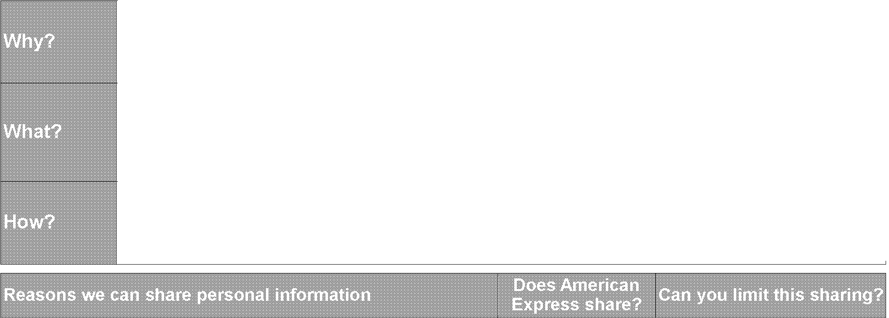

Rev. 9/2012

**WHAT DOES AMERICAN EXPRESS DO WITH YOUR PERSONAL INFORMATION?**

Financial companies choose how they share your personal information. Federal law gives consumers the right to limit some but not all sharing. Federal law also requires us to tell you how we collect, share, and protect your personal information. Please read this notice carefully to understand what we do.

The types of personal information we collect and share depend on the product or service you have with us. This information can include:

* + Security number and income
  + history and account history
  + claim history and credit history

All financial companies need to share customers' personal information to run their everyday business. In the section below, we list the reasons financial companies can share their customers' personal information; the reasons American Express chooses to share; and whether you can limit this sharing.

|  |  |  |  |
| --- | --- | --- | --- |
|  | | | |
| **For our everyday business purposes** -  such as to process your transactions, maintain your account(s), respond to court orders and legal investigations, or report to credit bureaus | | Yes | No |
| **For our marketing purposes** -  to offer our products and services to you | | Yes | No  (but please see the "To limit  direct marketing" box below for additional privacy choices) |
| **For joint marketing with other financial companies** | | Yes | No |
| **For our affiliates' everyday business purposes** - information about your transactions and experiences | | Yes | No |
| **For our affiliates' everyday business purposes** - information about your creditworthiness | | Yes | Yes |
| **For our affiliates to market to you** | | Yes | Yes |
| **For nonaffilia** | **tes to market to you** | No  (although we may  share aggregated or de-identified data) | We don't share personal information |

* Visit us online: [www.americanexpress.com/communications](http://www.americanexpress.com/communications) or
* Call us at 1-855-297-7748 - our menu will prompt you through your choices

*Please note:*

If you are a *new* customer, we can begin sharing your personal information 30 days from the date

we sent this notice. When you are *no longer* our customer, we continue to share your personal information as described in this notice.

However, you can contact us at any time to limit our sharing.

We provide additional privacy choices to customers. Privacy elections you make for any one product or service may not automatically be applied to other products and services. To let us know if you do not want us to use your personal information to communicate with you about offers by mail, telephone, and/or e-mail:

* Visit us online: [www.americanexpress.com/communications](http://www.americanexpress.com/communications) or
* Call us at 1-855-297-7748 (except for choices about e-mail communications)

Call 1-800-528-4800 or go to americanexpress.com/contact.

**Page 1of2**

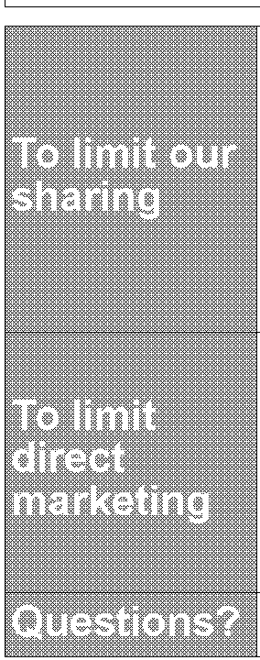

**How does American** To protect your personal information from unauthorized access and use, we use security **Express protect my** measures that comply with federal law. These measures include computer safeguards **personal information?** and secured files and buildings.

We collect your personal information, for example, when you

**How does American Express collect my personal information?**

**Why can't I limit all sharing of personal information?**

**What happens when I limit sharing for an account I hold jointly with someone else?**

* open an account or pay your bills
* give us your income information or give us your contact information
* use your credit card

We also collect your personal information from others, such as credit bureaus, affiliates, or

other companies.

Federal law gives you the right to limit only

* sharing for affiliates' everyday business purposes - information about your creditworthiness
* affiliates from using your information to market to you
* sharing for nonaffiliates to market to you

State laws and individual companies may give you additional rights to limit sharing. See

below for more on your rights under state law.

Your choices will apply to everyone on your account.

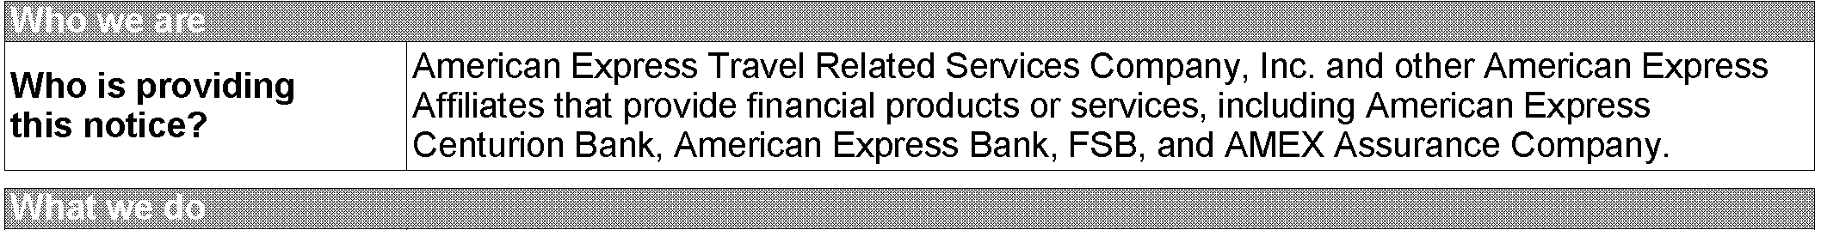

|  |  |
| --- | --- |
| **Affiliates** | Companies related by common ownership or control. They can be financial and nonfinancial companies.   * *Our affiliates include companies with the American Express name, including financial companies such as American Express Travel Related Services Company, Inc. and nonfinancial companies such as American Express Publishing. Affiliates may also include other companies related by common ownership or control, such as Serve Virtual Enterprises, Inc. and AMEX Assurance*   *Company,* a *provider of American Express Card-related insurance services.* |
| **Nonaffiliates** | Companies not related by common ownership or control. They can be financial and nonfinancial companies.   * *Nonaffiliates with which we share personal information include service providers, including, for example, direct marketers, that perform services or functions on our behalf.* |
| **Joint marketing** | A formal agreement between nonaffiliated companies that together market financial products or services to you.   * *Our joint marketing partners include financial companies.* |

We may transfer personal information to other countries, for example, for customer service or to process transactions.

**AMEX Assurance Company customers:** You may have the right to access and correct recorded personal

information. Personal information may be disclosed by us to detect fraud or misrepresentation, to verify insurance coverage, to an insurance regulatory authority, law enforcement or other governmental authority pursuant to law, or

to a group policyholder for purposes of reporting claims experience or conducting an audit. Personal information

related to insurance claim activity obtained from a report prepared by an insurance-support organization on our behalf may be retained by such organization and disclosed as required by law. State law may be more protective

than federal law.

**California:** If your American Express account has a California billing address, we will not share your personal information except to the extent permitted under California law.

**Vermont:** If your American Express account has a Vermont billing address, we will automatically treat your account

as if you have directed us not to share information about your creditworthiness with our affiliates.

**Page 2 of 2**

**Your Billing Rights: Keep this Document for Future Use**

This notice tells you about your rights and our responsibilities under the Fair Credit Billing Act. What To Do If You Find a Mistake on Your Statement

If you think there is an error on your statement, write to us at PO Box 981535, El Paso TX 79998-1535. In your letter, give us the following information:

* + *Account information:* Your name and account number.
  + *Dollar amount:* The dollar amount of the suspected error.
  + *Description of problem:* If you think there is an error on your bill, describe what you believe is wrong and why you believe it is a mistake.

You must contact us:

* + - Within 60 days after the error appeared on your statement.
    - At least 2 business days before an automated payment is scheduled, if you want to stop payment on the amount you think is wrong.

You must notify us of any potential errors *in writing.* You may call us, but if you do we are not required to

investigate any potential errors and you may have to pay the amount in question. What Will Happen After We Receive Your Letter

When we receive your letter, we must do two things:

* + - 1. Within 30 days of receiving your letter, we must tell you that we received your letter. We will also tell you if we have already corrected the error.
      2. Within 90 days of receiving your letter, we must either correct the error or explain to you why we believe the bill is correct.

While we investigate whether or not there has been an error:

* + - * + We cannot try to collect the amount in question, or report you as delinquent on that amount.
        + The charge in question may remain on your statement, and we may continue to charge you interest on that amount.
        + While you do not have to pay the amount in question, you are responsible for the remainder of your balance.
        + We can apply any unpaid amount against your credit limit. After we finish our investigation, one of two things will happen:
        + *If we made* a *mistake:* You will not have to pay the amount in question or any interest or other fees related to that amount.
        + *If we do not believe there was* a *mistake:* You will have to pay the amount in question, along with applicable interest and fees. We will send you a statement of the amount you owe and the date payment is due. We may then report you as delinquent if you do not pay the amount we think you owe.

If you receive our explanation but still believe your bill is wrong, you must write to us within *10 days* telling us

that you still refuse to pay. If you do so, we cannot report you as delinquent without also reporting that you are questioning your bill. We must tell you the name of anyone to whom we reported you as delinquent, and we must let those organizations know when the matter has been settled between us.

If we do not follow all of the rules above, you do not have to pay the first $50 of the amount you question even

if your bill is correct.

Your Rights If You Are Dissatisfied With Your Credit Card Purchases

If you are dissatisfied with the goods or services that you have purchased with your credit card, and you have tried in good faith to correct the problem with the merchant, you may have the right not to pay the remaining amount due on the purchase.

To use this right, all of the following must be true:

1. The purchase must have been made in your home state or within 100 miles of your current mailing address, and the purchase price must have been more than $50. (Note: Neither of these are necessary if your purchase was based on an advertisement we mailed to you, or if we own the company that sold you the goods or services.)
2. You must have used your credit card for the purchase. Purchases made with cash advances from an ATM or with a check that accesses your credit card account do not qualify.
3. You must not yet have fully paid for the purchase.

If all of the criteria above are met and you are still dissatisfied with the purchase, contact us *in writing* at PO Box 981535, **El** Paso TX 79998-1535. While we investigate, the same rules apply to the disputed amount as discussed above.

After we finish our investigation, we will tell you our decision. At that point, if we think you owe an amount and you do not pay, we may report you as delinquent.

**Annual EFT Error Resolution Notice**

This notice is to inform you about how you should notify us of errors or questions regarding any electronic fund transfers you initiate using your American Express Card, including Express Cash transactions, or electronic payments you make to American Express using Pay By Phone, Pay By Computer, or any other American Express electronic payment service.

In case of errors or questions about your Electronic Transfers, please contact us as soon as you can if you think your statement or receipt is wrong or if you need more information about a transfer listed on the statement or receipt. You can call us at 1-800-IPAY-AXP for Pay By Phone questions, at 1-800-528-2122 for Pay By Computer questions, at 1-800-528-4800 for AutoPay questions, and at 1-800-CASH-NOW for Express Cash questions. You may also write to us at American Express, Electronic Funds Services, P.O. Box 981531, **El** Paso, TX 79998-1531 or contact us online at [www.americanexpress.com/inquirycenter.](http://www.americanexpress.com/inquirycenter) We must hear from you no later than 60 days after we sent the FIRST statement on which the problem or error appeared or question arose.

When you contact us, please provide the following information:

1. Your name and card account number.
2. Description of the error or the transfer you are unsure about. Explain as clearly as you can why you believe it is an error or why you need more information.
3. The dollar amount of the suspected error.

If you notify us by phone, we may require that you send us your complaint or question in writing within 10 business days of the call.

We will determine whether an error occurred within 10 business days and will correct any error promptly. If we need more time, however, we may take up to 45 days to investigate your complaint or question. If we decide to do this, we will credit your bank account within 10 business days for the amount you think is in error, so that you will have the use of the money during the time it takes us to complete our investigation. If we ask you to

put your complaint or question in writing and we do not receive it within 10 business days, we may not credit your account.

For errors involving point-of-sale or foreign-initiated transactions, we may take up to 90 days to investigate your complaint or question.

We will tell you the results within three business days after completing our investigation. If we decide that there was no error, we will send you a written explanation. You may ask for copies of the documents that we used in our investigation.

If we have credited your bank account and there was no error, we will tell you when we will withdraw that amount from your bank account again. You authorize us to withdraw this amount from your bank account. If your bank account does not have enough funds to cover this withdrawal, we can charge the amount to your card account or collect the amount from you. If this happens, we may cancel your right to use our electronic transfer services.

**Notice for residents of Washington State**

In accordance with the Revised Code of Washington Statutes, Section 63.14.167, you are not responsible for payment of interest charges that result solely from a merchant's failure to transmit to us within seven working days a credit for goods or services accepted for return or forgiven if you have notified us of the merchant's delay in posting such credit, or our failure to post such credit to your account within three working days of our receipt of the credit.

**Membership Rewards®**



**Monthly Statement and Program News**

p. 13/15

**Prepared for SANTOSH LAD**



**Account Number 1M23337166**

###### Questions About Your Account?

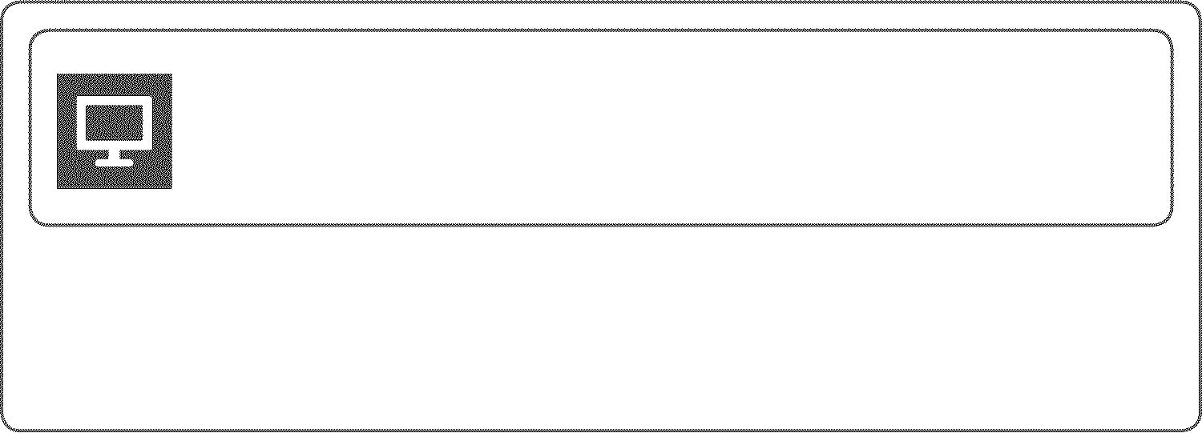

***Total Points Balance 505***



***Points Earned this Period 208***



***membershiprewards.com***

***1-800-AXP-EARN (297-3276)***

***International Collect: 1-336-393-1111***

**Account Summary**

March 1, 2017 - March 31, 2017

###### Did You Know?

***Use Points For Your Charges***



Opening Points Balance 7,622

Points Earned this Period +208

*Points Used this Period 0 Reinstated Points and Adjustments -7,325* ***Total Points Balance 505***

***Points Earned this Period are pending until charges are paid in full and all your accounts are in good standing.***



**Points Transaction Detail**

Use your Card for charges like travel, dining, groceries, and more, then go online and use the points you earned toward your eligible charges.

Learn more at

***membershiprewards.com/yourcharges****.*

March 1, 2017 - March 31, 2017

***Points Earned this Period Points Activity On Eligible Charges***

***Bonus Points***

***Awarded***

***Total Points Activity Per Card***

***Premier Rewards Gold Card***

XXXX-XXXXX4-01001

*98* ***110***

*PREMIER GOLD 2X PR2*

208

***Total 98 110 208***

***Reinstated Points and Adjustments Number of***

***Date***

***Points***

|  |  |  |
| --- | --- | --- |
| *PTS FOR YOUR CHARGES* | *-1,703* | *3/22/17* |
| *PTS FOR YOUR CHARGES* | *-5,622* | *3/22/17* |
| ***Total*** | ***-7,325*** |  |

*Membership Rewards points earned may be transferred or redeemed as long as all enrolled Card accounts are in good standing. Points transferred or redeemed cannot be reversed back into the program.* ***Forfeited points can be reinstated for a fee by calling the number provided below or visiting membershiprewards.com****. Terms and Conditions of the Membership Rewards® program apply. For more information, visit membershiprewards.com/terms or call 1-800-AXP-EARN (297-3276). From overseas, call collect 1-336-393-1111.*

Prepared for

###### SANTOSH LAD

Membership Rewards® Account Number

###### 1M23337166

p. 14/15

**Premier Rewards Gold Card**



p. 15/15

*SANTOSH LAD*

Closing Date 04/26/17 Account Ending 4-01001

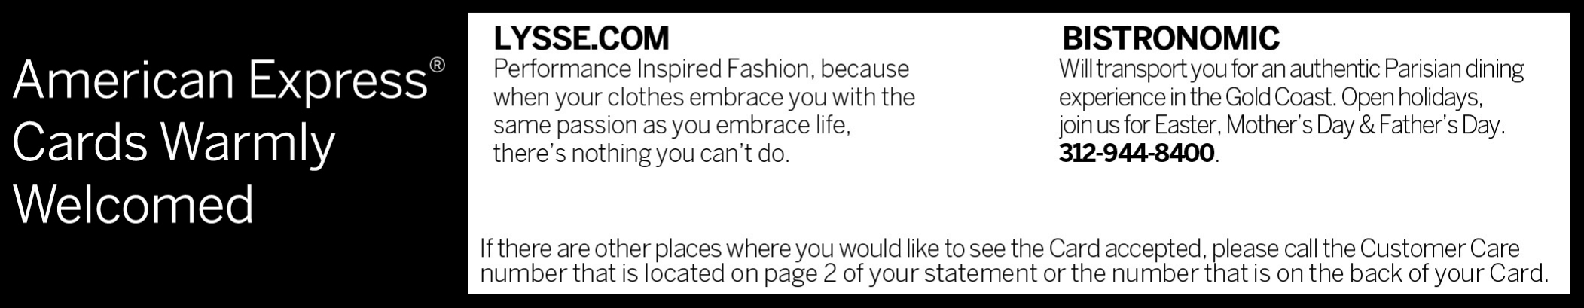

**Offers are made only to Cardmembers who meet certain qualifying criteria. By responding you will be disclosing to the merchant that you meet these criteria.**