**WEBSITE MANUAL**

**Before Starting**

Before the website can be accessed by the user, Visual Studio must be installed.

From the GitHub link: https://github.com/santosh2403/RP-Automated-Car-Plate-Recognition-System.git

Download the file ‘RP_LP_website.zip’ and extract it to the computer. On Visual Studios,

**Database Installation**

From the visual studio page, click on View as shown below.

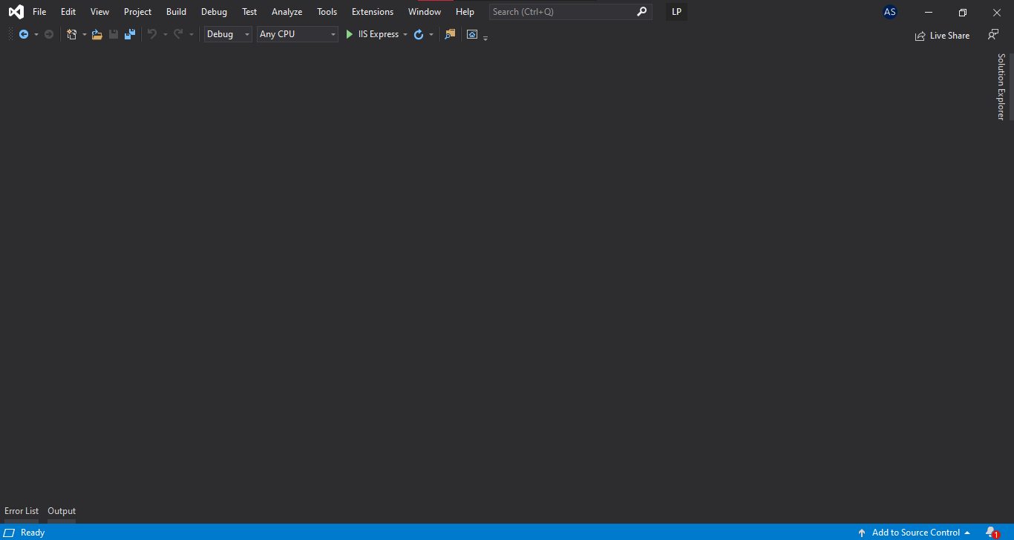

After clicking on View, you should be able to see the drop down as shown.

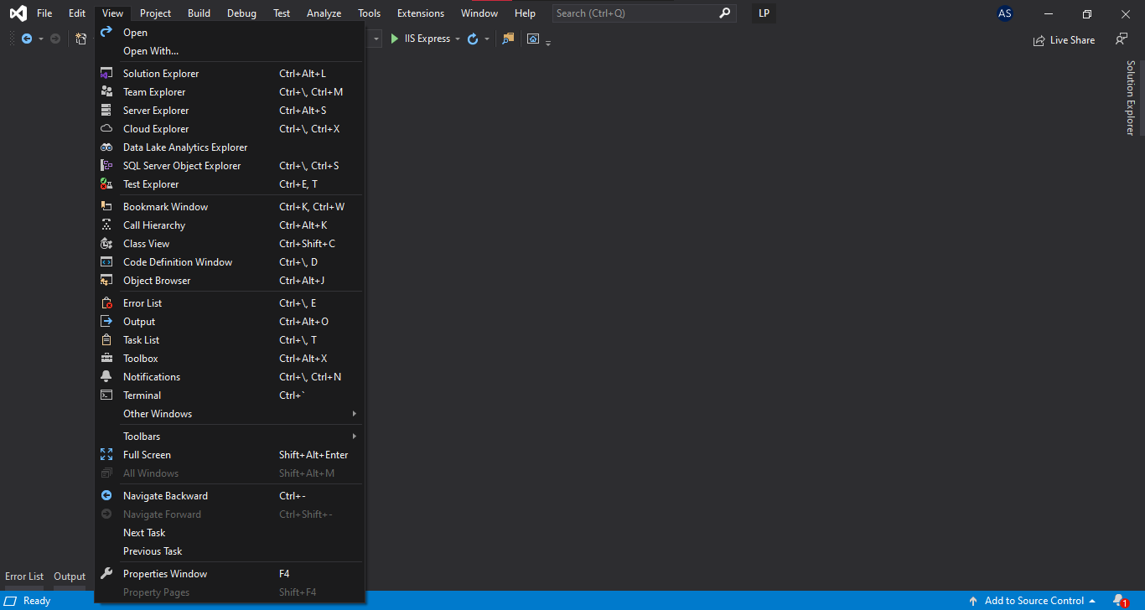

Click on SQL Server Object Explorer as shown below



After clicking on SQL Server Object Explorer, a pop up will be shown at the side

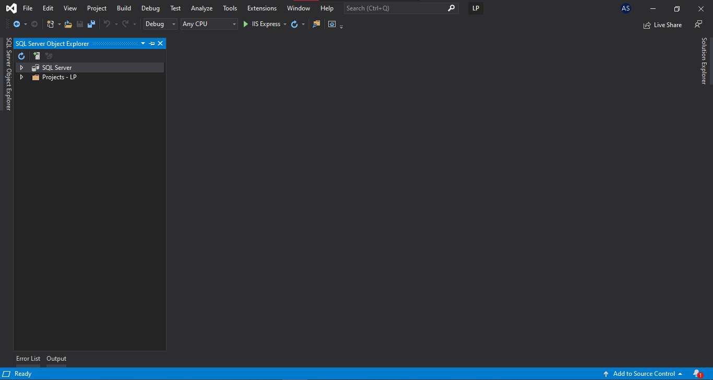

This is how it will look like if the pop-up is minimised

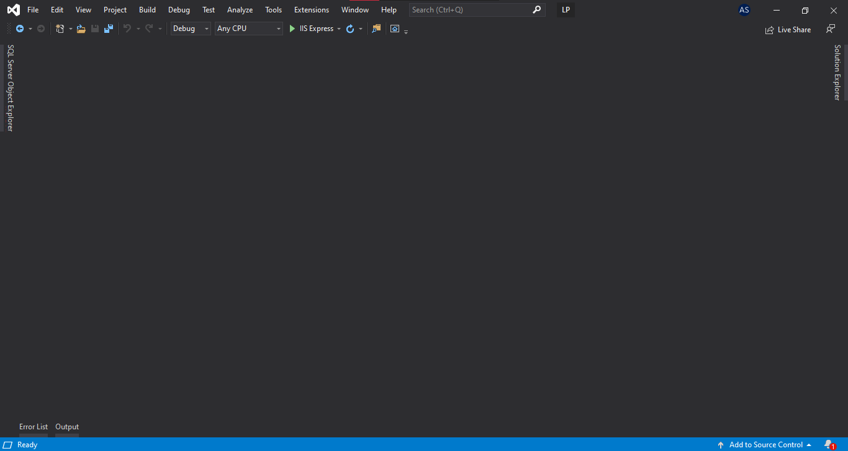

Expand the SQL Server tab



This will be shown after the tab is expanded

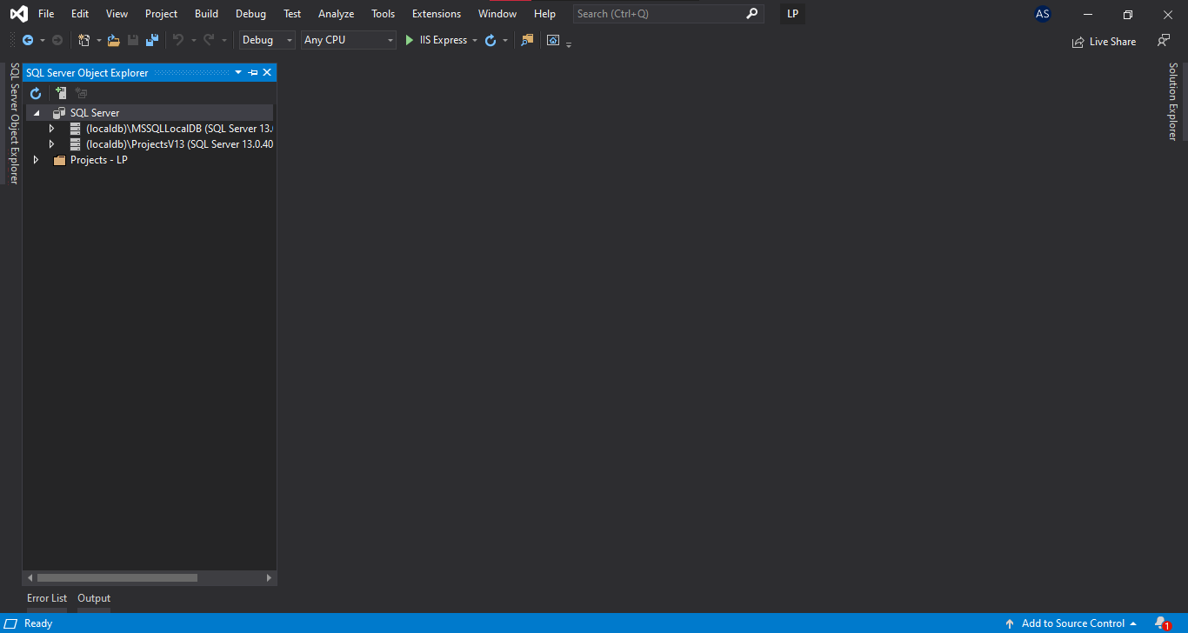

Expand the (localdb)\ProjectsV13 (SQL Server 13.0.40)



This will be shown once (localdb)\ProjectsV13 (SQL Server 13.0.40) is expanded

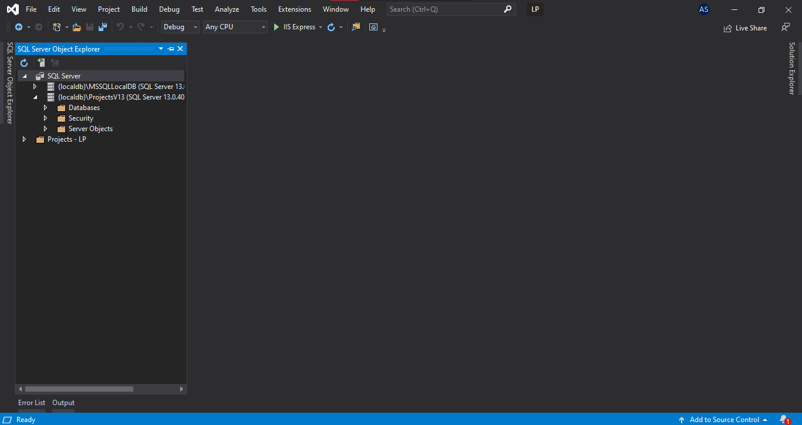

Right-click on the databases



After right-clicking it, this will be shown

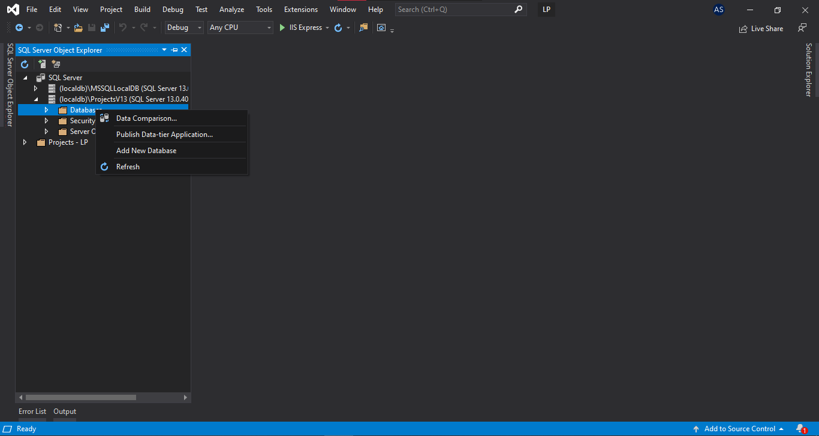

Click on "Add New Database"



After clicking "Add New Database", rename the Database Name to your own preference and click "Ok"

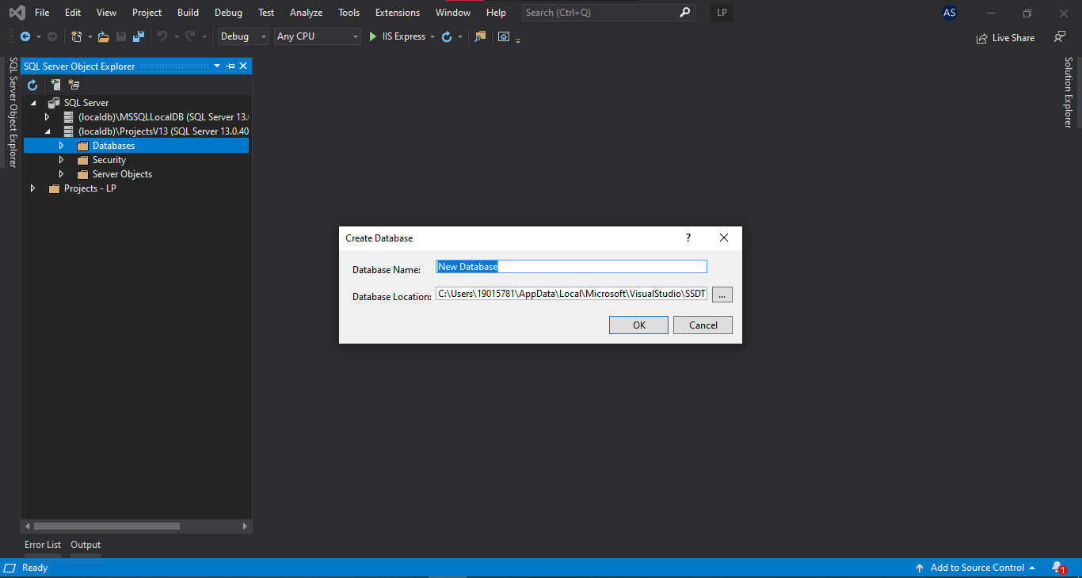

Expand the Databases



The created database will be seen once you have expanded the Database

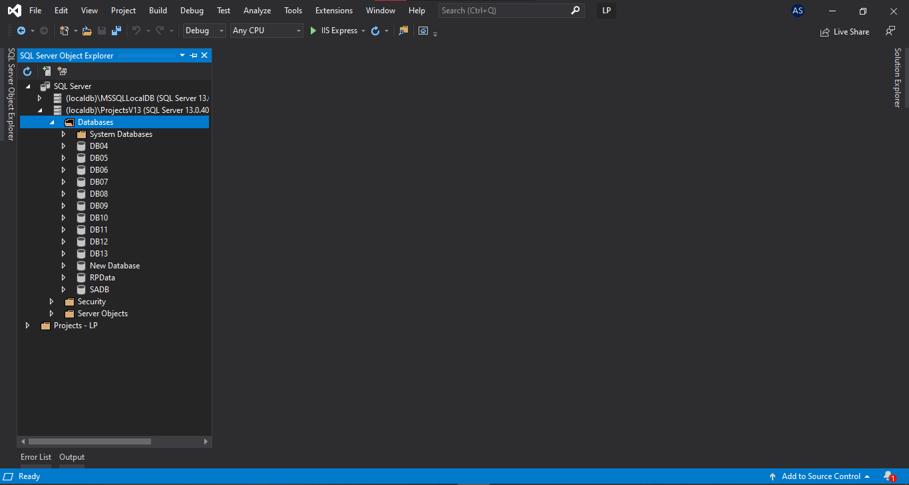

Right-click on New Database, this will be shown

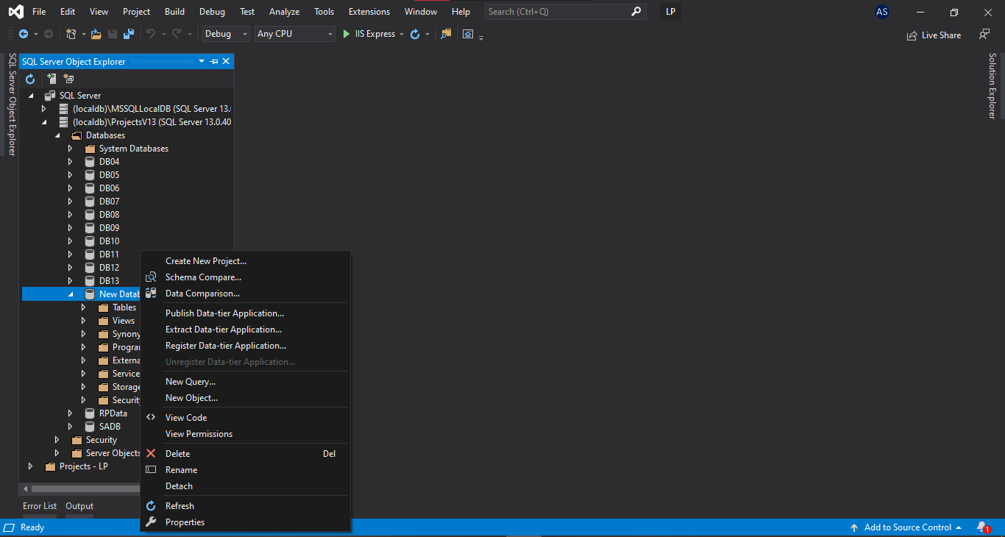

Click on New Query



A query tab will open

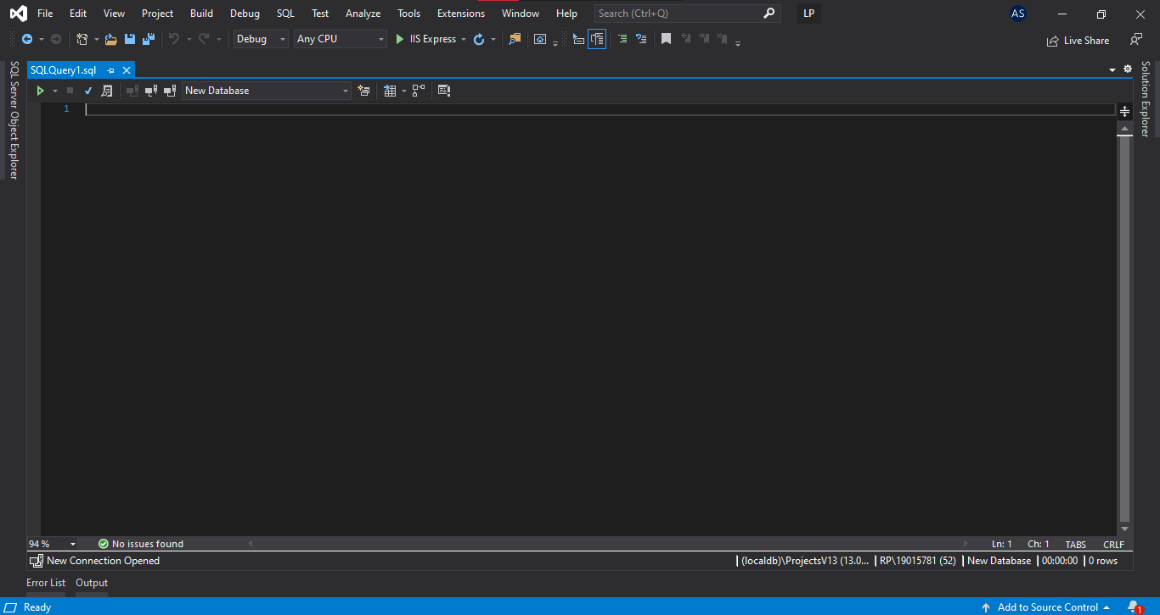

Open up DBSetup.txt

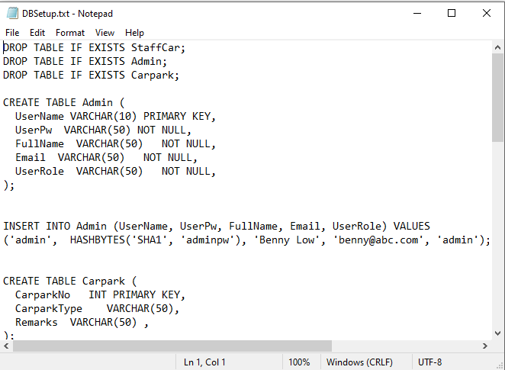

Copy the codes from the DBSetup.txt and paste it in the query tab as shown

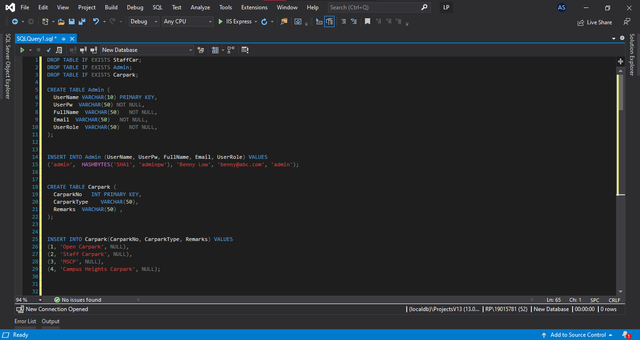

Run the query



You should receive this message at the bottom

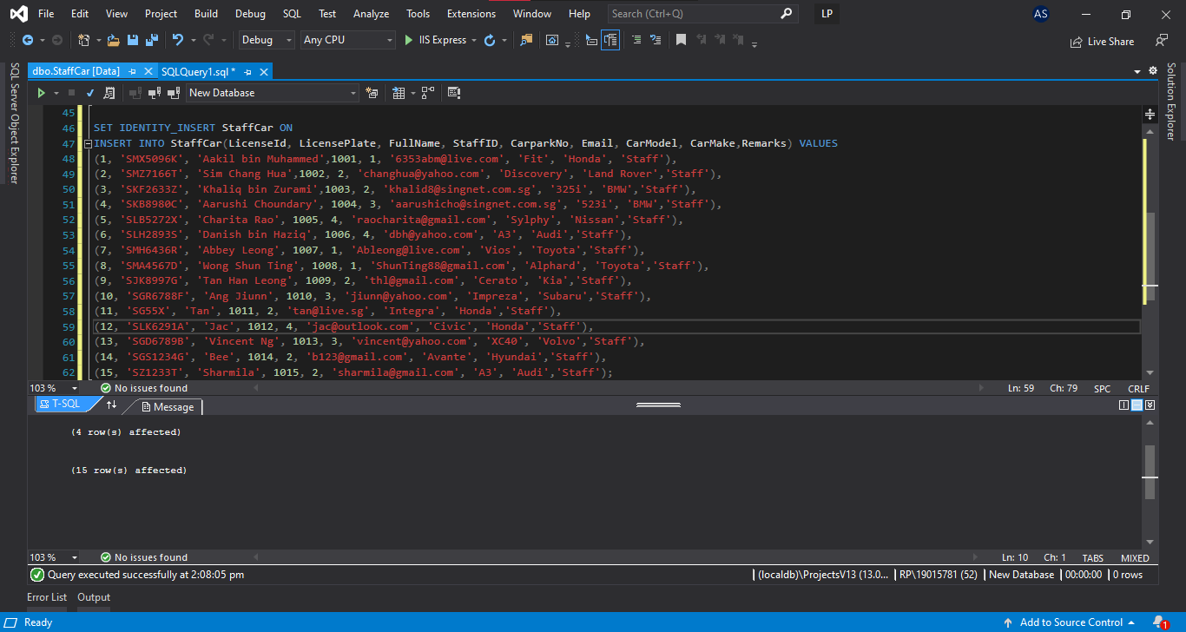

Open the SQL Server Object Explorer and right click on the database you created

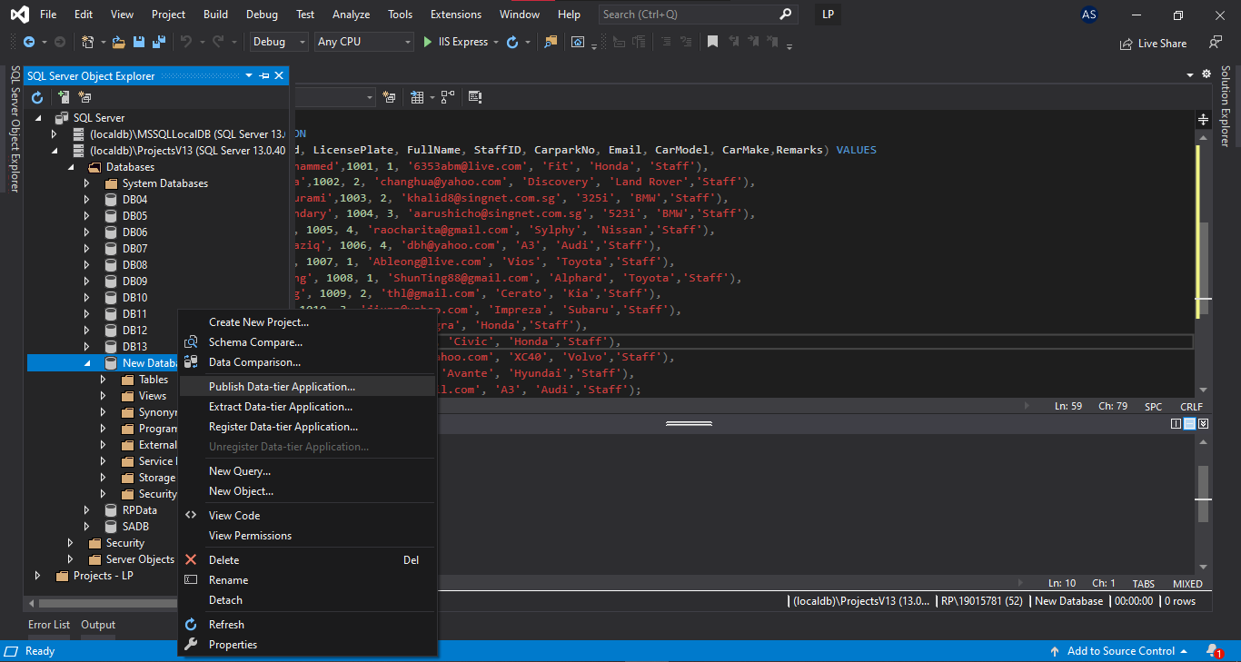

Click on the "Refresh" button



Expand "Tables" and you should see the 3 databases have been created for you

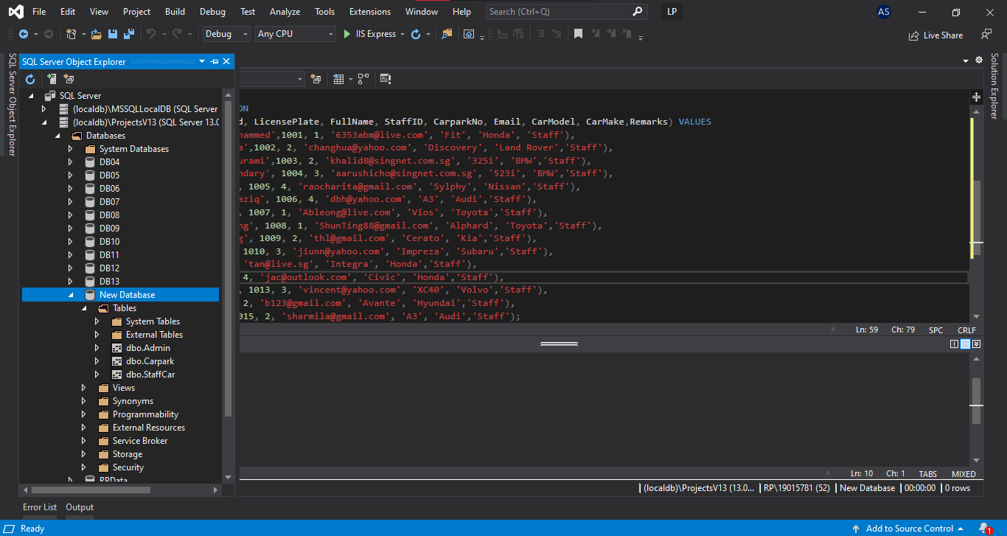

Close the SQLQuery and click "Don't Save"