Usage Forecasting
The core of the AR algorithm is predicting the usage pattern for the customers. The current MSS algorithm assumes that the customer’s monthly page volume is predominantly seasonal and will largely match their prior year’s page volume. For a new piece of equipment without a prior year’s worth of data the algorithm is typically seeded with a flat monthly usage based on the default product code average or the average early customer usage rate. The current model may take an entire year to react to changes in the customer’s usage pattern.
The following requirements outline a more sophisticated statistical model to be implemented in MSS to help improve the prediction algorithm. The new statistical model is a Dynamic Linear Model that is similar in function to a Kalman Filter. The model combines month-to-month and seasonality machine trends with machine family behavior in a Bayesian framework. The new model is expected to provide a more accurate forecast for usage for each machine in the field.
Of primary concern in the implementation of this algorithm is a desire to not tie the core DLM implementation to the MSS database. Assuming that this implementation is successful, the desire may be to move the implementation to a different platform that may have a completely different database.
During development of the SRD, a candidate Java based matrix library was identified that may be useful in implementing the Dynamic Linear Model. See section Error: Reference source not found for links to the library at code.google.com.

Requirement Number | Requirement
AEN.2100 | MSS shall implement multiple Dynamic Linear Models (DLM) for forecasting usage. A Dynamic Linear Model is of the form:  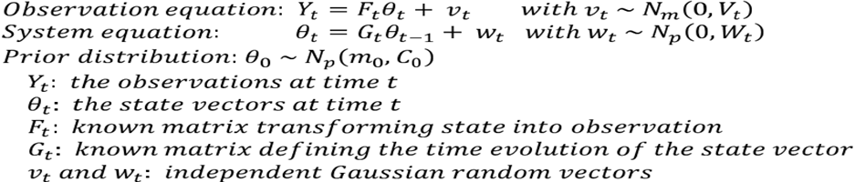  For the purposes of Usage Forecasting, Yt in the above equation represents the estimated monthly copy volume (EMCV) for a meter on a specifc piece of equipment not on ASR. EMCV is directly related to usage by the supply yield. For a machine on ASR, Yt in the above equation represents the usage for a specific supply reorder number for a specific piece of equipment.  F_{t}, G_{t}, V_{t}, and W_{t} are not time dependent in this implementation and will be provided by the business.
AEN.2102 | Given the model state at time t-1, θ_{t-1}~N_{p}(m_{t-1}, C_{t-1}), MSS shall forecast the observation distribution at time t, y_{t}~N_{p}(f_{t},Q_{t}), f_{t} is the mean and Q_{t} is the variance of the observation distribution:  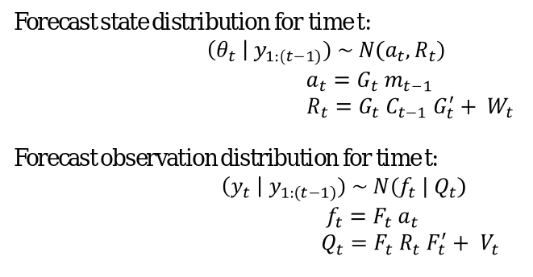  Where  m_{t-1}: the known system state  C_{t-1}: the known system covariance  a_{t}: the predicted state vector  R_{t}: the predicted state covariance  f_{t}: the predicted observation  Q_{t}: the predicted observation covariance  W_{t}: the system variance  V_{t}: the observation variance  F’: the transpose of matrix F  G’: the transpose of matrix G
AEN.2104 | Given the model state at time t-1, θ_{t-1}~N_{p}(m_{t-1}, C_{t-1}) and a new observation Yt, MSS shall update the new model state at time t, θ_{t}~N_{p}(m_{t}, C_{t}) as:  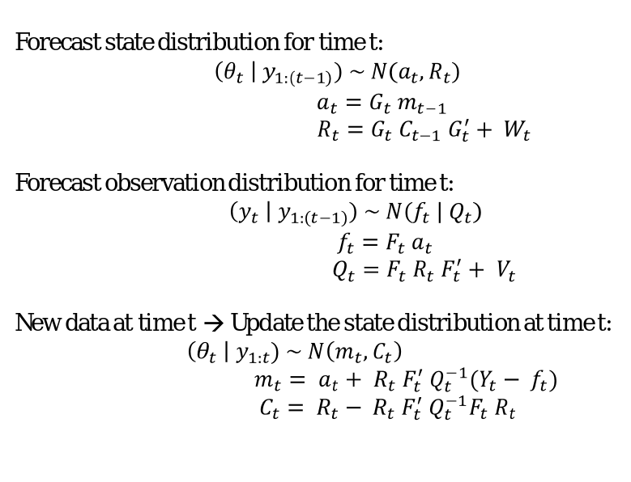  Where  m_{t-1}: the known system state  C_{t-1}: the known system covariance  a_{t}: the predicted state vector without knowledge of Y_{t}  R_{t}: the predicted state covariance without knowledge of Y_{t}  f_{t}: the predicted observation  Q_{t}: the predicted observation covariance  W_{t}: the system variance  V_{t}: the observation variance  m_{t}: the new state vector with knowledge of Y_{t}  C_{t}: the new state covariance with knowledge of Y_{t}  F’: the transpose of matrix F  G’: the transpose of matrix G  Q_{t}⁻¹: the inverse of matrix Q_{t}
AEN.2106 | MSS shall implement the DLM allowing for reuse. The DLM module itself should not directly access the database for any information. The proposed design shall consider the future option of deploying the DLM as a service.
AEN.2107 | MSS shall implement the DLM allowing for variable dimensions of the vectors and matrices. The algorithm shall not be implemented to only accept matrices of the dimensions of the specific models provided by the business.
AEN.2108 | MSS shall have the ability to initialize the DLM with specific values for m_{t}, C_{t}, F_{t}, G_{t}, V_{t}, and W_{t}
AEN.2110 | It shall be possible to specify a specific value for the observation matrix F_{t} and state transition matrix, G_{t}.  These values cannot be changed after the system goes live without rebuilding all stored state vectors in the system.
AEN.2112 | It shall be possible to specify a specific value for the observation variance V_{t} and system variance matrix, W_{t}.  These values can be purposefully adjusted with business knowledge after the system goes live, without the need to rebuild all the stored state vectors in the system.
AEN.2114 | MSS shall store DLM state vectors for each meter providing meter reads to MSS. These state vectors represent the observation variance V_{t}, system variance matrix W_{t}, the current system state (m_{t}) and system covariance (C_{t}) respectively.  For example, a machine with 3 meters will have 3 different sets of DLM state vectors representing the state of meter clicks, one for each meter assuming that the multiplicity described in AEN.2150 is 1. If the multiplicity is N, there will be 3N sets of DLM state vectors per machine.
AEN.2116 | MSS shall store DLM state vectors for each reorder number for each piece of equipment reporting ASR usage to MSS.  These state vectors represent the observation variance V_{t}, system variance matrix W_{t}, the current system state (m_{t}) and system covariance (C_{t}) respectively.  For example, a machine reporting ASR usage for four different supplies will have 4 different sets of DLM state vectors representing usage for each supply.
AEN.2118 | The system shall store the following information about a DLM state vector:  - Vector identifier – a unique identifier generated by a sequence  - Date of the state vector (this shall be set to the last day of the month for which the state vector was updated)  - Installed Unit ID – the installed unit that the state vector belongs to  - Meter Number – the meter number represented by this state vector (if applicable)  - Reorder Number – the supply reorder number represented by this state vector (if applicable)  - Model number – Index number of one of multiple models whose forecasts will be combined.  - Model type – type of model (valid values are ADDITIVE and MULTIPLICATIVE)  - Vector Type – the type of state vector represented (valid values are OBSERVATION_VARIANCE, SYSTEM_VARIANCE, STATE and STATE_COVARIANCE)  - Values of the state vector – these represent the number (double) values making up the state vector/matrix  Each state vector is uniquely identified by its vector identifier
AEN.2120 | MSS shall only store the latest version of the DLM state vector. New state vectors should only be created for new machines. In all other cases, the existing state vectors should be updated in the database after new states are computed through the update cycle of the DLM.
AEN.2122 | MSS shall avoid compounding numerical errors in the matrix calculations used to update the dynamic linear model system state.  In particular, it is recommended that singular value decomposition be used when computing the inverse of the predicted observation covariance matrix during the update stage of the DLM.
AEN.2124 | MSS shall have the ability to forecast predicted model for future time periods by iteratively forecasting the state of the model as described in AEN.2102 and assuming that m_{t} = a_{t} and C_{t} = R_{t} and iterating to the next time step to compute m_{t+1} and C_{t+1}
AEN.2126 | MSS shall have the ability to calculate the forecasted observation (f_{t}, Q_{t}) at any time t greater than or equal to the current model state
AEN.2128 | When forecasting page volume, the observations provided as input to the DLM and the forecast observations shall represent the estimated monthly copy/page volume.
AEN.2130 | The model state for a page volume DLM shall be updated when a meter read is processed that allows one or more months of copy volume to be calculated and finalized.  - Compute the raw monthly copy volume for a month; assume the date for the monthly copy volume is the last day of the month associated with the copy volume.  - Retrieve the state vectors for the current meter  - Initialize the DLM with the state vectors retrieved  - Compare the raw copy volume date to the current state vector for the meter:  - If the raw copy volume date is one month after the state vector date, update the state vector  - If the raw copy volume date is before the state vector date, the state vector is out of sync. The meter read data and state vector must be rebuilt. Stop processing and start an automatic rebuild.  - Update the state vector stored in the database with the raw monthly copy volume date and the new state values computed for the DLM.  For example, if the last meter read received for a meter was in July and a new October read is received the system can compute monthly copy volumes and update the state of the model for July, August, and September.
AEN.2132 | The raw copy volumes for each month shall be recorded as actual value. These actual values shall be stored in the INSTALLED_UNIT_EMC table with an EMCV_TYPE_CD = ‘AC’
AEN.2134 | When the state for a page volume DLM is updated, new forecasts, f_{t}, for the next 12 months of page volume shall be calculated and stored in the database. These values shall be stored in the INSTALLED_UNIT_EMC table with an EMCV_TYPE_CD = ‘FC’. . The forecast observation standard deviation (i.e. the square root of the forecast observation variance, Q_{t}) shall be stored in the INSTALLED_UNIT_EMC table with the EMCV_TYPE_CD = ‘SD’  For example, if the last meter read received for a meter was in July and a new October read is received the system can compute monthly copy volumes and update the state of the model for July, August, and September. After the state of the DLM has been updated, new estimates should be generated for October of the current year through September of the following year using the updated DLM.
AEN.2135 | The existing method of updating the ‘ES’ records in the INSTALLED_UNIT_EMC table must not be modified. These ‘ES’ records shall continue to reflect the actual EMCV value from the same month in the prior year.
AEN.2136 | When forecasting usage, the observations provided as input to the DLM and the forecast observations shall represent the usage for the specified supply in the specified equipment as reported by ASR.
AEN.2138 | The model state for the usage DLM shall be updated when new ASR usage data is received that allows one or more months of usage to be calculated. After the model has been updated for the most recent month available, the new state of the model shall be stored in the MSS database.
AEN.2140 | The raw usage vales for each month shall be recorded as actual values. These actual values shall be stored in the INSTD_UNIT_EST_USAGE with USAGE_TYP_CD = ‘AC’.
AEN.2142 | When the state for a usage DLM is updated, new forecasts, f_{t}, for the next 12 months of usage shall be calculated and stored in the database. These values shall be stored in the INSTD_UNIT_EST_USAGE table with a USAGE_TYP_CD = ‘FC’. The forecast observation standard deviation (i.e. the square root of the forecast observation variance, Q_{t}) shall be stored in the INSTD_UNIT_EST_USAGE table with the USAGE_TYP_CD = ‘SD’
AEN.2143 | The existing method of updating the ‘US’ records in the INSTD_UNIT_EST_USAGE table must not be modified. These ‘US’ records shall continue to reflect the actual usage value from the same month in the prior year.
AEN.2144 | MSS shall generate the default state vectors (the observation variance V_{t}, system variance matrix W_{t}, the current system state m_{t} and system state covariance C_{t}) using table and database lookup values for page volume forecasting.
AEN.2146 | MSS shall generate the default state vectors and covariance matrices (the observation variance V_{t}, system variance matrix W_{t}, the current system state m_{t} and system state covariance C_{t}) using table and database lookup values for supply usage forecasting
AEN.2148 | When a new machine is added to MSS, the state vectors and covariance matrices for the new machine shall be initialized when the first month of complete page volume or usage data is available. Prior to this data being available, the ‘FC’ records for page volume and usage shall be set to the same default values used in the existing implementation.  In this case, the values for the ‘FC’ records for page volume and usage shall be identical to the values in the ‘ES’ and ‘US’ records respectively.
AEN.2150 | MSS shall combine the output of multiple dynamic linear models to determine the final value when forecasting either page volume or usage
AEN.2152 | MSS shall combine the output of multiple dynamic linear models using a trimmed mean method. The outputs of the multiple models (f_{t,i} and Q_{t,i}) are sorted by their forecasted values f_{t,i} and models corresponding to the top P% and the bottom P% of the forecasted values are eliminated. The trimmed mean, f_{t}, is calculated as the mean of the forecasted values f_{t,i} for the remaining models. The trimmed variance Q_{t} is calculated as the mean of the forecast variances Q_{t,i} for the same models. The trimmed standard deviation is the square root of the trimmed variance, Q_{t}. P shall be implemented as a configurable parameter.  Initially, P will be set to 20, In this case, if 10 models are to be combined, the forecasts shall be sorted and only the models corresponding to the middle 6 values shall be used to compute the mean and variance for the trimmed combination.
AEN.2154 | For page volume forecasting, MSS shall store multiple state vector vectors (the observation variance V_{t}, system variance matrix W_{t}, the current system state m_{t} and system covariance C_{t}) for each installed unit and meter combination. One set of state vectors shall be stored for each dynamic linear model to be combined to determine the final forecast.  For example, a machine with 3 meters will have 3 different sets of DLM state vectors representing the state of meter clicks, one for each meter assuming that the multiplicity described in AEN.2150 is 1. If the multiplicity is N, there will be 3N sets of DLM state vectors per machine.
AEN.2156 | For usage forecasting, MSS shall store multiple state vectors (the observation variance V_{t}, system variance matrix W_{t}, the current system state m_{t} and system covariance C_{t}) for each installed unit and reorder number combination. One set of state vectors shall be stored for each dynamic linear model to be combined to determine the final forecast.
AEN.2157 | If the combined forecast from multiple dynamic linear models is less than zero, the forecast shall be set to zero as usage or page volume cannot be less than zero.
AEN.2162 | For each dynamic linear model to be used for forecasting, the business team shall supply a fixed value for F_{t}, and G_{t} and potentially varying values for V_{t}, and W_{t}
AEN.2164 | MSS shall store a variable number of dynamic linear models.  Initially, this is expected to be 30 dynamic linear models.
AEN.2165 | MSS shall support two different types of dynamic linear models. These two model types are additive and multiplicative.  Both model types use the same core mathematics described in AEN.2100, AEN.2102, and AEN.2104. The model types differ in the method of computing initial values for the model state vectors (the observation variance V_{t}, system variance matrix W_{t}, the current system state m_{t} and system covariance C_{t}) and in the processing of the observations input to adjust the model and the forecasts produced by the models.
AEN.2166 | For an additive model, MSS shall update the state of the DLM as follows:  For meter reads:  Y_{t} = complete month’s actual EMCV  For ASR:  Y_{t} = complete month’s usage
AEN.2167 | For an additive model, MSS shall interpret the forecast and variance calculated by the DLM as follows:  For meter reads:  Forecast EMCV = f_{t}  Forecast page variance = Q_{t}  Forecast page standard deviation = SQRT(Q_{t})  For ASR:  Forecast usage = f_{t}  Forecast usage variance = Q_{t}  Forecast usage standard deviation = SQRT(Q_{t})
AEN.2168 | For a multiplicative model, MSS shall update the state of the DLM as follows:  For meter reads:  Y_{t} = ln(complete month’s actual EMCV), where ln is the natural log function  For ASR:  Y_{t} = ln(complete month’s usage), where ln is the natural log function
AEN.2169 | For a multiplicative model, MSS shall interpret the forecast and variance calculated by the DLM as follows:  For meter reads:  Forecast EMCV = exp(f_{t}), where exp is the exponential function  Forecast page variance = exp(Q_{t}), where exp is the exponential function  Forecast page standard deviation = SQRT(exp(Q_{t})), where exp is the exponential function  For ASR:  Forecast usage = exp(f_{t}), where exp is the exponential function  Forecast usage variance = exp(Q_{t}), where exp is the exponential function  Forecast usage standard deviation = SQRT(exp(Q_{t})), where exp is the exponential function
AEN.2170 | MSS shall store initialization parameters for each of the multiple models that will be combined to forecast page volume or usage. For each model, MSS shall store the following values:  - Model Identifier – Unique model identifier (this model identifier will be referenced by each state vector described in AEN.2118 as Model Number)  - Model type – Valid values are ADDITIVE or MULTIPLICATIVE  - Factor One – One of the factors used to initialize the W matrix for each specific instance of the model (This is a double precision value)  - Factor Two – The primary factor used to initialize the C matrix for each specific instance of the model (This is a double precision value)  - Factor Three – The second factor used to initialize the W matrix for each specific instance of the model (This is a double precision value)
AEN.2171 | For the DLM specified by the business, the observation matrix, F_{t} is a 1x12 matrix with the following values:  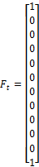
AEN.2172 | For the DLM specified by the business, the state transition matrix, G_{t}, is a 12x12 matrix with the following values:  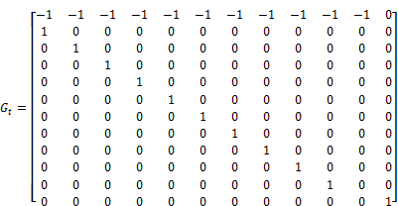  Note that row 12, column 11 is zero and breaks the pattern
AEN.2173 | For the DLM specified by the business, the observation variance, V_{t}, is a 1x1 matrix that is initialized when the first full months usage or page volume information is available.  For an additive model:  V_{t} = Y_{f}  For a multiplicative model:  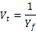  Where  For a machine using meter reads:  Y_{f} = first full month’s actual EMCV  For a machine using ASR  Y_{f} = first full month’s actual usage  “First full month” refers to the period of time when a unit is first installed. The model cannot be initialized until a full month of page volume or usage data is available. This typically means the first time ASR or meter read information is received in the second calendar month after the first ASR or meter read for that installation. For example, a machine is installed and the first meter read is recorded in December. The first full month of page volume information for that machine will be January which will be available and computed when a meter read is received in February or later.
AEN.2174 | For the DLM specified by the business, the system variance matrix, W_{t}, is a 12x12 matrix that is initialized when the first full month’s usage or page volume information is available.  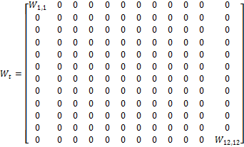  For an additive model:  For a multiplicative model:  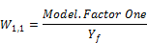  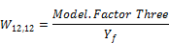  Where  For a machine using meter reads:  Y_{f} = first full month’s actual EMCV  For a machine using ASR  Y_{f} = first full month’s actual usage
AEN.2175 | For the DLM specified by the business, the system state matrix, m_{t}, is a 1x12 matrix that is initialized when the first full month’s usage or page volume information is available  For an additive model:  m₁₂ = Y_{fam}  For a multiplicative model:  m₁₂ = ln(Y_{fam}), where ln represents the natural logarithm  Where  For a machine using meter reads:  Y_{fam} = The average EMCV for the current meter for all machines with the same product code in the previous calendar month, this only includes full months EMCV. If no full months are available, use the default EMCV value for the product code  For a machine using ASR:  Y_{fam} = The average monthly usage for the current supply for all machines with the same product code in the previous calendar month, this only includes full months usage. If no full months are available, use default usage for the product code.
AEN.2176 | For the DLM specified by the business, the system covariance matrix, C_{t}, is a 12x12 matrix that is initialized when the first full month’s usage or page volume information is available  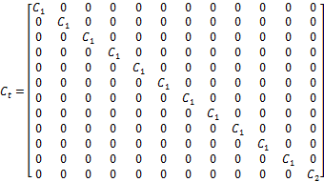  For an additive model:  For a multiplicative model:  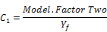  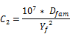  Where  For a machine using meter reads:  Y_{f} = first full month’s actual EMCV  D_{fam} = The default EMCV for the machine’s product code  For a machine using ASR  Y_{f} = first full month’s actual usage  D_{fam} = The default supply usage for the machine’s product code
AEN.2180 | When the meter reads for a machine are rebuilt, the page volume forecasting state vectors for that machine shall be reset to the default values based on the machine product code prior to starting the rebuild process.
AEN.2181 | When meter reads for a machine are rebuilt, the page volume DLM shall be updated for each meter read processed as described in requirement AEN.2130
AEN.2182 | When processing a meter read when a new read is added or during a rebuild MSS shall perform the following tests:  - Retrieve the value and date of the first prior meter read not marked to be ignored  - If the prior read value is greater than the value of the current read:  - Check the current read for a “meter flip”  - Compute flip total = maximum meter value to the new read value (new read value + 10^METER_READ.MTR_CNT  - Compute diff = flip total - prior read value  - If diff < 4 * Average Monthly Copy/Page Volume, the current read may be a failure  - Check the current read for a “meter fail”  - Compute missing clicks as Average Monthly Copy/Page Value * the fractional months between the current read and the prior read  - Fail Total = MAX(missing clicks, current read value)  - If Fail Total < 4 * Average Monthly Copy/Page Volume, the current read may be a failure  - If the current read is neither a flip or a fail  - Retrieve the next prior meter read not marked to be ignored. If the next prior meter read does not exist, mark the current read to be ignored.  - If the next prior meter read value is greater than the value of the current read, mark the current read to be ignored.  - If the next prior meter read value is less than the value of the current read:  - Mark the prior read to be ignored (Update the METER_READ table and set the MANUAL_IGNORE_IND for the prior read to ‘Y’)  - Mark all reads for this installed unit to be rebuilt (Update METER_READ and set PROCESS_FLG for all reads to ‘R’)  - Update the METER_READ table with the current read with the MANUAL_IGNORE_IND set to ‘N’ or NULL  - Stop processing the current read.
AEN.2195 | MSS shall have the ability to change the method for estimating page volume or usage by product code. The current options for estimation method are PRIOR_YEAR and STATISTICAL_FORECAST.
AEN.2196 | When estimating page volume for a machine using meter reads during the AR process, the EMCV used for predicting usage shall be determined by the estimation method set for the machine’s product code as follows:  - For PRIOR_YEAR, use the ‘ES’ row in the INSTALLED_UNIT_EMC table.  - For STATISTICAL_FORECAST, use the ‘FC’ row in the INSTALLED_UNIT_EMC table.  These changes impact the implementation of the ESTIMATE_USAGE stored procedure.
AEN.2197 | When estimating usage for a machine using ASR during the AR process, the usage values used for forecasting usage shall be determined by the estimation method set for the machine’s product code as follows:  - For PRIOR_YEAR, use the ‘US’ row in the INSTD_UNIT_EST_USAGE table.  - For STATISTICAL_FORECAST, use the ‘FC’ row in the INSTD_UNIT_EST_USAGE table.  These changes impact the implementation of the ESTIMATE_USAGE stored procedure.
AEN.2190 | The system shall record supply usage by equipment. For each, the following shall be recorded:  - Installed Unit ID  - Manufacturing Product Code  - Manufacturing Product Sequence Number  - Customer ID  - Supply Reorder Number  - Date of last update – set to SYSDATE when usage is computed and updated  - Supply Yield – updated with the yield value used to update this table  - Days of Supply – the number of days of supply used when estimating future usage  - Meter historical usage – all cartons of historical usage  - Meter estimated usage – estimated cartons of usage form the last meter read to the current date of update  - Meter future usage – the cartons of the current supply estimated to be used during the next “days of supply” days  - Meter monthly usage – estimated 30 days usage based on meter reads for the current supply  - ASR historical usage – all cartons of historical ASR usage  - ASR estimated usage – estimated usage from the date of the last ASR event to the current date the record was updated  - ASR future usage – the cartons of the current supply estimated to be used in the next “days of supply” days  - ASR monthly usage – estimated 30 days of usage based on ASR data for the current supply  - ASR achieved yield – The achieved yield for this supply and machine based on the available ASR and meter read data.  Estimated usage from, monthly usage, and achieved yield will frequently only exist for either ASR or meter read data depending on which is currently the active method of collection for the equipment. Historical usage is likely to exist regardless of the current method of usage tracking.

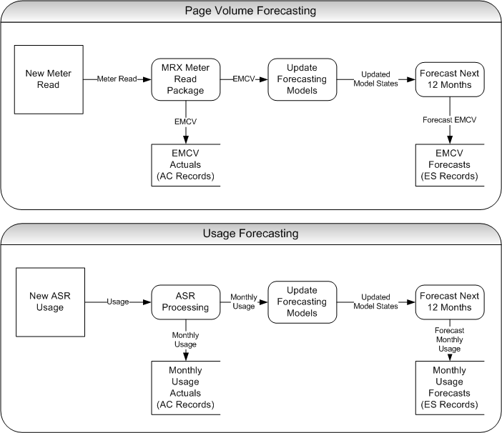
Figure 1 High Level Forecasting Process

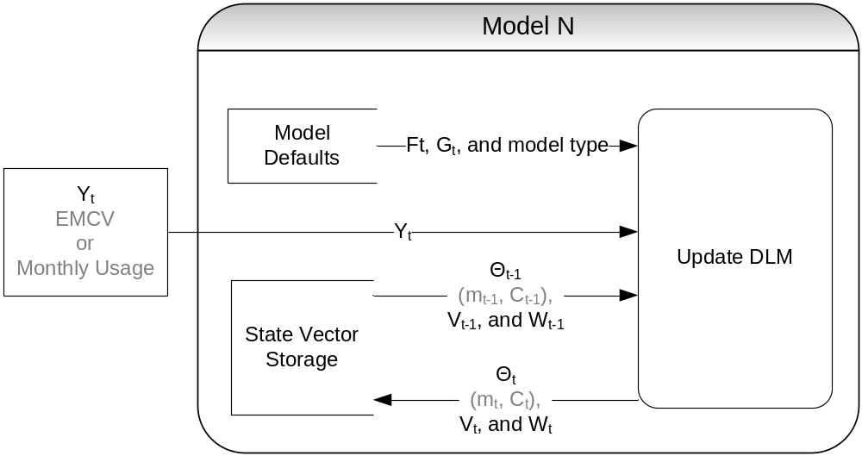
Figure 2 Update State for Model N

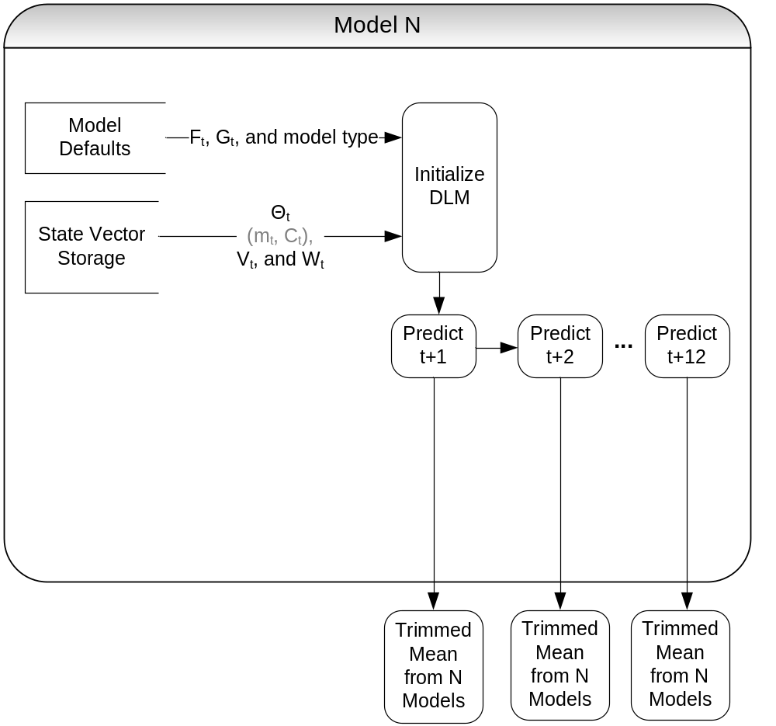
Figure 3 Forecast Next 12 Months (for N models)

