KMC Hackathon 1.0 Project Report

Project Title: Smart QR-Based Attendance System for Schools
Team Name: Tech Innovators
Team Members: Aayush Sharma, Sneha Gurung, Ritesh Thapa
Mentor: ____________________

1. Abstract
Taking attendance manually in classrooms wastes time and may lead to mistakes. Our project presents a QR Code–based Attendance System where students scan a QR code to mark their presence. Attendance is automatically stored in a digital database, making the process faster, more accurate, and paperless.

2. Problem Statement
Many schools still use manual attendance registers which take valuable teaching time, can lead to human error, and make report generation difficult. Schools need a quick and reliable digital attendance system.

3. Existing System
Teachers call student names and mark attendance in registers, then calculate attendance manually later. This process is time-consuming, error-prone, and does not provide real-time tracking.

4. Proposed Solution
We developed a Smart Attendance System where a unique QR code is generated for each class. Students scan the QR code using a mobile device, and attendance is automatically saved in a database. Teachers can view and download attendance reports instantly.

5. Objectives
• Reduce time taken for attendance
• Minimize human errors
• Maintain digital attendance records
• Provide easy access to attendance data

6. Technology Used
Frontend: HTML, CSS, JavaScript
Backend: Python (Flask) / Node.js
Database: MySQL / Firebase
QR Code Tool: QR Code Generator Library
Devices: Smartphone / Laptop

7. System Wireframe
The following wireframes show the basic layout of the system interfaces.
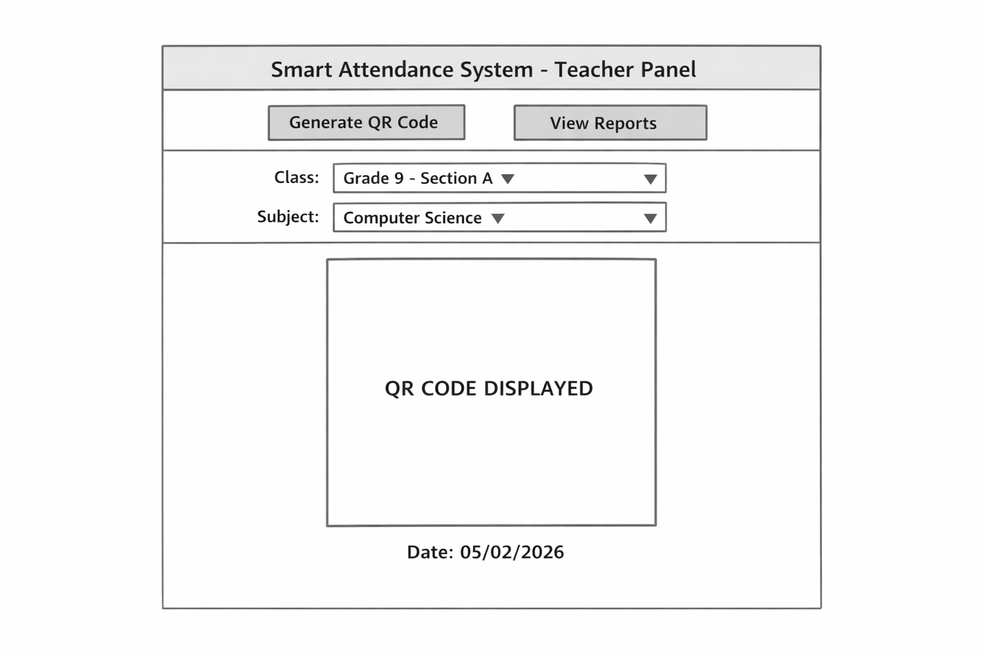
Figure 1: Teacher Dashboard Wireframe
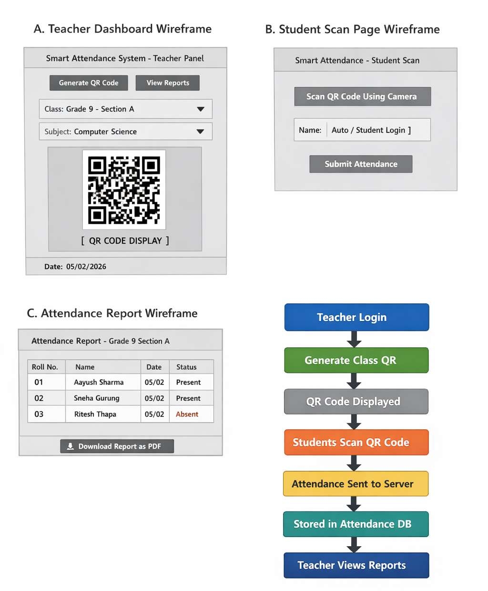
Figure 2: Student Page, Report Page, and Workflow Diagram

8. Results
After testing, attendance time was reduced from around 7 minutes to less than 1 minute. Records became fully digital and organized, and teachers could easily generate attendance reports.

9. Advantages
• Saves classroom time
• Reduces manual effort
• Accurate digital records
• Easy to manage large classes

10. Limitations
• Requires internet connection
• Students need access to a smartphone
• Initial technical setup required

11. Future Improvements
• Face recognition attendance
• SMS alerts to parents for absentees
• Dedicated mobile app
• Offline attendance sync

12. Conclusion
The Smart QR-Based Attendance System modernizes the traditional attendance process using simple technology. It saves time, reduces errors, and helps schools shift toward digital management. This project demonstrates how real-world educational problems can be solved using practical technology solutions.

