**Phase 2: Org Setup & Configuration**

**1. Salesforce Editions**

* Use Developer Edition Developer Org.
* **For LoanLine:** This is perfect. A free Developer Org provides all the features to build and test custom objects, flows, and security settings for the project.

**2. Company Profile Setup**

* Adding company info, time zone, and currency.
* **For LoanLine:**
* **Default Time Zone** to match your microfinance company's location (e.g., (GMT+05:30) India Standard Time).
* **Default Currency** to INR - Indian Rupee or whichever currency your company uses. This is essential for accurate loan amount and repayment tracking.

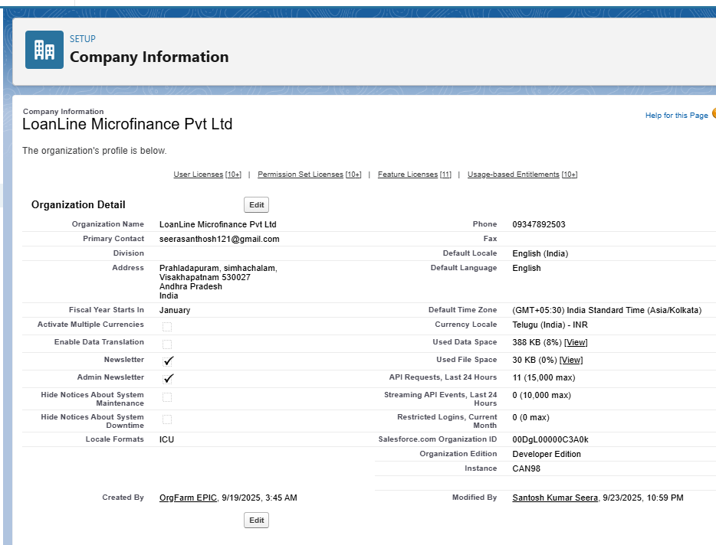

**3. Business Hours & Holidays**

* Defining working hours and add public holidays.
* **For LoanLine:**

**Business Hours:** Define the hours when your Loan Officers and Field Agents are available. Start Time: 09:00 AM End Time: 06:00 PM

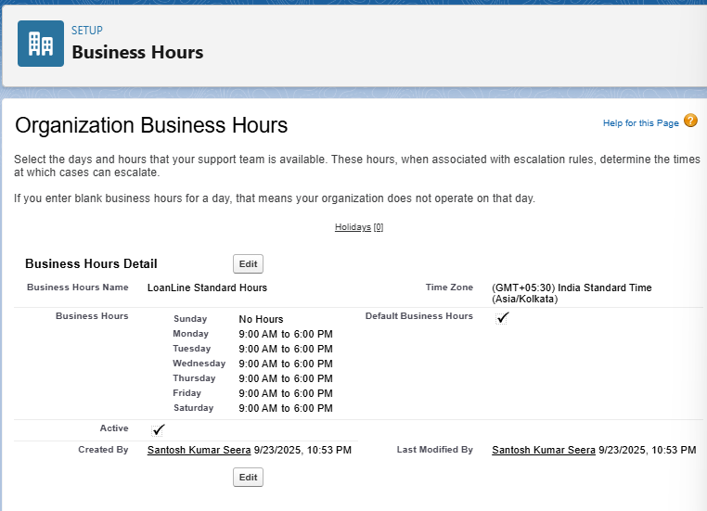

* **Holidays:** Adding national or regional holidays. Your automation loan approval processes should ideally not run on these days.

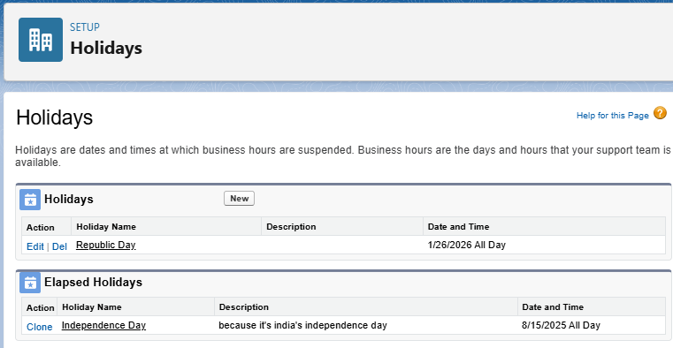

**4. Fiscal Year Settings**

* Standard (Jan–Dec).
* **For LoanLine:** Aligning the fiscal year with the calendar year simplifies reporting on loan disbursement and repayment metrics on a yearly basis.

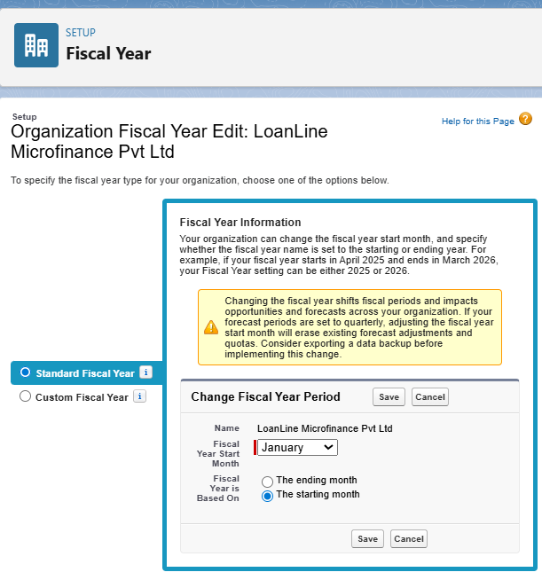

**5. User Setup & Licenses**

* **For LoanLine:**
* **Users:** Field Agent, Loan Officer , Manager
* **License:** Assign them the Salesforce license.

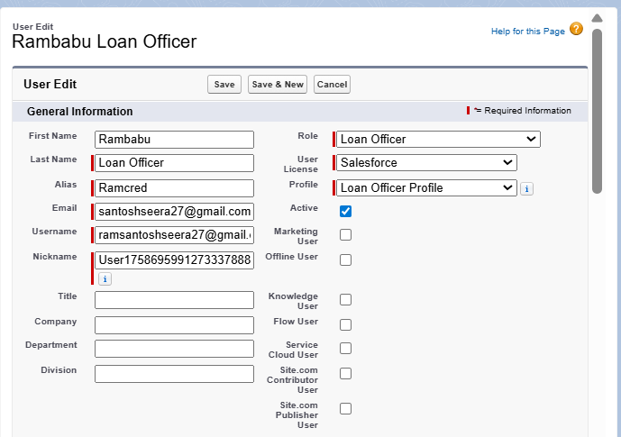

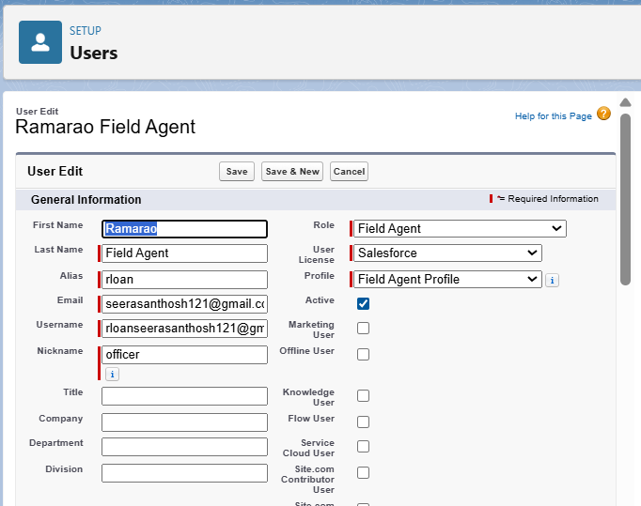

**6. Profiles & Permission Sets**

* **Your Plan:** Use Profiles for Agents and Managers.
* **For LoanLine:** .
* **Profiles:**
* **Field Agent Profile:** This profile should have **Create** and **Read** access on Borrower and Loan Application records. They should **not** be able to approve applications or view sensitive financial data like Credit Scores.
* **Loan Officer Profile:** This profile needs **Read**, **Create**, **Edit** on Loan Application, Loan Account, and Repayment records. They need to approve/reject loans and record payments. They should not have access to manage security settings.
* **Manager Profile:** The standard Salesforce Admin Profile is fine for your main account. It has full access to customize and manage the system.

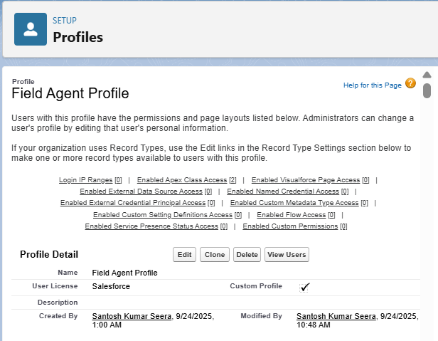

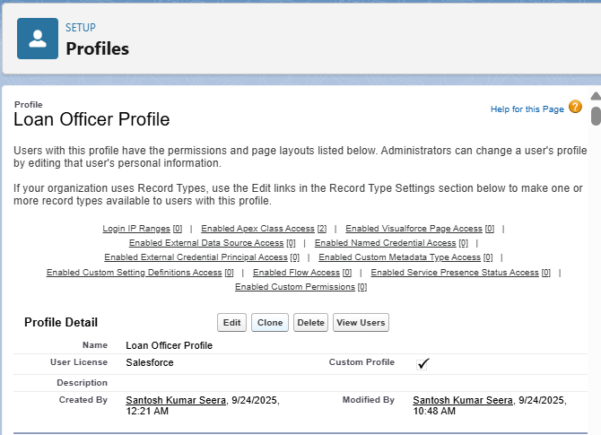

**7. Roles**

* **For LoanLine:** This is key for visibility.
* **Role Hierarchy:**
* **Top Level:** CEO / Management (optional)
* **Below Management:** Loan Officer Manager
* **Below Loan Officer Manager:** Loan Officer
* **Below Loan Officer:** Field Agent
* **Purpose:** This hierarchy ensures that a manager can see all the records (Borrowers, Loan Applications) owned by the people below them in the hierarchy. A Loan Officer can see all records owned by the Field Agents who report to them.

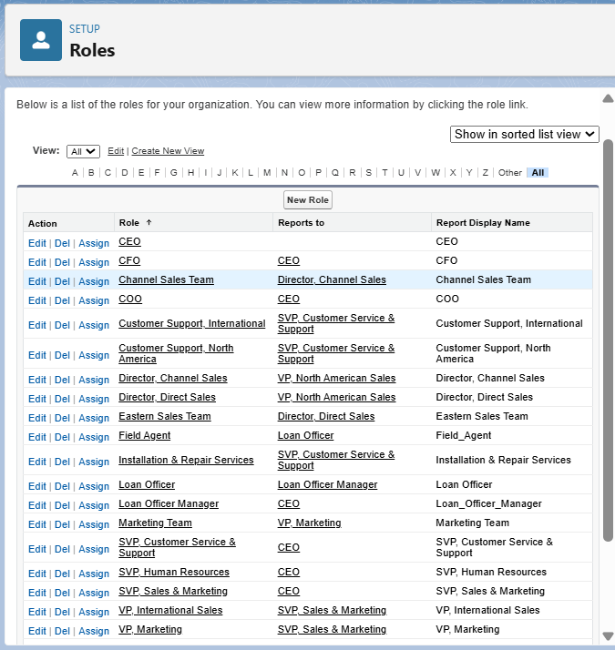

**8. OWD (Org-Wide Defaults) & Sharing Rules**

* **Your Plan:** Car Object (Public Read Only), Rental Booking (Private).
* **For LoanLine:** This is your base level of security.
* **Borrower & Loan Application Objects:** **Private**. This is critical. You want to ensure that a Field Agent can only see the borrowers and applications they created, not every single one in the company.
* **Loan Account & Repayment Objects:** **Private**. Similarly, a Loan Officer should only see the accounts and payments they are responsible for.
* **Sharing Rules:** You'll use these to open up access. For example:
* A **Sharing Rule** to allow all **Loan Officers** to view all Loan Applications that are pending approval.
* A **Sharing Rule** to allow a **Loan Officer Manager** to view all Loan Accounts in their department.