**Phase 3: Data Modeling & Relationships**

**Custom Objects for the LoanLine Project and fields creation alongth with relationships:**

**1. Borrower**

This object represents the person applying for the loan. It is the central record for each individual.

* **Purpose:** To store all personal, contact, and financial information about the loan applicant.
* **Key Fields:**
* Name (Standard Field)
* Contact Information (e.g., Email, Phone)
* Address (e.g., Street, City, State, Postal Code)
* Income (Currency)
* Occupation (Text)
* Documents Uploaded (Checkbox or a lookup to a Document object, if you build one)

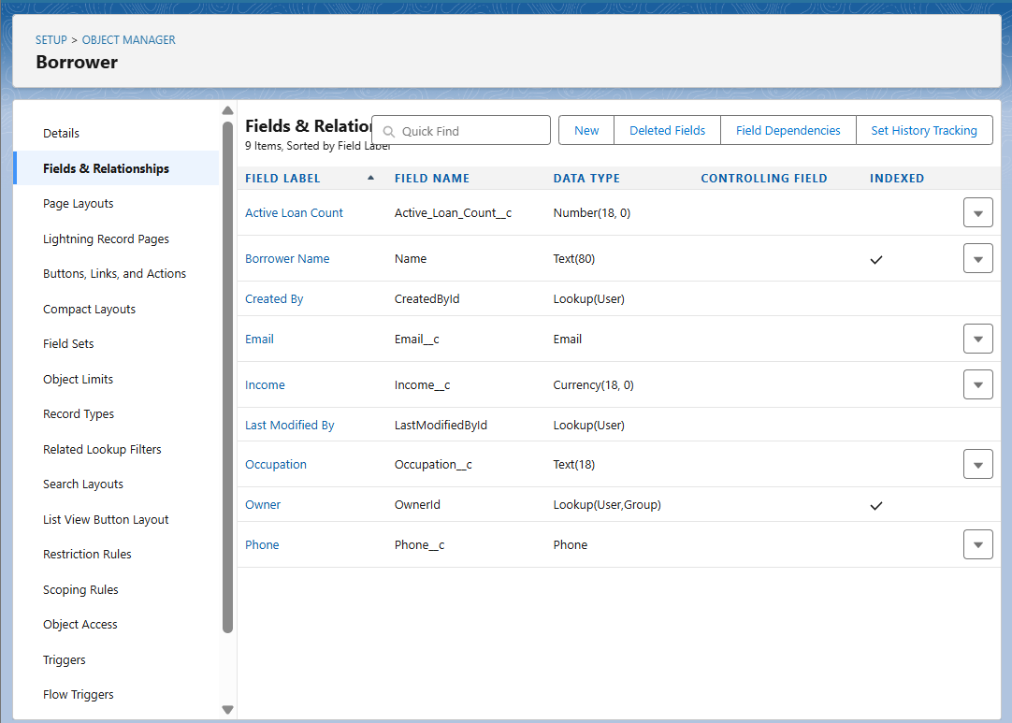

**2. Loan Application**

* This object represents a formal request for a loan. It tracks the details of a single application.
* **Purpose:** To capture the specifics of a loan request, link it to the borrower, and track its status through the approval process.
* **Key Fields:**
* Application Number (Auto-Number)
* Requested Amount (Currency)
* Loan Purpose (Picklist or Text)
* Repayment Period (Number, e.g., in months)
* Application Status (Picklist: e.g., Pending, Approved, Rejected, Processing)
* Application Date (Date)
* Borrower (Lookup relationship to the **Borrower** object)
  + 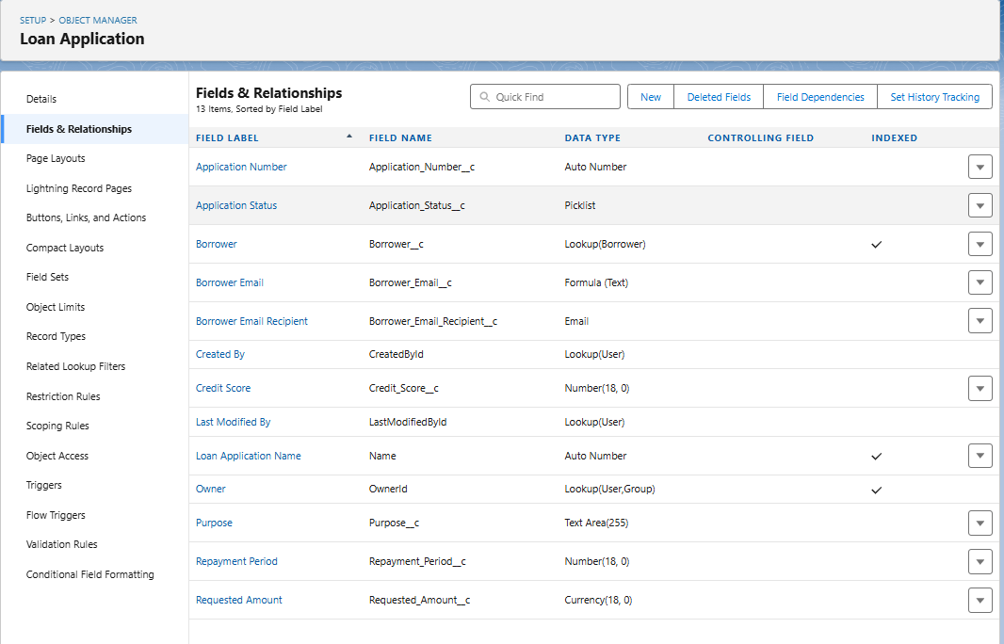

**3. Credit Score**

* This object stores the result of the credit assessment. It is linked to a specific loan application.
* **Purpose:** To store the calculated creditworthiness of a borrower for a specific application.
* **Key Fields:**
* Credit Score Value (Number)
* Score Calculation Date (Date)
* Risk Level (Picklist: e.g., Low, Medium, High)
* Related Loan Application (Master-Detail or Lookup relationship to the **Loan Application** object)
  + 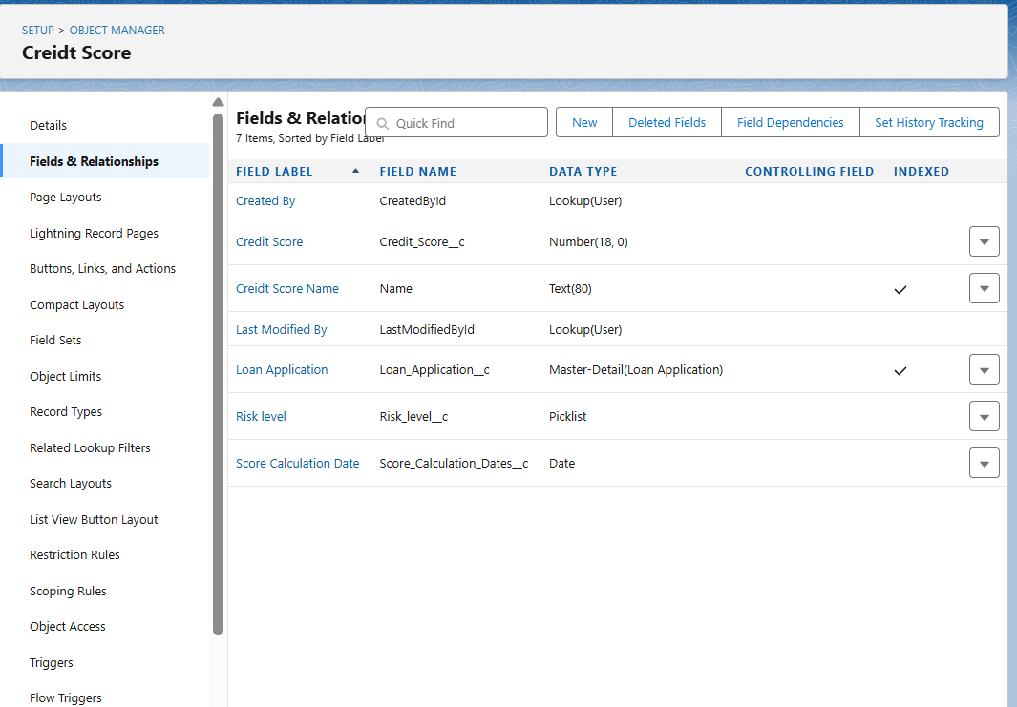

**4. Loan Account**

* This object represents the active loan once it has been approved. It is the financial account record.
* **Purpose:** To track the active loan, its terms, and the current balance.
* **Key Fields:**
* Loan Account Number (Auto-Number)
* Approved Amount (Currency)
* Interest Rate (Number)
* Start Date (Date)
* End Date (Date)
* Total Balance Due (Formula or Roll-Up Summary)
* Remaining Balance (Formula or Roll-Up Summary)
* EMI Amount (Currency)
* Related Loan Application (Lookup relationship to the **Loan Application** object)
* Borrower (Lookup relationship to the **Borrower** object)

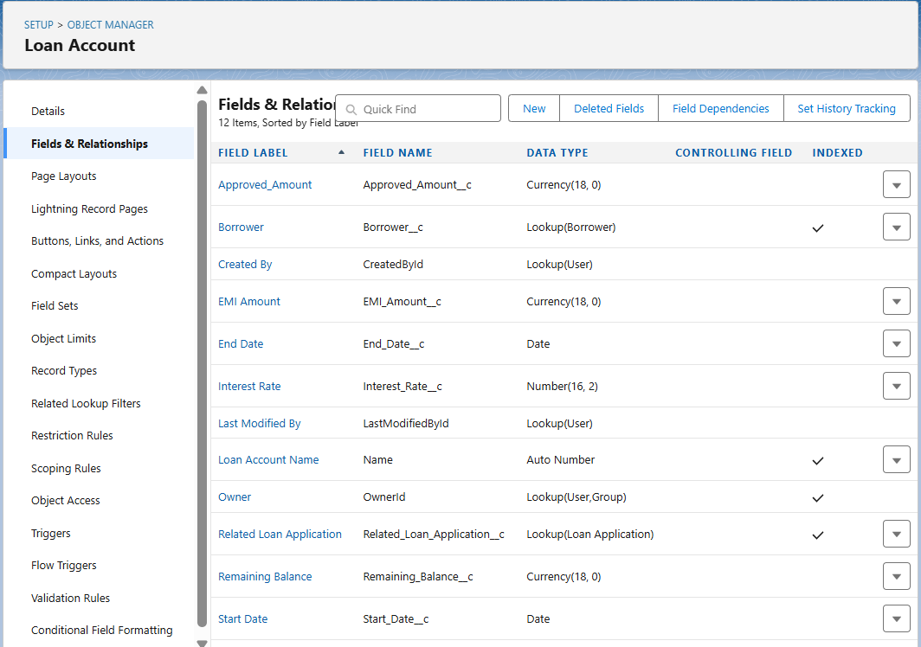

**5. Repayment**

* This object records each individual payment made by the borrower.
* **Purpose:** To track all installment payments and update the loan's balance.
* **Key Fields:**
* Repayment ID (Auto-Number)
* Payment Amount (Currency)
* Payment Date (Date)
* Payment Method (Picklist: e.g., Cash, Online Transfer, Check)
* Is On Time (Checkbox, updated by a flow)
* Related Loan Account (Master-Detail relationship to the **Loan Account** object)

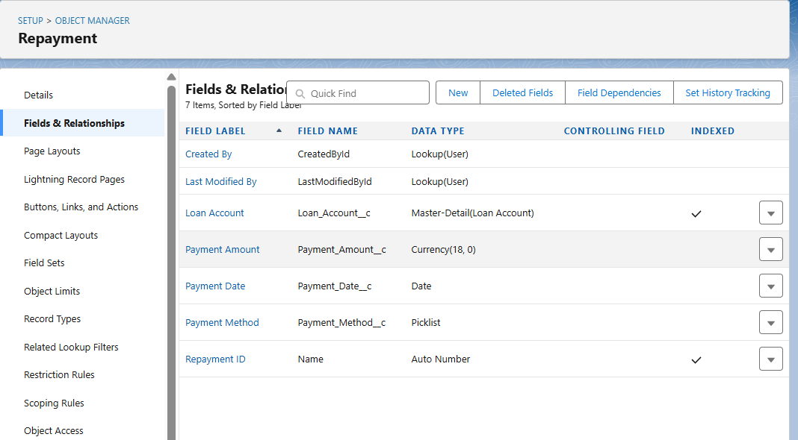

**Object Relationships**

* The relationships between these objects are critical for your data model. You will primarily use **Lookup** and **Master-Detail** relationships.
* **Borrower** → has many **Loan Applications** (Lookup)
* **Loan Application** → has one **Credit Score** and one **Loan Account** (Lookup or Master-Detail)

**Loan Account** → has many **Repayments** (Master-Detail is best here, as a Repayment record cannot exist without a Loan Account)

**Page layouts:**

**Borrower:**

