**Phase 4: Process Automation (Admin)**

**1. Validation Rules**

* **Purpose:** To prevent users from saving records with incorrect or incomplete data. This ensures data quality from the moment it is entered.
* **For Loanline Project:** a validation rule to ensure that the Requested Amount on a Loan Application is within an acceptable range. This prevents common data entry errors.

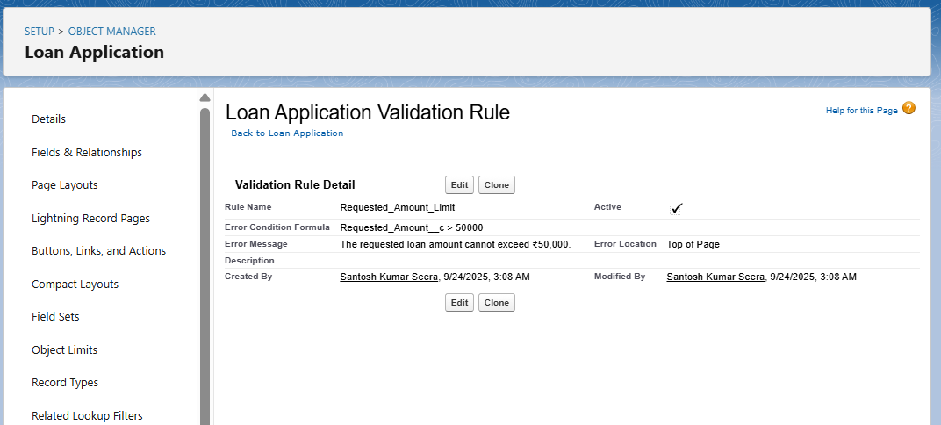

**2. Flow Builder**

* **Purpose:** To automate the credit score calculation, loan account creation, and reminders.
* **For Loan line Project:** We will build a single, powerful **Record-Triggered Flow** on the Loan Application object.

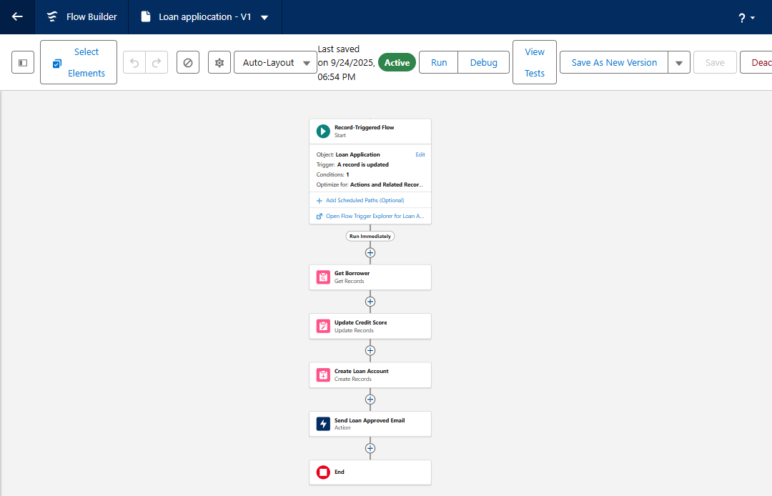

**3. Approval Process**

* **Purpose:** To send a loan application to a manager for approval before a loan account is created. This ensures oversight for high-value loans.
* **For Your Project:** You will create an approval process for Loan Applications over a certain amount.

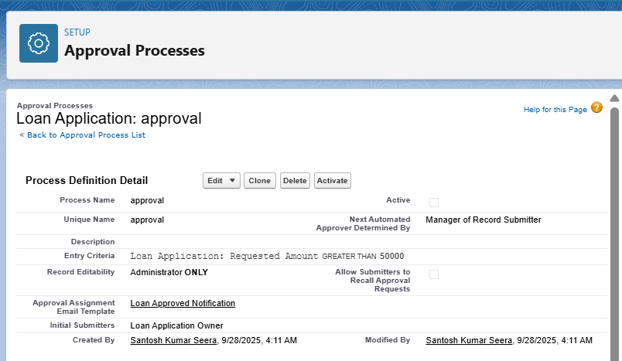

**4. Custom Notifications**

* **Purpose:** To send in-app notifications to users when an important event happens.
* **For Loan line Project:** send a notification to the Loan Officer when a new repayment is recorded.

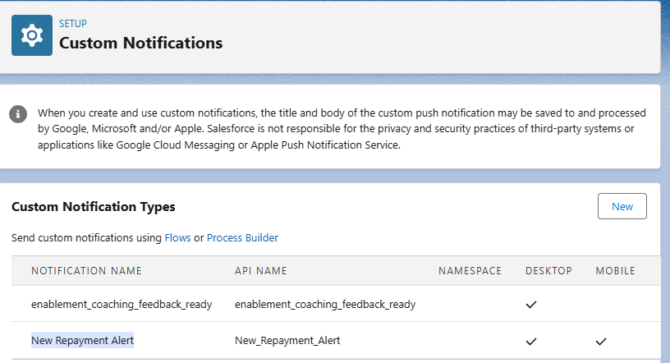

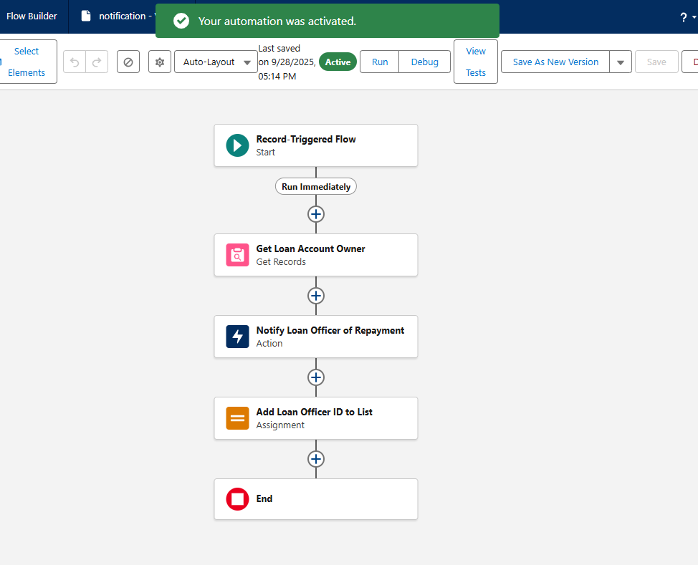

**5.Email Alerts:**

Add the Email Alert Action This is the final step, which calls the email alert you've already created.

