**Phase 5: Apex Programming (Developer)**

**Preventing Duplicate Borrower Records**

This is a very common requirement for financial institutions. You need to prevent a Borrower record from being created if one with the same name, email, or other unique identifiers already exists.

**Apex Trigger:**

The purpose of this trigger is to **prevent duplicate Borrower records** when a new record is inserted.

* It runs **before insert** on the custom object Borrower__c.
* It calls the handler method checkDuplicateBorrowers() inside the BorrowerTriggerHandler class.
* This ensures data quality by checking if a similar borrower already exists before allowing the record to be saved.

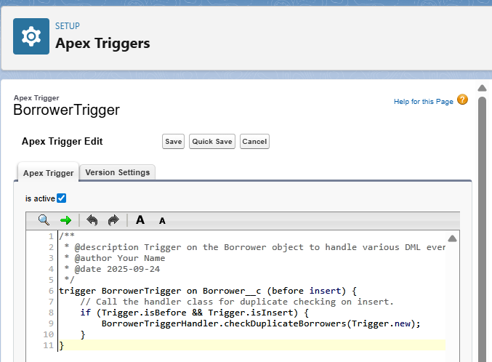

**Trigger Handler class:**

The BorrowerTriggerHandler class ensures that **duplicate Borrower records are not created** in Salesforce.

* It checks if a new Borrower being inserted has the same **Name** or **Email__c** as an existing record.
* If a duplicate is found, it prevents the insert and shows an **error message** to the user.

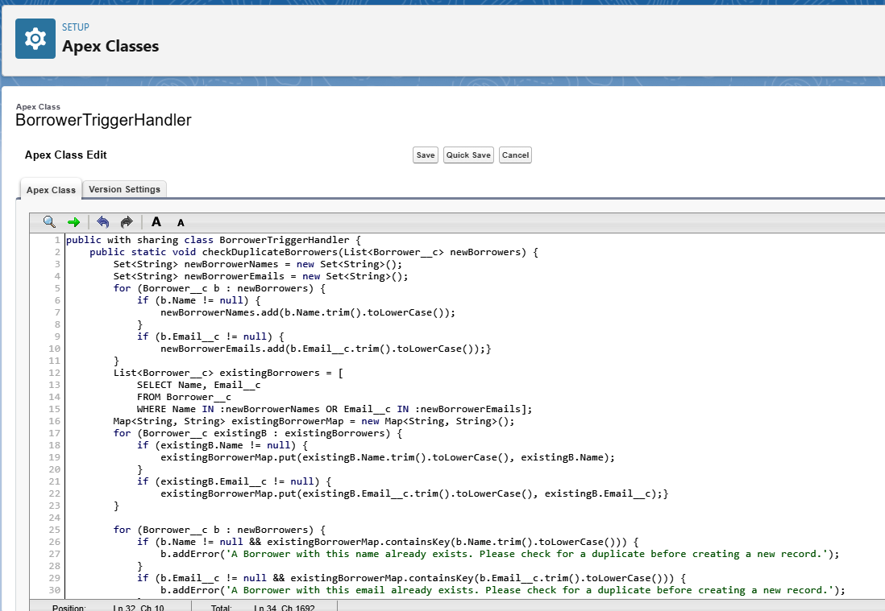

**BorrowerTriggerHandlerTest:**

This **Apex test class** verifies that the BorrowerTriggerHandler correctly prevents the creation of **duplicate Borrower__c records**.

* It first inserts a valid Borrower record (unique Name and Email).
* Then it tries to insert another record with the **same Name and Email**.
* The test confirms that the trigger/handler raises an error (addError) and blocks the duplicate.

