**Phase 6: User Interface Development**

**Lightning record page:**

This customized page is vital because it creates a single source of truth for the borrower. It ensures Loan Officers immediately see the borrower's financial risk status (Active Loan Count, Income) and their full loan history (Applications, Accounts) on one screen, reducing navigation time and speeding up decision-making.

**Steps:**

1. Borrower->new lightning page
2. Select record page->Label ( Borrower_Custom_Page)
3. **Highlights Panel, Tabs,Activities**

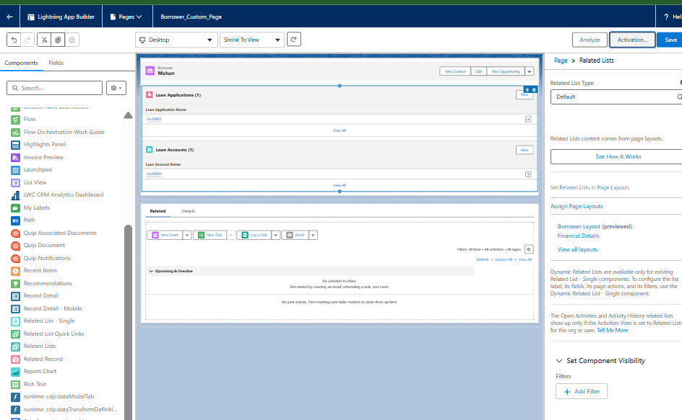

**Tabs:**

1 **Setup**, ->**Tabs**.

2 "Custom Object Tabs" s-? **New** button.

3 **Choose the Object:** From the "Object" dropdown,

4 **Add to Profiles:**

5 **Add to Apps:** Deselect all apps except your new **LoanLine CRM** app.

6 Click **Save**.

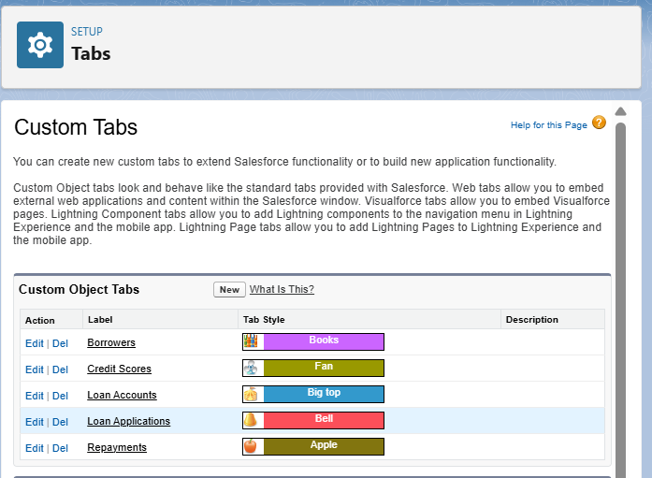

**Lightning App Builder: Create the LoanLine App**

1 From **Setup**, search for **App Manager** and click **New Lightning App**.

2 **App Details & Branding:**

* **App Name:** LoanLine CRM
* **Developer Name:** LoanLine_CRM (This will auto-populate).
* **Description:** A custom CRM for managing the microfinance loan lifecycle.

3 **App Options:** Keep the default settings.

4**Navigation Items:** This is where you add the tabs for your custom objects. Move the following items from the "Available Items" list to the "Selected Items" list:

* Borrowers
* Loan Applications
* Loan Accounts
* Repayments
* Reports
* Dashboards

