**Phase 7: Integration & External Access**

**1. Named Credentials**

Named Credentials are the most secure way to store credentials (username, password, API key) for an external service. Instead of hard-coding them, you reference the Named Credential, and Salesforce handles the authentication.

* **Purpose for LoanLine:** To securely store the API credentials for a credit scoring service or a payment gateway.

**Step-by-step to Set It Up:**

1. **Setup**->**Named Credentials**.
2. Click **New Named Credential**.
3. **Label:** Credit Scoring Service
4. **Authentication Protocol:** Choose the appropriate protocol (e.g., OAuth 2.0 or Basic Authentication).

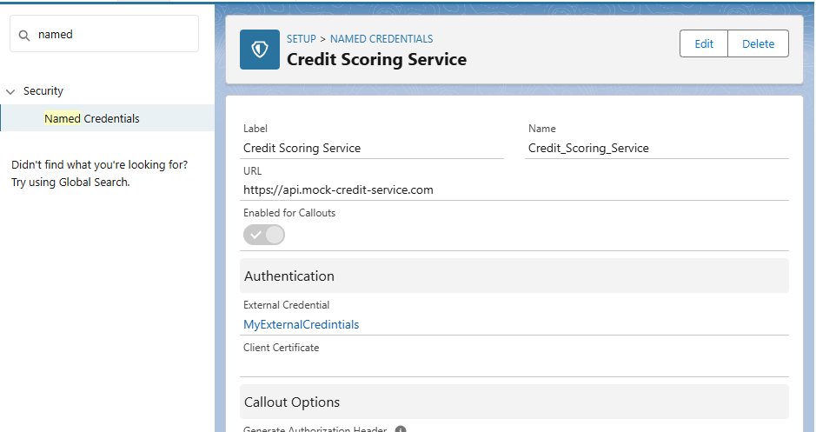

**Prevent duplicate loan application:**

* This is a **Record-Triggered Flow** on the **Loan Application** object, triggered when a record is created.
* The flow retrieves existing loans for the borrower using the **Get Records** element.
* A **Decision** checks if the borrower has any active loans.
* If active loans exist, a **Validation Error** is shown and the process ends.
* If no active loans are found, the flow ends successfully, allowing the loan application.

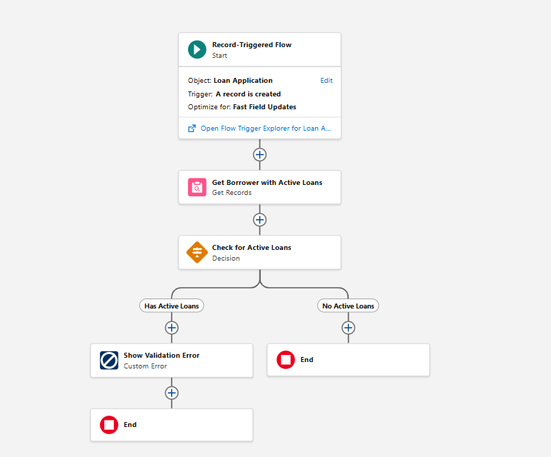

**Notification to loan officer on repayment:**

* A Record-Triggered Flow runs when a Repayment record is created.
* The flow gets the Loan Account Owner (Loan Officer) using the Get Records element.
* It sends a notification to the loan officer about the repayment.
* The officer’s ID is added to a list for tracking purposes.
* The flow ends after completing the notification and assignment steps.

