**Phase 8: Data Management & Deployment**

**Data Import Wizard**

Using the **Data Import Wizard** is a simple and effective way to get your initial data into Salesforce without writing any code. It's a key part of setting up your project.

Here is a step-by-step guide to importing your **Borrower** records using a spreadsheet.

**Create a new spreadsheet.**

* **Add column headers** that match the names of the fields on your Borrower object. For example, your spreadsheet should have columns like:
  + Name
  + Email
  + Phone
  + Address
  + Income
* **Fill in a few rows** of sample data for your test borrowers.
* **Save the file** as a **.csv** (Comma Separated Values).
* Launch the Data Import Wizard
* Map the Fields
* Review and Import

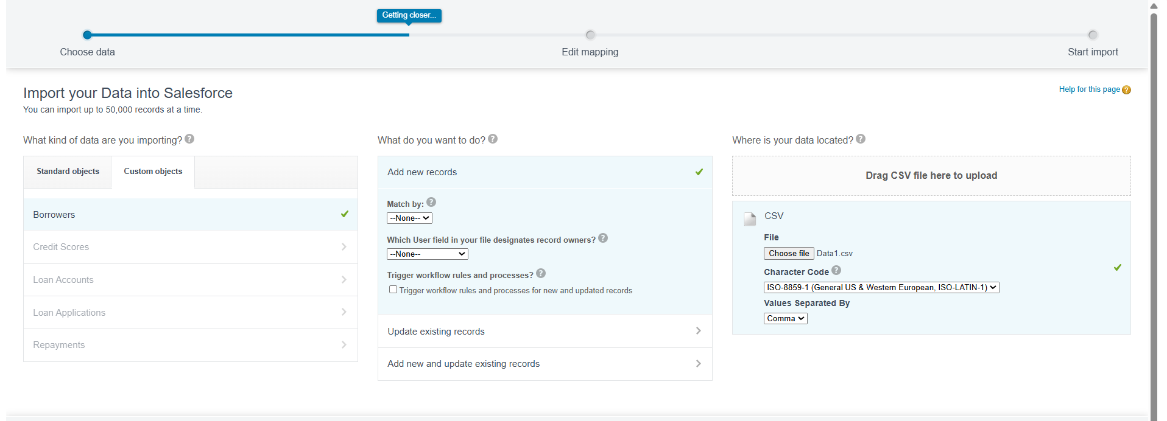

**Matching Rule**

The Matching Rule defines the criteria (fields) Salesforce uses to identify a potential duplicate. We will tell it to match based on the **Borrower Name** and **Email**.

* **Setup** (gear icon ⚙️) → **Matching Rules**.
* **Start New Rule:** For **Object to Match On**, select **Borrower**.
* 3 **Name the Rule:** **Rule Name:** Borrower Name and Email Match
* **Define Matching Fields:**
* Click **Add Mapping**.
* **Field:** Select **Name** (Borrower Name).
* **Matching Method:** Select **Exact Match** (This requires the name to be identical).
* Click **Add Mapping** again.
* **Field:** Select **Email**.
* **Matching Method:** Select **Exact Match**

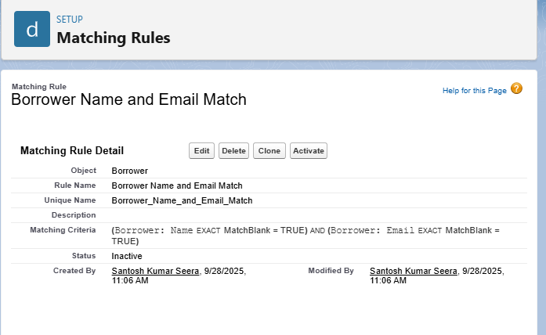

**Duplicate Rule:**

* Go to **Setup** → In Quick Find, search for **Duplicate Rules**.
* Click **New Rule** and select the **Borrower** object.
* **Rule Name:** Block Duplicate Borrower Creation
* **Set Actions (Crucial Step):**
  + Scroll to the **Actions on Create** section.
  + Set **Alert** to On and **Report** to On (optional for reporting).
  + Set **Block** to **On**. (This is the action that stops the user from saving the record).
  + Set **Actions on Edit** the same way: **Block** set to **On**.
* **Alert Text:** Enter a clear message for the user, such as: **A Borrower with this exact Name and Email already exists.**
* **Link the Matching Rule:**
  + Scroll down to **Matching Rule Configuration**.
  + Use the dropdown to select the rule you created in Step 1: **Borrower Name and Email Match**

