**Phase 9: Reporting, Dashboards**

**Reports**

* **Create the Report Type (The Data Link):** Go to **Setup** → **Report Types**. Create a new report type for your custom object (e.g., **Repayments** or **Loan Accounts**) and set the status to **Deployed**.
* **Start New Report:** Navigate to the **Reports** tab, click **New Report**, and select the custom Report Type you just created.
* .**Set Filters:** Go to the **Filters** tab. Ensure the report shows **All [Your Object]** records, and adjust the **Date Filter** (e.g., Payment Date) to cover the appropriate time frame.
* **Group the Rows:** Go to the **Outline** tab. In the **Group Rows** section, add the field you want to summarize by (e.g., **Owner: Full Name** or group by **Calendar Month**).
* **Summarize Columns:** Find the metric field in the columns. Use the dropdown arrow to select **Summarize** and choose **Sum** to calculate the totals for each group.
* **Save and Share:** Click **Run** to review the data, then **Save**. Give the report a clear name and save it to your public **LoanLine Dashboards** folder.
* **Add to Dashboard (The Final View):** Open your **LoanLine Overview** dashboard and use **+ Widget** to add your new report, selecting a visual component like a **Donut** or **Bar Chart**.

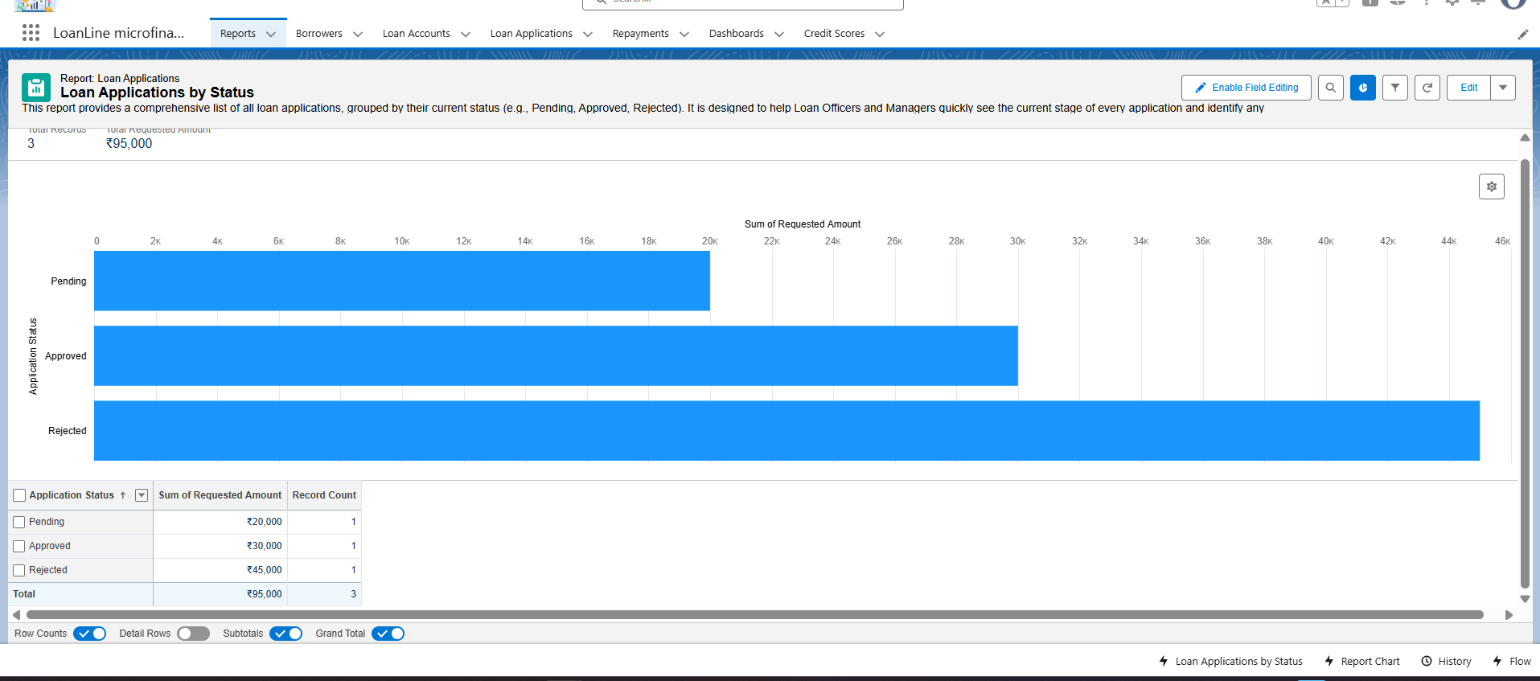

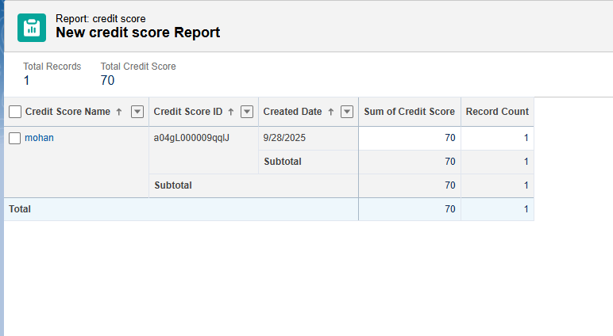

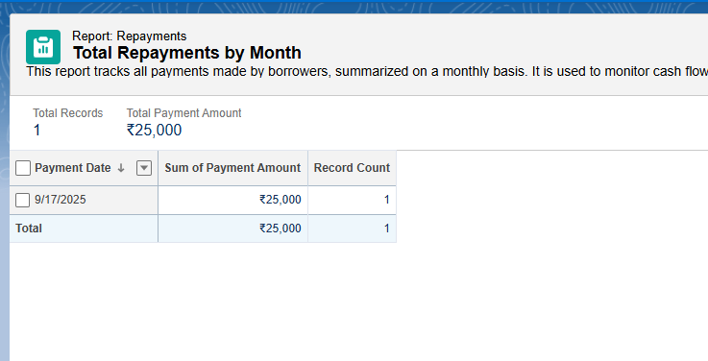

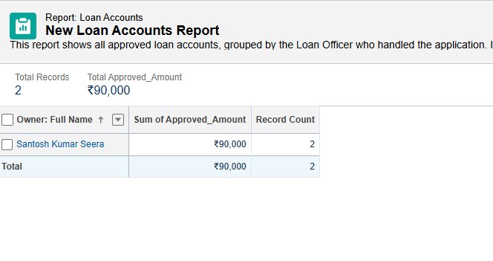

**Dashboards**

* **Define the Report Type:** Go to **Setup** and create a **Custom Report Type** for your object (e.g., Repayments), setting the status to **Deployed**.
* **Start New Report:** Navigate to the **Reports** tab and begin a **New Report**, selecting the custom Report Type you just created.
* **Set Filters:** Use the **Filters** tab to set the scope to **All [Your Object]** records and adjust the required **Date Filter**.
* **Group the Rows:** Go to the **Outline** tab to **Group Rows** by a field like **Owner: Full Name** or group dates by **Calendar Month**.
* **Summarize Columns:** Select the financial columns (e.g., **Approved Amount**) and choose the **Sum** option under **Summarize** to calculate the totals.
* **Save and Share:** **Save** the report with a clear name and ensure it is saved in your shared **LoanLine Dashboards** folder.
* **Visualize on Dashboard:** Open your **LoanLine Overview** dashboard, click **+ Widget**, and add the new report as a visual component.

