Docker Images & Containers

Docker WSL, Windows, Linux Distros

🧠 Here's how it really works:
- ✅ WSL (Windows Subsystem for Linux) lets you run Linux distros on Windows, like Ubuntu, Debian, Alpine, etc. You can install multiple distros side-by-side.
- ✅ When you install Docker Desktop, it sets up:
  - A special WSL distro called docker-desktop (which runs the Docker engine)
  - Another helper distro called docker-desktop-data (for storing Docker volumes and system stuff)
- ✅ Docker Desktop wires everything up so both your Windows command line (CMD or PowerShell) and your WSL distros can talk to the same Docker daemon that lives in docker-desktop.

🧩 What About Your Own Linux Distros?
This is the cool part:
- Docker Desktop injects the Docker CLI into each integrated WSL distro (like Ubuntu), so you can run docker run or docker ps directly inside your Linux shell.
- When you run a Docker command in Ubuntu, it doesn't start its own daemon—instead, the CLI talks to the Docker daemon running in docker-desktop, through a special Unix socket connection that Docker sets up automatically.

- 🔍 To Check Integration:
Open Docker Desktop → Settings → Resources → WSL Integration
There, you'll see a list of all installed WSL distros and toggles to allow or block Docker access.

So in short: Your Linux distros don’t run Docker by themselves—they piggyback off the one in docker-desktop, like clients talking to a server.

CPU Cores
When you create a new Docker container, it will have its own isolated CPU resources, including the number of cores. This means that the second container will not automatically share the CPU resources of the first container, even if they are running on the same host and operating system.
In your case, if you have a 32-core CPU and one Docker container using 8 cores, creating another container will not use the same 8 cores as the first container. Instead, the new container will have its own set of CPU resources that are allocated by Docker based on the host's available CPU resources.
Docker uses a technology called "container isolation" to ensure that each container has its own isolated environment, including CPU resources. This means that each container is given a specific amount of CPU time and memory, regardless of how much resources are being used by other containers on the host.
So, if you create another container, it will use its own 8 cores (or whatever number of cores you specify when creating the container) and not share them with any other container running on the same host. This allows you to run multiple isolated environments on a single host without worrying about resource conflicts between containers.

Specify CPU Cores
Yes, when creating a Docker container, you can specify the number of CPU cores that the container will have access to. This is done using the `--cpu-shares` or `-c` option when running the `docker run` command.
For example, if you want a container to use 8 CPU shares (which is equivalent to 8 cores), you can use the following command:
docker run --cpu-shares 8 my-image
Alternatively, you can specify an integer number of CPU cores using the `--cpu` or `-c` option:
docker run --cpu 4 my-image
In this example, the container will have access to 4 CPU cores.
Note that when specifying the number of CPU shares or cores, Docker will allocate a portion of the host's CPU resources to the container based on the specified amount. However, Docker will not reserve the entire amount for the container, as other containers running on the same host may also have claims on the available CPU resources.
Also, keep in mind that specifying a higher number of CPU shares or cores than what is available on the host can result in slower performance for the container, as it will have to compete with other containers and the host's operating system for access to the available resources.

Dockerize a project
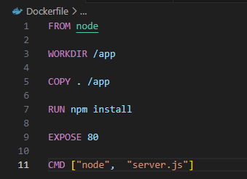
- Create a file named “Dockerfile”
- All these here are instructions to Docker for setting up the image. Now keep in mind the image should be the template for the container. The image is not what you run in the end, you run a container based on an image.
- COPY:
  - The first path is to path outside of the container, outside of the image where the files live that should be copied into the image.
  - And if you just specify a dot here that basically tells Docker that it's the same folder that contains the Dockerfile. Excluding the Dockerfile though.
  - So in this case dot would tell Docker that all the folders, sub folders and files here in this project should be copied into the image.
  - And now the second dot/path is the path inside of the image where those files should be stored. Every image and for also every container created based on an image, has its own internal file system which is totally detached from your file system on your machine. It's hidden away inside of the Docker container.
- By default, all those commands will be executed in the working directory of your Docker container and image. And by default, that working directory is the root folder in that container file system. Since I'm copying my code into the app folder here, I actually want to run NPM install inside of the app folder as well.
- And a convenient way of telling Docker that all commands should be executed in that folder, is that you set another instruction here before you copy everything. And that's the WORKDIR instruction for a setting the working directory of the Docker container and setting this to slash app. And this tells Docker that all the subsequent commands will be executed from inside that folder.
- RUN vs CMD
  - RUN will execute when the image is getting created
  - Cmd will execute when the container is started based on the image

Create an image
To create an image, use “docker build .”
- . indicates the current folder
- The command generates the image id at the end

List containers
To list all the running containers, use docker ps
To list all the contianers, use “docker ps -a”

Stop a container
To stop a container use, docker stop <containerid/containername>

Docker run vs start
`docker run` and `docker start` are two different commands in Docker, with distinct uses:
1. `docker run`: This command is used to start a new container based on an image. When you run a container using `docker run`, the container is created from scratch, and the image's dependencies are installed and configured automatically. The `run` command is useful when you want to create a new container without affecting any existing containers or images.
2. `docker start`: This command is used to start an already-existing container. When you use `docker start`, the container is started, but it doesn't create a new instance of the container. Instead, it uses the same container that was previously running. The `start` command is useful when you want to quickly start a container without creating a new one.
Here are some key differences between `docker run` and `docker start`:
* Creation: `docker run` creates a new container based on an image, while `docker start` starts an already-existing container.
* Dependencies: When you use `docker run`, Docker automatically installs and configures the dependencies for the container. When you use `docker start`, the container's dependencies are not affected.
* Resource usage: `docker run` uses more resources than `docker start` because it creates a new container from scratch.
* Convenience: `docker start` is generally considered more convenient than `docker run` because it saves time and effort by not requiring you to create a new container.
In summary, use `docker run` when you want to create a new container based on an image, and use `docker start` when you want to quickly start an already-existing container.

Images are read only
If you made any changes to code and you just use docker build to build a new image and use docker run to start a new container
Whenever you build an image, Docker caches every instruction result, and when you then rebuild an image, it will use these cached results if there is no need to run an instruction again. And this is called a layer based architecture. Every instruction in your Dockerfile represents a layer. And an image is simply built up from multiple layers based on these different instructions. In addition, an image is read only, which means once an instruction has been executed and once the image is built, the image is locked in and code in there can't change unless you rebuild the image, which technically means you create a new image.

Start a container
To start a container use, docker run/start (“docker start <container_name_or_id>”)
Don’t forget to add publish flag when using docker run
I just want to clarify again, that EXPOSE 80 in the Dockerfile in the end is optional. It documents that a process in the container will expose this port. But you still need to then actually expose the port with -p when running docker run. So technically, -p is the only required part when it comes to listening on a port. Still, it is a best practice to also add EXPOSE in the Dockerfile to document this behavior.
As an additional quick side-note: For all docker commands where an ID can be used, you don't always have to copy / write out the full id.
You can also just use the first (few) character(s) - just enough to have a unique identifier.
So instead of
docker run abcdefg
you could also run
docker run abc
or, if there's no other image ID starting with "a", you could even run just:
docker run a
This applies to ALL Docker commands where IDs are needed.

Container doesn’t copy code
A container does not copy over the code and the environment from the image into a new container into a new file. That is not what's happening. A container will use the environment stored in an image, and then just add this extra layer on top of it, this running node server process for example, and allocate resources, memory and so on to run the application, but it will not copy that code.

Attached vs Detached Containers
- Docker run’s default is attached (foreground)
- Docker start default is detached
- Attached will display logs (if logging was used)
- Detached will not display any logs
- Use -d flag to detach the docker run
- Use docker attach <container_name> to attach again
- Use -a flag to attach the docker start

Docker Ports
Docker uses ports for communication between containers. When you run a container, you can publish its ports to allow external access. Here’s how it works:
- Publishing Ports:
  - During container creation, use the -p (or --publish) flag with docker run.
  - Syntax: $ docker run -d -p HOST_PORT:CONTAINER_PORT nginx
    - HOST_PORT: Port on your host machine to receive traffic.
    - CONTAINER_PORT: Port within the container that’s listening for connections.
  - Example: To publish container port 80 to host port 8080: $ docker run -d -p 8080:80 nginx
  - Now, traffic to port 8080 on your host forwards to port 80 in the container.
- Ephemeral Ports:
  - If you don’t care which host port is used, omit HOST_PORT.
  - Docker will choose an ephemeral port on the host.
  - Example: $ docker run -p 80 nginx (shows chosen port with docker ps)
- Publish All Exposed Ports:
  - The EXPOSE instruction in a container image specifies ports used by the app.
  - By using -P or --publish-all, you publish all exposed ports to ephemeral ports.
  - Useful to avoid port conflicts during development/testing.

Docker logs
Use docker logs <container_name> to see all the previous logs
Use docker logs -f <container_name> to attach and follow the logs

Interactive Mode
The --it option in the docker run command is a combination of two flags: -i and -t. Here’s what they do:
- -i (interactive): Keeps the standard input (stdin) open, allowing you to interact with the container.
- -t (tty): Allocates a pseudo-TTY, which provides a terminal interface.
When used together as -it, these flags allow you to run an interactive shell session inside the container. For example, you can start a bash shell in a container with:
docker run -it ubuntu /bin/bash
This command will start an Ubuntu container and open an interactive bash shell, allowing you to execute commands inside the container.

Remove container
To remove a Docker container, you can use the `docker rm` command. Here's how:
docker rm <container_name>
If you want to remove all containers, use the following command:
docker rm --all
Once you have confirmed that you want to remove the container, Docker will stop and remove the container from its repository. The container will no longer be available for use in your system.
Note: Before removing a container, make sure you have stopped it using the `docker stop` command and that it is not running any processes or applications that you want to retain. Once a container is removed, it cannot be recovered

Remove Container automatically
To remove container automatically after stopping it, use docker run --rm flag
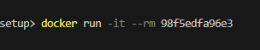

Remove Image
To delete a Docker image, you can use the `docker rmi` command. Here's how:
docker rmi <image_name>
If you want to delete all images in a specific namespace, use the following command:
docker rmi --namespace <namespace>
Replace `<namespace>` with the name of the namespace you want to delete the images from.
If you want to delete all images in the `latest` namespace, use the following command:
docker rmi --latest
To confirm that the image will be deleted, use the `--force` or `-f` option:
docker rmi --force <image_name>
Note: Before deleting an image, make sure you have backed up any data that you need to retain. Once an image is deleted, it cannot be recovered.

Inspect image
To inspect the image to see what’s in there, use docker image inspect <image_id>

Naming and tagging
Docker image and container naming and tagging are crucial parts of Docker's functionality, enabling users to identify, organize, and manage their Docker images and containers efficiently. Here’s a detailed explanation:

Docker Images

Naming
A Docker image name typically follows the format: `repository/image:tag`.
- **Repository**: Often a Docker registry (like Docker Hub, a public or private registry). If the repository isn't specified, Docker assumes the default Docker Hub registry.
- **Image**: The name of the image.
- **Tag**: A label that references a specific version of the image. If not specified, Docker uses the `latest` tag by default.
Example: `docker.io/library/ubuntu:20.04`
- `docker.io` is the Docker Hub registry.
- `library/ubuntu` is the repository and image name.
- `20.04` is the tag.

Tagging
Tags are used to version images. They help distinguish between different builds or versions of the same image.
- **Creating a Tag**: You can tag an image when you build it or later.
- During build: `docker build -t myrepo/myimage:1.0 .`
- Post build: `docker tag image_id myrepo/myimage:1.0`
- **Listing Tags**: Use `docker images` to list all images and their tags.

Pushing and Pulling
- **Push**: Upload a tagged image to a registry.
docker push myrepo/myimage:1.0
- **Pull**: Download a tagged image from a registry.
docker pull myrepo/myimage:1.0

Docker Containers

Naming
When you run a container from an image, Docker assigns it a unique ID. Optionally, you can give it a human-readable name for easier management.
- **Default**: Docker assigns a random name if you don’t specify one.
- **Custom**: Use the `--name` option to assign a name.
docker run --name mycontainer myrepo/myimage:1.0

Best Practices
**Regular Cleanup**: Regularly clean up unused images and containers to save disk space and reduce clutter.
- Remove dangling images: `docker image prune`
- Remove stopped containers: `docker container prune`
Understanding Docker's naming and tagging mechanisms enables better organization and control over your Docker environments, ensuring that you can easily manage and deploy applications.

Docker Exec
The docker exec command lets you run a command inside a running Docker container—like opening a terminal window into a live container. It’s super handy for debugging, inspecting, or interacting with your app without restarting anything.

🧪 Basic Syntax
docker exec [OPTIONS] <container_name_or_id> <command>

🔍 What It Can Do
Feature | Description
Run commands | Execute any shell command inside the container (e.g. ls, cat, env)
Open a shell | Start an interactive session with sh or bash
Debug apps | Check logs, config files, or running processes
Set environment variables | Use -e to pass variables to the command
Run as another user | Use -u to specify a different user (like root or www-data)

🧑‍💻 Example: Open a shell
docker exec -it my_container /bin/bash
- -i keeps STDIN open
- -t allocates a pseudo-terminal
- You’ll get a shell prompt inside my_container

🛠️ Example: Run a quick command
docker exec my_container ls /app
Lists the contents of /app inside the container.

Managing Data & Working with volumes

Data Categories
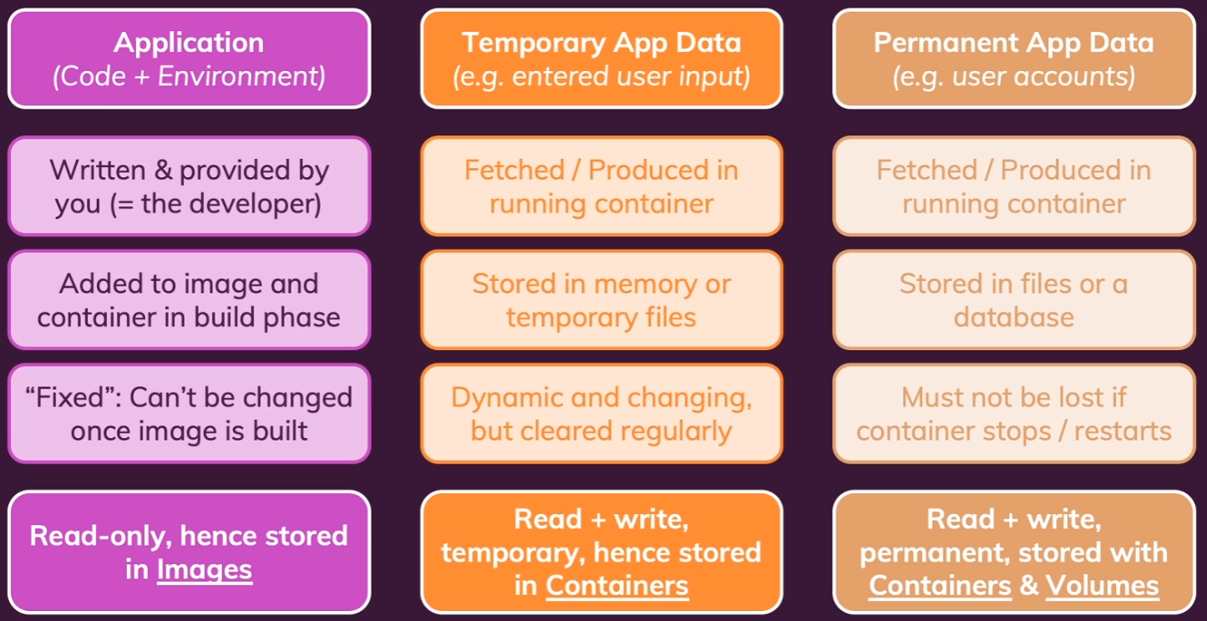

How File Retention works
- When we launch Docker container based on the image, that container is added as an extra thin read-write layer on top of this image.
- So container has access to this image file system and it's able to read and write without manipulating the image.
- But container is also able to read and write in it’s own layer. It has its own copy of that you could say managed in a very efficient way. But the problem is, that the file system is inside of the container. So if we stop it and restart it everything is fine because the container never changed. And just because it was stopped does not mean that its file system is cleared or erased. If that would be the case our application code would be gone as well, right? So that's not happening. But if we remove a container, then that's different. Then all the data in the container is cleared because the container overall is cleared and deleted. And if we then run a new container, even if it's based on the same image, all the data that was created and stored in the previous container is lost, because the image is read-only.

Volumes vs Bind Mounts
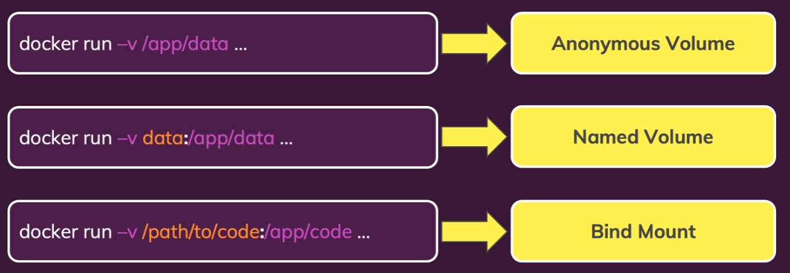
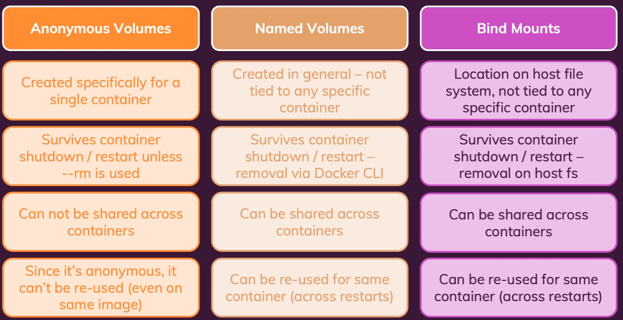

Volumes
Docker has a built-in feature called volumes. And volumes help us with persisting data. Volumes are folders on your host machine, so not in the container, not in the image, but on your host machine hard drive, which are mounted, which basically means, made available or mapped, into containers. So volumes are folders on your host machine, on your computer, which you make Docker aware of and which are then mapped to folders inside of a Docker container.
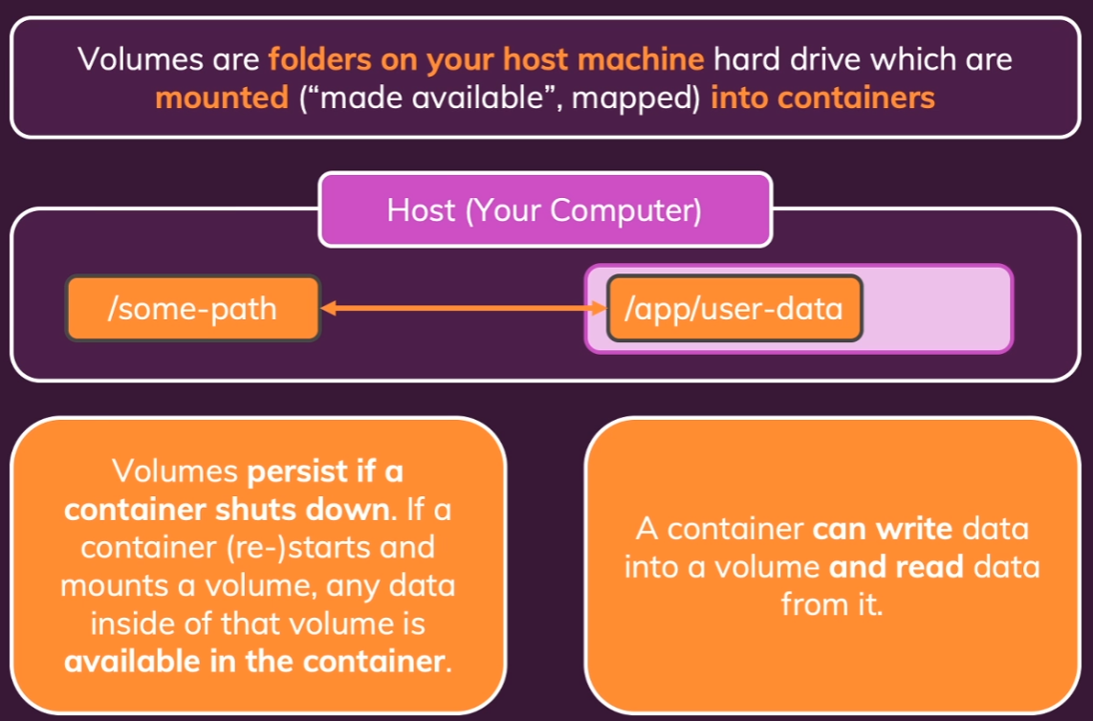
There are two types of Volumes:
- anonymous
- Named
Docker named volumes and anonymous volumes are two different ways to persist data in Docker. Here's a comparison of the two:

Named Volumes:
- A named volume is a persistent volume that is created using the `docker volume create` command, and it has a unique name.
- The data stored in a named volume is persisted even after the container is deleted or recreated.
- You can access the data stored in a named volume from any container running on the same host as the volume.
- To access a named volume, you need to specify the full path of the volume, including the hostname and the volume name.
- Named volumes are recommended for long-term storage of data that needs to be accessed by multiple containers or hosts.
- To create a named volume in Docker, you can use the following command:
  - docker volume create <volume_name>
- Docker will automatically generate a directory for the volume on the host under the `/var/lib/docker/volume/` path. You can then mount this volume on a container, ensuring data persistence and sharing among multiple containers¹².
  - You won’t be able to see it as docker uses a virtual machine and in that virtual machine it will store it in the var folder
- For example, let's create a named volume called "myAwesomeApp":
  - docker volume create myAwesomeApp
- Once created, you can use it in your containers by specifying the volume name when running them.
- If you'd like to create a named volume directly within a `docker run` command, you can use the `-v` or `--volume` option:
  - docker run -d --name="myApp-1" -v="myAwesomeApp:/data/app" myApp:1.5.3
  - Mounts a volume named myAwesomeApp to the container’s path /data/app. This allows data to persist outside the container or be shared across multiple containers.

Anonymous Volumes:
- docker run -v /data nginx
  - In this command, Docker mounts an anonymous volume to the /data directory inside the nginx container
- An anonymous volume is a transient volume that is created automatically when a container is started.
- The data stored in an anonymous volume is not persisted after the container is deleted or recreated.
- You can access the data stored in an anonymous volume from within the container using the `docker exec` command, but the data is lost when the container is deleted or recreated.
- Anonymous volumes are recommended for short-term storage of data that does not need to be accessed by other containers or hosts.
- you have to declare in the docker file
- You won’t know where they will be stored
- You can list all the anonymous volumes using docker volume ls
- They will get removed if you start the container with -rm flag
- If the container didn’t start with the -rm flag, they will persist. You can delete them using
  - “docker volume prune” or
  - “docker volume rm <volume_name>”

key differences
Here are some key differences between named and anonymous volumes:
1. Persistence: Named volumes persist data even after the container is deleted or recreated, while anonymous volumes do not.
2. Accessibility: You can access a named volume from any container running on the same host as the volume, while an anonymous volume can only be accessed from within the container itself.
3. Lifecycle: Named volumes have a longer lifespan than anonymous volumes, which are automatically deleted when the container is deleted or recreated.
4. Security: Anonymous volumes are considered less secure than named volumes since the data stored in them is not persisted and can be lost easily and it is really hard to set access permissions set on anonymous volumes
5. Performance: Named volumes are generally faster than anonymous volumes since they do not need to be created or mounted every time a container is started.
In summary, named volumes are recommended for long-term storage of data that needs to be accessed by multiple containers or hosts, while anonymous volumes are recommended for short-term storage of data that does not need to be persisted beyond the lifetime of a single container.

Bind Mounts
A Docker bind mount allows you to share files and directories between the host machine and a Docker container. This can be particularly useful for development environments, where you want the container to have access to the host filesystem to read and write files directly. Here's a detailed overview of how to use Docker bind mounts.

What is a Bind Mount?
A bind mount is a way to map a directory or file from the host machine to a directory or file inside a Docker container. When you use a bind mount, a file or directory on the host machine is mounted into a container at runtime.

Using Bind Mounts
Syntax
The basic syntax to use a bind mount in a Docker run command is:
docker run -v /path/on/host:/path/in/container [other options] image
or using the more explicit `--mount` flag:
docker run --mount type=bind,source=/path/on/host,target=/path/in/container [other options] image
Example
Let's walk through an example.
1. Create a directory on the host machine:**
mkdir -p /host/data
echo "Hello from the host" > /host/data/hello.txt
2. Run a container with the bind mount:
docker run -it --name my_container --mount type=bind,source=/host/data,target=/container/data ubuntu
3. Access the files inside the container:
cat /container/data/hello.txt
This should output "Hello from the host".
Bind Mount Options
- **Read-Only Mounts:**
If you want the bind mount to be read-only, you can add the `readonly` option:
docker run -it --mount type=bind,source=/host/data,target=/container/data,readonly ubuntu
- **Propagation Options:**
These options control how changes to mounts are propagated between the host and the container. Available options are `rprivate`, `private`, `rshared`, `shared`, `rslave`, and `slave`. For example:
docker run -it --mount type=bind,source=/host/data,target=/container/data,bind-propagation=rshared ubuntu
Use Cases
- **Development Environments:**
Developers can share their code directory from the host machine into the container, enabling live editing and testing.
- **Configuration Sharing:**
Sharing configuration files or secrets securely from the host to the container.
- **Data Persistence:**
Persisting data generated by the container to the host machine, ensuring data is not lost when the container is removed.
Conclusion
Bind mounts are a powerful feature in Docker that facilitate direct file sharing between the host and containers. By understanding and effectively using bind mounts, you can significantly enhance your Docker-based workflows, especially in development and data persistence scenarios.

Example
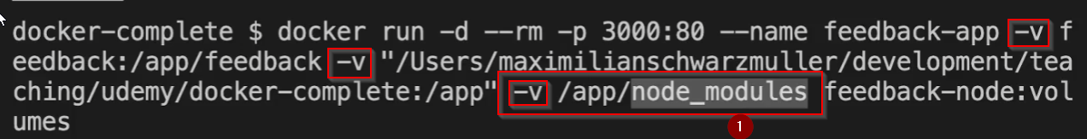
- You can add multiple volumes to the container when creating it by using multiple “-v” flags
- If you use bind mount to mount your code from the host onto the container and you didn’t have the packages installed in your code, the installed packages layer from docker file will not be there or overwritten by your app code
  - To address this, use anonymous volume (see 1) to exempt the packages folder from bind mount mounting
  - If you mount a volume that is little deeper (ex: /app/temp or /app/node_modules), then it will take precedence over it’s parent volume (ex: /app)

Read Only Volumes
Use “:ro” flag at the end of the volume to make the volume/bind readonly.
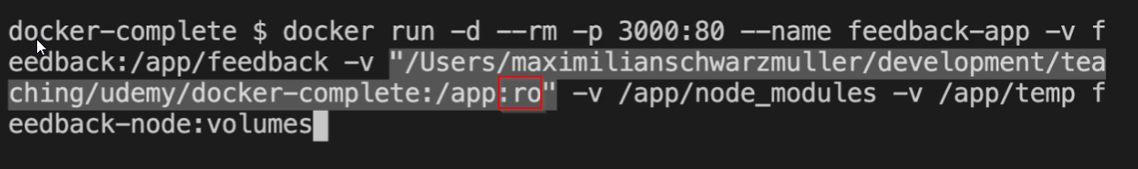

Environment Variables
Environment variables in Docker are essential for configuring application settings and other parameters that may vary between different environments, such as development, testing, and production¹. Here are some ways to set environment variables in Docker containers:
- Compose File:
  - You can define environment variables directly in your docker-compose.yml file using the environment attribute. For example:
services:
webapp:
image: my-webapp-image
environment:
- DEBUG=true
- API_KEY=your-api-key
Alternatively, you can use an .env file in Docker Compose to centralize and manage configuration. Place the .env file at the root of your project directory next to your docker-compose.yml file and use it during docker run (see screenshot below). Example .env file:
TAG=v1.5
Then reference the variables in your Compose file:
services:
web:
image: "webapp:${TAG}"
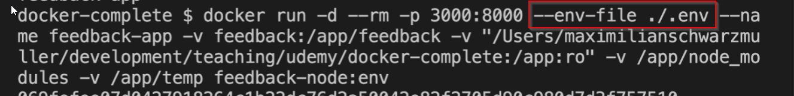
- Dockerfile:
In a Dockerfile, you can set environment variables using the ENV instruction. For example:
FROM ubuntu
ENV DEBUG=true
ENV API_KEY=your-api-key
- CLI Options:
When running a container, you can set environment variables using the -e flag. For example:
docker run -e DEBUG=true -e API_KEY=your-api-key my-webapp-image
Remember not to use environment variables to pass sensitive information (such as passwords) directly into your containers. Instead, consider using secrets or other secure methods¹

Build Arguments
When working with Docker, build arguments (commonly referred to as “build args”) are a powerful feature that allows you to pass variables exclusively during the Docker image’s build process. They are particularly useful when you need to build Docker images that require specific configurations, but you want to avoid hardcoding those configurations in the Dockerfile¹.
Here are some key points about build arguments:
- Defining Build Arguments in Dockerfile:
  - You define build arguments inside your Dockerfile using the ARG instruction. For example:
  - ARG EXAMPLE_VAR
  - ARG DEMO_VAR
  - RUN echo $EXAMPLE_VAR
  - In this example, two arguments (EXAMPLE_VAR and DEMO_VAR) are added to the build process.
- Setting Build Argument Values:
  - You set the values of available arguments via the --build-arg flag when running the docker build command. For instance:
  - docker build --build-arg EXAMPLE_VAR=value1 --build-arg DEMO_VAR=value2 .
- Use Cases for Build Arguments:
  - Changing Runtime Versions:
    - Suppose your image uses the golang:1.21-alpine base image, but you want to allow users to build with a different Go version. You can use a build argument like this:
    - ARG GO_VERSION=1.21
    - FROM golang:${GO_VERSION}-alpine AS base
    - # ...
    - Users can then specify a different Go version using the --build-arg flag during the build process.
  - Injecting Values into Source Code:
    - You can also use build arguments to modify values in your application’s source code at build time. For example, if your Go code contains a conditional statement to print the app version: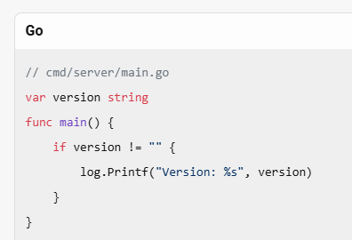
    - Pass the version string as a build argument and inject it into the code: 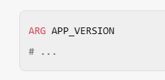
    - Users can set the version during the build process.
Remember to use build arguments wisely to enhance flexibility and avoid hardcoding sensitive information in your images

ARGuments vs ENVironment Variables
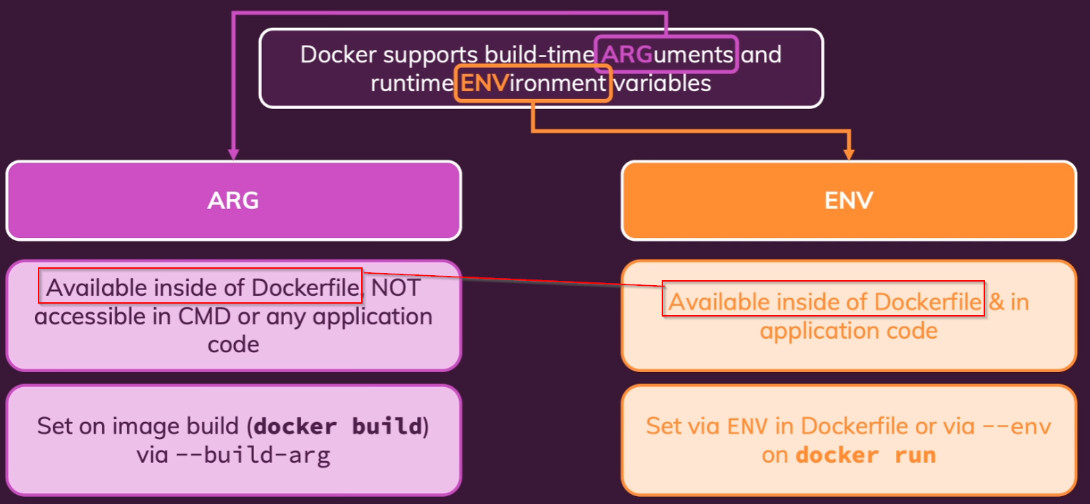
In Docker, both build arguments (ARG) and environment variables (ENV) are used to pass information into the build process, but they serve different purposes and are used in different contexts¹².
Build Arguments (ARG)
- Purpose: Used to pass variables at build time.
- Scope: Only available during the image build process and not accessible in the running container.
- Use Case: Ideal for setting values that are needed during the build but not required at runtime. For example, specifying the version of a dependency to install.
- Example:
- ARG VERSION=1.0
- RUN echo "Building version $VERSION"
Environment Variables (ENV)
- Purpose: Used to set environment variables that are available both during the build and in the running container.
- Scope: Persist in the container and can influence the behavior of the application at runtime.
- Use Case: Suitable for configuration values that the application needs at runtime, such as database connection strings or API keys.
- Example:
- ENV APP_ENV=production
- RUN echo "Environment is $APP_ENV"
When to Use Each
- Use ARG when you need to pass build-time variables that do not need to be available in the running container. This helps keep your Dockerfile flexible and maintainable.
- Use ENV for variables that your application needs to access at runtime. These variables can be overridden when running the container using the -e flag in the docker run command.

Networking

Container -> Web/api access
By default, docker containers can communicate with world wide web. You don’t need to do anything else.

Container -> Host Machine
If container wants to communicate with host machine services (such as hosted web server, mongodb, etc.), you have to use a host.docker.internal as the address instead of localhost

Example 1:
Lets say you want to communicate to a mongodb service that is hosted on your host machine of the container.
Mongodb address:
‘mongodb://localhost:27017/swfavorites’
New Address:
‘mongodb://host.docker.internal:27017/swfavorites’

Example 2:
Lets say you want to communicate to a web server/api that is hosted on your host machine of the container.
Website/api address:
‘http://localhost:27017/swfavorites’
New Address:
‘http://host.docker.internal:27017/swfavorites’

Container -> Container

Approach 1:
If you are trying to use a service such as mongdb, you can directly pull that image by using docker run
“docker run mongo”
or
“docker run -d --name mongodb mongo”
This will automatically download the image and create a container
Use docker container inspect, to inspect the above container that you created (mongodb)
“docker container inspect mongodb”
Under the network settings, you will see the ip address and port information
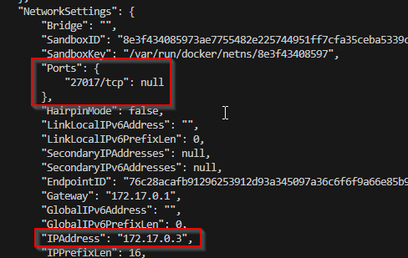
Use these settings in your app container to communicate with the mongodb container
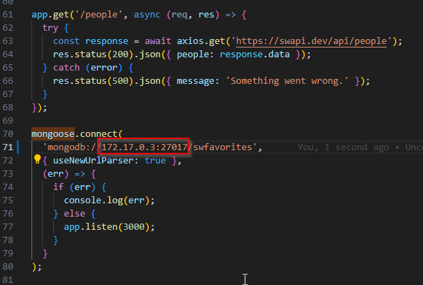

Approach 2:
In the above approach, we need docker inspect to figure out the ip address and make sure you update your code. In this approach we will try to avoid this by
- Creating a network 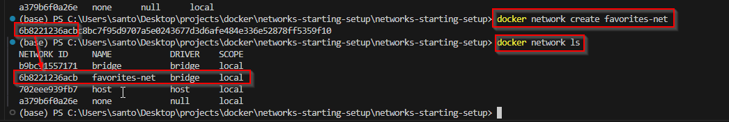
- Creating all the containers within the network
  - 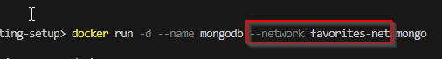
- Communicating between containers through their container name instead of localhost/host.docker.internal/ipaddress
  - 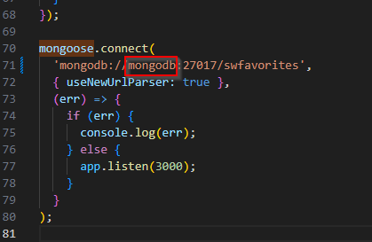

Things to remember
When you create a network and its strictly container to container communication, you don’t need to publish ports in docker run command
But if it’s a UI app that communicates with the backend/database container, we still need to publish the ports on backend/database

List Networks
To list all the Docker networks, you can use the docker network ls command. This command will display a list of all networks that the Docker Engine daemon knows about. Here’s how you can use it:
docker network ls
This will output something like:
NETWORK ID NAME DRIVER SCOPE
7fca4eb8c647 bridge bridge local
9f904ee27bf5 none null local
cf03ee007fb4 host host local
78b03ee04fc4 multi-host overlay swarm
You can also use additional options with this command, such as --filter to filter the networks by specific criteria, or --format to format the output¹².

Add network after initializing the container
To add a running Docker container to a network after it has been initialized, you can use the docker network connect command. Here’s how you can do it:
- Identify the Network and Container: Make sure you know the name of the network and the container you want to connect.
- Use the docker network connect Command:
- docker network connect <network-name> <container-name>
For example, if you have a network named my-network and a container named my-container, you would run:
docker network connect my-network my-container
This command will connect the specified container to the specified network, allowing it to communicate with other containers on that network¹².

List containers in a network
To list all containers connected to a specific Docker network, you can use the docker network inspect command. Here’s how you can do it:
- Identify the Network: First, list all networks to find the one you’re interested in.
- docker network ls
- Inspect the Network: Use the docker network inspect command followed by the network name or ID to get detailed information, including the containers connected to it.
- docker network inspect <network_name_or_id>
For example, if your network is named my-network, you would run:
docker network inspect my-network
This command will output detailed information in JSON format. Look for the Containers section in the output, which lists all the containers connected to the network along with their details¹.

Remove a network
To remove a Docker network, you can use the docker network rm command. Here are the steps:
- List Networks: First, list all the networks to find the one you want to remove.
- docker network ls
- Remove Network: Use the docker network rm command followed by the network name or ID.
- docker network rm <network_name_or_id>
For example, to remove a network named my-network, you would run:
docker network rm my-network
If you want to remove all unused networks, you can use the docker network prune command:
docker network prune
This command will prompt you to confirm the action. You can bypass the prompt by adding the -f (force) flag:
docker network prune -f
Make sure no containers are connected to the network you want to remove, as Docker will not allow you to delete a network with active endpoints¹².

How Docker resolves IP Addresses
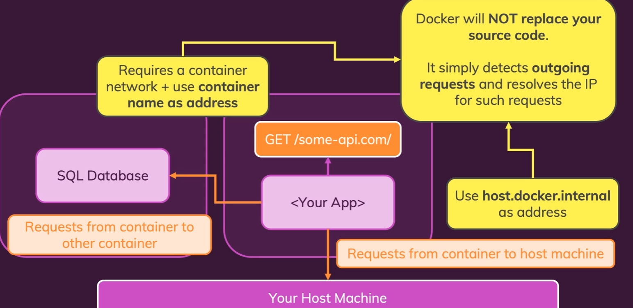

Mongodb’s data location
Mongodb stores it’s data in /data/db.
Use this in the named volume to create one
docker run --name mongodb --rm -d --network goals-net -v data:/data/db mongo

Mongodb’s userid, pwd environment variables
You can use mongodb’s username and password variables to make the db accessible with userid and password only
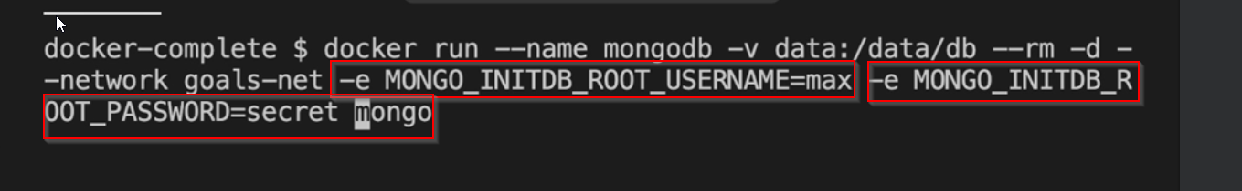
The backend needs to change the mongodb connection string to look like this to connect to db

Docker Compose
Docker Compose is a tool that simplifies the management of multi-container Docker applications. Instead of running multiple docker run commands for each container, Docker Compose allows you to define and manage all your containers in a single YAML file called docker-compose.yml.

How It Works
- Define Services: In the docker-compose.yml file, you specify the services (containers) you need, their images, ports, volumes, and dependencies.
- Run the Application: Use docker-compose up to start all the services. Docker Compose will pull the required images, create containers, and set up networking.
- Manage the Application: Use commands like docker-compose ps to view running services or docker-compose logs to check logs.

Example:
Here’s a simple example of a Node.js app with a MongoDB database:
- app: Defines the Node.js application container.
- db: Defines the MongoDB container.
- volumes: Creates a persistent volume for MongoDB data.

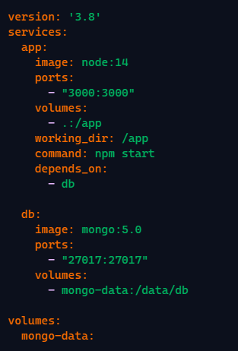
Example
Here's a great real-world example of Docker Compose in action: a simple project that runs a Node.js API connected to MongoDB, all inside Docker containers. This setup is ideal for web developers, backend engineers, or anyone exploring microservices and container orchestration.
Project Overview: Node.js + MongoDB
This project includes:
- A Node.js Express API server
- A MongoDB database
- Docker Compose to orchestrate both services
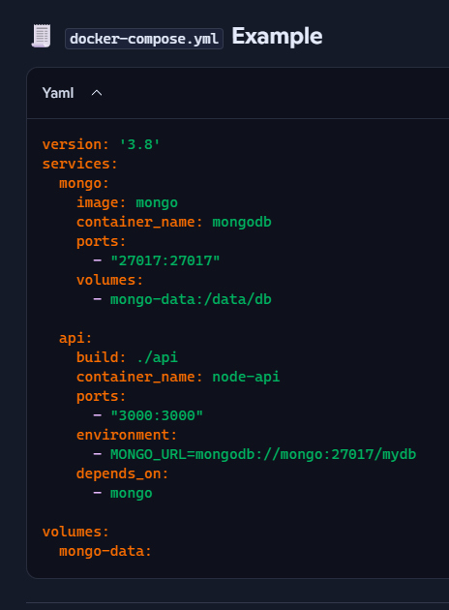
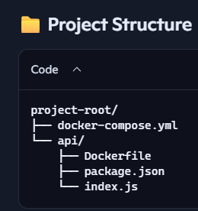
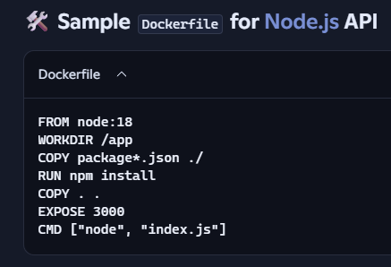
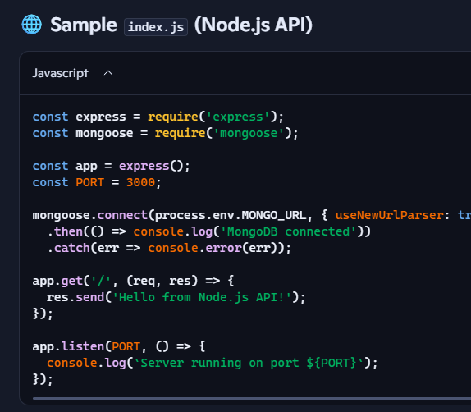

How to Run
- Place the files in the correct structure.
- Run docker compose up --build from the root directory.
  - --build: Forces Docker to build or rebuild the images for any services defined with a build: section in your docker-compose.yml file.
  - up: Starts all the services defined in the Compose file, creating containers, networks, and volumes as needed.
- Visit http://localhost:3000 to see the API response.
If you want to rebuild everything from scratch and remove old containers, use:
- docker compose down --volumes --remove-orphans
- docker compose up --build

Utility Containers
Look for Entry points

Complex project setup

Delegated option during volumes (bind mount) setup
