# Eclipse

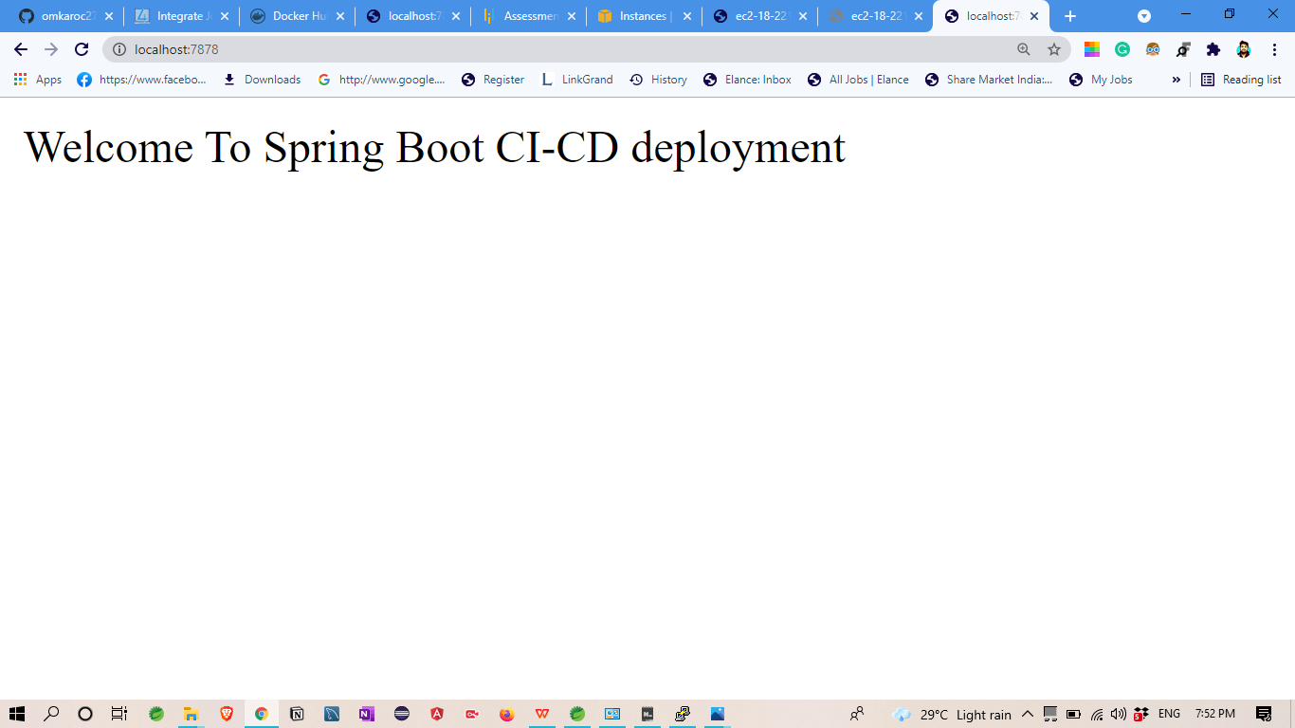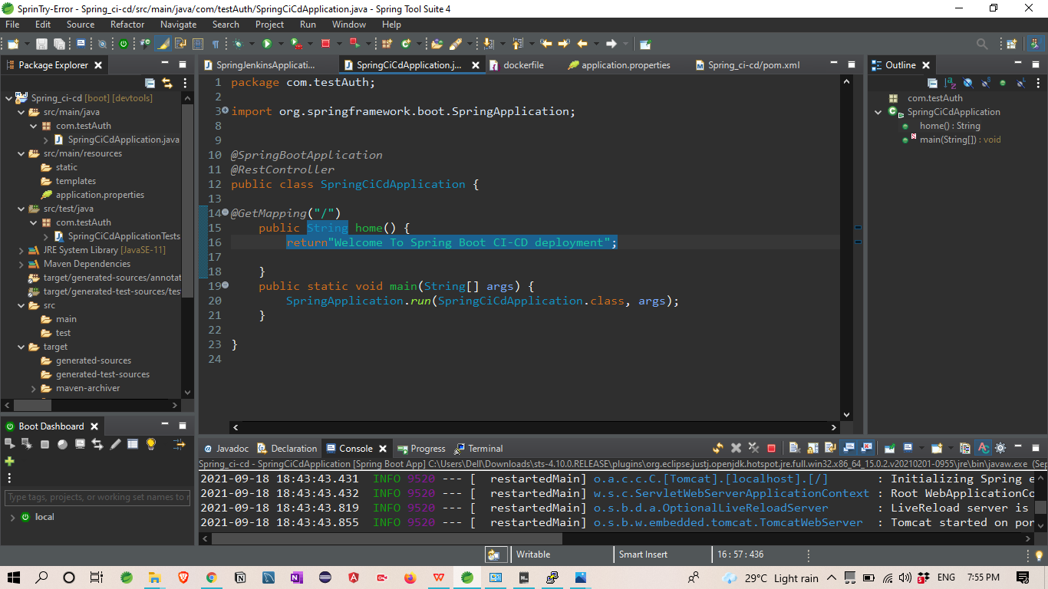

## I create Simple Spring boot Application to

## build a CI/CD pipeline to demonstrate continuous deployment

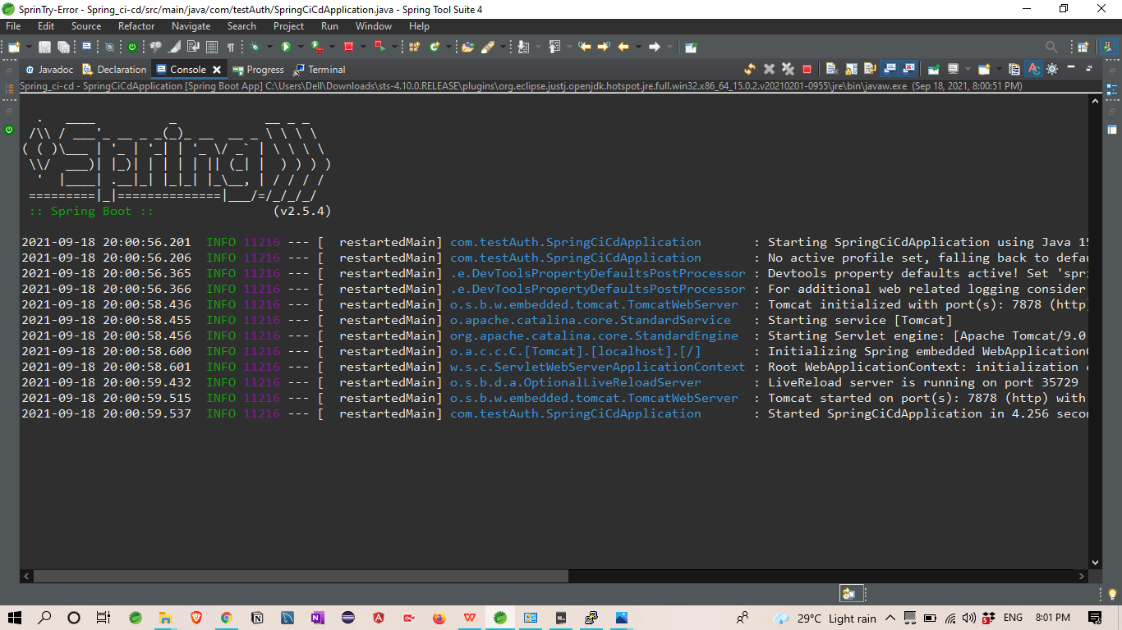

Output :-



# Git Hub: Application Deploy on git Hub

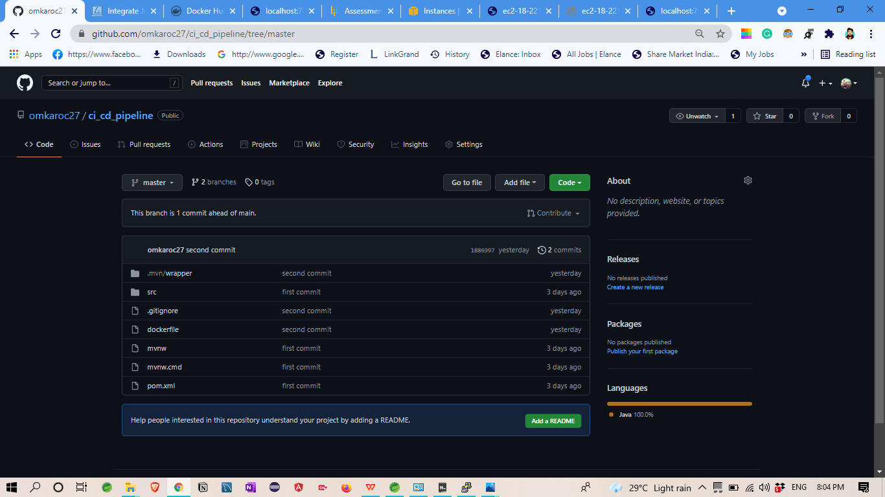

## 2.

## Then that application Uploaded on Git Hub

# GitHub link-

<https://github.com/omkaroc27/ci_cd_pipeline.git>

# Jenkins : Run Jenkins

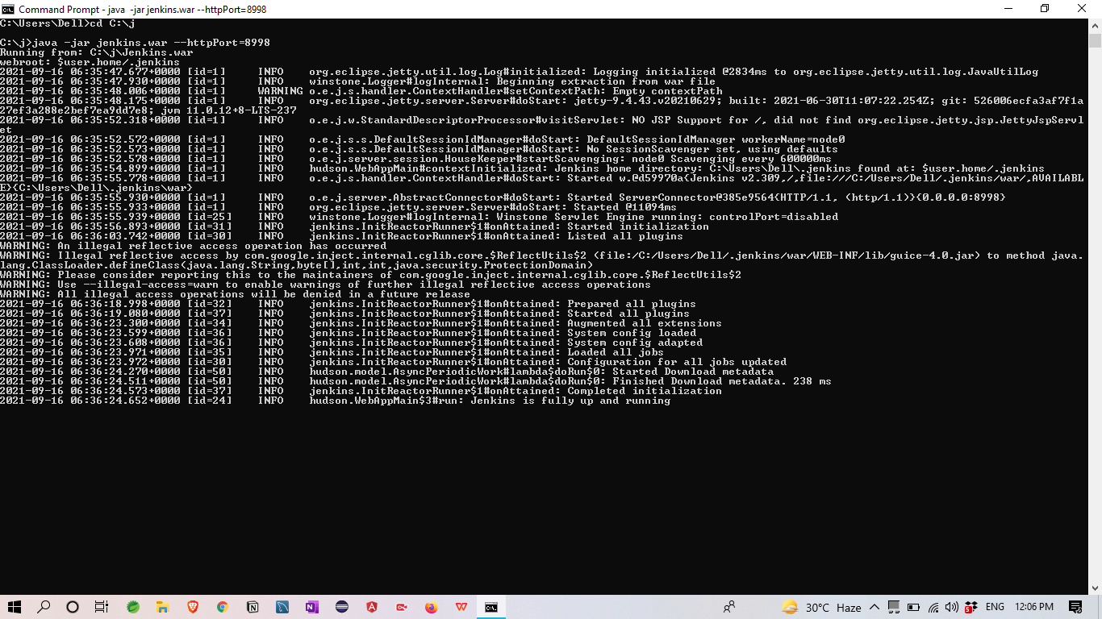

CREATE THREE JENKINS PROJECT DEPLOYMENT:-

DEPLOYMENT-TESTING-PRODUCTION

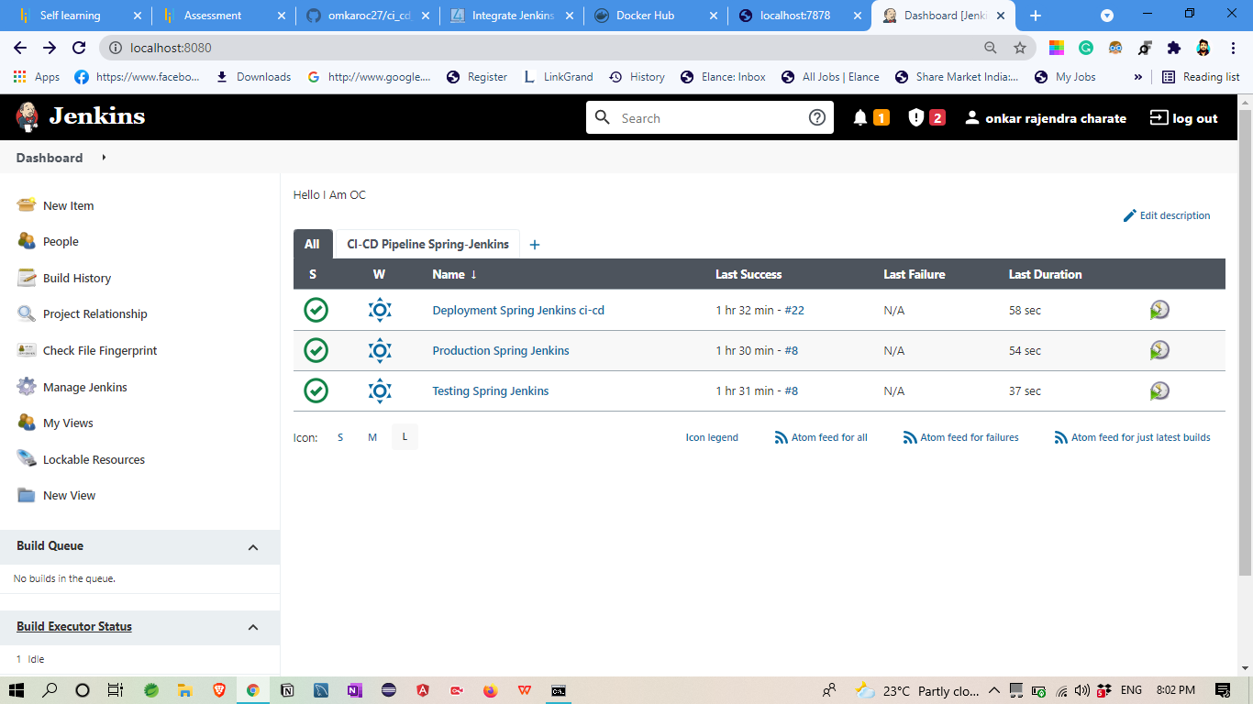

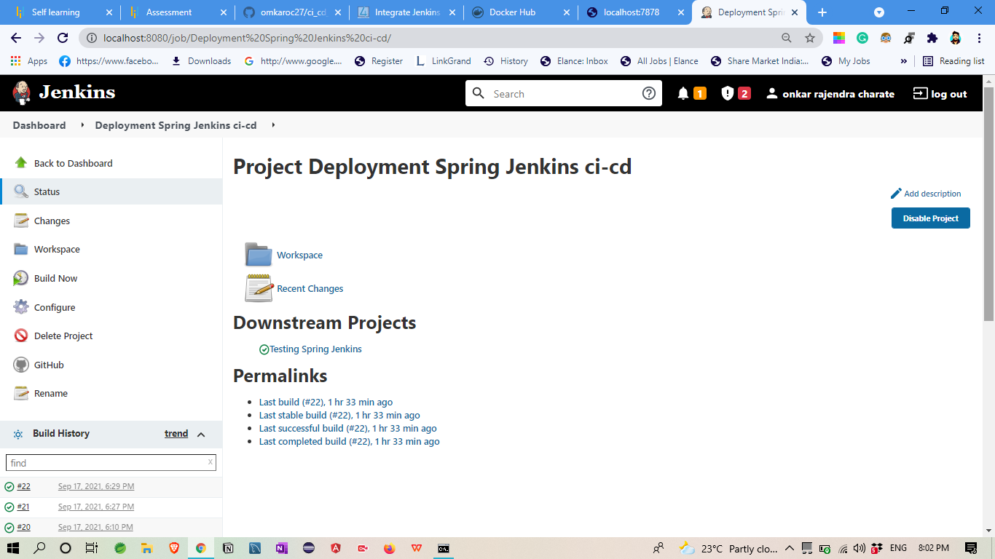

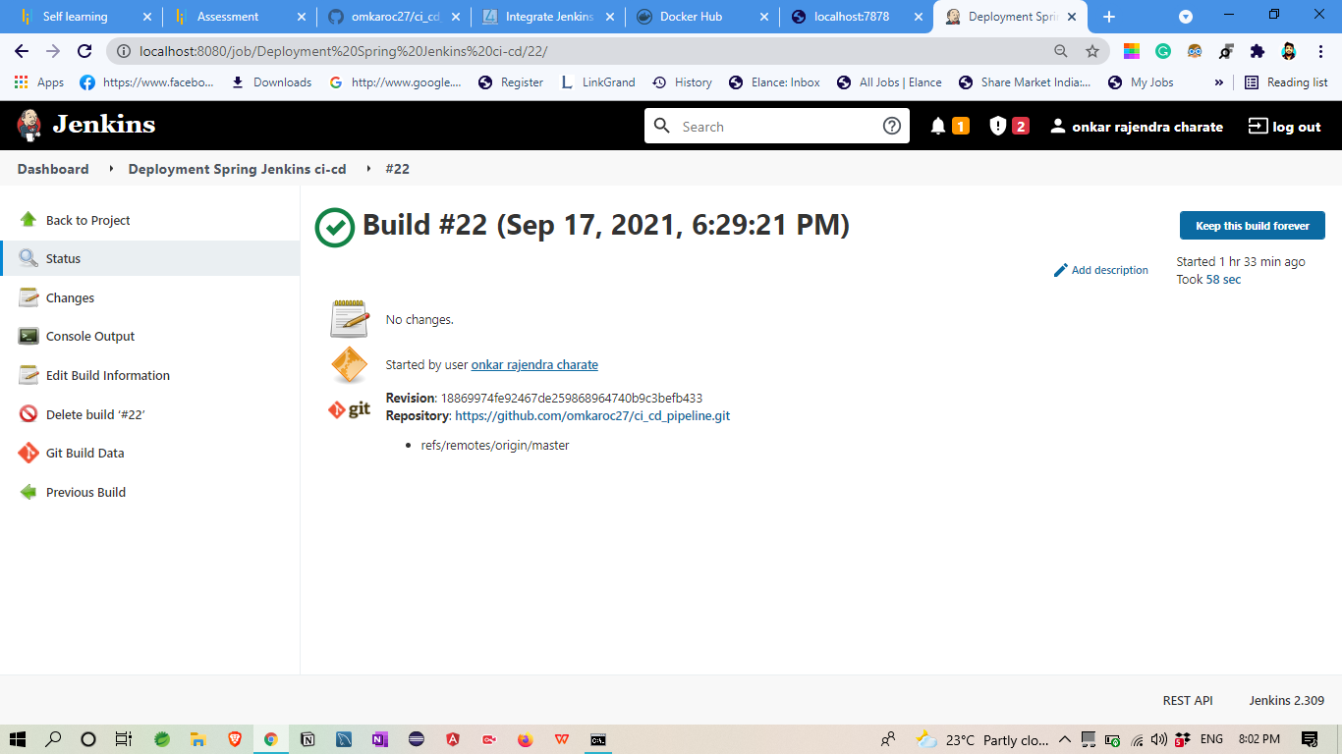

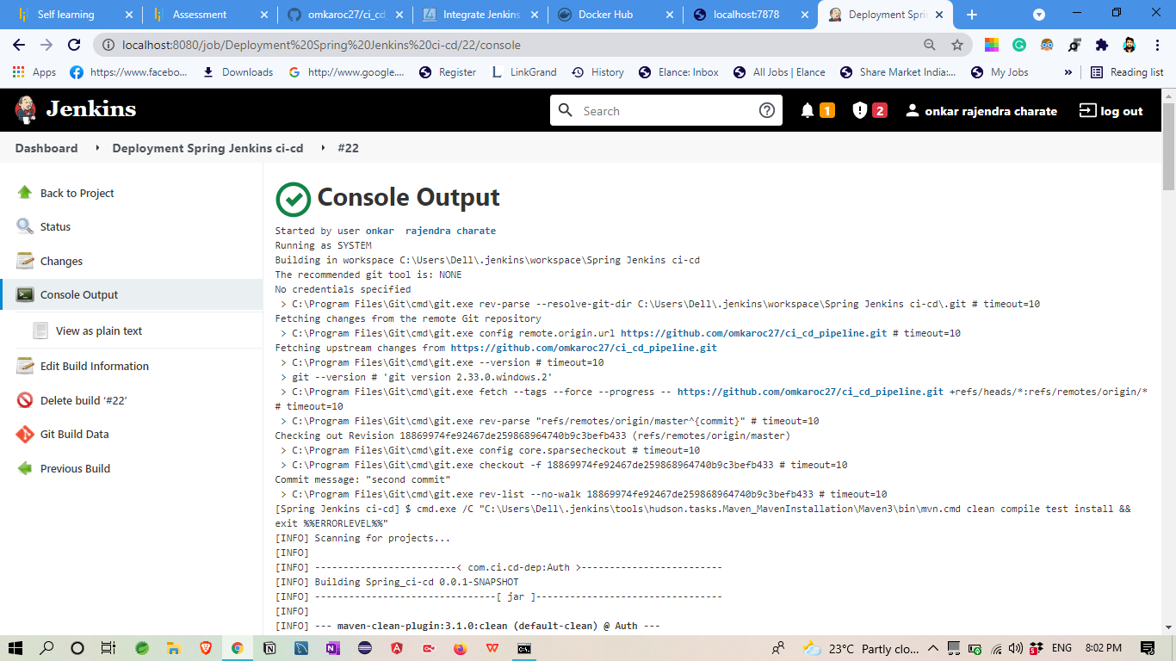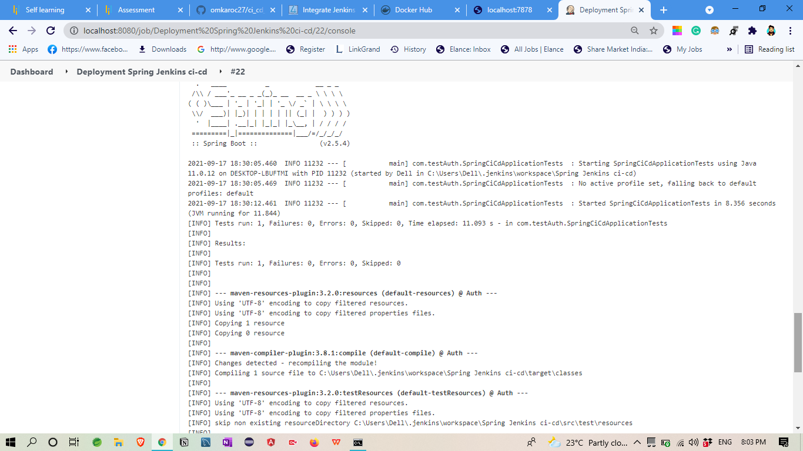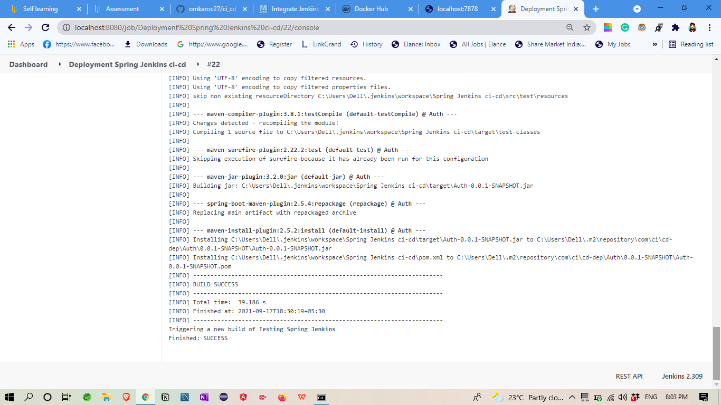

**TESTING**

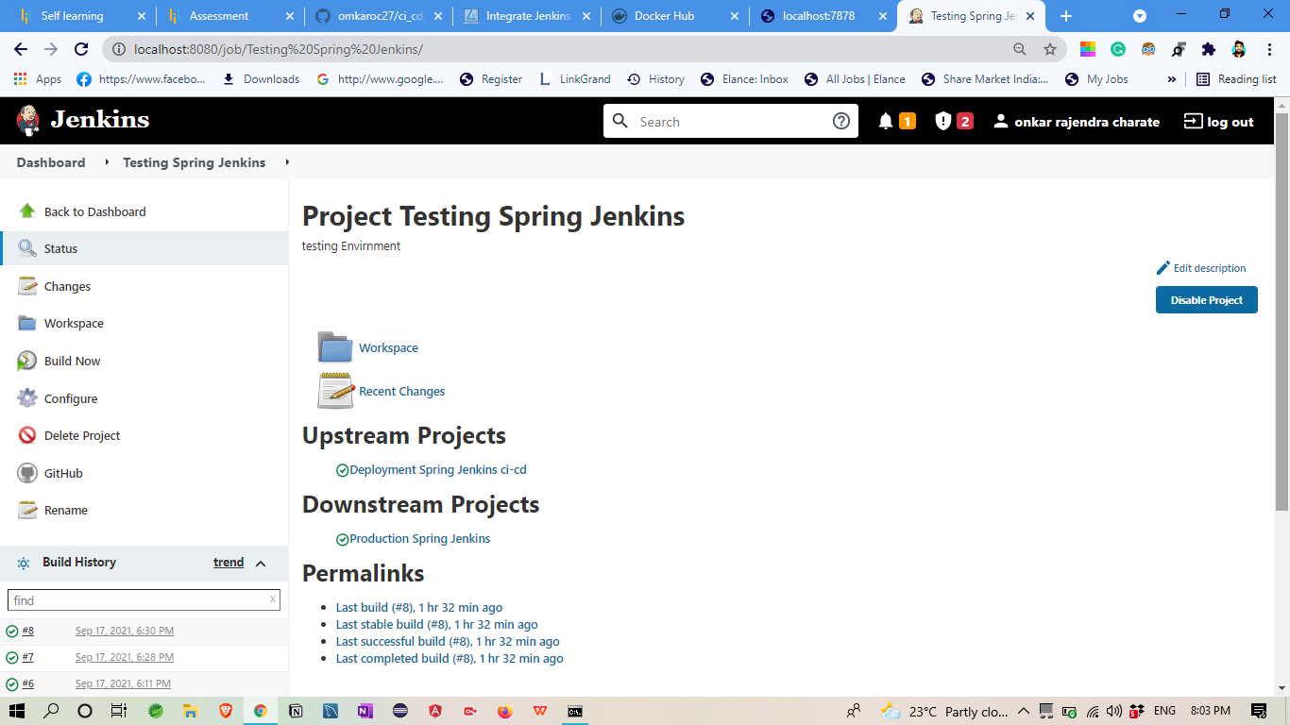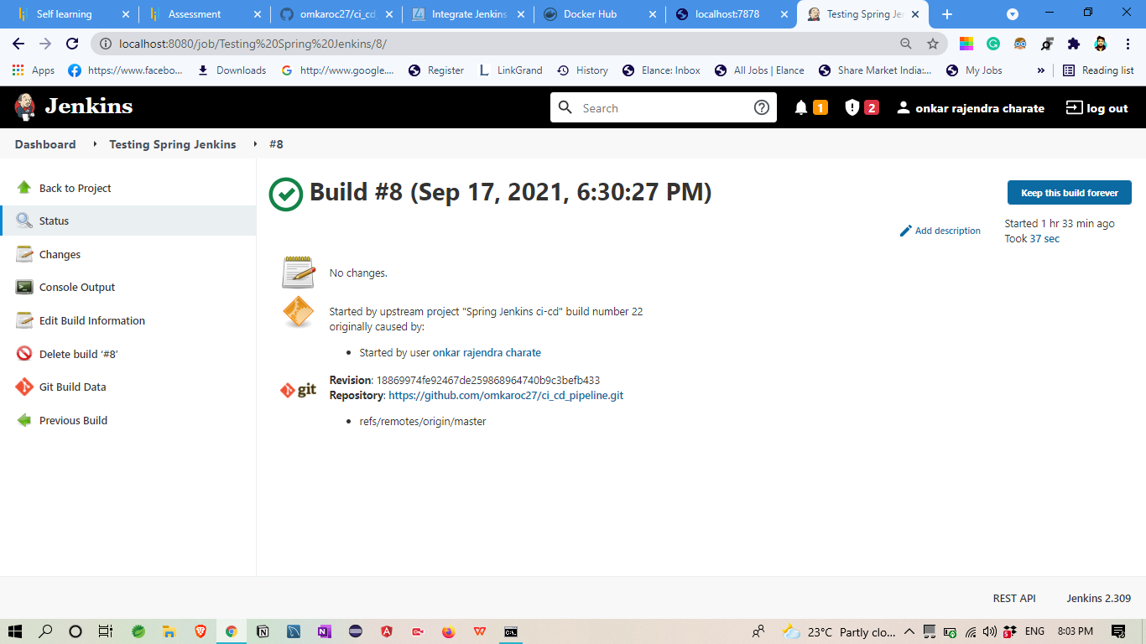

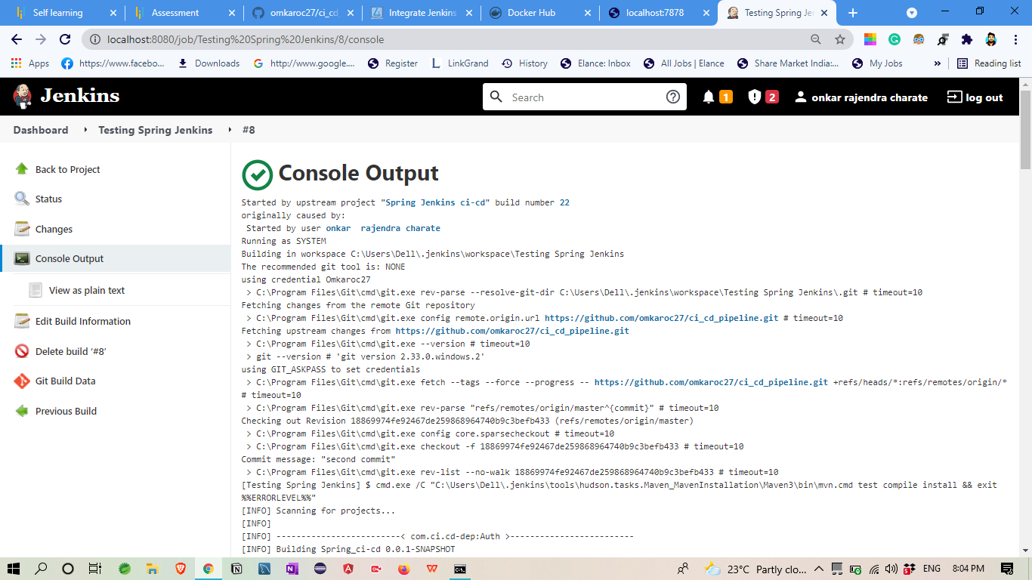

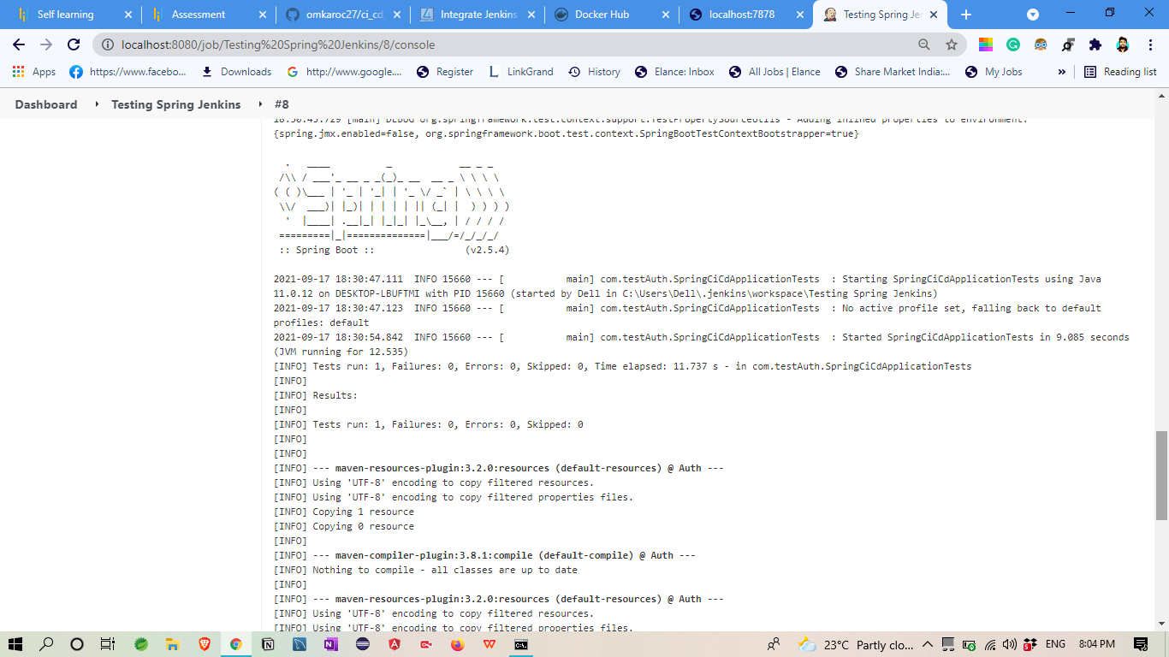

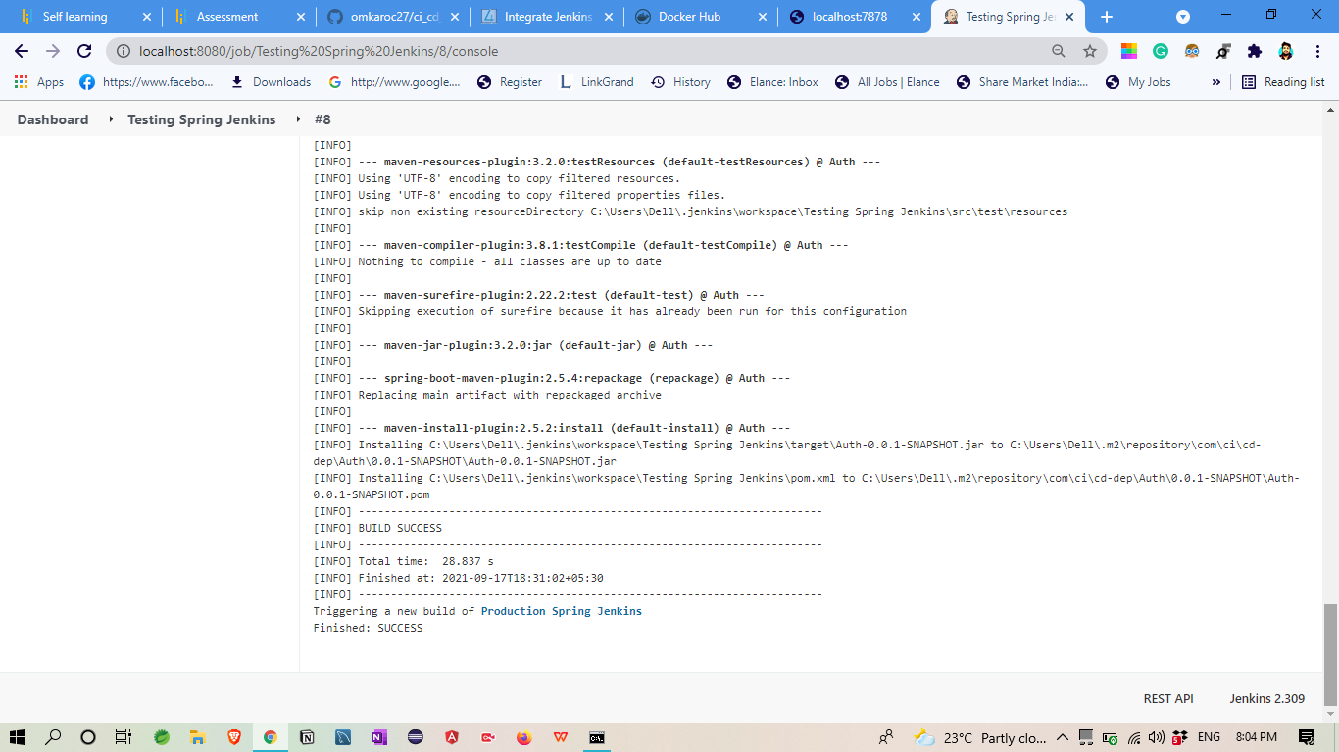

PRODUCTION

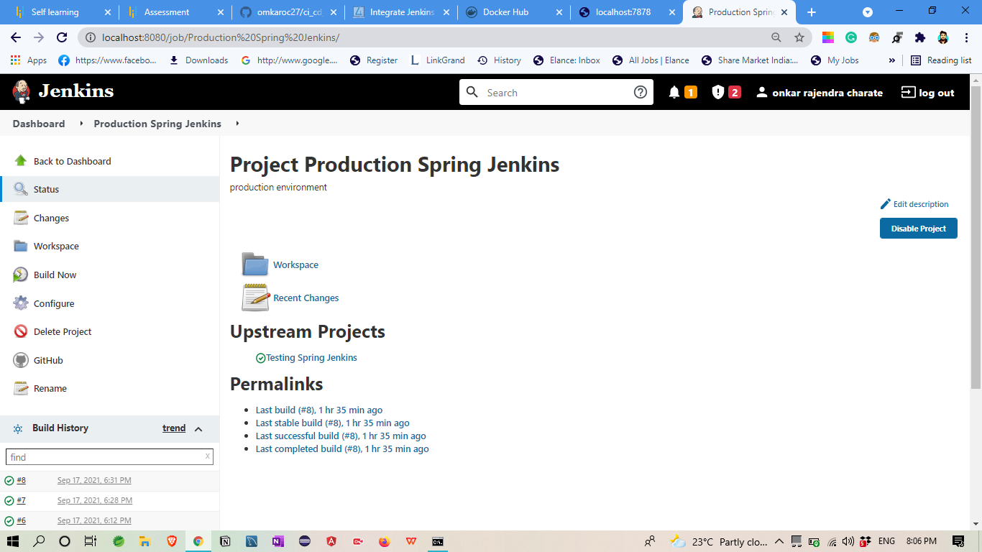

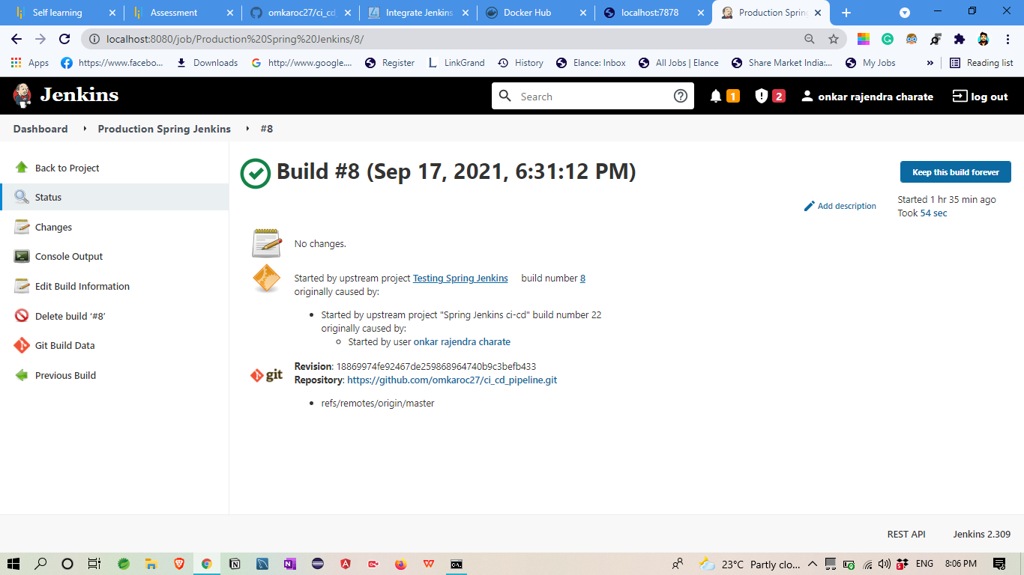

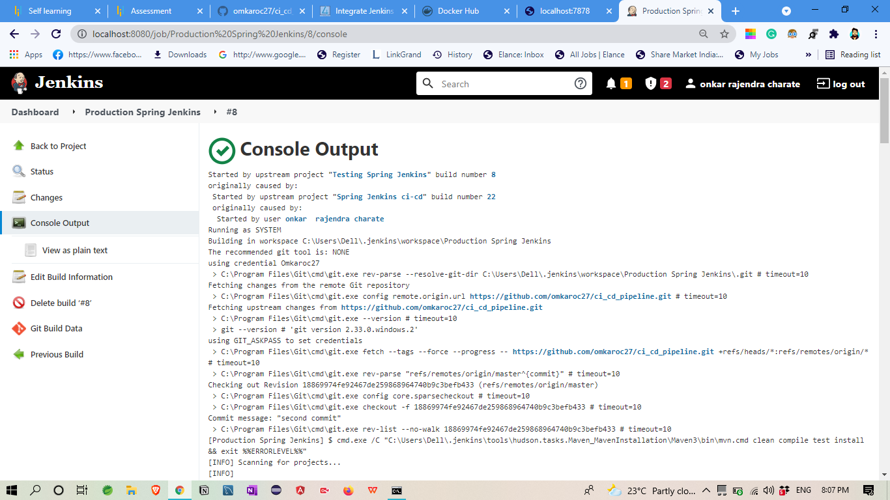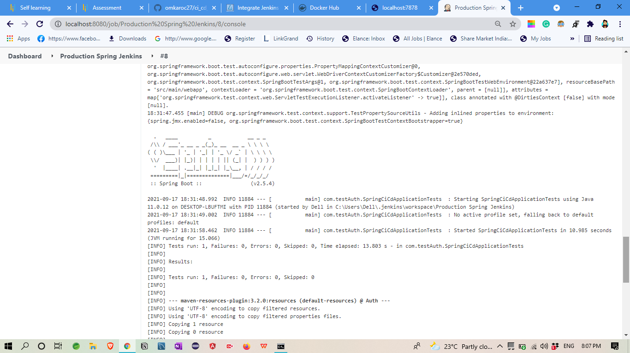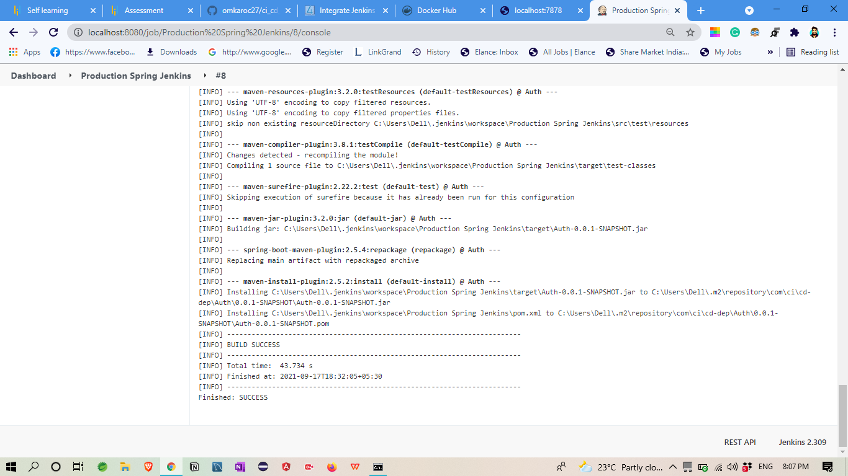

## in Jenkins I create three build for continues deployment

## And pipeline them

**build a CI/CD pipeline to demonstrate continuous deployment**

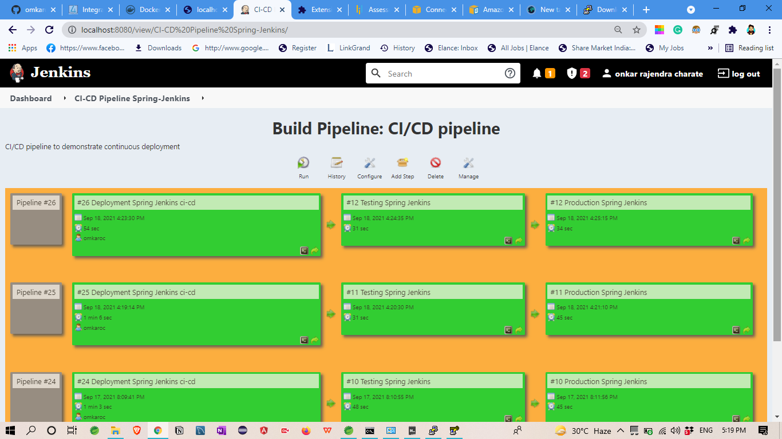

AWS EC2

1. First I create EC2 instance
2. Create Spring boot Application jar file

(Spring_CI-CD-deployment-exe.jar)

1. then its store in s3 bucket

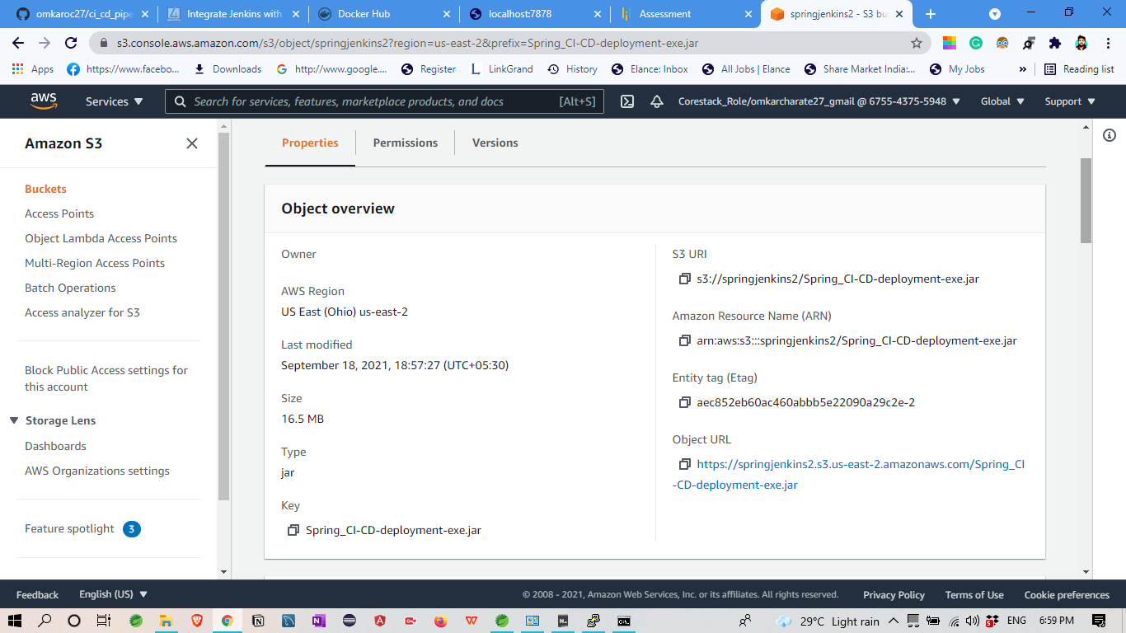

1. then open command line and deploy Application in EC2 Instance

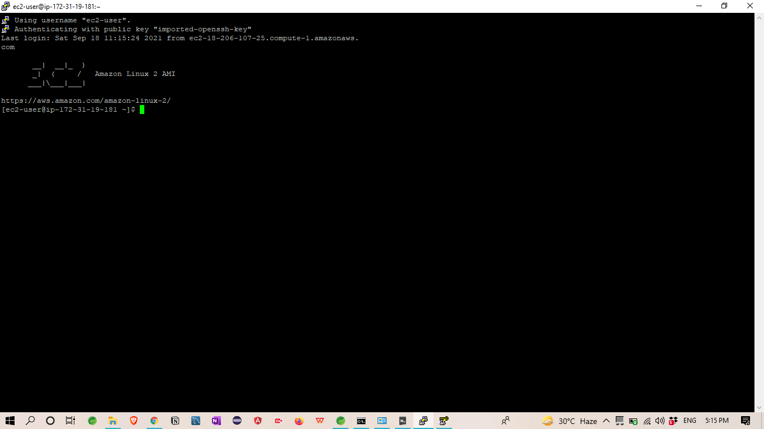

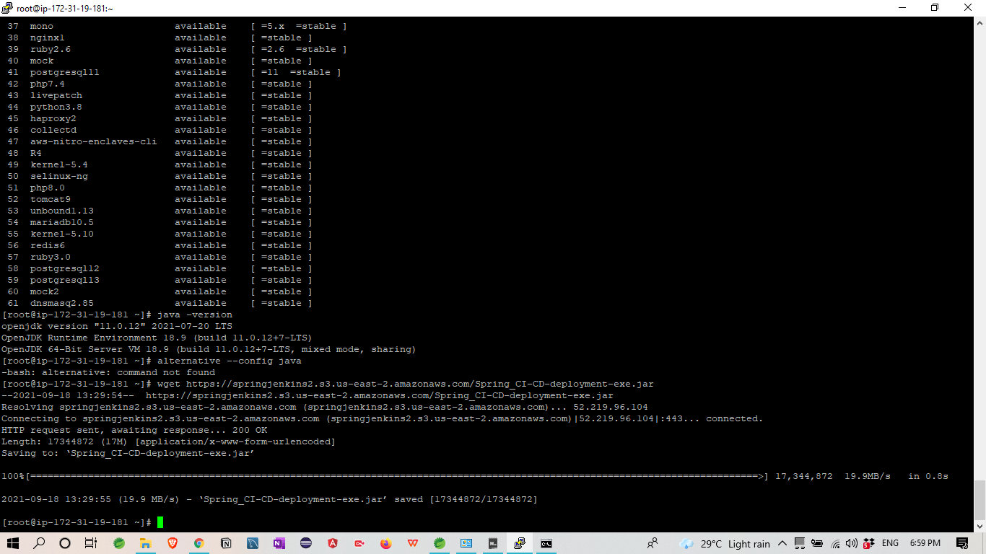

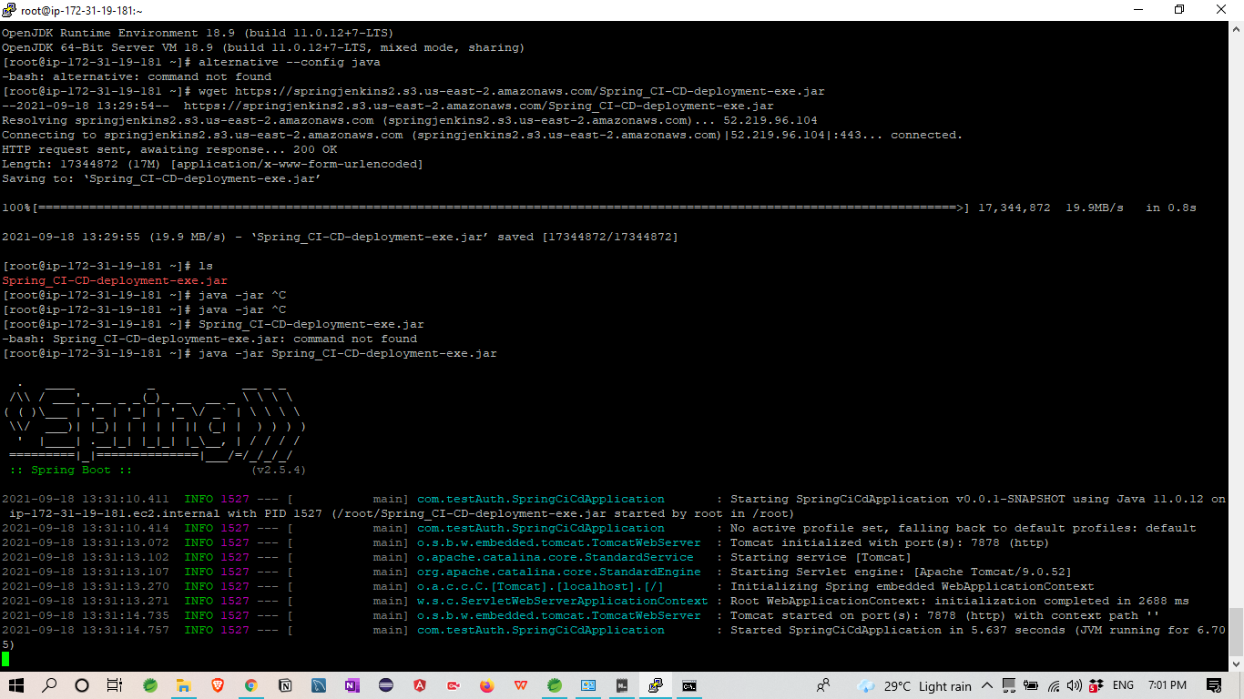

1. Application Started running with Port no 7878

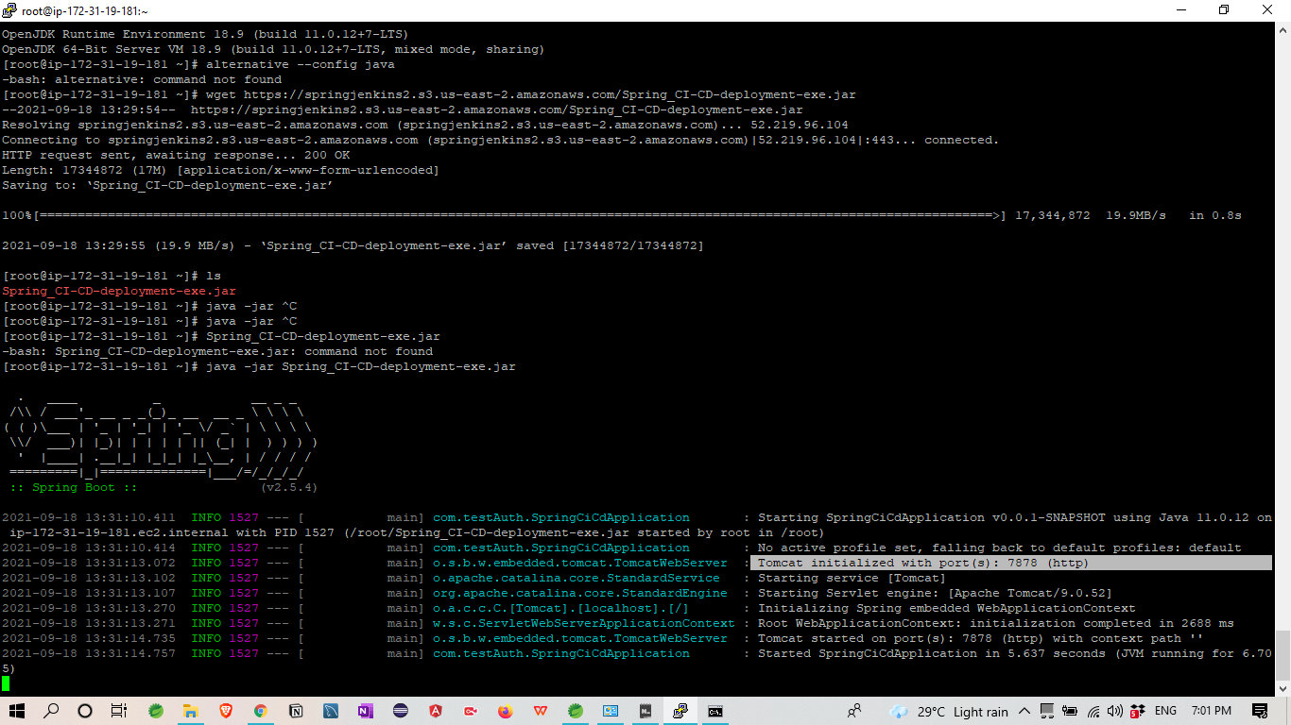

6.Last **host the application on AWS EC2 instance.**

Application running with this URL:-

ec2-18-221-78-17.us-east-2.compute.amazonaws.com:7878/

Final Output:-

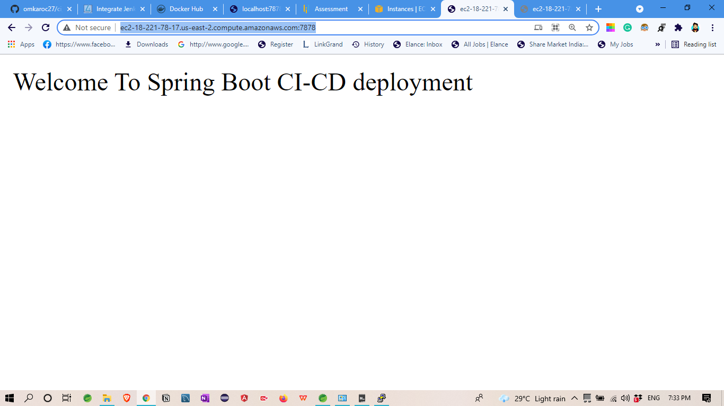

With this AWS Hosted URL

