* **Install Power BI Desktop and share the final screenshot of the report view page which appears when power desktop starts.**

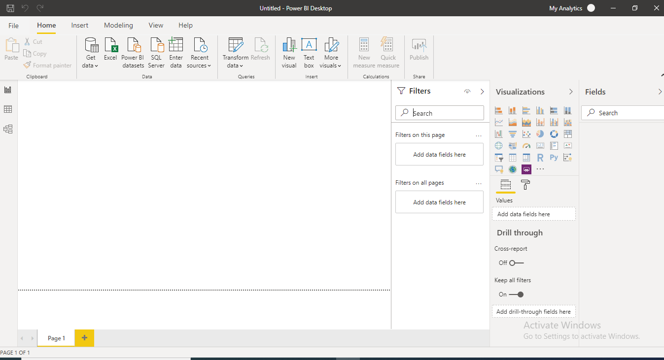

* **Prepare a document and with the following screenshot**

− Report View

− Data View

− Model View

− Power Query Editor

− Advance Editor

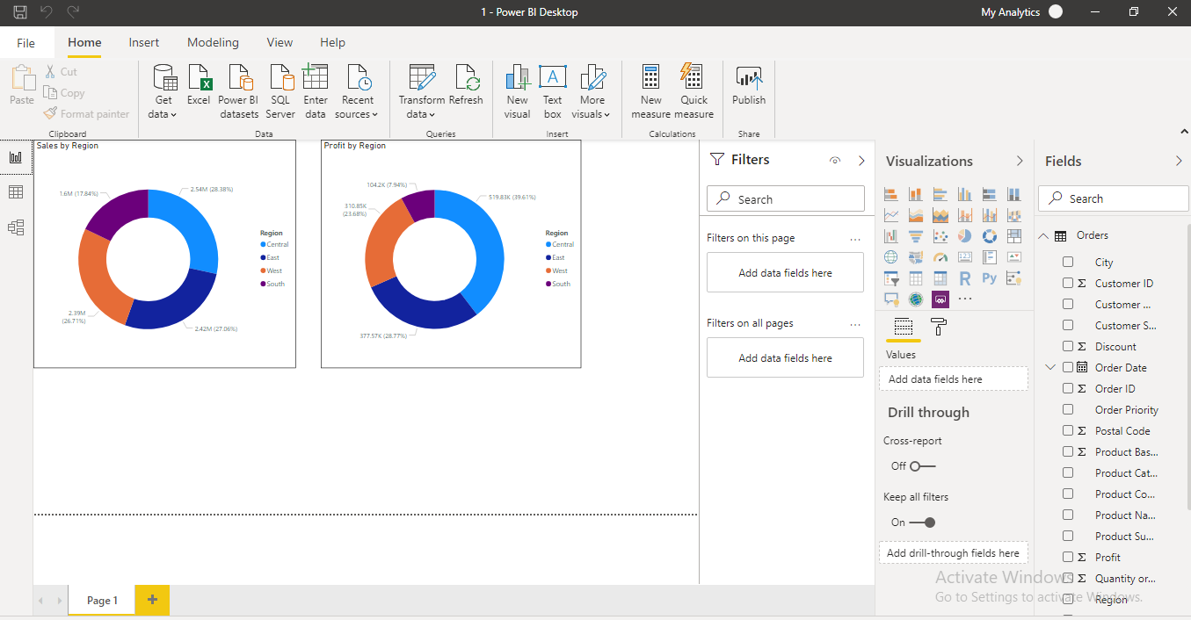

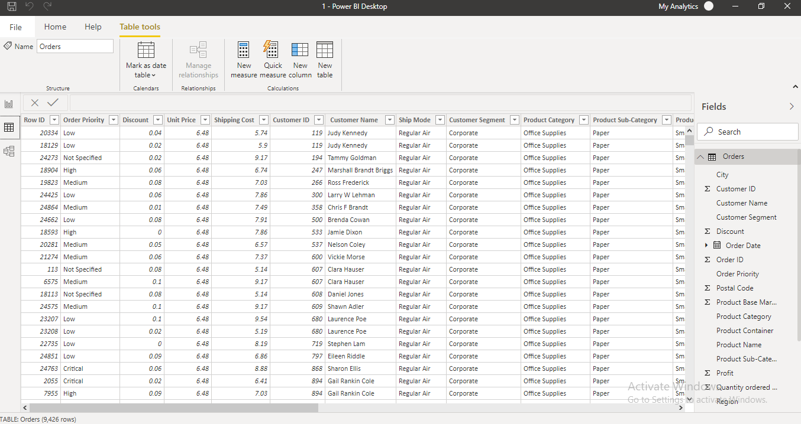

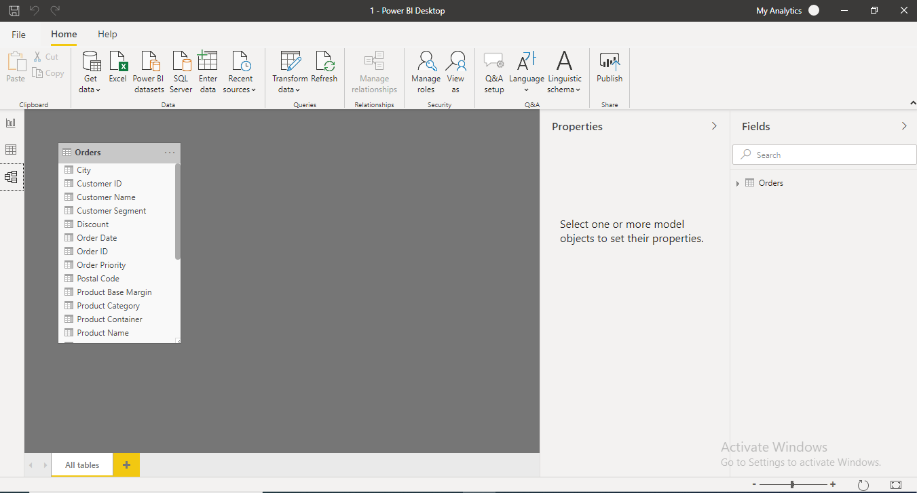

* **Power Query Editor**

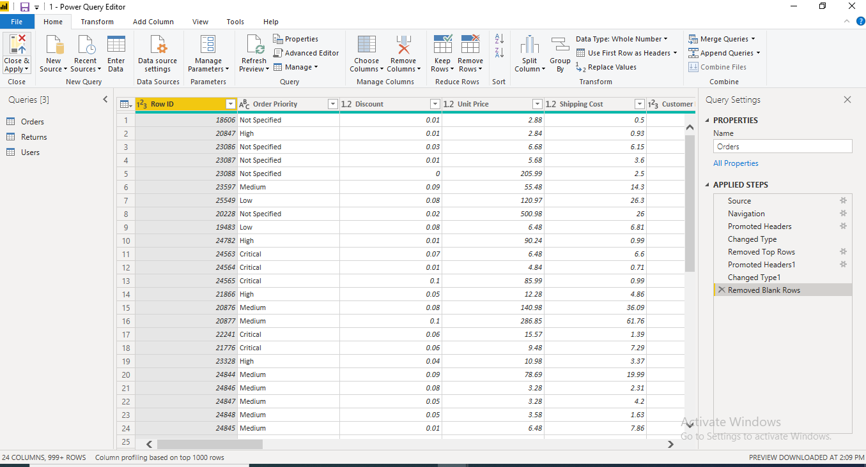

− **Advance Editor**

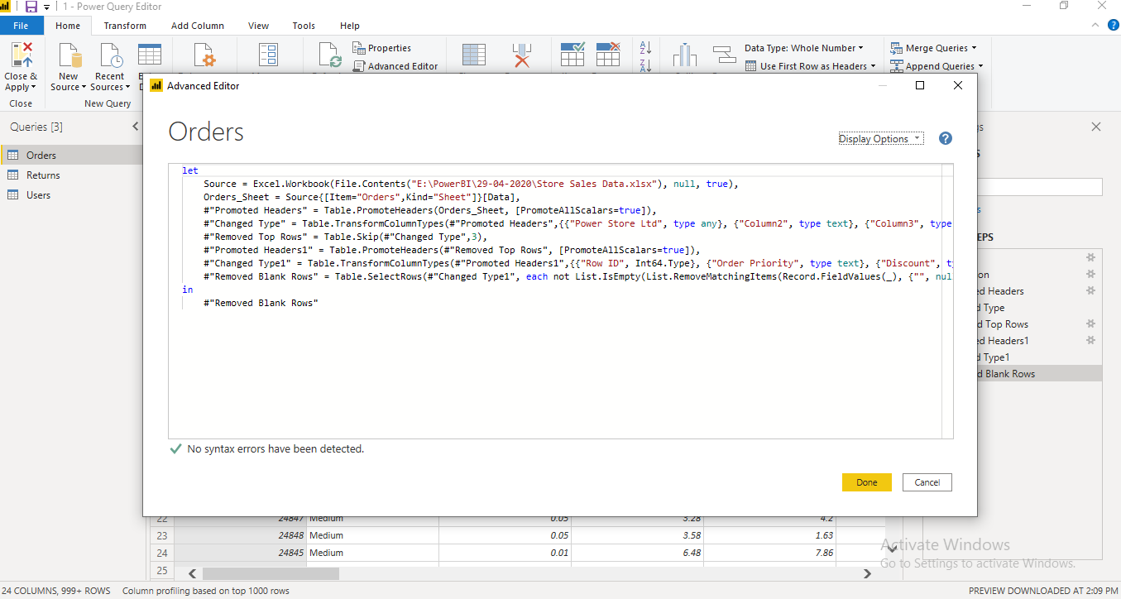

* **Prepare a document with details of the following along with their price**

− Power BI Desktop

− Power BI Pro

− Power BI Premium

**Power BI Desktop**

**Power BI Desktop** is a free application you install on your local computer that lets you connect to, transform, and visualize your data. With **Power BI Desktop**, you can connect to multiple different sources of data, and combine them (often called modeling) into a data model.

**Power BI Pro**

Power BI Pro is an individual user license that lets users read and interact with reports and dashboards that others have published to the Power BI service. Users with this license type can share content and collaborate with other Power BI Pro users. Only Power BI Pro users can publish or share content with other users or consume content that's created by others, unless a Power BI Premium capacity hosts that content.

**Purchase Power BI Pro user licenses**

This article explains how to buy Power BI Pro user licenses in the Microsoft 365 admin center. After you buy licenses, you can assign them to users in either the Microsoft 365 admin center or the Azure portal.

 Note

Beginning January 14, 2020, self-service purchase, subscription, and license management capabilities for Power Platform products (Power BI, Power Apps, and Power Automate) are available for commercial cloud customers. For more information, see [**Self-service purchase FAQ**](https://docs.microsoft.com/microsoft-365/commerce/subscriptions/self-service-purchase-faq). To enable or disable self-service purchasing capabilities, see [**Enable or disable self-service sign-up and purchasing**](https://docs.microsoft.com/en-us/power-bi/admin/service-admin-disable-self-service).

**Power BI Premium**

You can use Power BI Premium to get dedicated and enhanced resources for your organization, so users in your organization can use the Power BI service with better performance and responsiveness. For example, with a Power BI Premium subscription, you and your organization's users get access to:

* Greater scale and performance
* Flexibility to license by capacity
* Unify self-service and enterprise BI
* Extend on-premises BI with Power BI Report Server
* Support for data residency by region (Multi-Geo)
* Share data with anyone without purchasing a per-user license

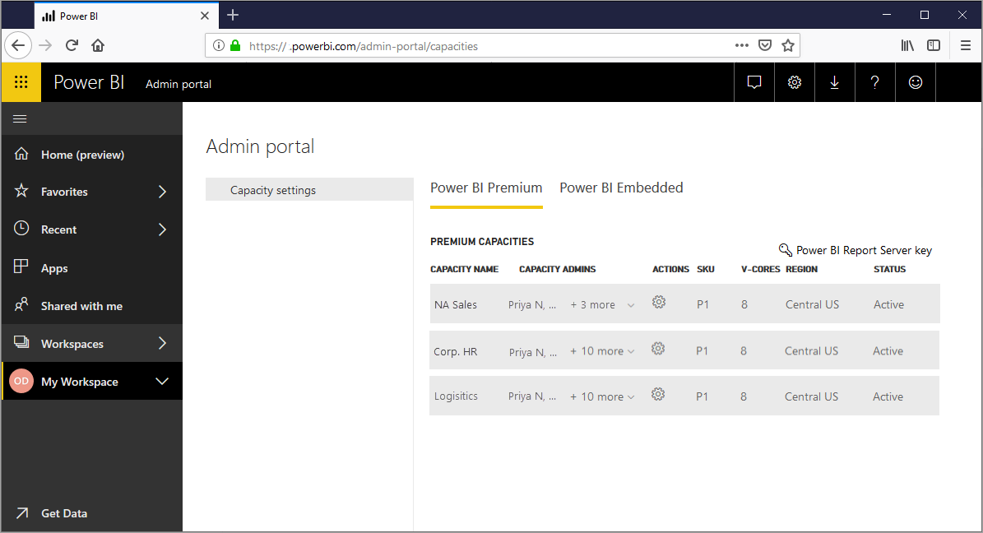

This article introduces key features in Power BI Premium. Where necessary, links to additional articles with more detailed information are provided. For more information about Power BI Pro and Power BI Premium, see the *Power BI features comparison* section of [Power BI pricing](https://powerbi.microsoft.com/pricing/).

**Subscriptions and licensing**

Power BI Premium is a tenant-level Office 365 subscription available in two SKU (Stock-Keeping Unit) families:

* **P** SKUs (P1-P5) for embedding and enterprise features, requiring a monthly or yearly commitment, billed monthly, and includes a license to install Power BI Report Server on-premises.
* **EM** SKUs (EM1-EM3) for *organizational* embedding, requiring a yearly commitment, billed monthly. EM1 and EM2 SKUs are available only through volume licensing plans. You can't purchase them directly.

An alternative approach is to purchase a **Power BI Embedded** subscription in Azure. There is a single **A** (A1-A6) SKU family that requires no commitment and is billed hourly for use white labeling Power BI in applications, portals, and websites or as a way to test P or EM capacities. All SKUs deliver v-cores to create capacities, but the EM SKUs are restricted for smaller scale embedding. EM1, EM2, A1, and A2 SKUs with less than four v-cores do not run on dedicated infrastructure.

While the focus of this article is on the P SKUs, much of what is described is also relevant to the A SKUs. In contrast to the Premium subscription SKUs, Azure SKUs require no time commitment and are billed hourly. They deliver full elasticity enabling scale up, scale down, pause, resume, and delete.

Azure Power BI Embedded is largely out of scope for this article, but it is described in the [Testing Approaches](https://docs.microsoft.com/en-us/power-bi/service-premium-capacity-optimize#testing-approaches) section of the Optimizing Premium capacities article as a practical and economic option to test and measure workloads. To learn more about Azure SKUs, see [Azure Power BI Embedded Documentation](https://azure.microsoft.com/services/power-bi-embedded/).

**Purchasing**

Power BI Premium subscriptions are purchased by administrators in the Microsoft 365 admin center. Specifically, only Office 365 Global administrators or Billing Administrators can purchase SKUs. When purchased, the tenant receives a corresponding number of v-cores to assign to capacities, known as *v-core pooling*. For example, purchasing a P3 SKU provides the tenant with 32 v-cores. To learn more, see [How to purchase Power BI Premium](https://docs.microsoft.com/en-us/power-bi/service-admin-premium-purchase).