**TEAM NAME: SPECTER LABS.**

**TEAMMATES: Saarthak Agarwal, Santosh Vasisht, Yukti Khosla.**

**Our Approach**

**Setup**

**Urban Regions:**

We develop an app where each voter has to create an account to have their names on the voters’ list. This procedure of creating accounts should be done in two weeks and would be completed two weeks before the polling dates.

To create the account, the voter needs to upload three government-approved IDs, which are:

* Aadhar Card – for Fingerprint and Retina information related to the cardholder.
* PAN card /Ration card/ Passport
* Driving license/ Credit card/ Bank passbook/ KSC(Kisan Suraksha Card)

All the voters would be given 1 vote in the form of credit.

**Rural Areas:**

An official appointed by the Election Commission will hold a special account in our app which would let the official create accounts for people who lack the required facilities to create an app.

The requirements for creating a voters’ account on our app remains the same.

**Advantages of the app:**

* We propose this method in order to do away with the voter IDs. This way, we also tackle the problem of names missing from the voters’ list.
* We need three Government IDs and not just the Aadhar Card because Aadhar Cards of non-existent people are easily available in the black market. Moreover, three IDs ensures the creation of valid accounts only.
* People who turn 18 do not have to go through the tedious process for applying for Voter IDs, all that is needed is uploading three different kinds of government IDs and they have their names on the voters’ list once the verification is done. Hence, a person who is eligible is not deprived of their right.

**Day of polling:**

People would be given a particular location in order to cast their votes. This will prevent the chaos and the wastage of hours that comes with long queues.

Government Banks, Schools, and other such institutions with the facility of Computers and an Internet connection would be serving as Polling stations across the country.

People would get a one-time QR Code on their apps which they scan at the polling stations to confirm their presence. Once the QR codes are scanned, they move to a booth which consists of a computer with an on-screen animated guide in the voters’ preferred language to prevent language from being a barrier thereby guiding them through all the steps to prevent any human intervention in any of the procedures, hence preventing any sorts of manipulation and also ensures the voters’ safety.

In order to prevent any mistakes from the voters’ side, the voters need to confirm their vote. First, they scan their fingerprints which are verified against their fingerprints in the Aadhar database, they then cast their vote. Once done, they have to do an eye-scan, their retinas are matched against the ones stored in the Aadhar Database, once verified, they cast their vote again in order to confirm that there was not any mistake while casting the vote in their first try.

Note that the voters are not getting two votes, it’s the same vote is cast twice to confirm their choice. This also ensures the absence of another person, preventing any kind of manipulation or oppression, since only the voters are allowed into the polling stations with just one government official in charge.

**Use of Blockchain:**

Public blockchains come with a few disadvantages, the primary ones include heavy power consumption that is necessary to maintain the distributed public ledger. Other issues include lack of complete privacy and anonymity leading to weaker security of the network and of the participant’s identity. Along with genuine contributors, at times the participants may also include the faulty ones who may be involved in malicious activities like hacking, token stealing, and network clogging.

The dangers of centralization that come with the use of PoW cannot be denied. Additionally, the public blockchain’s use of a consensus algorithm like PoW currently requires a huge amount of computational power and therefore enormous amounts of energy.

On the other hand, private blockchains control who is allowed to participate in the network, execute the consensusprotocol that decides the mining rights and rewards, and maintain the shared ledger. The owner or operator has the rights to override, edit or delete the necessary entries on the blockchain as required.

Therefore, in the true sense, a private blockchain is not decentralized and is a distributed ledger. Technically speaking, not everyone can run a full node on the private blockchain, make transactions, or validate/authenticate the blockchain changes.

Hence, we use the third category of blockchains that is permissioned blockchains, which allow a mixed bag between the public and private blockchains with lots of customization options. With permissioned blockchain systems, the consensus process is controlled by a pre-selected list of participants. Users can’t join without permission.

Yes, within these kinds of blockchain networks, the participants are typically known but with our architecture, the names and the choices they make would be encrypted to prevent any kind of identity leaks.

We use PBFT (**Practical Byzantine Fault Tolerance**) as our consensus mechanism.

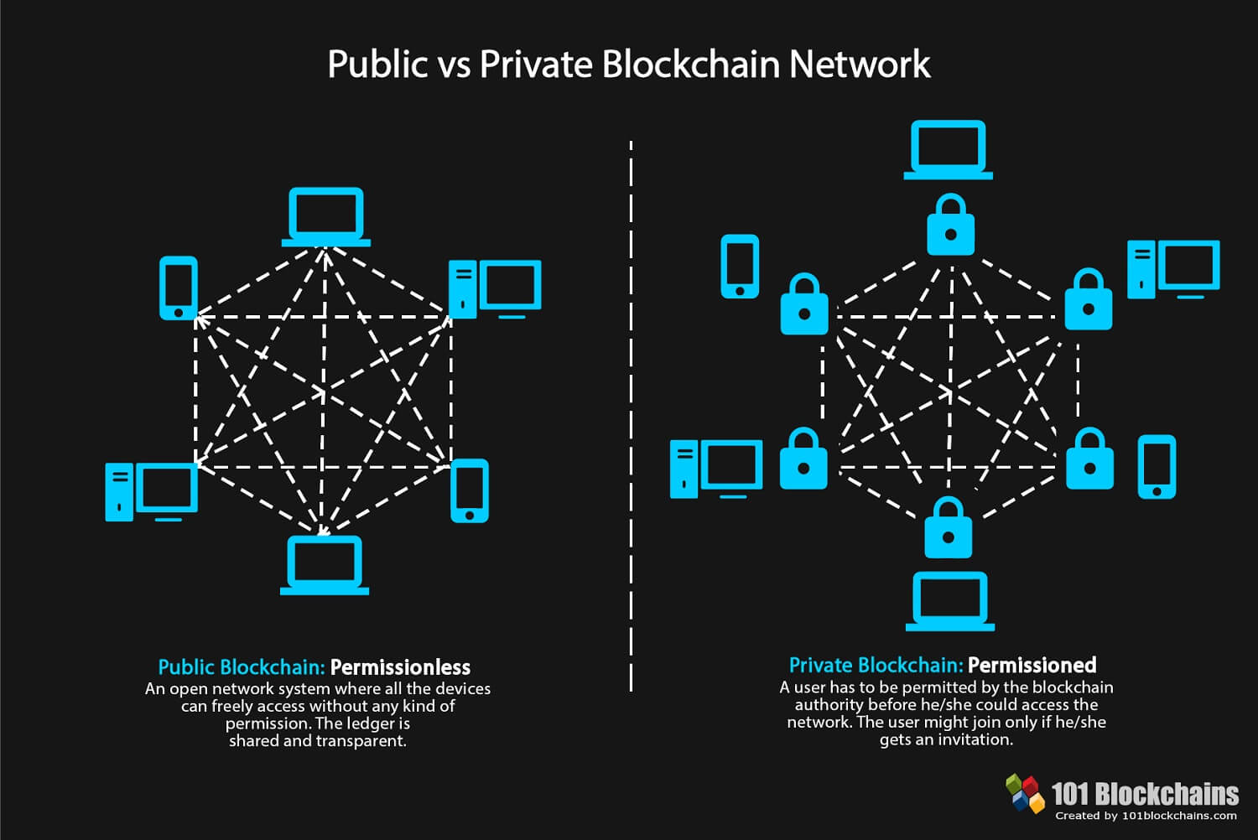

*Source: 101 Blockchains*

The vote which is given to the voters in the form of a credit, once cast, is sent to the Voted party’s account.

Once the polling is over, the party with maximum credits and has secured majority is declared as the winner.

Additionally, voters can also send their credits to the NOTA account. If NOTA credits exceed 1/3 of the votes, no absolute winner will be announced.

**Features of the app:**

* The app has a decision helper; it has a list of promises made vs promises kept, attendance in the house, criminal record, fund utilization, questions asked in the house, number of debates participated in and more.
* The app translates into 22 languages. This tackles the problem of language being a barrier.
* For NRIs the app can be used as a voting machine. Allowing them to vote from their phone directly. (With the restriction that the device should have a fingerprint scanner).
* The app would send a reminder regarding upcoming elections and information regarding where the polling booths are being set up and voters can also choose their stations.
* Once the polling is over, the voters can view who they have voted for. Any voter can verify that their vote has been counted and not tampered with, hence ensuring transparency and security.
* Voters can also view graphs for the statistics related to votes from multiple sub-regions like city, district and state.
* After the, the results of the elections come on the app within minutes as it is being updated each time a voter sends a credit.