Criteria

* FRR (%) = 1-GAR (%) [AREA]
  + FRR $=\frac{\text{false attempts}}{\text{total attempts}}$
* FAR (%) = FAR [AREA]
  + FAR $=\frac{accepted attempts}{total attempts}$
* EER (%)
  + EER: When false positive rate equals false negative rate

Mode 1

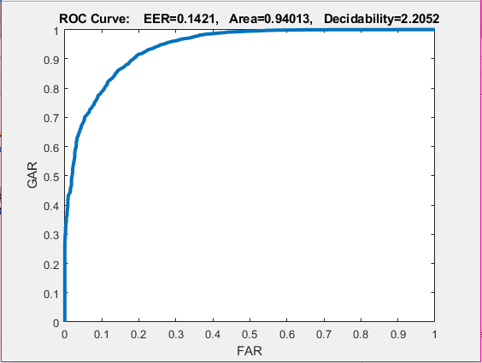 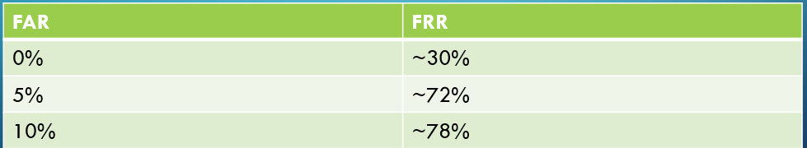

* FRR: 0.05987
* FAR: 0.94013
* EER : 0.1421

Mode 2

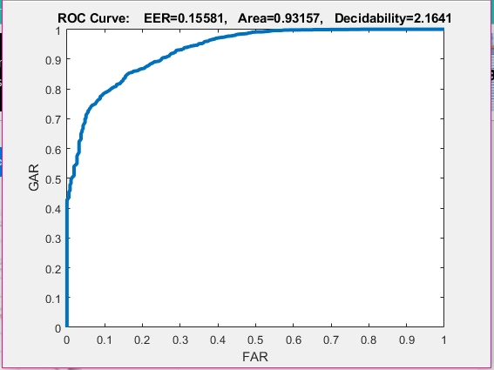 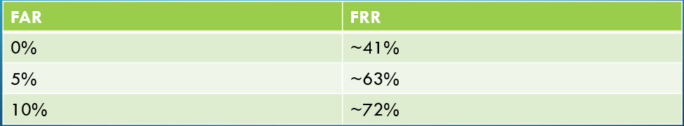

* FRR: 0.06843
* FAR: 0.93157
* EER : 0.15581

ROC curves are a plot of false positive rate vs true positive rate. In the ROC curve given in the results, the area under the curve shows accuracy. The larger the area, the more accurate the classifier is. As a result, since the ROC area of Mode 1 (94.0 %) was greater than the ROC area of Mode 2 (93.2 %), **Mode 1 was slightly more accurate.**

EER is also a good measurement of classifier accuracy, and since the EER of Mode 1 (14.2%) was less than Mode 2 (15.6%), it also shows that **Mode 1 was a little more accurate classifier than Mode 2.**

This makes sense from a theoretical perspective because the first five photos in each of the 40 subjects, from Mode 1, were used to create the PCA vector space. This was then utilized from a training and testing perspective, with the corresponding labels, to produce the accurate results. The labels were created using the 0 values for each corresponding genuine user and 1 for each imposter. As a result, the testing results, which were images 6-10 from Mode 1 was based on a trained version of images 1-5 from the 40 subjects. On the contrary, Mode 2 had an increased training sample size by 25% in comparison to Mode 1, so that could also lead to the notion that Mode 2 could perform better. However, this is probably why Mode 1 barely performs better than Mode 2, with both models giving very similar results. **Therefore, Mode 1 giving slightly better results than Mode 2 makes sense from a theoretical perspective.**