Criteria

* FRR (%) = 1-GAR (%) [AREA]
  + FRR $=\frac{\text{false attempts}}{\text{total attempts}}$
* FAR (%) = FAR [AREA]
  + FAR $=\frac{accepted attempts}{total attempts}$
* EER (%)
  + EER: When false positive rate equals false negative rate

Mode 1

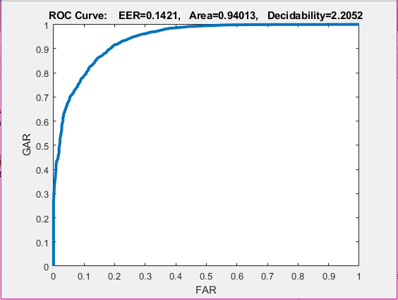 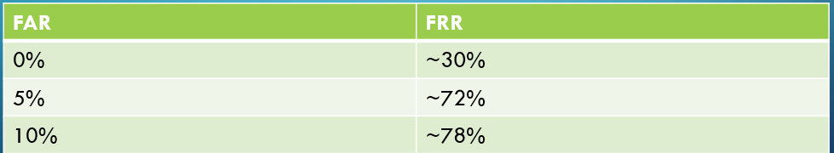

* FRR: 0.05987
* FAR: 0.94013
* EER : 0.1421

Mode 2

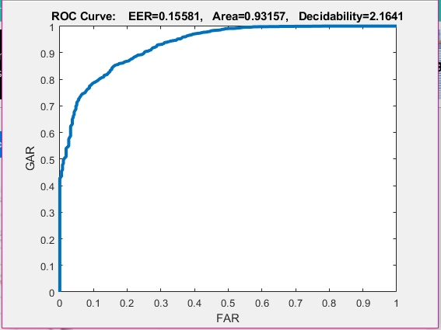 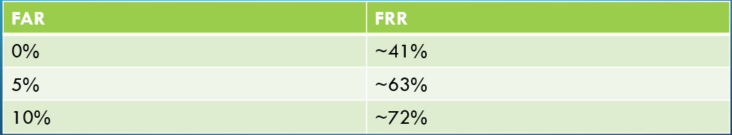

* FRR: 0.06843
* FAR: 0.93157
* EER : 0.15581

ROC curves are a plot of false positive rate vs true positive rate. In the ROC curve given in the results, the area under the curve shows accuracy. The larger the area the more accurate the classifier is. As a result, since ROC area of Mode 1 (94.0 %) was greater than the ROC area of Mode 2 (93.2 %), **Mode 1 was more accurate.**

EER is also a good measurement of classifier accuracy, and since EER of Mode 1 (14.2%) was less than Mode 2 (15.6%), it also shows that **Mode 1 was a more accurate classifier.**

This makes sense from a theoretical perspective because the first five photos in each of the 40 subjects was used to create the PCA vector space. This was then utilized from a training and testing perspective, with the corresponding labels, to produce the accurate results. The labels were created using the 0 values for each corresponding genuine user and 1 for each imposter. As a result, the 0 matrix was created in a diagonal form. Therefore, Mode 1 giving better results than Mode 2 was expected from a theoretical perspective.