**Task 1:**

**Write a function to compute 5/0 and use try/except to catch the exceptions.**

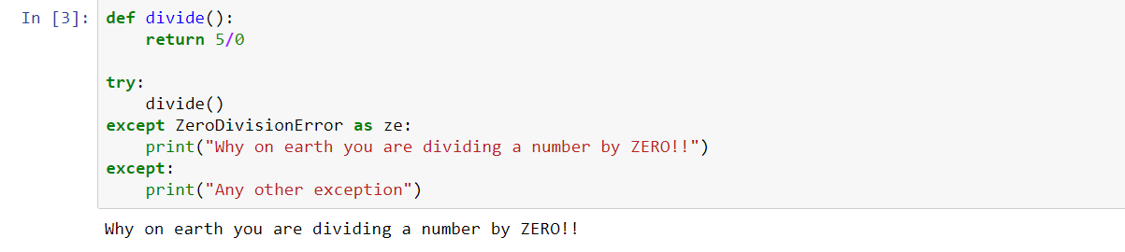

**Implement a Python program to generate all sentences where subject is in ["Americans", "Indians"] and verb is in ["Play", "watch"] and the object is in ["Baseball”, “cricket"].**

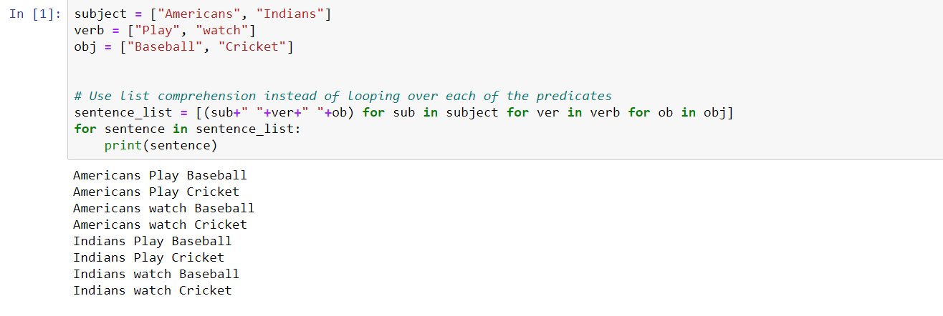

**Write a function so that the columns of the output matrix are powers of the input vector.**

