Selenium is an open-source umbrella project encompassing various tools and libraries designed to support browser automation. Its primary use is in automating web applications for testing purposes, but it can also be utilized for other web-based administration tasks like data extraction or repetitive form filling.

Key components of the Selenium suite include:

* **Selenium WebDriver:**

This is a collection of language-specific bindings (e.g., Java, Python, C#, Ruby) that allow you to programmatically control a web browser. It enables the creation of robust test automation suites and scripts for functional and regression testing.

* **Selenium IDE:**

A browser add-on (for Chrome, Firefox, Edge) that provides a record-and-playback tool for authoring functional tests. It allows users to record their interactions with a web application and then play them back, making it useful for creating bug reproduction scripts or assisting in exploratory testing.

* **Selenium Grid:**

This component enables the parallel execution of tests across multiple machines, browsers, and operating systems simultaneously. It significantly reduces test execution time, especially in large-scale testing environments.

Selenium is widely adopted due to its open-source nature, cross-browser and cross-platform compatibility, and support for various programming languages. It allows testers and developers to automate web application testing, ensuring consistency and compatibility across different environments.

**Selenium History**

Selenium was developed by Jason Huggins in 2004 at ThoughtWorks. He was working on an internal/web application at ThoughtWorks after some time he noticed that instead of testing his application manually, he could automate his testing. He developed a JavaScript program to test his web application, allowing him to automatically rerun tests. He called his program  “JavaScriptTestRunner”. After some time this tool was open-sourced and renamed as Selenium Core.   
Selenium Remote Control was developed by Paul Hammant. The reason behind developing Selenium RC was testers who are using Selenium core had to install the whole application under test and the web server on their local computers because there were some restrictions forced by the same-origin policy. To overcome this restriction Paul Hammant came to a decision and developed a server that will act as an HTTP proxy to trick the web browser, so that thinks that Selenium Core and the web application being tested came from the same domain.   
[Selenium IDE](https://www.geeksforgeeks.org/software-testing/selenium-ide/) was developed by Shinya Kasatani of Japan. It was implemented as a Firefox add-on/plugin and now we can use Selenium IDE on every web browser. He gave Selenium IDE to the Selenium project in 2006.

Selenium Grid was developed by Philippe Hanrigou in 2008. It is a server that allows the test to use web browser instances running on remote machines. It provides the ability to run the test on a remote web browser, which helps to divide a load of testing across multiple machines and it will save enormous time. It allows the executing parallel tests across different platforms and operating systems. Grid provided, as open-source, a similar capability to the private Google cloud for Selenium RC. Pat Lightbody had already made a private cloud system named "HostedQA” and sold it to Gomez, Inc.   
Selenium WebDriver was developed by Simon Stewart in 2006. WebDriver automates and controls initiated by the web browser. It does not rely on JavaScript for automation. It controls the browser directly by communicating with it. It was the first cross-platform testing framework that could control the browser from the OS level.   
In 2009, after a meeting whole Selenium team decided to merge the two projects Selenium RC and WebDriver, and call it Selenium 2.0.

**Selenium IDE**

Selenium, a powerful automation tool, simplifies the process of testing web applications by automating browser interactions. It allows testers to write scripts in various languages, making it versatile for different environments. Components like WebDriver and Grid enable more efficient testing, ensuring the application functions smoothly across browsers.

At the beginning, Selenium IDE( Integrated Development Environment ) was implemented as a Firefox add-on/plugin and now it can be used Selenium IDE on every web browser. It provides record and playback functionality. The figure shows Selenium IDE.

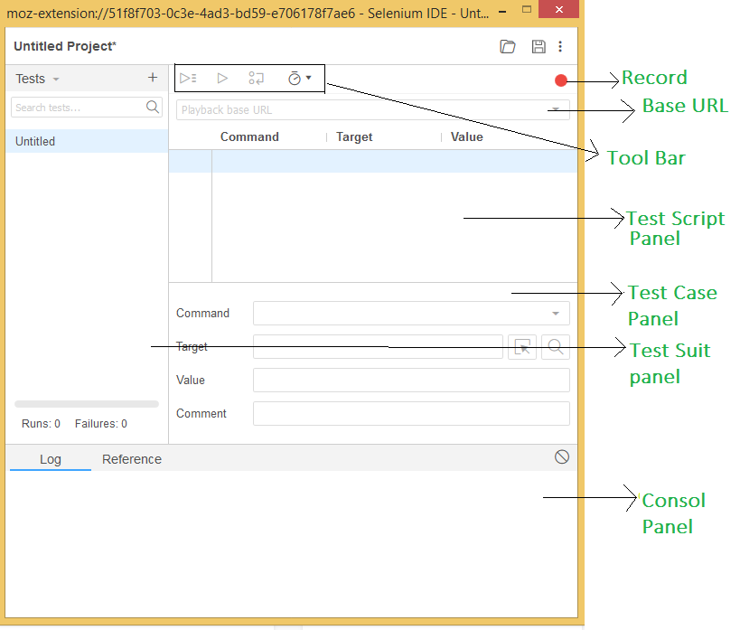Selenium IDE

**Advantages of Selenium IDE:**

* It is an open-source tool.
* Provide base, for extensions.
* It provides multi-browser support.
* No programming language experience is required while using Selenium IDE.
* The user can set breakpoints and debug.
* It provides record and playback functions.
* Easy to Use and install.
* Languages supported by Selenium IDE are Java, Python, C# etc.

**Dis-advantages of Selenium IDE:**

* There are no support iteration and conditional operations.
* Execution is slow.
* It does not have any API.
* It does not provide any mechanism for error handling.
* Dynamic web applications are not used to test.

**Selenium RC**

RC stands for Remote Control. It allows the programmers to code in different programming languages like C#, Java, Perl, PHP, Python, Ruby, Scala, Groovy. The figure shows how the Remote Control Server works.

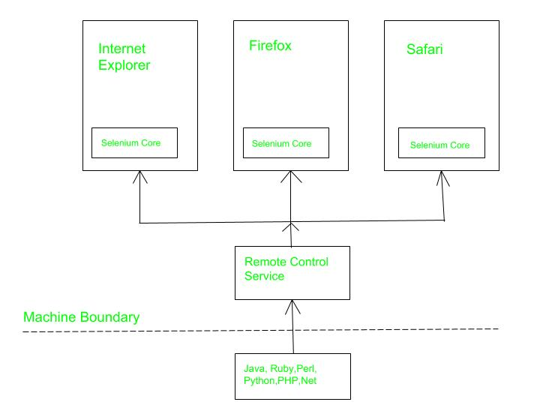Selenium RC

**Advantages of Selenium RC**

* It supports all web browsers.
* It can perform iteration and conditional operations.
* Execution is faster as compared to IDE.
* It has built-in test result generators.
* It supports data-driven testing.
* It has a matured and complete API.
* There is also support for cross browser testing.
* There is also support for user preferred languages.

**Dis-advantages of Selenium RC**

* Programming language knowledge is needed.
* It does not support testing for IOS/Android.
* It is a little slower than Selenium Webdriver in terms of execution.
* It does not support record and playback functions.
* Complicated configuration than selenium IDE.
* The API in selenium RC are quite confusing.

**Selenium Web Driver**

Selenium Web Driver automates and controls initiated by the web browser. It does not rely on JavaScript for automation. It controls the browser directly by communicating with it. The figure shows how web driver works as an interface between Drivers and Bindings

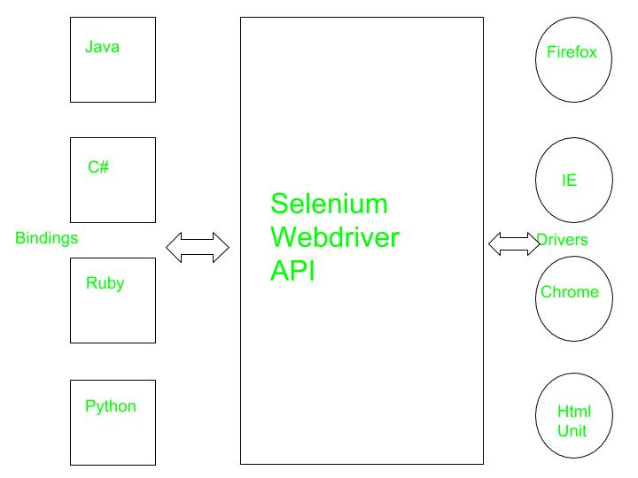Selenium Web Driver

**Advantage of Selenium Web Driver**

* It directly communicates with the web browser.
* Execution is faster.
* It supports listeners.
* It supports IOS/Android application testing.
* Installation is simpler than Selenium RC.
* Purely object-oriented.
* No need of any separate Component.

**Dis-advantage of Selenium Web Driver**

* It requires programming knowledge.
* There’s no built-in mechanism for the generation of the test result file.
* Installation process is quite complicated than selenium IDE.
* There is no support for any new browsers.
* There is no detailed test reports.

**Selenium Grid**

Basically, it is a server that allows the test to use a web browser instance running on remote machines. It provides the ability to run the test on a remote web browser, which helps to divide a load of testing across multiple machines and it will save enormous time. It allows executing parallel tests across different platforms and operating systems.

Selenium Grid is a network of HUB & nodes. Each node registers to the HUB with a certain configuration and HUB is aware of the browsers available on the node. When a request comes to the HUB for a specific browser [with desired capabilities object], the HUB, if found a match for the requested web browser, redirects the call to that particular Grid Node and then a session is established bi-directionally and execution starts. It makes the easy use for multiple machines to run the tests in parallel.

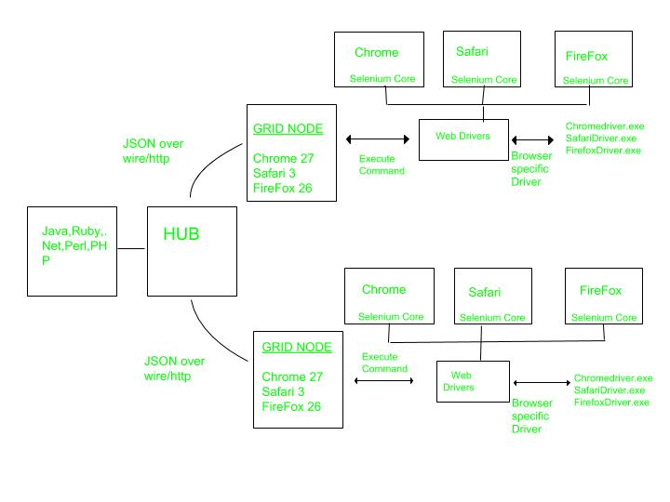Selenium Grid

**Features of Selenium**

1. **Cross-browser compatibility:** Selenium supports testing on multiple browsers like Chrome, Firefox, Safari, Edge, and Internet Explorer.
2. **Language support:**Selenium supports multiple programming languages like Java, Python, C#, Ruby, and JavaScript, making it easy for developers to write automation scripts in their preferred language.
3. **Multiple testing frameworks:**Selenium can integrate with multiple testing frameworks like JUnit, TestNG, and NUnit.
4. **Record and playback:**Selenium provides the option to record and playback test scripts, which makes it easy for testers to create test cases without having to write code.
5. **Parallel execution:**Selenium can execute test cases in parallel across multiple machines, which reduces the overall execution time.
6. **Element identification:**Selenium can identify web elements using various locators like ID, Name, XPath, CSS Selector, and Class Name.
7. **Handling dynamic elements:** Selenium can handle dynamic web elements like dropdowns, pop-ups, and alerts.
8. **Integration with third-party tools:**Selenium can integrate with various third-party tools like Jenkins, Docker, and Appium.
9. **Support for mobile testing:** Selenium can also be used for mobile testing using Appium.

**Advantages of using Selenium**

1. **Open-source:**Selenium is open-source, making it freely available to anyone who wants to use it.
2. Cross-platform compatibility: Selenium supports multiple operating systems and browsers, making it a versatile tool for automating web applications.
3. **Multiple programming language support:**Selenium supports multiple programming languages, including Java, Python, Ruby, and C#, making it accessible to a wide range of developers.
4. **Large community:**Selenium has a large and active community of users, providing a wealth of resources and support for those who use it.
5. **Cost-effective:**Because Selenium is open-source, there is no need to pay for expensive licenses, making it a cost-effective solution for automating web applications.
6. **Integration with other tools:**Selenium can be integrated with other testing tools, such as JUnit and TestNG, making it a flexible and comprehensive solution for automating web applications.

**Disadvantages of Selenium**

1. **Steep learning curve:** The syntax and architecture of Selenium can be complex, making it challenging for inexperienced developers to learn and use effectively.
2. **Maintenance:** Selenium scripts require ongoing maintenance and updates as the web application changes, adding to the overall cost of using the tool.
3. **Limited testing capabilities:** Selenium is primarily used for automating web applications, and may not be suitable for other types of testing.
4. **Test script creation:**Creating effective and comprehensive test scripts for Selenium can be time-consuming and challenging, requiring significant effort from the development team.
5. **Test execution speed:**Running automated tests with Selenium can be slow, as it involves launching a web browser and executing a large number of tests.