24CC3046-P008
Role-Based Access Control Redesign for Least Privilege
Domain: Identity & Access | Platform: Microsoft Azure
Interim Project Report (Phases 1–3)
Team T008
Name | Register No. | Project Role
Nallapu Santosh Reddy | 2400031196 | Administrator (Subscription Owner)
Narasing Siva Akshaya | 2400031487 | Developer
Matta Pujith Abhiram | 2400031202 | Operations
Kaza Kumar Sai Teja | 2400031690 | Auditor
K L University (Koneru Lakshmaiah Education Foundation)
September 2026

Table of Contents

1. Introduction
Cloud environments often grow with broad, convenience-based permissions. Assigning the Owner role to every team member is the most common example: it lets people get work done quickly, but it also allows anyone to delete production resources, change security settings, or grant access to others. This violates the principle of least privilege, which states that every identity should have only the permissions required for its job, at the smallest possible scope.
This project redesigns the access model of an Azure subscription using Azure Role-Based Access Control (RBAC). Broad Owner assignments are replaced with scoped built-in roles and, where needed, a custom role, while still allowing developers safe self-service within their own environment.

2. Problem Statement
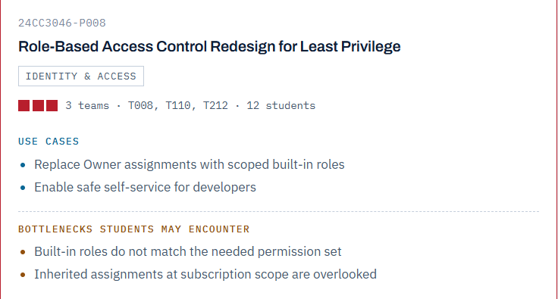
Figure 1: Allotted problem statement (24CC3046-P008)

2.1 Use Cases
- Replace Owner assignments with scoped built-in roles.
- Enable safe self-service for developers.

2.2 Expected Bottlenecks
- Built-in roles do not match the needed permission set.
- Inherited assignments at subscription scope are overlooked.

3. Objectives
- Build a realistic over-privileged baseline in which all users hold Owner at subscription scope.
- Audit the baseline to identify excessive and inherited permissions.
- Replace Owner with scoped built-in roles mapped to each job function.
- Create a custom role where no built-in role fits the requirement.
- Allow developers to delegate limited access safely using conditional role assignment.
- Verify every change by testing allowed and denied actions for each user.

4. Environment and Tools
Item | Details
Cloud platform | Microsoft Azure
Subscription | Azure for Students
Directory (tenant) | K L University (kluniversity.in), Microsoft Entra ID Basic for EDU
Region | Central India
Tools | Azure Portal, Access control (IAM), Microsoft Entra ID
Test identities | Existing KL University accounts of team members

5. Methodology
The project is carried out in eight phases. This interim report covers Phases 1 to 3.
Phase | Activity | Status
1 | Environment setup and verification | Completed
2 | Resource setup and over-privileged baseline | Completed
3 | Access audit (including inherited assignments) | Completed
4 | Replace Owner with scoped built-in roles | Pending
5 | Custom role for Operations | Pending
6 | Safe self-service for Developers | Pending
7 | Verification testing | Pending
8 | Final report and resource cleanup | Pending

6. Implementation

6.1 Phase 1: Environment Setup and Verification
- Subscription access: The administrator account was verified as Owner of the Azure for Students subscription using Access control (IAM) → View my access.
- Directory constraint: The subscription belongs to the K L University tenant (kluniversity.in), which contains over 1.5 lakh users and is centrally managed. Students cannot create new users in this directory.
- Solution adopted: Instead of creating test users, the existing KL University accounts of team members were used as test identities. A subscription Owner can assign Azure roles to any user in the tenant without directory administrator rights.
- Groups: Roles are assigned directly to user accounts. In a production environment, roles should be assigned to security groups to simplify management.
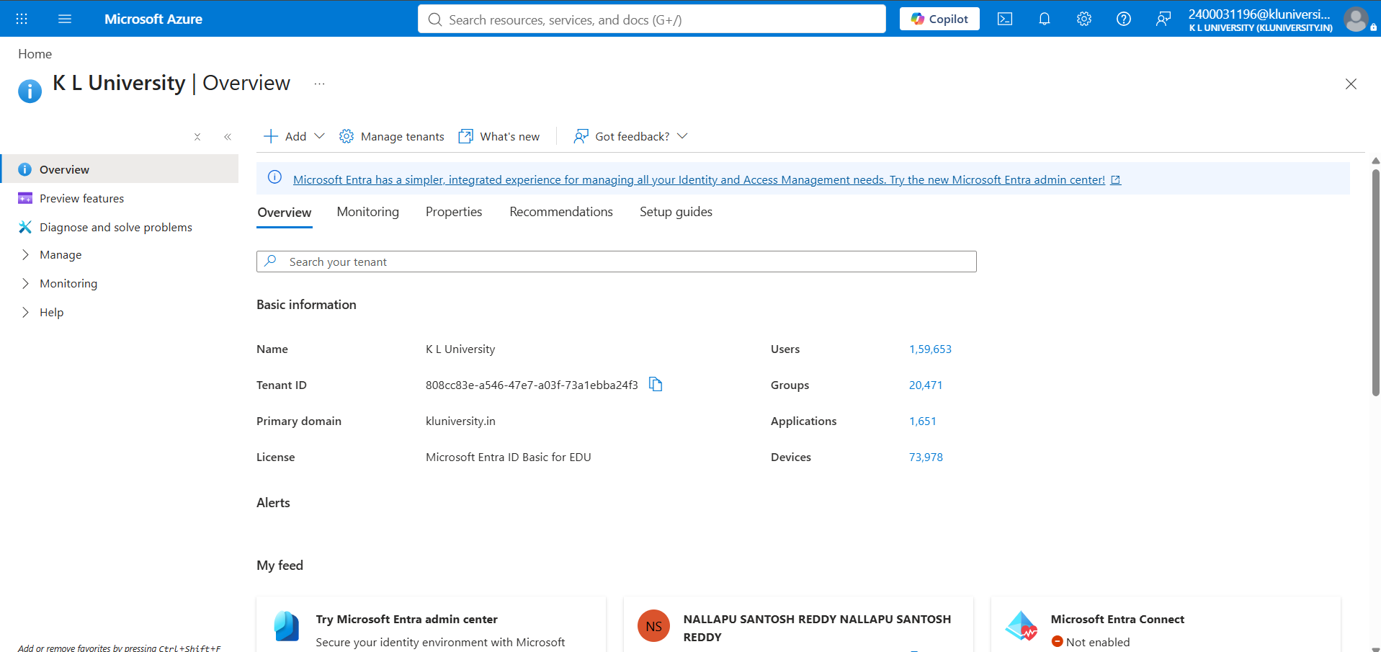
Figure 2: Microsoft Entra ID overview showing the K L University tenant

6.2 Phase 2: Resource Setup and Over-Privileged Baseline
Resource groups. Two resource groups were created to represent separate environments:
- rg-app-dev: development environment where developers are expected to work freely.
- rg-app-prod: production environment that must be protected.
Resources. One storage account was created in each group so that permissions could be tested on real resources. Standard performance and Locally-redundant storage (LRS) were chosen to minimise cost.
Resource group | Storage account | Performance / Redundancy | Region
rg-app-dev | t008devstore1196 | Standard / LRS | Central India
rg-app-prod | t008prodstore1196 | Standard / LRS | Central India
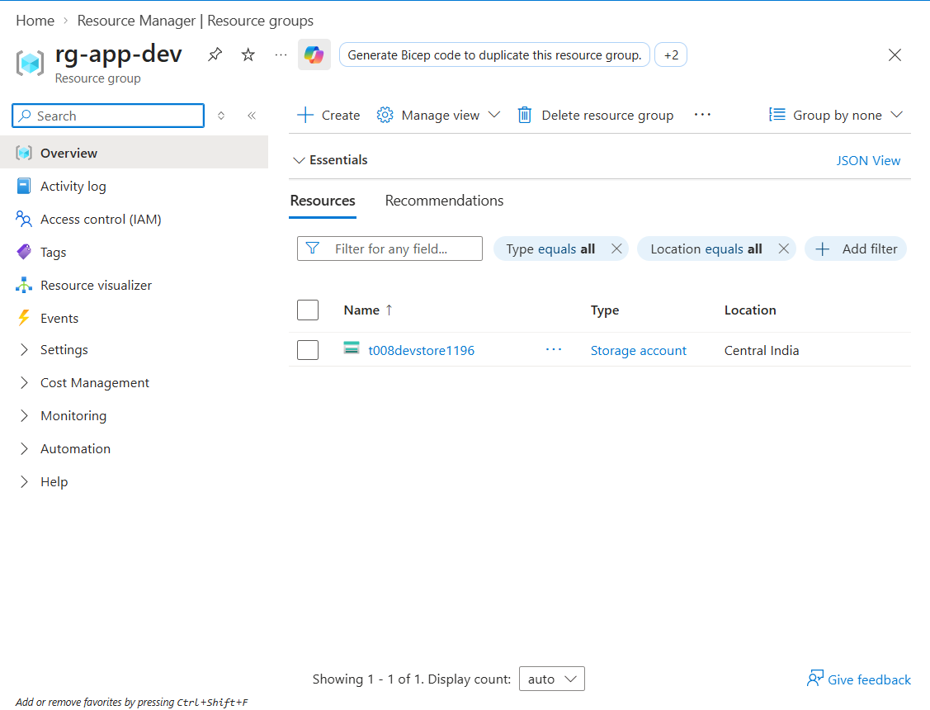
Figure 3: rg-app-dev containing t008devstore1196
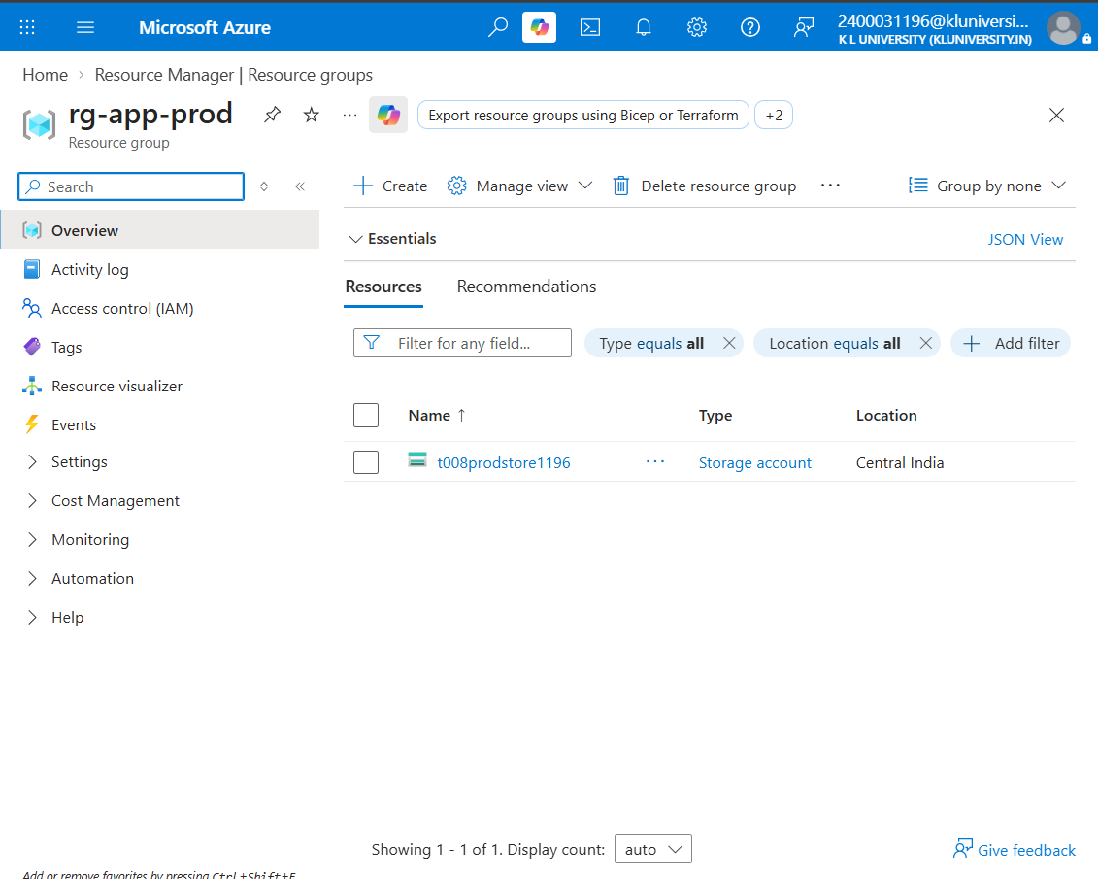
Figure 4: rg-app-prod containing t008prodstore1196
Over-privileged baseline. To simulate a typical insecure setup, all three team members were assigned the Owner role at subscription scope with the condition option “Allow user to assign all roles (highly privileged)”. This means each user could create, modify and delete any resource and could also grant any role to anyone.
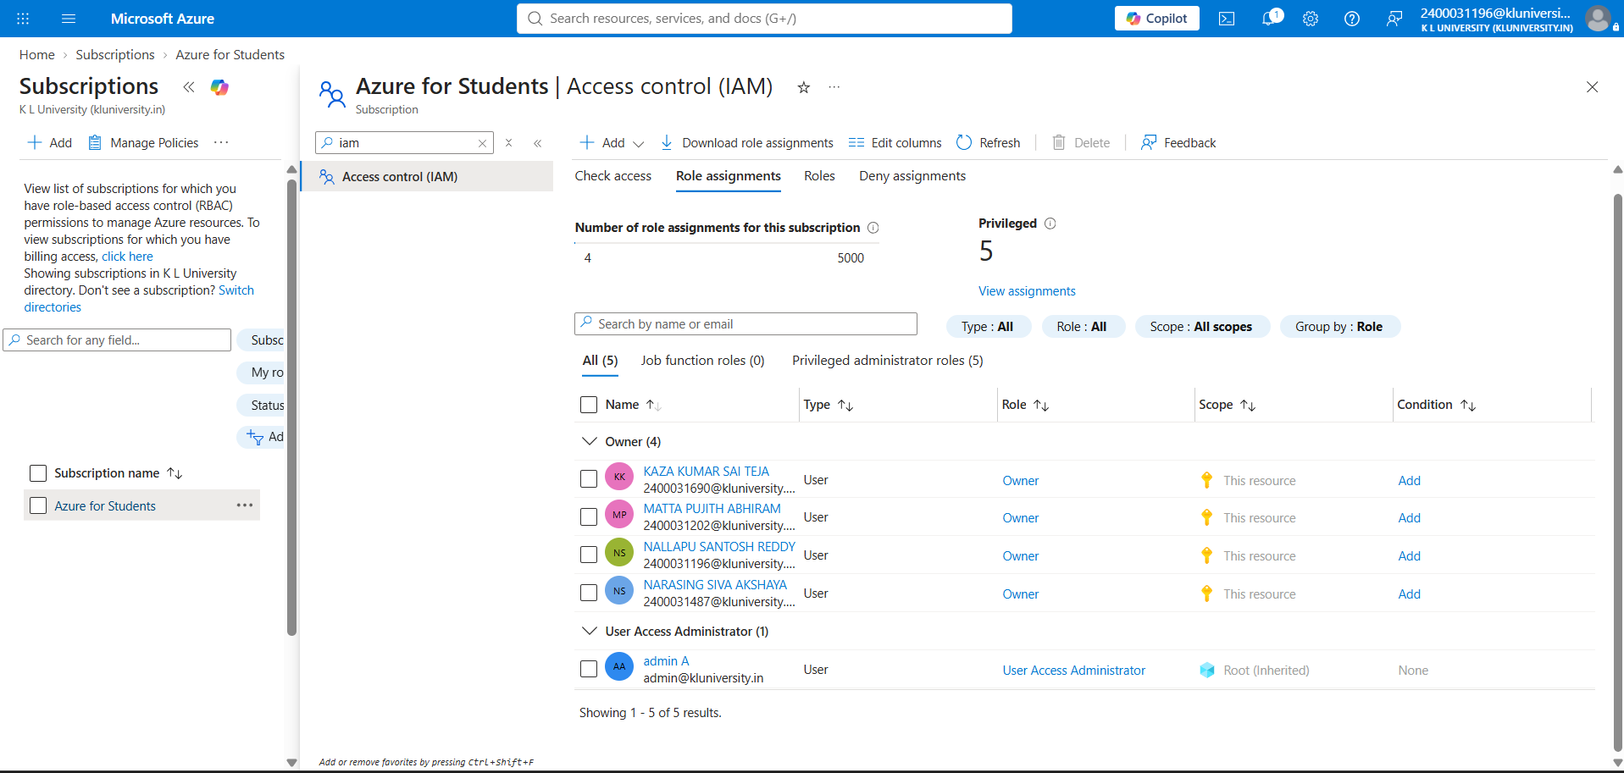
Figure 5: Baseline: all team members hold Owner at subscription scope

6.3 Phase 3: Access Audit
Step 1: Export of role assignments. All role assignments at the subscription were exported to before-audit.csv using Download role assignments, including inherited assignments and assignments at the current scope.
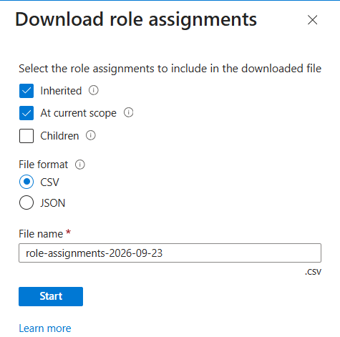
Figure 6: Download role assignments options used for the audit export
Step 2: Inherited assignments at resource group level. The Access control (IAM) page of rg-app-prod was reviewed. Although no role was ever assigned directly on this resource group, all four Owners appear with the scope “Subscription (Inherited)”. A tenant-level User Access Administrator (admin A) also appears with the scope “Root (Inherited)”.
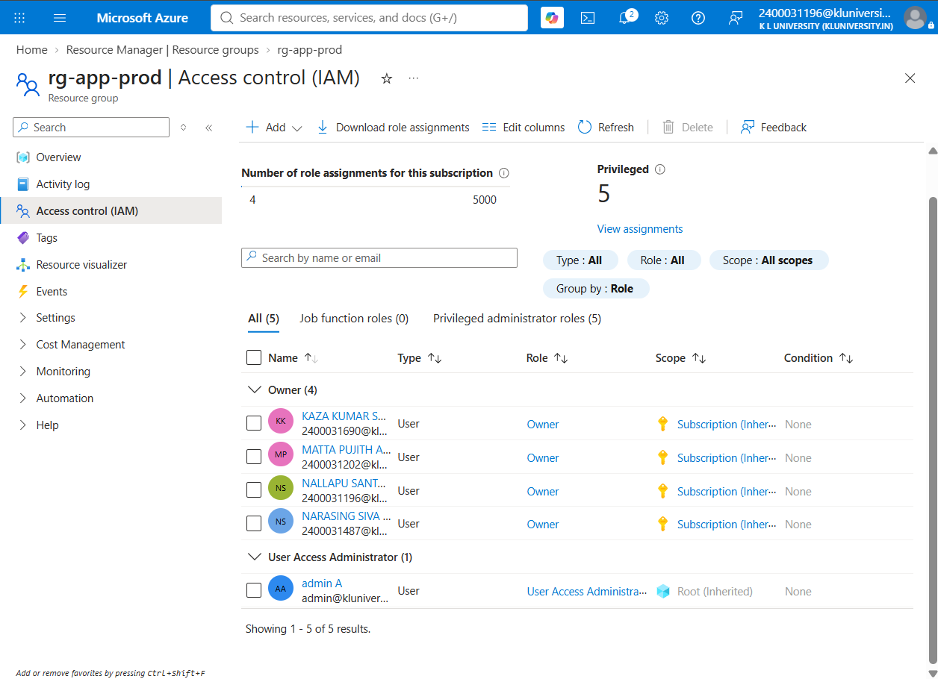
Figure 7: rg-app-prod shows Owner assignments inherited from the subscription
Step 3: Inherited assignments cannot be removed at the child scope. When an inherited assignment is selected on rg-app-prod, the Delete option remains disabled. Inherited access can only be removed at the scope where it was originally assigned.
[ Insert screenshot here: 02b-cannot-delete-inherited.png ]
Figure 8: Delete is disabled for inherited assignments
Step 4: Effective access check. Check access was used on rg-app-prod for the Operations user (Matta Pujith Abhiram). The result confirms that he holds Owner on production through inheritance, although his job only requires restarting or operating resources.
[ Insert screenshot here: 03-check-access-before.png ]
Figure 9: Check access result for the Operations user before redesign

7. Audit Findings
# | Finding | Risk
F1 | All three users hold Owner at subscription scope. | High: any user can delete production resources.
F2 | Owner was assigned with unrestricted delegation (can assign all roles). | High: any user can escalate others to Owner.
F3 | Subscription-level Owner flows down to every resource group, including production. | High: dev and prod are not separated.
F4 | Inherited assignments cannot be removed at the resource group level. | Medium: fixes attempted at the wrong scope silently fail.
F5 | A tenant-root User Access Administrator (admin A) is inherited into the subscription. | Informational: outside the subscription owner’s control; must be documented.
F6 | Roles are assigned to individual users rather than groups. | Low: harder to manage at scale; limited by tenant policy.

Key observation (Bottleneck 2): Looking only at a resource group’s direct assignments would suggest that nobody has access to it. The real access comes from inheritance, so every audit must include inherited assignments and must remove them at their source scope.

8. Planned Target Design (Phases 4–6)
User | Project role | Role | Scope
Nallapu Santosh Reddy | Administrator | Owner | Subscription
Narasing Siva Akshaya | Developer | Contributor | rg-app-dev
Narasing Siva Akshaya | Developer | Reader | rg-app-prod
Narasing Siva Akshaya | Developer | RBAC Administrator (constrained to Reader) | rg-app-dev
Matta Pujith Abhiram | Operations | Custom: App Operator | rg-app-prod
Kaza Kumar Sai Teja | Auditor | Reader | Subscription

- Use case 1 (scoped built-in roles): Owner will be removed at subscription scope and replaced with Contributor and Reader at resource group scope.
- Bottleneck 1 (custom role): Operations needs to operate production resources without creating or deleting them. No built-in role matches this exactly, so a custom App Operator role will be defined.
- Use case 2 (safe self-service): The Developer will receive Role Based Access Control Administrator on rg-app-dev with a “Constrain roles” condition, allowing her to grant only the Reader role.

9. Conclusion (Interim)
Phases 1 to 3 established a realistic over-privileged Azure environment and audited it. The audit confirmed that subscription-level Owner assignments grant every user full control of both development and production resources, and that this access is inherited silently into every resource group. These findings form the baseline against which the least-privilege redesign in Phases 4 to 6 will be implemented and verified.

