A

PRACTICAL TRAINING SEMINAR REPORT

ON

StudyHub Notes

In partial fulfillment of

B.E IV yr (Information Technology)

Work Carried Out At “HCL CDC”

Submitted To: Submitted by:

---------------------- --------------------------

Pr. Pankaj Acharya Divyavrat Jugtawat

Asst. Professor IT Branch, IV year

Acknowledgment
I would like to express my special thanks of gratitude to my teacher Pr. Pankaj Acharya as well as my mentor Mr. Ashutosh who gave me the golden opportunity to do this wonderful project of StudyHub Notes, which also helped me in doing a lot of Research and I came to know about so many new things. I am really thankful to them.
Secondly I would also like to thank my parents and friends who helped me a lot in finalizing this project within the limited time frame.

CERTIFICATE FROM THE COMPANY
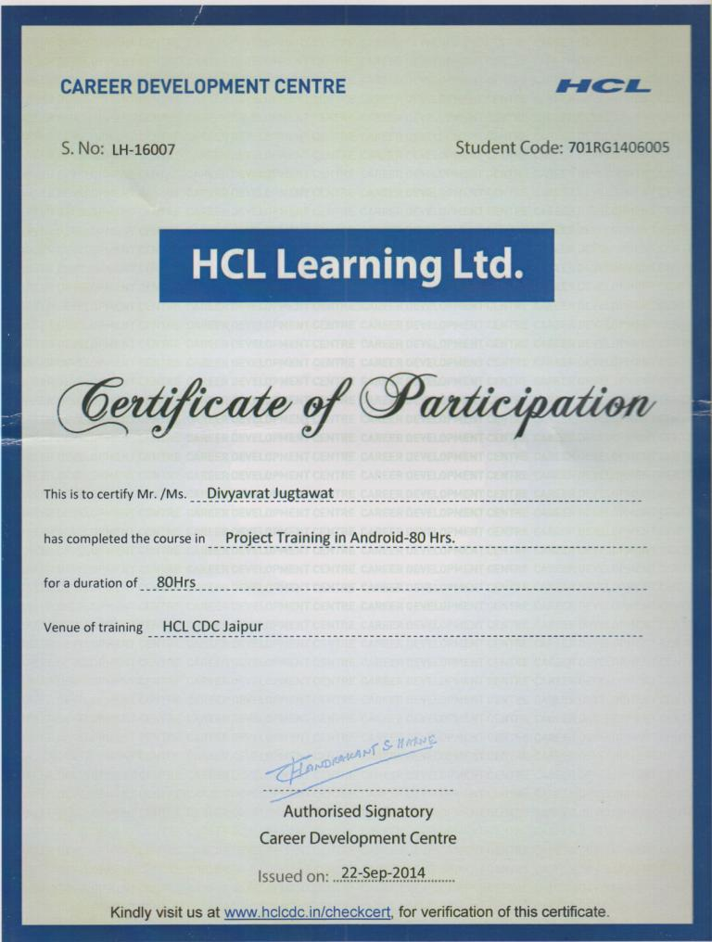

Table of Contents
Acknowledgment 2
CERTIFICATE FROM THE COMPANY 3
1. Table of Contents 4
2. Introduction 5
3. Company/Organization Overview 6
3.1 HCL Career Development Centre 6
3.2 Mentor 6
3.3 Contact Details 6
4. Technology used in Project 7
5. Technical Details of Project/Study 8
5.1 Architectural Overview - 8
5.2 Functional Block Diagram - 8
5.3 Flow Chart 8
5.4 Functions/Modules Details - 9
5.5 Pseudo Code/ Algorithm - 10
6. Applications 11
7. Future Work 12
8. Conclusion 13

Introduction

Notes application was made to create an alternate method of use to simplify notes sharing and group studying. It can take pictures of notes and store it on its server. You can also store raw text and other files like pdf and doc on the server.

Notes Application also has a port of a website that can be run in any browser and device. Thus all notes added to it can be viewed anywhere with the same reliability and functions.

It has a dynamic view customized for the user. And has common features like searching and downloading useful notes directly to the device.

We try to explain its features in this document.

Company/Organization Overview
I finished my training at HCL CDC with WsCubeTech. It’s a growing group of developers that mentor students for all software development courses like Android, PHP, etc.

WsCube Tech is one of the leading Web Design and Development Company in Jodhpur, India. It's a group of young and enthusiasts people that provide innovative ideas for businesses to grow it faster on Web World, learning cost effective strategies for development solutions.

HCL Career Development Centre
with association to WsCubeTech

Mentor
Mr. Ashutosh Sir - Android and Java

Contact Details
- HCL - 02912613698
- Ashutosh Sir at WsCube - 7737871097

Technology used in Project
Android, Java, SQL, Android Development IDE (adt), PHP, xml, JSON, JavaScript, HTML, JSON, XAMPP.

Hardware Platforms -
- Android
- PC (website)

Android is a mobile operating system (OS) based on the Linux kernel and currently developed by Google. With a user interface based on direct manipulation, Android is designed primarily for touch-screen mobile devices such as smart-phones and tablet computers, with specialized user interfaces for televisions (Android TV), cars (Android Auto), and wrist watches (Android Wear). The OS uses touch inputs that loosely correspond to real-world actions, like swiping, tapping, pinching, and reverse pinching to manipulate on-screen objects, and a virtual keyboard. Despite being primarily designed for touch-screen input, it also has been used in game consoles, digital cameras, regular PCs (e.g. the HP Slate 21) and other electronics.

Application Development languages -
- Java
- XML
- PHP

Development Softwares -
- Android Development Toolkit (adt)
- git (for source code management)
- WinMerge (code comparision)
- Eclipse (IDE)

Technical Details of Project/Study

Architectural Overview -
This application is based upon Android OS. All the coding done in this Platform is on Java and thus is machine-independent. Since Android Devices exist in all sizes and Shapes thus this application uses XML layouts to create dynamic application pages.

Functional Block Diagram -

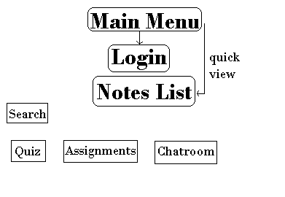

Flow Chart

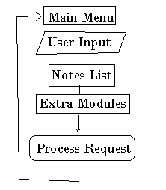

Functions/Modules Details -
- Main Menu - The initial view shown to user containing all links and notifications to other pages and features. A scrolltab feature is used to implement the basic view design.
- Notes List - All saved notes (images, text, files) are shown in a customized list to quickly check the needed files. It contains link to download and add more notes.
- Search - A button is added in each view to quickly search notes according to user, college, topic or date.

Pseudo Code/ Algorithm -

Algorithm -
- Download Notes List from server as JSON text
- If raw text then show the note text directly
- If the note is an image then check
  - If its thumbnail already exists in local folder.
  - Else download thumbnail.
- If note is a file then show it in default view
- If other feature links are used than move view to its main page.
- Save user details and preferences to server.
- Quit Application

Pseudo Code -

GET notes data
CHECK each note
PRINT text
SHOW images
SHOW files
GET user_input
PROCESS request according to the input
LOOP back to main menu

Applications

- NOTES - It can be uses to create and save notes on its server. It can be used to store notes as text or as images. Other file can be opened too using this application.
- QUIZ - A general method of digital exams and automated checking can fasten the preparation and examination process.
- ASSIGNMENT - All classroom work given to students can be digitized to automate submission of answer sheets, checking and question doubts to the teacher.
- COLLEGES - Many features of the app are classified according to each college. All notes can be searched for each college. Also easing the submission and handling of each college's app data, a student coordinator can be appointed.
- NEWS FEED - New notes, quizzes and assignments are notified on the news feed.
- CHATROOM - This feature is provided to allow students and teachers to collaborate in clarifying doubts.

Future Work

- It can be extended to allow dynamic content according to the user's location, bandwidth and institution.
- This application is open source and thus can be extended to other apps that can use these modules.
- It can be made more user-friendly by adding voice and gesture controls.

Conclusion
Notes application is open source and can be edited and reviewed at any point of time. It is created actively by many developers of our team and will be modified and updated over long period of time.
It has setup its data over a server which is shared by its website. Notes Application uses a vast range of technologies and languages to optimize the services provided to the user.

Notes app can be used as a replacement for the common practices of education to allow newer, quicker and neater forms of knowledge transfers.

Any suggestions and reports are always welcomed and can be notified to its website.

9. References

- android.developer website for architecture overview
- StackOverflow forum site for design examples and algorithms
- github pages for basic git tutorial
- google.code.com for early source code management
- android documentation
- w3schools for JSON and URL problems
- Extra android videos at youtube.com and newboston.org

