**GIT command and steps to save the file in remote repository.**

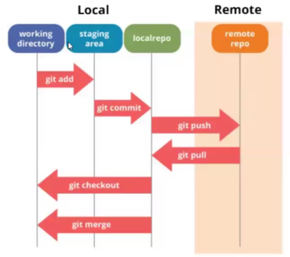

Git should be installed on your system, verify using command **git –version**.



First command we need to use is **git init.** This will initialize the repository.

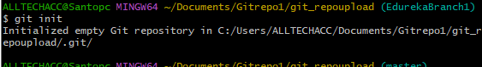

When we initialize the repository, .git will be created, this will be hidden file. To check if its created use the command. **ls -alrt**

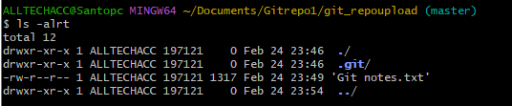

Now we can check the status use the command **git status**

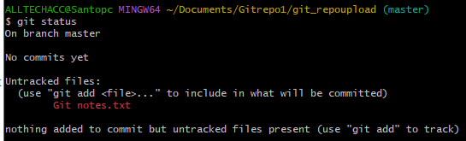

This is also to check if our changes are in sync or not. This is still in our **working directory.**

Now we need to add the file. Use the command git add and followed by name of the file.



Now we can check the status, this is now ready to be committed, This is now in Staging area in same system.

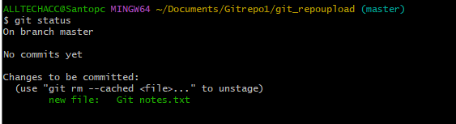

Now we can commit the file using command **git commit -m “comments”**

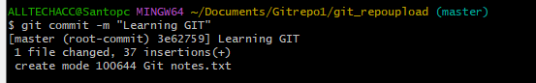

**We need to configure with our email id. So that when we commit changes git will update who made the changes.**



**Use the command git ls-files this will show the files in local directory. Now the files are in local directory.**



**Use git log to check files, when and who committed and time.**

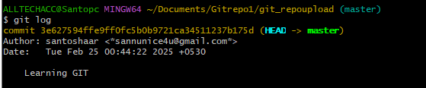

We can now push the file to the repository using **git push . But before that we need to ad the remote repo.**



Now give the command **git push origin master this will push to remote repository.**

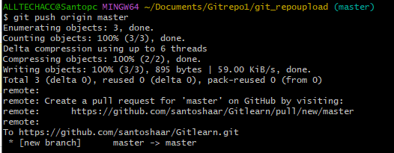

**The files are now pushed to remote location in master git repository.**

