# Files Introduction

As we know that Computers are used for storing the [information](http://ecomputernotes.com/fundamental/information-technology/what-do-you-mean-by-data-and-information) for a Permanent Time or the Files are used for storing the Data of the users for a Long time Period. And the files can contains any type of information means they can Store the text, any Images or Pictures or any data in any Format. So that there must be Some Mechanism those are used for Storing the information, Accessing the information and also Performing Some Operations on the files.

# Operations on Files

1. Open a File
2. Reading data from a File
3. Writing Data to a File
4. Modifying the Contents of a File
5. Closing the File

## Open a file

The open() function is used to open a file present on the system. It key to open a file is the path of its existence on the system. Open Function on a file should be called before calling the read, write of modifying the contents of the file. The syntax for this API is as follows

Syntax: open(filename, mode)

*Filename: it’s a string and holds the filename that needs to be opened.*

*Mode: contains few character and denotes the operation for which the file is opened for. This argument is optional, by default the file gets opened in the read mode.*

|  |  |
| --- | --- |
| Mode | *Explanation* |
| ‘r’ | *For read only* |
| ‘w’ | *For write only* |
| ‘a’ | *Open the file for appending; the data written to the file is automatically added to the end of file.* |
| ‘r+’ | *Open the file for both read and write* |

*For binary files append the letter ‘b’ after the ‘r’ or ‘w’ mode. This mandatory to be done in windows but an optional in the Linux environment but has no effect.*

*Returns a file Object.*

## Methods of File Objects

|  |  |  |
| --- | --- | --- |
| Operations | Syntax | Description |
| Read | f.read(bytes) | Reads the bytes specified as argument, if not given or if its negative it reads the entire file. If end of file is reached it returns empty string(“”). |
| Readline | f.readline() | Reads a single line from the opened file i.e. until it reaches the new line character which is ‘\n’. this call also returns empty string when the end of file is reached. Generally we iterate over this object until end of file with a for statement |
| Write | f.write(string) | Writes string specified as argument to the file opened, to write anything other than string it has to be converted/typecasted to string and then written. |
| Tell | f.tell() | Returns an integer which indicates the file pointer of the opened file. Its measured in bytes from the beginning of the file. |
| Seek | f.seek(offset, reference_point) | The position is computed from adding the offset to the reference point. The reference point can take the value 0 (zero) which means from the beginning of the file. 1 used the current position of the file. 2 uses the end of the file as reference point. By default the reference point is set to 0 (zero). |
| Close | f.close() | Closes the file handle object from further operations. Once the file object it needs to be opened again to perform operation. |

## Opening a file

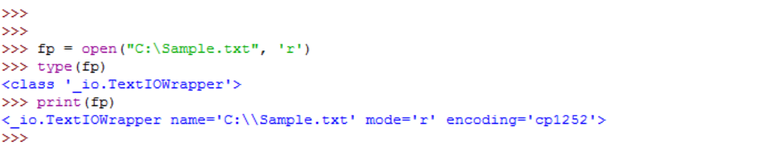

## Reading a File



Reading a file as is

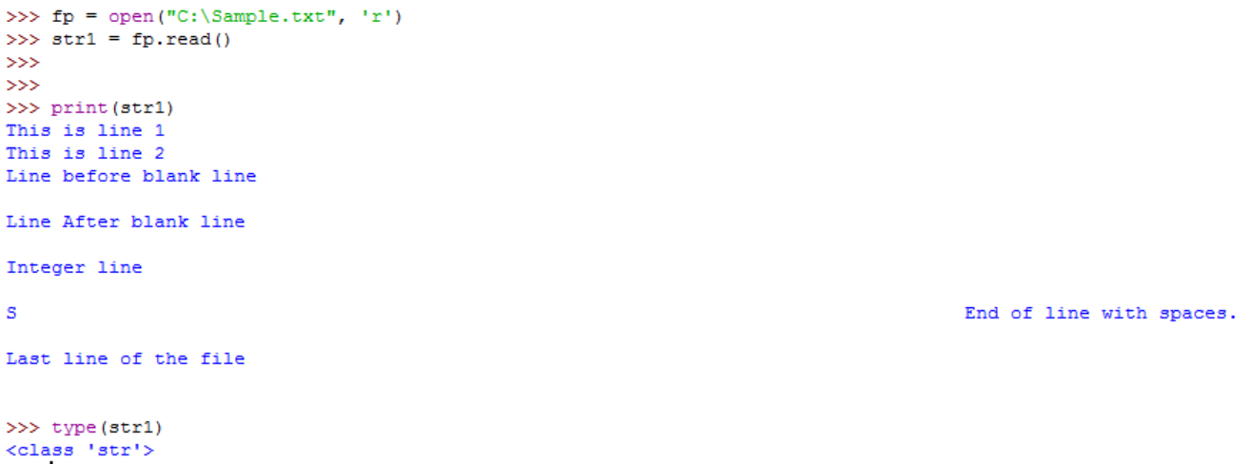

Readlines from a file



Note: the type of the return value is a list.

Write 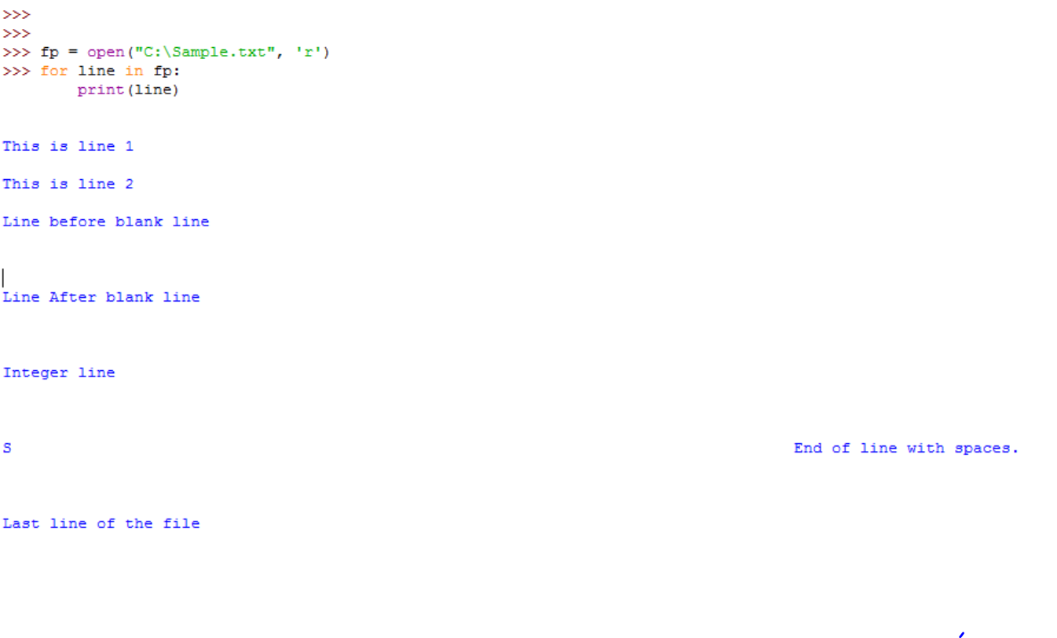

## Write to a File

