调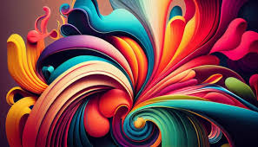

图像是视觉表示。 图像可以是二维的, 如绘画、 绘画或照片, 或三维的, 如雕刻或雕塑。 图像是视觉表示。 图像可以是二维的, 如绘画、 绘画或照片, 或三维的, 如雕刻或雕塑。 图像是视觉表示。 图像可以是二维的, 如绘画、 或照片, 或三维的, 如雕刻或雕塑。 图像可以是二维的, 如绘画、 或照片, 或三维的, 如雕刻或雕刻。 图像是视觉表示 。 图像可以是二维的, 如绘画、 或照片, 或三维的, 如雕刻或雕刻。 图像可以是二维的 。 图像可以是二维的, 如绘画、 或照片, 或三维的, 如雕刻或雕塑 。 图像可以是二维的 。 An image is a visual representation. An image can be two-dimensional, such as a drawing, painting, or photograph, or three-dimensional, such as a carving or sculpture. An image is a visual representation. An image can be two-dimensional, such as a drawing, painting, or photograph, or three-dimensional, such as a carving or sculpture. An image is a visual representation. An image can be two-dimensional, such as a drawing, painting, or photograph, or three-dimensional, such as a carving or sculpture. An image is a visual representation. An image can be two-dimensional, such as a drawing, painting, or photograph, or three-dimensional, such as a carving or sculpture.