**Documentation for AI News Research Tool**

**Project Overview**

The AI News Research Tool is a web application that enables equity research analysts to gather and analyze news articles using AI. It integrates **LangChain**, **OpenAI/Groq**, **NewsAPI**, and **Streamlit** to fetch and summarize relevant news articles based on user queries.

**Features**

* Fetch news articles based on user queries using **NewsAPI**.
* Generate AI-powered analysis using **Groq LLM**.
* Provide key insights, trends, and recommendations.
* User-friendly **Streamlit** interface for searching and displaying results.

**Installation & Setup**

**Step 1: Install Dependencies**

Run the following command to install required libraries:



**Usage**

**Step 1: Run the Application**



**Step 2: Enter API Keys (if not set in .env)**

* If API keys are not preconfigured, enter them in the UI when prompted.

**Step 3: Search & Analyze**

* Enter a search query (e.g., "AI advancements").
* Select the number of days to look back.
* Click **Search & Analyze** to retrieve and analyze articles.

**Core Functions & Code Explanation**

**1. API Initialization (initialize_apis)**

* Loads API keys from environment or user input.
* Initializes **NewsAPI** and **Groq LLM** clients.

**2. Fetching News (get_news_articles)**

* Retrieves news articles from **NewsAPI** for the given query.
* Limits results to recent news (default **7 days**).

**3. Summarizing Articles (summarize_articles)**

* Extracts top 5 article summaries.

**4. AI Analysis (get_analysis)**

* Uses **Groq LLM** to analyze the articles.
* Provides:
  + **Key Points**
  + **Trends**
  + **Implications**
  + **Recommendations**

**5. Streamlit Interface (display_articles)**

* Displays articles with:
  + **Title, source, and date**
  + **Summary and full article link**

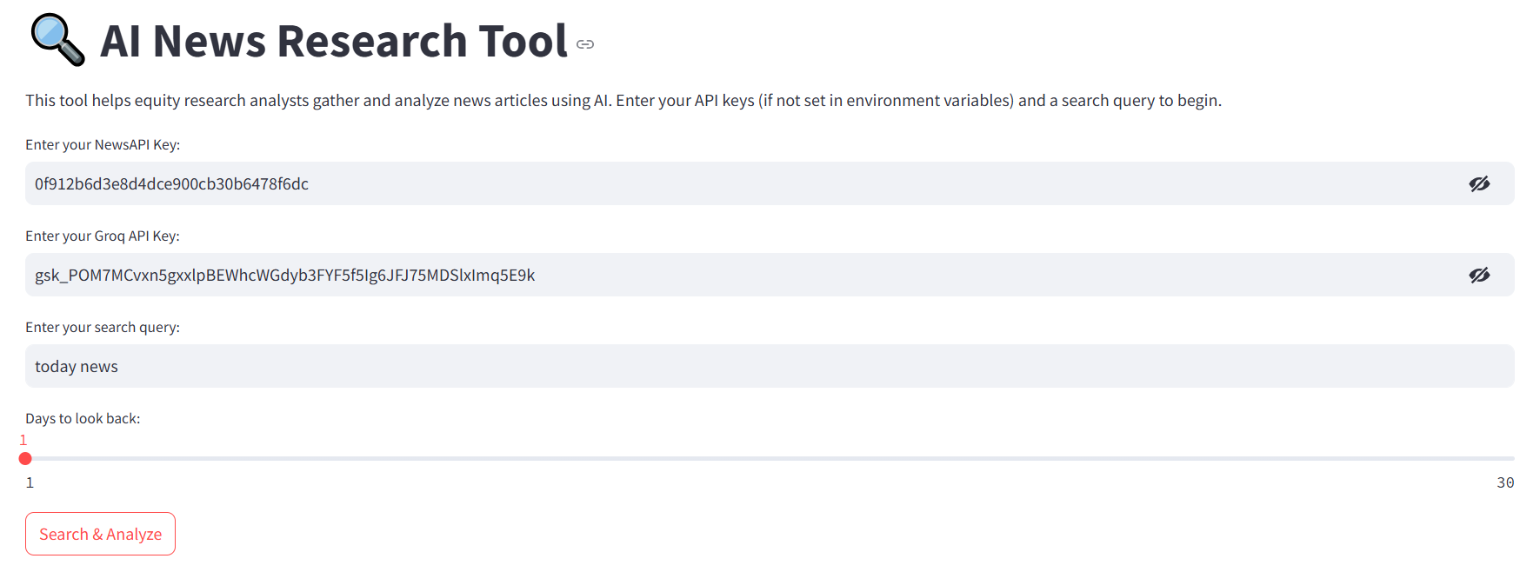

* **Conclusion**
* This AI-powered News Research Tool enables efficient research by fetching and summarizing news articles. By leveraging **LangChain, Groq LLM, and NewsAPI**, it provides key insights for analysts.