Advanced Research Methodology Project Report
Forecasting Consumer Demand in the Retail Sector Using Data Analytics and Machine Learning Techniques

Student Name: Santosh Doddaiah
Program: MSc Data Science
Course: Advanced Research Methodology
Submission Date: 16 January 2026

Abstract
This study focuses on forecasting consumer demand in the retail sector using machine learning techniques. The Rossmann Store Sales dataset was used to develop a complete demand forecasting pipeline including data preprocessing, exploratory data analysis, feature engineering, model training, and evaluation. Multiple machine learning models were implemented and compared, including Linear Regression, Random Forest, and XGBoost. The models were evaluated using RMSE, MAE, and R², where XGBoost achieved the best performance (RMSE = 925.72, MAE = 644.53, R² = 0.908). The results demonstrate that machine learning-based forecasting can enhance retail planning, improve inventory control, and support operational decision-making.

1. Introduction
Retail businesses depend heavily on accurate demand forecasting to maintain optimal inventory levels, reduce stockouts, and avoid overstocking. Consumer demand is influenced by factors such as promotions, holidays, seasonality, store characteristics, and competition. Traditional forecasting methods often struggle to capture nonlinear effects and complex interactions among these variables. Machine learning methods provide an effective solution by learning patterns directly from historical sales and contextual store data. This project aims to develop and evaluate machine learning models to forecast daily sales and identify key drivers of consumer demand.

2. Research Objectives and Questions

2.1 Research Objectives
1. To analyze historical retail sales data and identify key demand patterns.
2. To examine the influence of promotional events, holidays, and seasonal effects on sales.
3. To build machine learning models to forecast retail demand.
4. To compare model performance using evaluation metrics.
5. To interpret important predictors affecting retail consumer demand.

2.2 Research Questions
RQ1: What patterns and seasonal trends exist in Rossmann retail sales data?
RQ2: How do promotions and holidays influence consumer demand?
RQ3: Which machine learning model provides the best demand forecasting performance?
RQ4: What are the most important factors influencing sales predictions?

3. Dataset Description
The Rossmann Store Sales dataset contains historical daily sales records for 1,115 stores, along with store-level metadata. The dataset includes promotion information, state and school holidays, competition distance, store type, and assortment level. The original dataset was provided in multiple files (train.csv, test.csv, store.csv) and was merged using the Store identifier.

4. Methodology
This project followed a standard data analytics and machine learning workflow:
1. Data Collection: Dataset obtained and imported in Python (VS Code environment).
2. Data Merging: train/test files merged with store metadata using Store as the key.
3. Data Cleaning: Missing values imputed (median/default), datatype issues corrected, and closed-store records removed (Open = 0).
4. Feature Engineering: Date-based variables were created (Year, Month, Day, WeekOfYear, DayOfYear, IsWeekend). Categorical variables were one-hot encoded.
5. Model Development: Linear Regression (baseline), Random Forest, and XGBoost models were trained and compared.
6. Validation Strategy: Time-based split; last 42 days used as validation set.
7. Evaluation: RMSE, MAE, and R² used to compare model performance.
8. Final Forecast Output: Best model retrained on full dataset and predictions generated for the test dataset, exported as submission.csv.

5. Exploratory Data Analysis (EDA)
Exploratory data analysis was conducted to understand demand patterns, trends, seasonality, and the influence of promotions and holidays.
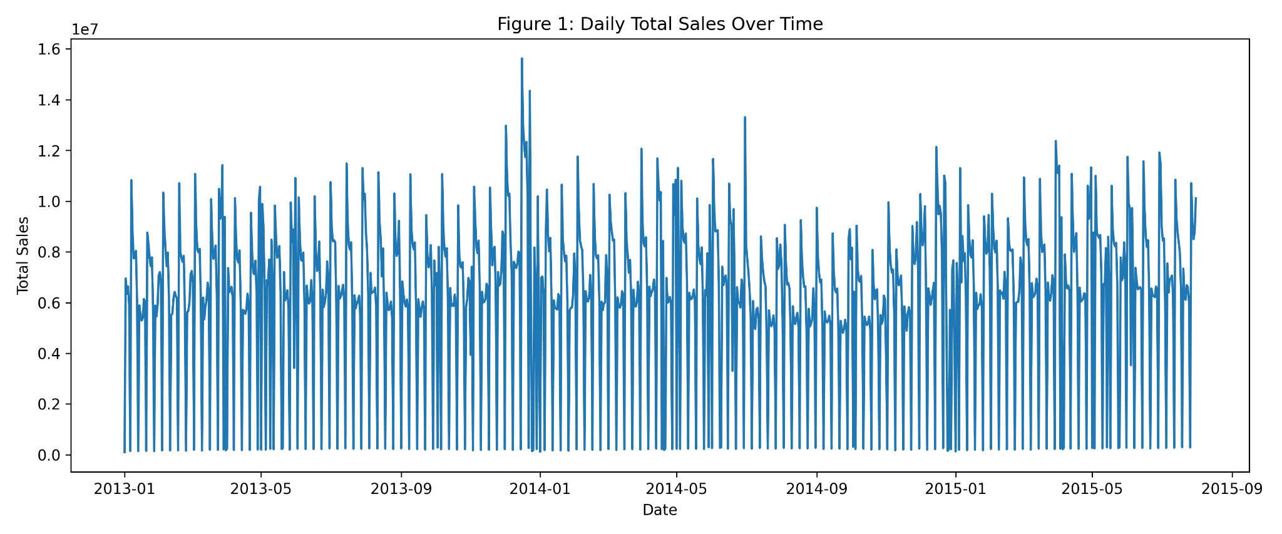
Figure 1: Daily Total Sales Over Time
This figure shows the overall trend and time-based fluctuations in total daily sales across all Rossmann stores. It highlights seasonality and demand variations over time.
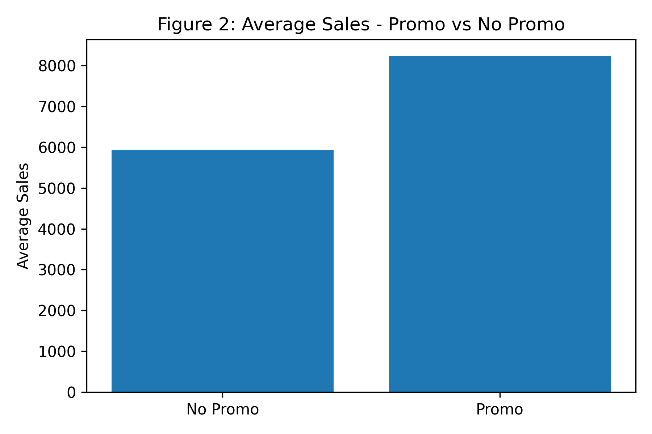
Figure 2: Average Sales - Promo vs No Promo
This figure compares the mean sales during promotion and non-promotion periods. The results indicate that promotional activity significantly increases consumer demand and sales levels.
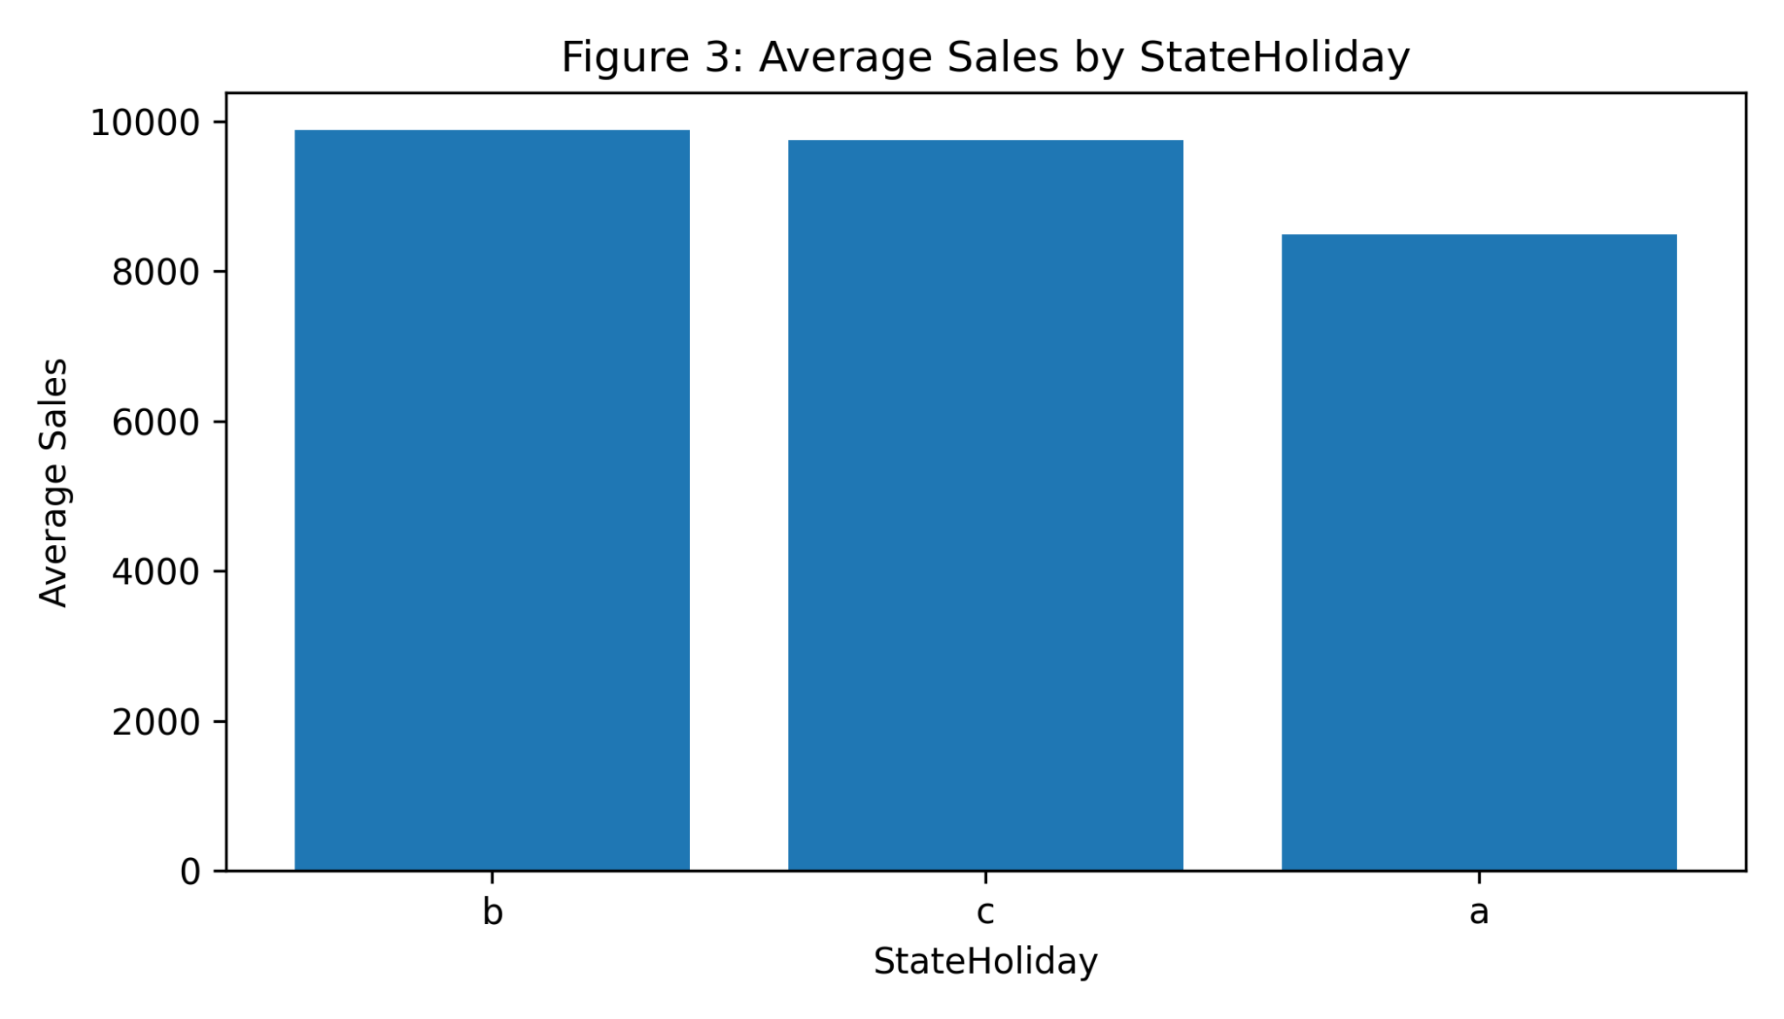
Figure 3: Average Sales by StateHoliday
This figure illustrates the impact of state holidays on average sales. It demonstrates how demand changes during holiday periods compared to non-holiday periods.
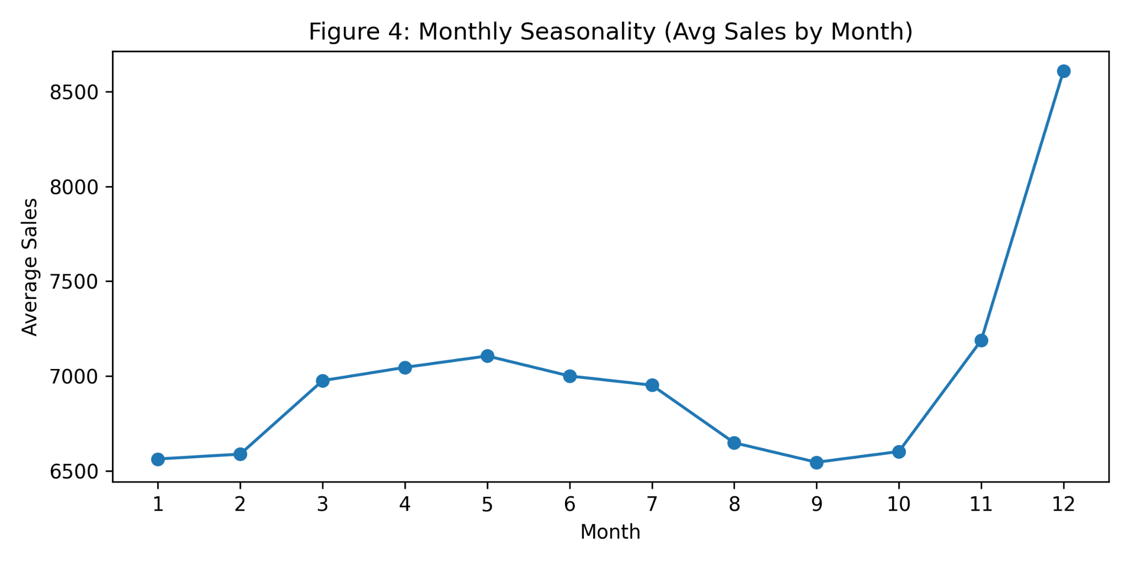
Figure 4: Monthly Seasonality (Avg Sales by Month)
This figure presents monthly seasonality patterns in sales, showing how consumer demand varies across different months and reflecting seasonal retail behavior.
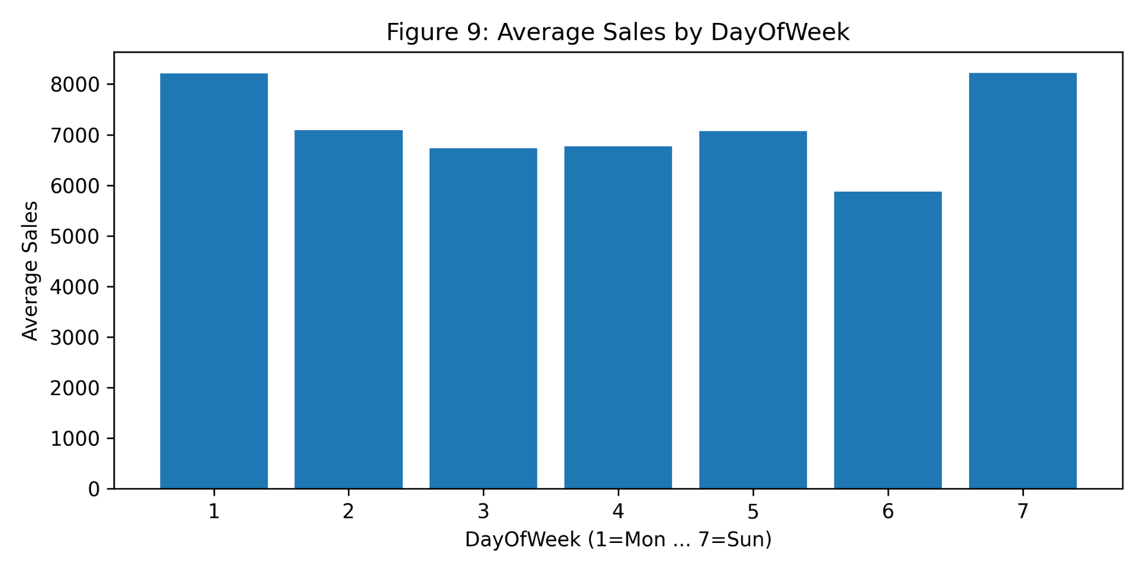
Figure 9: Average Sales by DayOfWeek
This figure shows average sales patterns across days of the week. It reveals weekly demand cycles and identifies peak/low sales days, supporting operational planning and staffing decisions.
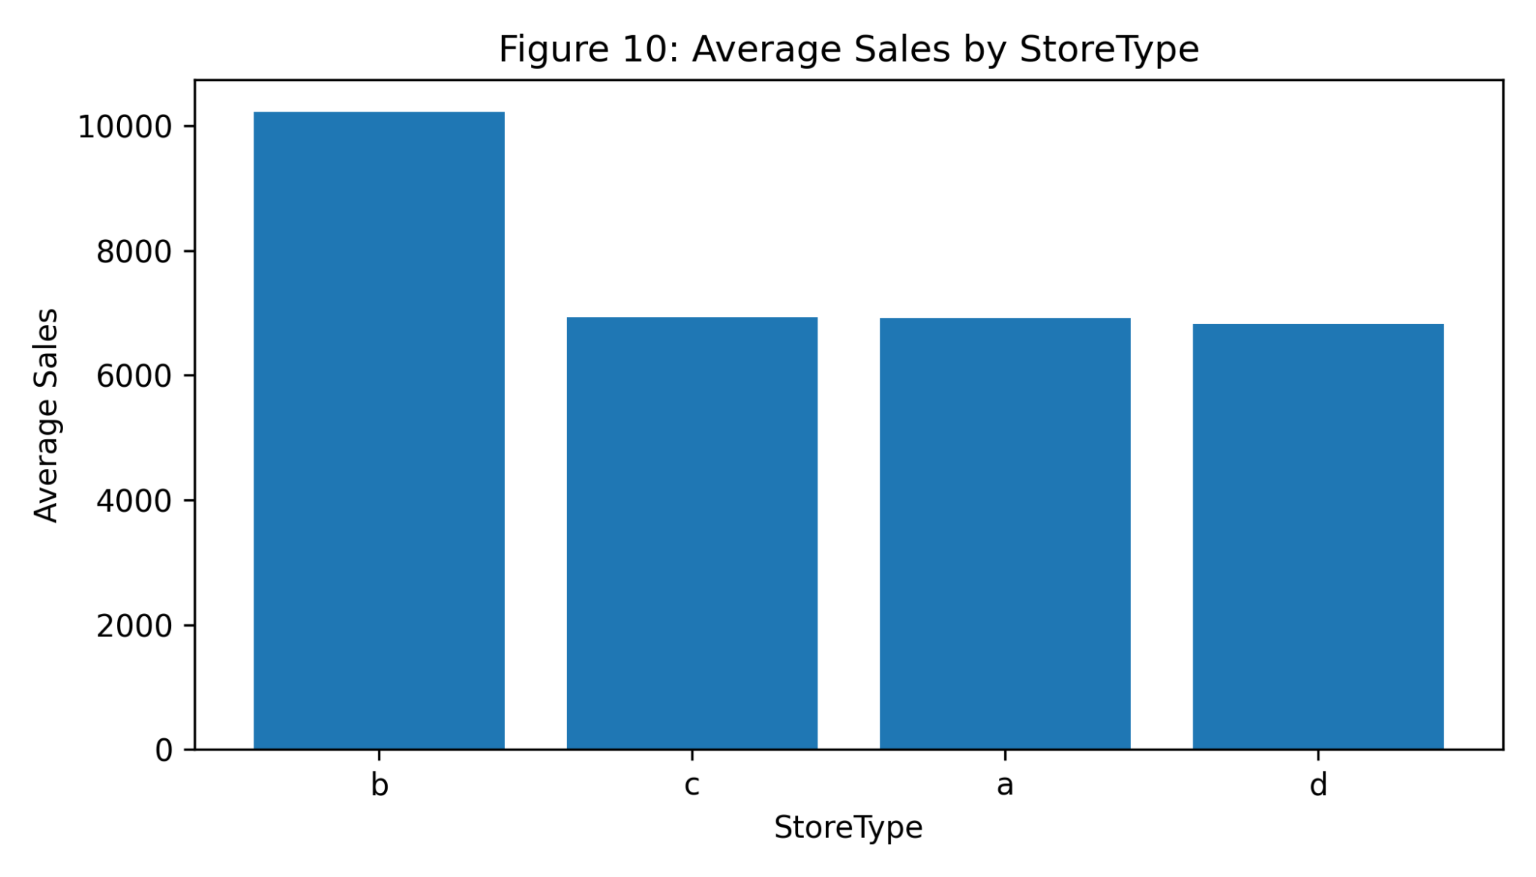
Figure 10: Average Sales by StoreType
This figure compares average sales across different store types. It highlights differences in consumer demand based on store category, helping explain structural variation in store-level performance.

5.1 EDA Summary
The EDA results show strong time-based patterns and seasonality in retail sales. Promotions significantly increase average sales compared to non-promo periods. Holiday periods also influence sales, resulting in visible changes in demand. Weekly patterns indicate variations in average sales across weekdays, and store-level differences across store types suggest structural variation in consumer demand.

6. Feature Engineering
Feature engineering was used to improve model performance by capturing seasonality and calendar effects. Time-based variables were derived from the Date column, and categorical features were converted using one-hot encoding.
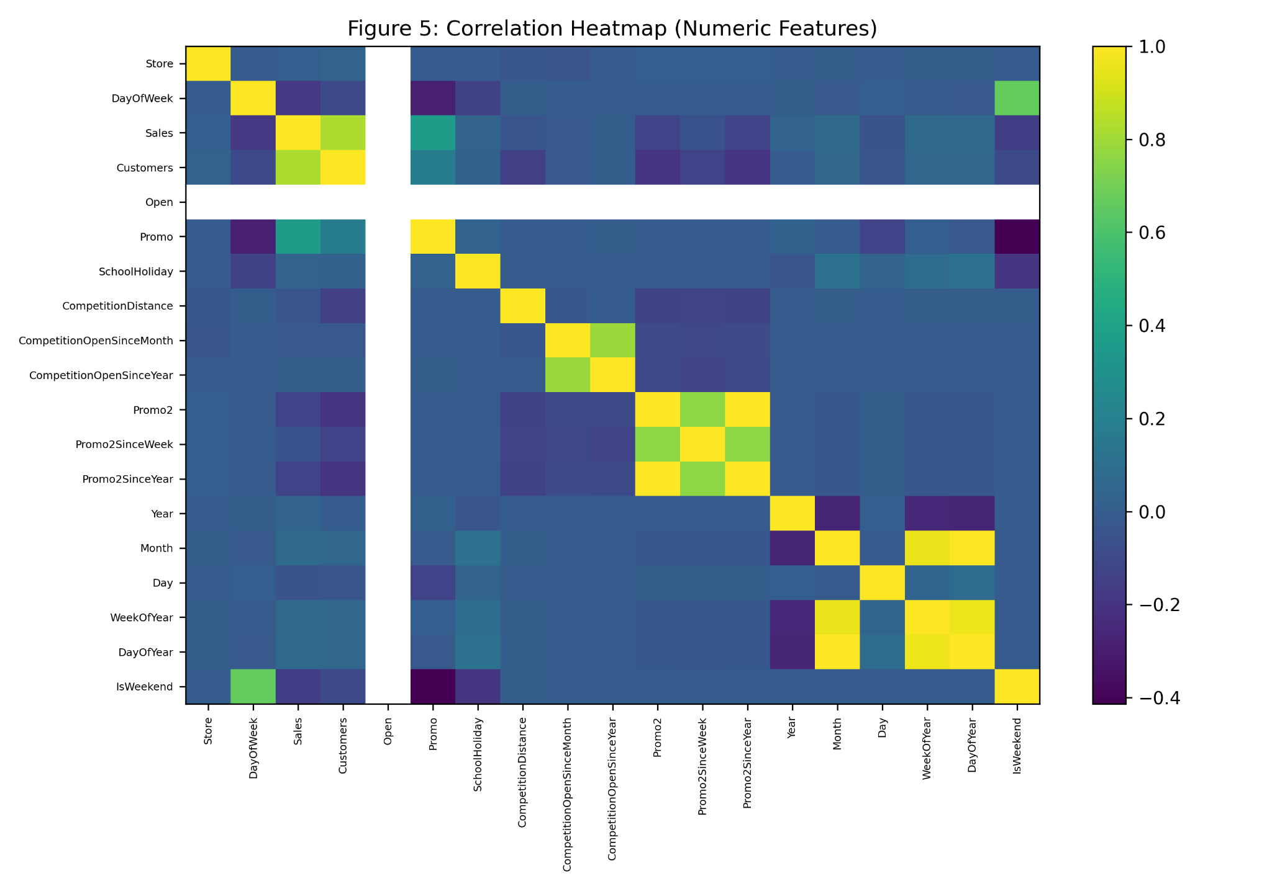
Figure 5: Correlation Heatmap (Numeric Features)
This heatmap visualizes the correlation among numerical features such as customers, promotions, competition distance, and sales. It helps identify relationships that are useful for feature selection and model building.

7. Model Development and Results
Three models were implemented and evaluated: Linear Regression (baseline), Random Forest, and XGBoost. Model performance was measured using RMSE, MAE, and R² (for the final model).
Model | RMSE | MAE | R²
Linear Regression | 2636.46 | 1961.36 | —
Random Forest | 1167.59 | 788.97 | —
XGBoost (Final) | 925.72 | 644.53 | 0.908

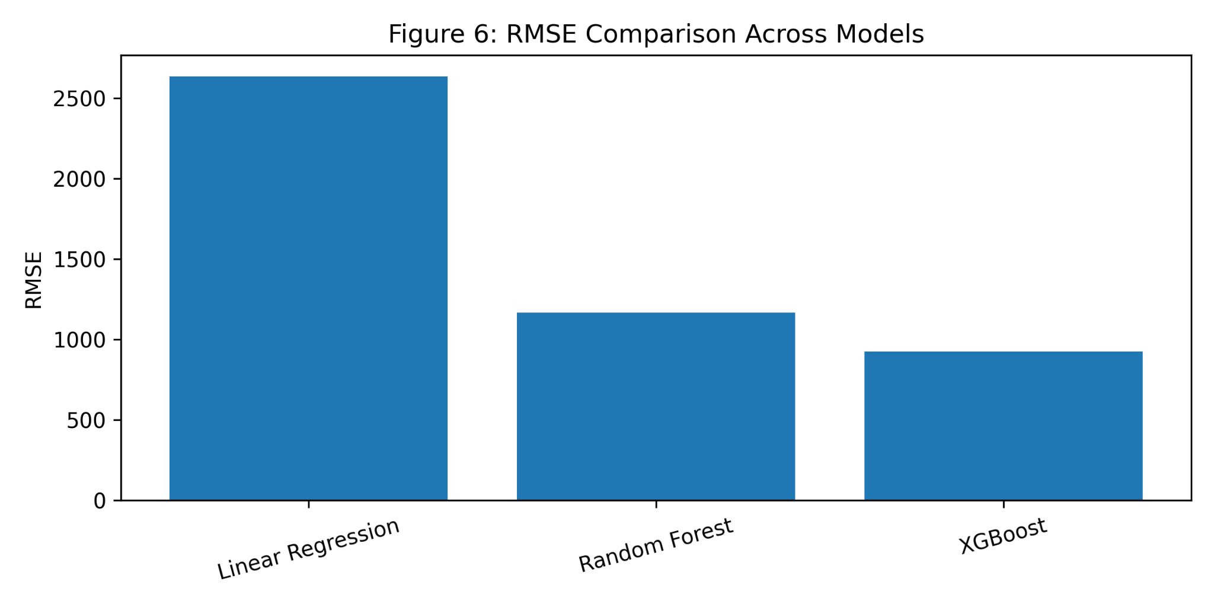
Figure 6: RMSE Comparison Across Models
This figure compares forecasting performance (RMSE) across Linear Regression, Random Forest, and XGBoost. XGBoost achieves the lowest RMSE, indicating the highest predictive accuracy.
Linear Regression performed weakest due to its limited ability to model nonlinear sales patterns. Random Forest substantially improved accuracy by capturing nonlinear relationships. XGBoost achieved the best forecasting performance (lowest RMSE and MAE) and was selected as the final model.

8. Model Evaluation and Interpretation
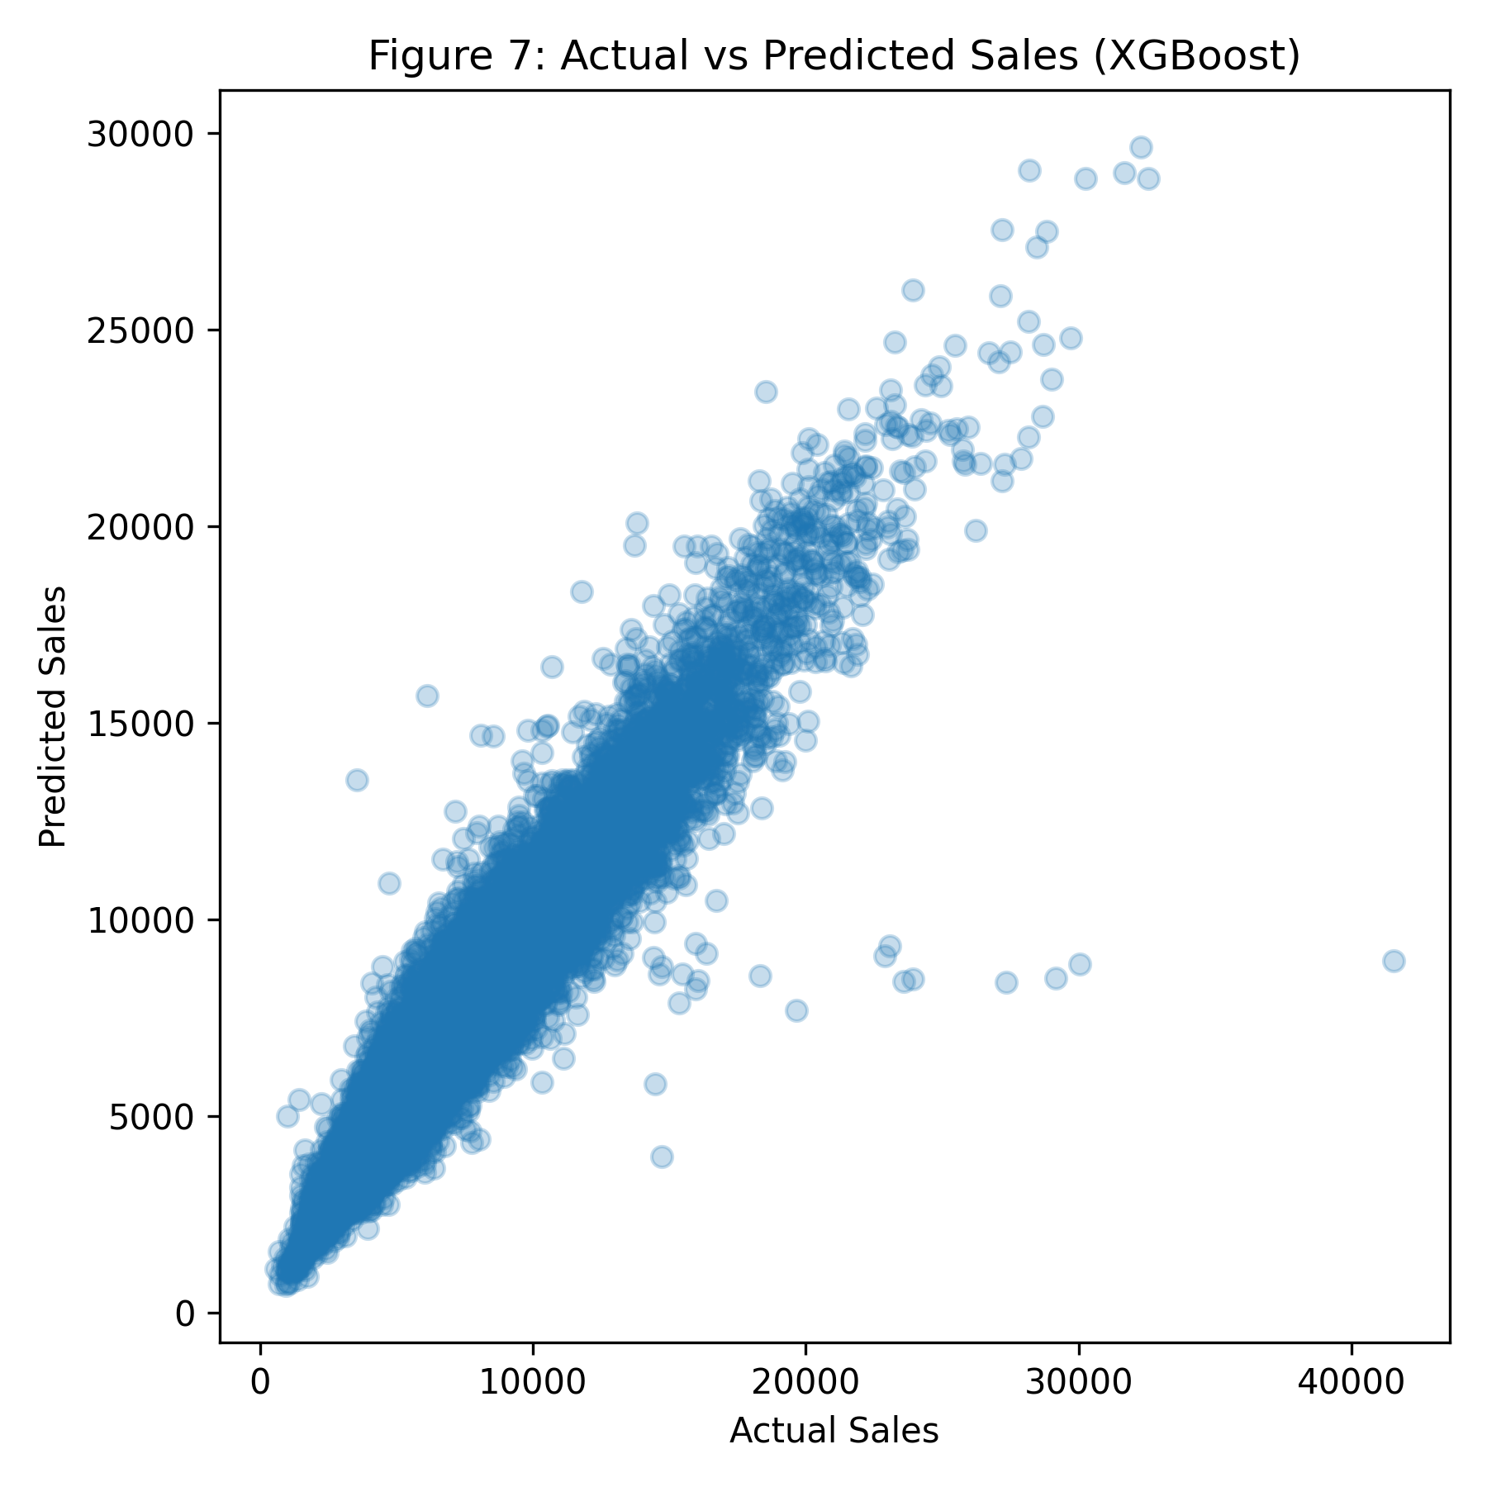
Figure 7: Actual vs Predicted Sales (XGBoost)
This scatter plot compares actual sales values against predicted sales values for the validation period. A strong alignment along the diagonal indicates that the model predictions closely match actual sales.
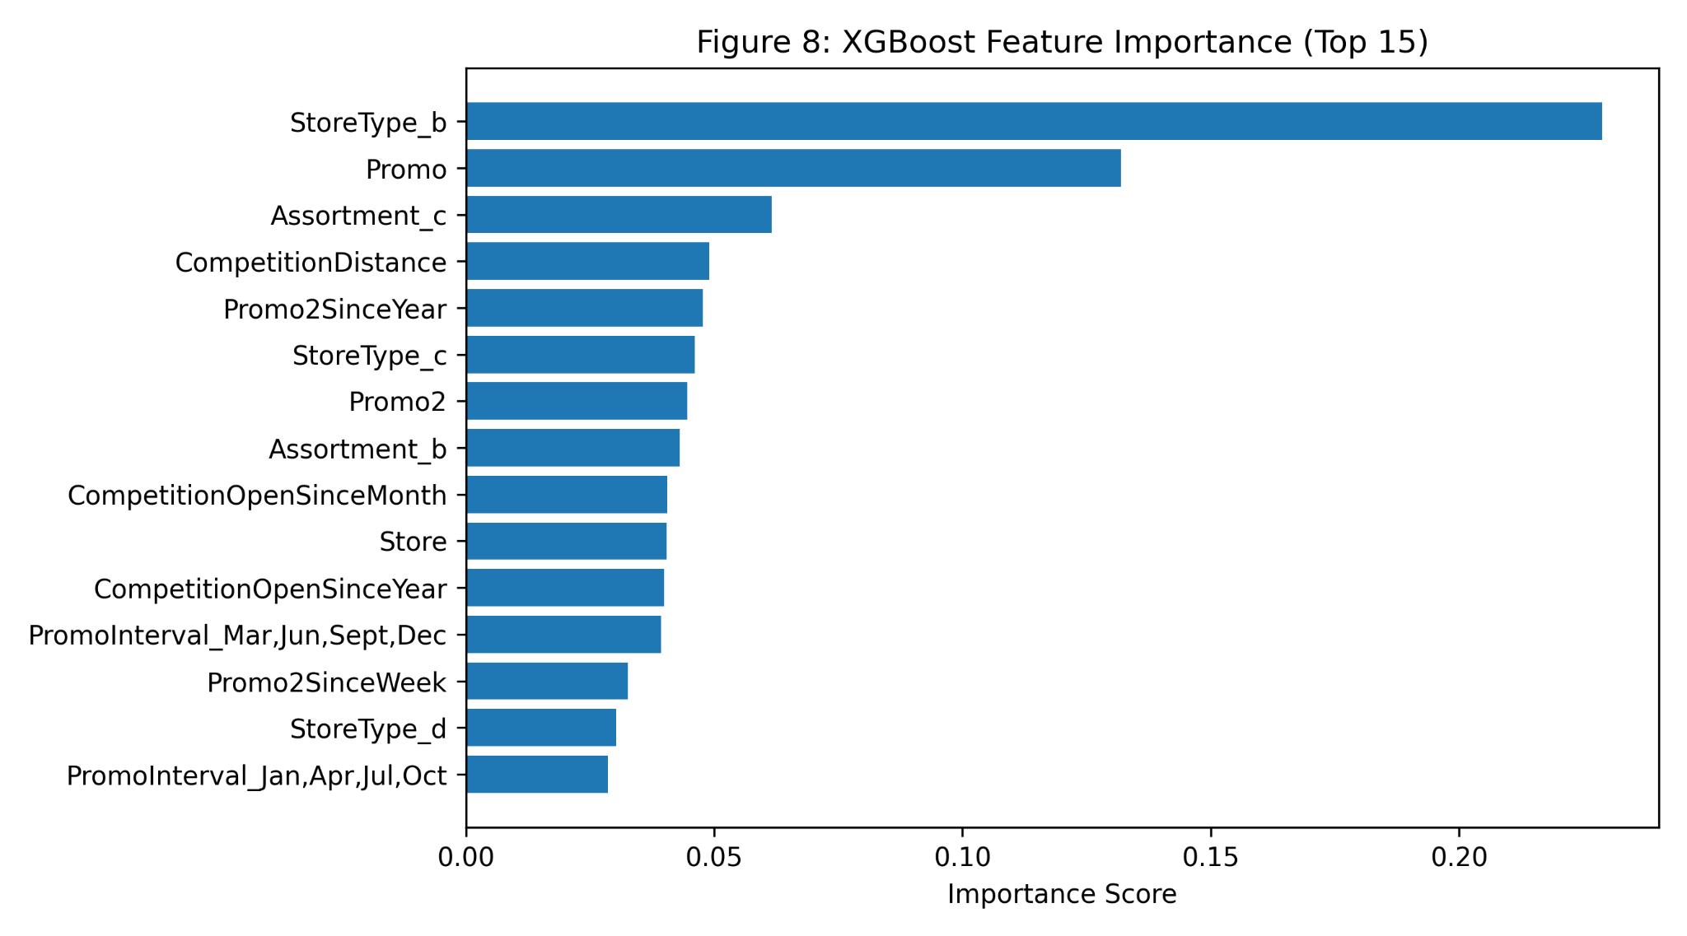
Figure 8: XGBoost Feature Importance (Top 15)
This figure displays the top 15 most influential predictors used by the XGBoost model. It provides interpretability by highlighting which variables most strongly affect retail demand forecasting.
The Actual vs Predicted plot indicates a strong alignment between the predicted and actual sales values, confirming strong generalization during validation. Feature importance results highlight the key drivers of sales prediction, including store type, promotions, assortment, and competition-related variables.

9. Conclusion
This project developed a complete machine learning pipeline to forecast consumer demand in the retail sector using the Rossmann dataset. After data preprocessing, exploratory analysis, feature engineering, and model comparison, XGBoost achieved the best performance (RMSE = 925.72, MAE = 644.53, R² = 0.908). The study concludes that machine learning-based forecasting can support better retail decision-making, including inventory planning, staffing, and promotion strategy optimization.

10. Future Work
• Add lag features such as Sales(t−7), Sales(t−14), and rolling averages to capture temporal dependence.
• Perform hyperparameter tuning (GridSearchCV / Bayesian optimization) to further improve accuracy.
• Incorporate external variables such as weather, macroeconomic indicators, and local events.
• Compare against pure time-series models such as Prophet and deep learning models such as LSTM.

11. References
Kaggle. Rossmann Store Sales Dataset. https://www.kaggle.com/c/rossmann-store-sales
Scikit-learn Documentation. https://scikit-learn.org/
XGBoost Documentation. https://xgboost.readthedocs.io/

