Thanks for reading my story. This won't make much sense if you haven't read the other parts. :)  
  
\*\*\*\*\*  
  
A few days had passed since my appointment with Jay and Emma and, overall, it had been good. Emma and I had seen each other again a couple of times and I'd also seen a steady stream of clients in my apartment. All had been OK and just the usual sex requests that were often over a little too quickly.   
  
I had been thinking about updating my online profile and offering some additional services but the one that offered the big bucks was anal sex and I just didn't feel ready for that just yet. I put it out of my mind as I got dressed and switched on my phone to await my daily clients.   
  
It turned out to be a slow day and by lunchtime, I had only received two calls, both of them timewasting. I made myself a sandwich and a coffee and enjoyed a lunch in front of the TV, I can't really remember what I saw, just some crappy daytime gameshow. Finally, after an hour, I had a call from a guy call Andrew who wanted to stop by and see me. We exchanged details as usual and I freshened myself up for him. In no time at all, I was letting him in.   
  
I was a little surprised to see such a young man in front of me, I had been used to seeing older men, but Andrew was in his early 20s and really quite hot. I couldn't really understand why he was visiting with an escort, but I was glad he was here. He seemed really friendly as he came in and he greeted me with a kiss on the cheek.  
  
"You're so much hotter than your pictures." He offered.  
  
I thanked him and smiled. He suddenly looked at bit awkward as he thrust out his hand and offered me a load of scrunched up $20 bills. I giggled and took them, putting them on the table.   
  
"So, you want a drink or you wanna go straight to my room?" I asked.  
  
Andrew relaxed a bit as he replied. "Can we just go to your room?"  
  
"Sure." I said as I took his hand and turned, leading him to the bedroom.   
  
He seemed nervous and I could almost hear a tremble in his voice. I decided to do my best to get him to relax.  
  
Once we got inside, he kicked off his trainers while I closed the door and straight away I began to release the buttons on his shirt. Once I was done, I pulled it off his shoulders and ran my hands over his chest, feeling quite impressed with his muscles. He obviously kept in shape. I bit my lip as I looked at him while I unbuckled his belt and then unbuttoned his jeans. I Pushed them down and let my hand gently rub over the front of his boxer shorts. I could feel that his dick was semi hard, and it felt pretty big too.  
  
Crouching down in front of him, I pulled down is boxers releasing his big dick. I mean, really big.   
  
"Wow, baby!" I exclaimed, "You're huge."  
  
"Yeah, can you take it?" he asked.  
  
"I'll do my best!" I promised. "Lay down on the bed baby." I directed.  
  
Andrew did as I asked, and I watched him lay on his back. The thought of his giant dick inside me was a real turn on. I was pretty sure I could take it but couldn't wait to see how it felt and I was even starting to get a little wet as I stood at the foot of the bed and slowly stripped my clothes off in front of Andrew.  
  
Turning to bend over so Andrew could see my butt, I pulled off my panties, leaving me wearing only my black, hold-up stockings. My little striptease had worked its magic and Andrew's cock was almost fully hard.   
  
I climbed up onto the bed, straddling Andrew's legs and wrapped my hand around his cock, I could feel it throbbing in my hand. Dropping my head, Andrew groaned a little as I slipped my lips over the tip of his cock and slid my mouth down as far as I could. No way could I deep throat this guy, but I sucked him firmly until he was rock hard.  
  
My pussy was pretty much dripping as I slid his cock out my mouth and stroked it with my hand. "You want me to sit on this big cock baby?"  
  
Andrew managed to nod. I leant over and grabbed the rubber which I'd placed next to the bed and slowly, I managed to unroll it down his dick, it was so big, it was hard to get it in place but eventually, I managed it.  
  
I spat in my hand and rubbed my saliva over the condom before I climbed over him with one leg either side and straddled his hard cock. Now was the moment of truth!  
  
Reaching between my legs I grabbed his dick and heard Andrew breathing faster as I rubbed the giant head around my wet pussy entrance. It felt so good as I sank down a little and felt it begin to slide in. My pussy was stretching around his dick as I slowly sank down on him.   
  
"Fuuckkk!" I blurted out as I pushed myself down and felt him filling me. I'd done it and he was inside me.  
  
"Shit baby, that feels fucking good!" Andrew noted as I started to ride him, real slow at first, feeling his cock slide nearly right out before I pushed myself back down on it. After 5 or 6 thrusts I began to grind myself into his dick and Andrew suddenly grunted and pushed his hips up hard. His cock bottomed out in my pussy and he grunted as I felt him cum. It was quite disappointing, he'd only been inside of me for about a minute and I was enjoying the feeling of such a big cock in my body. Andrew's cock flopped out of my pussy as I slid myself up. Andrew didn't say anything as I cleaned him up, which I was starting to realise was normal.  
  
He was getting dressed and he stopped, turned to me and said. "Thanks, I am too shy to get a girlfriend but that was just what I needed."

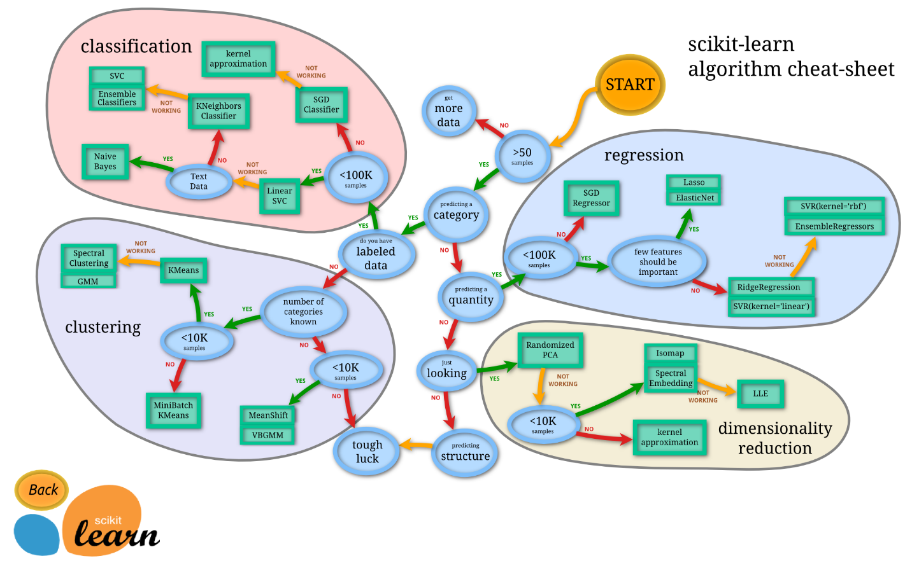  
I kissed his cheek and thanked him. Andrew was soon leaving my apartment and so I straightened out the room and made a cup of coffee, trying to put my disappointment and frustration out of my mind for now. After all, this wasn't about me. I would have to wait to see Emma for a few days as she was working away but I promised myself, I'd make up for my lack of good sex when she was back.  
  
This is when my day suddenly became a lot more interesting.  
  
My phone rang, and I was pleased to have the possibility of another client. When I answered, I was more than a little shocked to hear a female voice.   
  
"Hiya, is that Clarissa?" The voice asked.  
  
I said that it was, and the woman introduced herself as Katie, she sounded a little stern. I listened as she went on to explain that she had gotten my number from Emma and that she was an associate of a businessman known as Ramon who needed a new girl to join his parties and that Emma thought I'd be ideal.  
  
As Katie was talking, I was intrigued but also a little annoyed that Emma hadn't asked me first.   
  
"What service does he need?" I asked once Katie had finished.  
  
"Baby, he gets whatever he wants, you'll be there to entertain him and his business associates, that's the deal. You'll be with 4 or so other girls. Pay is $2500 dollars and you need to be ready for a limo to collect you at 10pm. Yes or No?"  
  
The only real words that stuck were 'Pay is $2500.'  
  
"Urrr, OK, I guess, yes then."  
  
"Great!" said Katie, "Dress to impress and we'll see you later."  
  
Before I could say anything else, she'd hung up.  
  
It was then that I became a little worried. I didn't know where I'd be going or really what I'd have to do. I wasn't too worried about being with other girls and I guess, If Emma had been there, then she wouldn't send me anywhere dangerous. I decided to call her, partly to find out what the fuck she was thinking.  
  
Emma barely stopped laughing as I told her about the call. I couldn't be mad at her and soon was laughing too.   
  
"I was going to tell you but got caught up with a client." Emma explained. "Also, Ramon isn't a businessman, he's a drug dealer but he's loaded and a fucking perve!"   
  
"What??" I barked back.  
  
"Oh look, he's nice, he has these parties and a few girls around so that him and his guests can fuck you all. What's the problem? It's like 2 ½ grand for a night. You can do this, easy!"  
  
"Ok," I replied, my mind spinning a little. "Are you sure it's all OK and safe."  
  
"I promise!" Emma replied, "Just, like normal, do as the client asks and try and enjoy it. You could make a fortune from this guy if he likes you. Katie is his personal fuck toy I think, she oversees the girls, she's quite nice if you do as you're told."  
  
As I said goodbye to Emma and promised to call her afterwards, I did feel a little uneasy as I showered and began to prepare myself for the night. I did trust Emma, so I decided to go through with it. Anyway, it would hopefully be more interesting than the regular clients and, to look on the bright side, I'd never knowingly met a drug dealer before, so at least that would be a new experience.  
  
Once I'd enjoyed a long shower and fixed my hair and makeup. I settled on wearing white. A sexy short white cocktail dress, with white stockings, suspender belt, g string and lace bra. Finished off with white high heels.   
  
I was still feeling nervous as I looked in the mirror, but I was pleased with how I looked, I hoped that I'd impress Katie and Ramon.   
  
Just as I was starting to relax, my buzzer went, and I looked out of the window to see a black car outside. I answered the buzzer and a man simply said, "Car for Clarissa."  
  
I left my building and the middle-aged man with shaved hair opened the back door of the car for me. I thanked him and smiled as I climbed in, he said nothing as he closed the door. The car had lovely leather seats and dark windows. I felt lucky to be riding in such a hot car at least. Once the driver got back in I said hello.  
  
"Sorry, Miss. I'm not allowed to talk to the girls, I'm just here to drive you."  
  
"Oh my God!" I thought to myself and started to worry about the whole thing again. There was nothing I could do, I was on my way. I sat back and tried to figure out where we were going. After about 40 minutes, we had left the city and were in an expensive suburb. It was dark by the time we pulled up outside a large detached house surrounded by trees and a high metal fence. It was clearly a very expensive property.  
  
Before I would take that in the car door opened and a sweet looking, blonde-haired girl stuck her head inside. "You must be Clarissa? Hi, I'm Jo."  
  
I nodded and said hello as I climbed out of the car. Jo was wearing red heels and a tight red vest top with a pink and white miniskirt. She seemed sweet.  
  
"This way." She said as she began to walk off. I followed her through the gates and up the long drive to the house. We walked around the side of the huge house and around the back where there were extensive gardens and a huge, lit, swimming pool. I couldn't see anyone, but it was clear that there was a party going on, I could hear loud rap music and the sound of people talking and shouting coming from the house. In that moment, I felt quite intimidated and very nervous.   
  
Jo opened a door that led to a stairway and I followed her down to the basement of the house. I was surprised to be entering a well-equipped gym. Just as we crossed the room, a door opened, and another woman entered. She looked a little more imposing and slightly older than Jo, she was dressed in full length gown with a plunging top and immaculately made up. She held out her hand as she reached us and put it on my shoulder. "I'm Katie, it's nice to meet you, Clarissa, thanks for coming."  
  
"Nice to meet you too." I replied, trying to sound in control.  
  
Katie took a step back and looked up and down at me. "They'll all love you honey!"  
  
I blushed a little. Katie looked at Jo for a second and said, "Thanks Jo, Mr Paloma is waiting for you in guest room 3, go see to him."   
  
Jo nodded, "Yes, of course." She said obediently. As she walked off, she turned to me and smiled sweetly.   
  
"Right then." Katie said, "Follow me please."   
  
We left the gym and walked along a corridor to a small room with just a desk, it seemed like an office but obviously wasn't used very often. Katie was clearly in control. "Ok, we're all running a little late and Ramon doesn't like to be kept waiting."  
  
I nodded, "OK."  
  
"Take off the dress and bra, you won't need them. You can put them on the chair, along with your bag."  
  
"Yes, OK." I said as I did as Katie asked. I lifted off my dress and unclasped my bra. In a few seconds, they were on the chair as Katie had asked.  
  
"Good." Katie said as she looked up and down at me. "Mmm, shaved too, Ramon likes that."  
  
I felt a little awkward as Katie stared at me.  
  
"Ramon likes to try out the new girls first, we're gonna go see him now, please, honey, just do as he asks and I'm sure he'll love you."  
  
I nodded, nervously as I followed Katie out of the room. We went up a marble stairway to the ground floor and the music was a lot louder as we approached a doorway. Katie opened the door and we went inside. The room was fitted out with a marble fireplace and a real wood floor. The walls were light yellow with exotic plants dotted around, in the centre, was a small padded platform. Katie looked at me. "On your hands and knees right there." She said as she pointed to the little platform.   
  
It was passed the point I could easily leave, and I had made up my mind to go through with this, for the money if nothing else and so I got to my knees on the little platform and stuck my ass up in the air.  
  
"Good girl." Katie said. She walked over to the door and opened it, I heard her say "Tell him she's ready," to someone but I didn't hear a reply. Katie returned and knelt on the floor in front of me which surprised me a little. I was just about to ask when the door flew open and next to me appeared a guy who had to be Ramon. He was a tall, muscled black guy with a neatly trimmed beard and lots of jewellery. Dressed in shorts and a vest he looked cool, but his expression was fierce. I stared up at him as he looked down at me.  
  
"This the new bitch huh?" He said as he turned to Katie.  
  
"Yes Ramon." Replied Katie. "She's ready for you."  
  
He stood in front of her and pulled down his shorts exposing a giant dick that had to be even bigger than the one from my client earlier in the day. The memory of that and the kinky nature of the situation I was now in was starting to make me get a little wet, which had to be a good thing. "Suck it!" Ramon ordered to Katie who dutifully, took his dick in her hand and guided it into her mouth. I watched, in awe as she sucked the cock deep into her mouth at the same time she slid her hand up and down the length of his growing dick.  
  
"Yeah, make it hard." Ramon encouraged Katie who was red in the face as she worked on her boss' cock.  
  
I knew this next place this cock would be was in my pussy and just as I was processing that, Ramon pulled his dripping cock from Katie's mouth who gasped for air and turned to me, still he said nothing. Katie got to her feet and walked behind me. I felt her pull my G string to one side and then I heard her spit, which I soon realised was on her hand because she rubbed her saliva into my, already wet pussy which I still had pushed up in the air.  
  
"She's nice and wet for you, you can take her now." Katie said to Ramon.  
  
I breathed deeply as Ramon moved behind me and I felt him grab my hips. "Good, let me fuck this bitch." Without further warning, I felt the head of his cock rub between my wet pussy lips and then, Oh my God! In one long thrust, he impaled his giant black cock all the way up my pussy which stretched around his cock. I couldn't help yelping out loud at the shock. Ramon and Katie both laughed. "I filled the bitch right up!" Ramon said as I gasped.  
  
"Does her tight little cunt feel good on your cock baby?" Katie said.  
  
"Yeah, I'm gonna fuck her hard right now."   
  
With that, Ramon started fucking me, firmly and hard, quickly speeding up. I felt his cock powering into my body I panted and relaxed as he took me, pushing my ass back to meet him.  
  
"Yeah bitch, you take it good!" he finally said to me.   
  
Ramon fucked me for several minutes harder and harder. I was on the verge of cumming from the feeling of his cock head rubbing over my G spot when he pulled his dick out.   
  
I felt my juices drip out as he appeared next to me. I was shocked when he pulled up his shorts. "Clean her up and take her to Dominic." Ramon turned and walked out of the room. I sat back on my knees and looked at Katie.   
  
"Didn't he want to cum?" I asked her.  
  
"No, He'll save himself and cum later." Katie said as she passed me some wipes. I did as was asked and cleaned my pussy and thighs as I stood up. I also put my G string back into place.  
  
"I need to take you up to Dominic now." I again followed Katie feeling cheated by an orgasm that just wouldn't happen that day. As we walked up the marble staircase to the second floor of the house. Katie spoke quietly to me "This guy is one of Ramon's most important business contacts. It's vital he leaves here happy." I nodded "He likes to cum in your face, you ok with that?" I nodded again, no problem there for me. "Oh, he may wanna fuck you in the ass." I stopped briefly. I wasn't ready for that and for some reason I hadn't considered that as a possibility. Katie saw my hesitation. "Oh fuck, you have to do it if he wants. He's good at it, it won't hurt so just fucking go with it." She seemed annoyed and I wasn't feeling in control and so I just nodded. It was obvious at this point that I would have very little choice in the matter.  
  
"OK Katie, I've got it." I said as we reached a door. Katie knocked.   
  
The door was swung open by an older, tall, muscular man with grey hair and a grey beard. I smiled at him and he just nodded and stood back from the door. I went inside, and he shut the door behind me. He was dressed in a silk gown which he undid and threw on a chair. I looked quickly around at the room which was a large bedroom with a huge bed near the window. It was painted white with wooden floors. As I looked back at Dominic, he was looking me up and down, holding his growing cock in his hand. I was pleased that it wasn't as big as Ramon's but still, it was larger than average.   
  
Dominic nodded at me and put his hands on his hips, leaving his cock sticking out in the air. "Suck it!" he ordered in a South American accent.   
  
"Yes, Sir." I replied and knelt in front of him. I grabbed his cock and slid it into my mouth. I could feel it growing straight away as I slid my head up and down.   
  
"Yes, suck it like that, slut." Dominic said as he began to thrust his cock into my mouth. His dick hit the back of my throat, making me gag. I decided to keep going as I didn't want to piss off any of these men. Pretty soon, my eyes were watering, and saliva was dribbling from my mouth as his cock had grown full hard.  
  
"Enough!" Dominic ordered as he pulled out his cock and I gasped for air. He grabbed my arm and I got to my feet. Dominic guided me to the corner of the bed and pushed me forward so that I was bending over the corner. He pulled my G string down and I stepped out of it, wiggling my butt in the air for him as the same time.   
  
Without saying a single word, He rubbed his saliva-covered cock around my pussy and found the right place and just rammed it deep into me. I squealed as he started fucking me hard. He was like an animal and even thought it was uncomfortable at first it soon began to feel nice. I pushed back to meet his thrusts as he fucked me harder.   
  
"Yeah, fuck me, FUCK me!" I squealed as he dug his fingers into my hips and pulled me back hard.   
  
"Take this you fucking whore!" Dominic shouted and then, out of nowhere, I felt myself starting to cum, there was no way I could stop it. I went with it.  
  
"Fuck, I'm cumming, make me fucking CUM!" I screamed out.  
  
"Cum on my cock you bitch!" Dominic growled as he rammed me even harder and sent me over the edge. Finally, I was cumming and oh god, it was a powerful orgasm. My pussy clenched around his invading cock and I squirted all over the floor and my legs.  
  
Dominic laughed and pulled his cock out, slapping my ass with it as my legs shook. I could barely stand.