CREATE PROCEDURE SP_INSERT_DATA_NOV20_SANTOSHI

AS

INSERT INTO T_COURSE

(

CourseID ,

CourseName,

CourseCreditHours

)

VALUES

(106,

'Data Mining',

3

);

IF @@ERROR =0

PRINT 'COURSE ADD SUCCESSFUL'

ELSE

PRINT 'COURSE ADD ERROR'

INSERT INTO T_Textbook

(

ISBNNUM ,

Title,

WriterName ,

Edition ,

PublishedDate,

CourseID

)

VALUES

(706,

'Data Mining',

'David D',

'9th',

20-13-2009,

106

);

IF @@ERROR =0

PRINT 'TEXTBOOK ADD SUCCESSFUL'

ELSE

PRINT 'TEXTBOOK ADD ERROR'

INSERT INTO T_Publisher

(

PublisherID ,

PublisherName,

PublisherAddress,

publisherPhone,

publishedDate,

ISBNNum

)

VALUES

(803,

'Adobe',

'3467 chicago lake pkwy,ch,5555',

'240555888',

2018-13-2018,

706

);

IF @@ERROR =0

PRINT 'PUBLISHER ADD SUCCESSFUL'

ELSE

PRINT 'PUBLISHER ADD ERROR'

EXEC SP_INSERT_DATA_NOV20_SANTOSHI

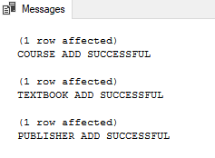

ALTER PROCEDURE SP_INSERT_DATA_NOV20_SANTOSHI

AS

/*INSERT INTO T_COURSE

(

CourseID ,

CourseName,

CourseCreditHours

)

VALUES

(110,

'Data Mining',

3

);*/

INSERT INTO T_COURSE

(CourseID,CourseName,CourseCreditHours)

select MAX(CourseID)+1 , 'STATISTICS',3

from T_COURSE

SELECT * FROM T_COURSE;

IF @@ERROR =0

PRINT 'COURSE ADD SUCCESSFUL'

ELSE

PRINT 'COURSE ADD ERROR'

/*INSERT INTO T_Textbook

(

ISBNNUM ,

Title,

WriterName ,

Edition ,

PublishedDate,

CourseID

)

VALUES

(711,

'Data Mining',

'David D',

'9th',

11-13-2009,

106

);*/

INSERT INTO T_Textbook

(ISBNNUM,TITLE,WriterName,Edition,PublishedDate,CourseID)

select MAX(ISBNNUM)+1 , 'CIS STATISTICS','PAUL G.CRAIG','10TH','11-20-2018',110

from T_Textbook;

SELECT * FROM T_Textbook;

IF @@ERROR =0

PRINT 'TEXTBOOK ADD SUCCESSFUL'

ELSE

PRINT 'TEXTBOOK ADD ERROR'

/*INSERT INTO T_Publisher

(

PublisherID ,

PublisherName,

PublisherAddress,

publisherPhone,

publishedDate,

ISBNNum

)

VALUES

(811,

'Adobe',

'3467 chicago lake pkwy,ch,5555',

'240555888',

2018-11-20,

706

);*/

INSERT INTO T_Publisher

(PublisherID,PublisherName,PublisherAddress,PublisherPhone,PublishedDate,ISBNNum)

select MAX(PUBLISHERID)+1 , 'PEARSON','555 EXCHANG STREET,AKRON,OHIO,44231', '222-333-4356','2018-11-20',711

from T_Publisher;

IF @@ERROR =0

PRINT 'PUBLISHER ADD SUCCESSFUL'

ELSE

PRINT 'PUBLISHER ADD ERROR'

EXEC SP_INSERT_DATA_NOV20_SANTOSHI

=============================================================================================

ALTER PROCEDURE SP_INSERT_DATA_NOV20_SANTOSHI

@CourseName varchar(45),@Title char (55), @PublisherName char(55)

AS

INSERT INTO T_COURSE(CourseName)

VALUES

(@CourseName)

IF @@ERROR =0

BEGIN

PRINT 'COURSE INSERT SUCCESSFUL'

END

ELSE

BEGIN

PRINT 'cOURSE INSERT FAILED'

END

INSERT INTO T_Textbook(Title)

VALUES(@Title);

IF @@ERROR =0

PRINT 'TEXTBOOK ADD SUCCESSFUL'

ELSE

PRINT 'TEXTBOOK ADD ERROR'

INSERT INTO T_Publisher

(PublisherName)

VALUES

(@PublisherName)

IF @@ERROR =0

PRINT 'PUBLISHER ADD SUCCESSFUL'

ELSE

PRINT 'PUBLISHER ADD ERROR'

exec SP_INSERT_DATA_NOV20_SANTOSHI

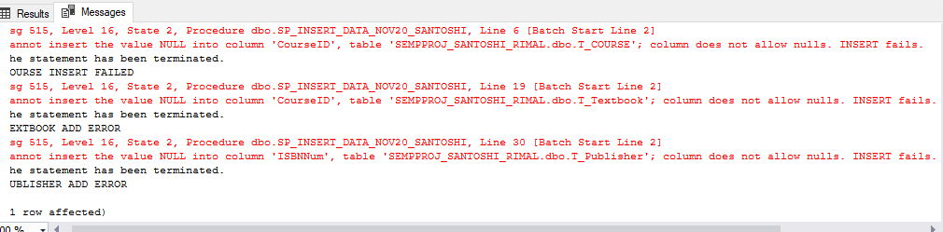

ALTER PROCEDURE SP_INSERT_DATA_NOV20_SANTOSHI

@CourseID char(10),@CourseName varchar(45),@CourseCreditHours int,

@ISBNNUM int ,@Title char (55), @WriterName char (55) ,@Edition char(55),@PublishedDate DateTime,

@PublisherID int,@PublisherName char(55),@PublisherAddress char(55),@publisherPhone char(55)

AS

INSERT INTO T_COURSE(

CourseID ,

CourseName,

CourseCreditHours

)

VALUES

(@CourseID,

@CourseName,

@CourseCreditHours

);

IF @@ERROR =0

BEGIN

PRINT 'COURSE INSERT SUCCESSFUL'

END

ELSE

BEGIN

PRINT 'cOURSE INSERT FAILED'

END

INSERT INTO T_Textbook

(

ISBNNUM ,

Title,

WriterName ,

Edition ,

PublishedDate,

CourseID

)

VALUES

(@ISBNNUM,@Title,@WriterName,@Edition,@PublishedDate,@CourseID);

IF @@ERROR =0

PRINT 'TEXTBOOK ADD SUCCESSFUL'

ELSE

PRINT 'TEXTBOOK ADD ERROR'

INSERT INTO T_Publisher

(

PublisherID ,

PublisherName,

PublisherAddress,

publisherPhone,

publishedDate,

ISBNNum

)

VALUES

(@PublisherID,@PublisherName,@PublisherAddress,@publisherPhone,@PublishedDate,@ISBNNUM)

IF @@ERROR =0

PRINT 'PUBLISHER ADD SUCCESSFUL'

ELSE

PRINT 'PUBLISHER ADD ERROR'

