**Advance Excel Assignment – 6**

1. What are the various elements of the Excel interface? Describe how they're used.

Ans: Here are the key elements of the Excel interface and their uses:

1. **Ribbon**: The top part of the interface with tabs (Home, Insert, Page Layout, etc.) that contain groups of related commands and tools.

* Use: Provides quick access to functions and formatting tools.

1. **Workbook**: The entire Excel file that contains one or more worksheets.

* Use: Organizes and stores data in a structured way.

1. **Worksheet**: A single spreadsheet within a workbook.

* Use: Holds data in rows and columns for analysis and calculations.

1. **Cell**: The intersection of a row and column, where data is entered.

* Use: Stores individual data points, formulas, or text.

1. **Formula Bar**: Located above the worksheet, it shows the contents of the active cell.

* Use: Allows you to enter or edit data and formulas in the selected cell.

1. **Name Box**: Located to the left of the formula bar, it displays the address of the active cell.

* Use: Helps navigate to specific cells or name ranges.

1. **Status Bar**: Located at the bottom of the Excel window, it displays information about the current mode and provides quick calculations like sum, average, and count.

* Use: Offers useful insights and shortcuts.

1. **Sheet Tabs**: Located at the bottom of the workbook, these tabs represent individual worksheets.

* Use: Allows you to switch between different sheets and manage them.

1. **Scroll Bars**: Horizontal and vertical bars on the right and bottom sides of the worksheet.

* Use: Helps navigate through the worksheet.

1. **Gridlines**: The lines that separate cells in a worksheet.

* Use: Provides a visual structure to organize data.

2. Write down the various applications of Excel in the industry.

Ans: Excel is a versatile tool used across various industries for a wide range of applications. Here are some key applications:

1. **Financial Analysis and Modeling**:
   * Budgeting
   * Forecasting
   * Financial statements
   * Investment analysis
2. **Data Management**:
   * Data entry and storage
   * Data cleaning and preprocessing
   * Database management
3. **Reporting and Dashboards**:
   * Creating visual reports
   * Building interactive dashboards
   * Generating summaries and insights
4. **Project Management**:
   * Gantt charts for project timelines
   * Task tracking and scheduling
   * Resource allocation
5. **Sales and Marketing**:
   * Sales tracking and analysis
   * Customer relationship management (CRM)
   * Marketing campaign analysis
6. **Inventory Management**:
   * Stock tracking
   * Order management
   * Supply chain analysis
7. **Human Resources**:
   * Employee records
   * Payroll management
   * Performance tracking
8. **Research and Development**:
   * Data analysis for research
   * Experiment tracking
   * Trend analysis
9. **Education**:
   * Grade tracking
   * Attendance records
   * Curriculum planning
10. **Operations Management**:
    * Process improvement analysis
    * Workflow management
    * Quality control

3. On the ribbon, make a new tab. Add some different groups, insert commands in the groups and name them according to their commands added. Copy and paste the screenshot of the steps you followed.

Ans:

* In the Excel Options dialog, **select "Customize Ribbon"** from the left sidebar. On the right side, **click on "New Tab"** to create a new tab in the ribbon.

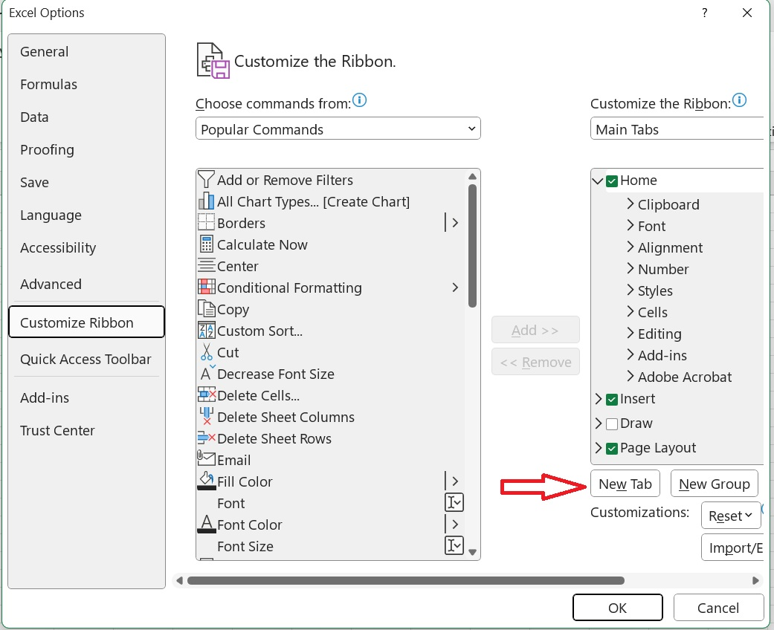

* Rename the New Tab and Select "New Group (Custom)" under your newly created tab, rename it.

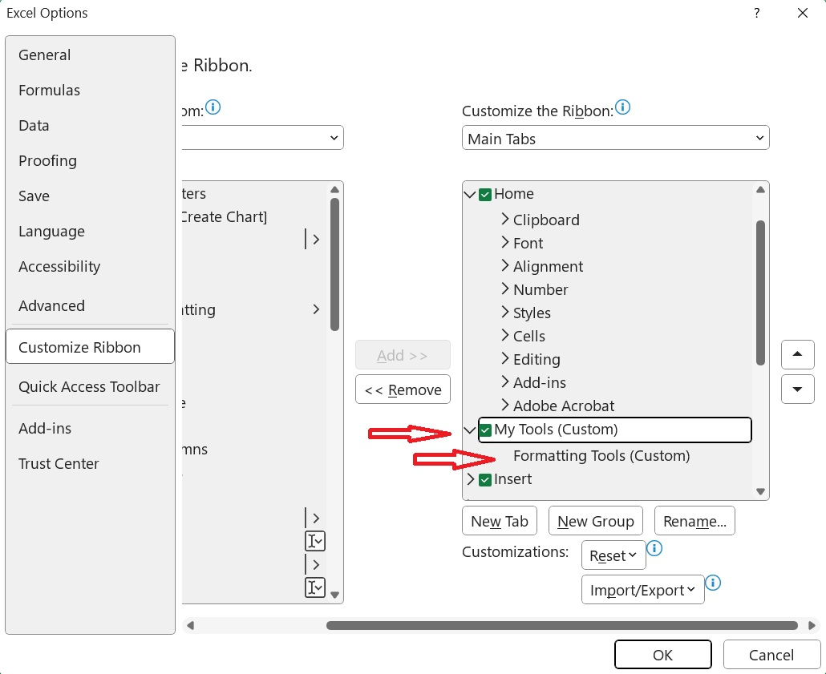

* On the left side, under "Choose commands from," select the commands you want to add to your group. Click on "Add" to move them to your custom groups.

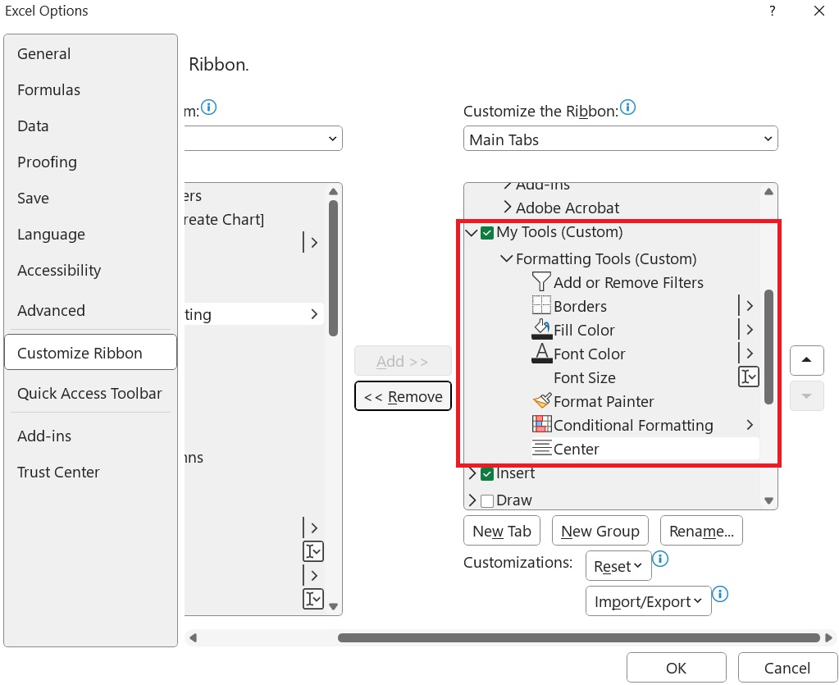

* Once you’ve added all the commands and groups, click "OK" to save your changes and close the Excel Options dialog.
* Now you can see our custom Ribbon.

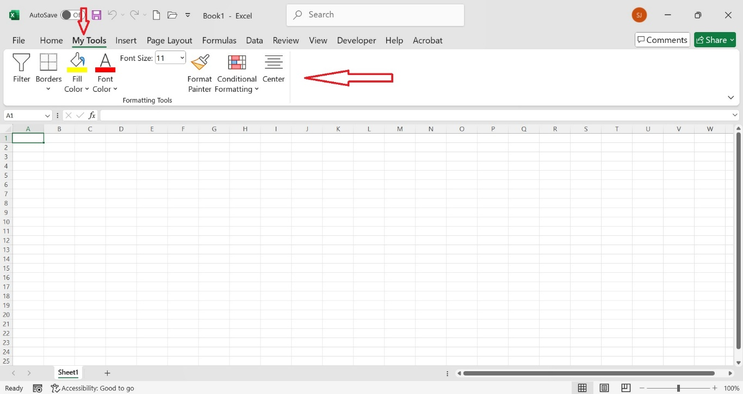

4. Make a list of different shortcut keys that are only connected to formatting with their functions.

Ans: Here's a list of formatting shortcut keys in Excel along with their functions:

* **Ctrl + B**: Bold selected text or cell contents.
* **Ctrl + I**: Italicize selected text or cell contents.
* **Ctrl + U**: Underline selected text or cell contents.
* **Ctrl + 1**: Open the Format Cells dialog.
* **Ctrl + 5**: Apply or remove strikethrough to the selected cells.
* **Ctrl + Shift + $**: Apply the currency format with two decimal places.
* **Ctrl + Shift + %**: Apply the percentage format with no decimal places.
* **Ctrl + Shift + #**: Apply the date format with day, month, and year.
* **Ctrl + Shift + @**: Apply the time format with hours and minutes, and AM or PM.
* **Ctrl + Shift + !**: Apply the number format with two decimal places, thousands separator, and minus sign for negative values.
* **Ctrl + Shift + ^**: Apply the scientific format with two decimal places.
* **Ctrl + Shift + &**: Apply borders to the selected cells.
* **Ctrl + Shift + _**: Remove borders from the selected cells.
* **Alt + H + A + C**: Center align the contents of the selected cells.
* **Alt + H + H**: Open the Fill Color menu to change the background color of the selected cells.
* **Alt + H + F + C**: Open the Font Color menu to change the text color of the selected cells.
* **Alt + H + B**: Open the Borders menu to add different types of borders.

5. What distinguishes Excel from other analytical tools?

Ans: Excel stands out from other analytical tools for several reasons:

1. **User-Friendly Interface**: Excel's interface is intuitive, making it accessible even to users with minimal technical background.
2. **Versatility**: Excel can handle a wide range of tasks, from simple data entry and basic calculations to complex financial modeling and data analysis.
3. **Formulas and Functions**: Excel offers a vast library of built-in formulas and functions for mathematical, statistical, financial, and logical operations, making it highly versatile.
4. **Customization**: Users can customize their spreadsheets with conditional formatting, charts, pivot tables, and custom macros.
5. **Integration**: Excel integrates seamlessly with other Microsoft Office applications and third-party tools, enhancing its functionality.
6. **Visualization**: Excel provides robust tools for data visualization, including charts, graphs, and conditional formatting, helping users to easily interpret and present data.
7. **Pivot Tables**: Excel's pivot tables are powerful tools for summarizing, analyzing, exploring, and presenting large data sets.
8. **Availability**: Excel is widely available and used globally, making it a standard tool in many industries.
9. **Community and Support**: There is a large community of Excel users and a wealth of online resources, tutorials, and forums for support and learning.
10. **Scalability**: Excel can handle relatively large data sets and complex calculations, although for very large data sets, specialized tools like SQL databases might be more appropriate.

6. Create a table and add a custom header and footer to your table.

Ans:

