

Tribhuvan University
Institute of Engineering
Thapathali Campus, Thapathali

Subject: Computer Networks

Lab: #5

Submitted By:
Name: Santosh Khadka
Roll: THA080BCT039
Lab Report On: Routing Protocol (Static Route) Configuration
Submitted To:
Department Of Electronics and Computer Engineering
Date: 10th Feb, 2026
LAB 4: ROUTING PROTOCOL (STATIC ROUTE) CONFIGURATION
THEORY:
Routing is the process of selecting the best path for data packets to travel from a source network to a destination network. In computer networks, routers are responsible for forwarding packets between different networks using routing tables.
Static routing is a routing technique where routes are manually configured by the network administrator. In static routing, the router does not automatically learn routes; instead, each route to a destination network must be explicitly defined using the ip route command. Static routing is simple, secure, and suitable for small or stable networks where network topology does not change frequently.
Dynamic Host Configuration Protocol (DHCP) is a network protocol that automatically assigns IP addresses and other network configuration parameters (such as subnet mask and default gateway) to devices on a network. DHCP reduces manual configuration errors and simplifies network management.
In this lab, DHCP is configured on routers to dynamically assign IP addresses to hosts, while static and default routes are used to enable communication between multiple networks connected through serial links.
OBJECTIVE:
The main objectives of this lab experiment are:
- To understand the concept of static routing in a multi-router network.
- To configure router interfaces using Cisco IOS commands.
- To configure DHCP server functionality on routers.
- To establish connectivity between different networks using static and default routes.
- To verify network connectivity using routing tables and ping commands.

PROCEDURE:
DHCP Configuration on Router (Cisco IOS)
General steps:
The general steps followed in this lab experiment are:
- Enter router privileged and global configuration mode.
- Configure IP addresses on router interfaces (Gigabit and Serial interfaces).
- Enable router interfaces using the no shutdown command.
- Configure DHCP pools on routers to assign IP addresses dynamically to end devices.
- Configure static routes or default routes to enable inter-network communication.
- Verify routing and DHCP configuration using show ip route and show ip protocols.
- Test end-to-end connectivity using the ping command.

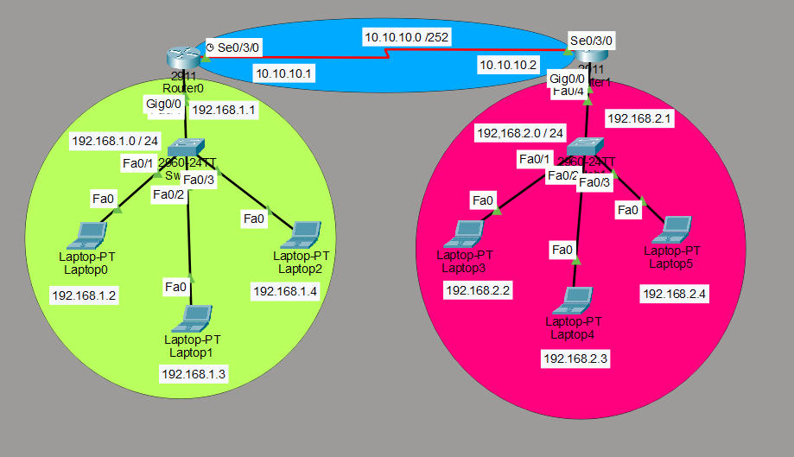
- Network architecture

Fig 1: Network architecture for DHCP along with static route configuration

Commands Used
1. Enter Global Configuration Mode
Router> enable
Router# configure terminal
2. Configure Router Interface (Gateway)
Router 0
Router(config)# interface g0/0
Router(config-if)# ip address 192.168.1.1 255.255.255.0
Router(config-if)# no shutdown
Router(config-if)# exit
Router 1
Router(config)# interface g0/0
Router(config-if)# ip address 192.168.2.1 255.255.255.0
Router(config-if)# no shutdown
Router(config-if)# exit
3. Configure IP address on interface Gig0/0 and Se0/3/0
Router 0
Router0(config)#interface serial 0/3/0
Router0(config-if)#ip address 10.10.10.1 255.255.255.252
Router0(config-if)#no shut
Router 1
Router1(config)#interface serial 0/3/0
Router1(config-if)#ip address 10.10.10.2 255.255.255.252
Router1(config-if)#no shut
4. Configure DHCP Server
Router 0
Router(config)#ip dhcp pool router1
Router(dhcp-config)#network 192.168.1.0 255.255.255.0
Router(dhcp-config)#default-router 192.168.1.1
Router 1
Router(config)#ip dhcp pool router2
Router(dhcp-config)#network 192.168.2.0 255.255.255.0
Router(dhcp-config)#default-router 192.168.2.1
5. Configure Static Route or Default Route
Router 0
Static:
Router0(config)#ip route 192.168.2.0 255.255.255.0 10.10.10.2
Default:
Router0(config)# ip route 0.0.0.0 0.0.0.0 10.10.10.2
Router 1
Static:
Router1(config)#ip route 192.168.1.0 255.255.255.0 10.10.10.1
Default:
Router1(config)# ip route 0.0.0.0 0.0.0.0 10.10.10.1

Verification
Router0# show ip protocols
Router0# show ip route

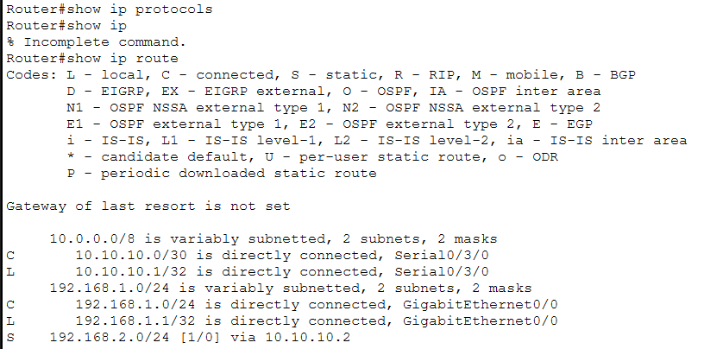
Fig 2: Verification of DHCP and Static route configuration on router 0
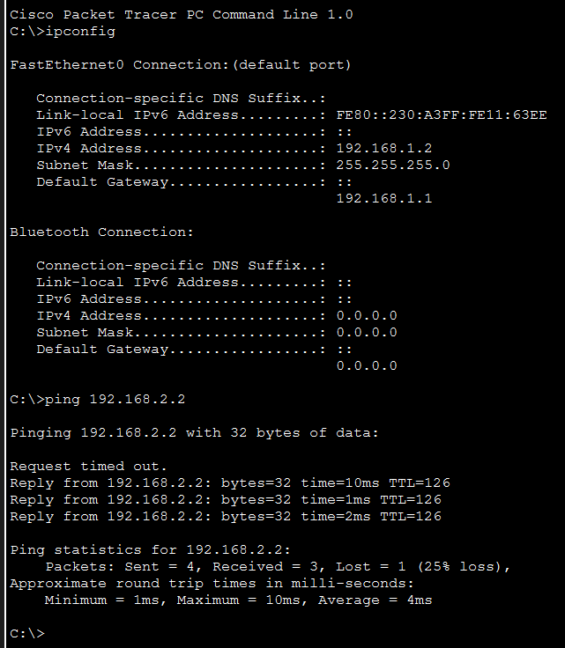
Ping from labtop0 to labtop3:

Fig 3: Verification of connectivity using ping
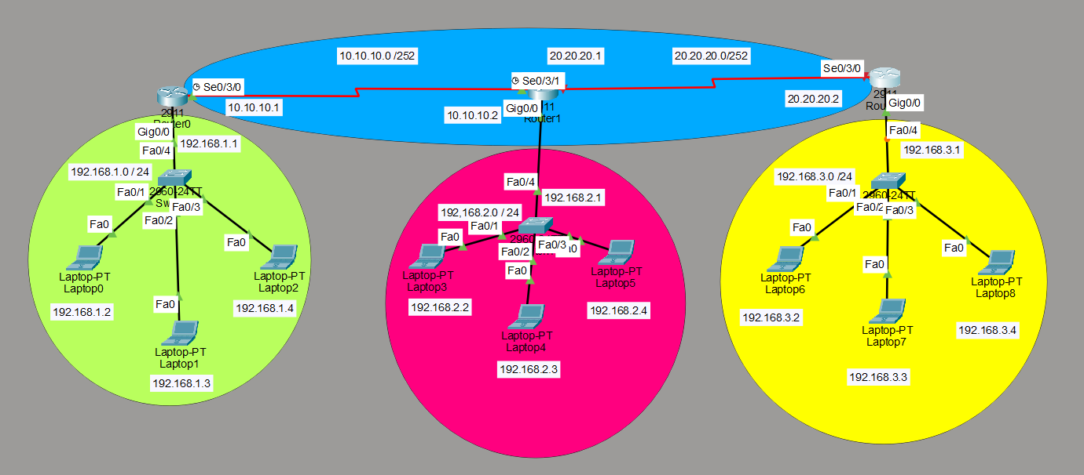
- Network architecture

Fig 3: DHCP and Static\Default route configuration on multi router system

Commands Used
1. Enter Global Configuration Mode
Router> enable
Router# configure terminal
2. Configure Router Interface (Gateway)
Router 0
Router(config)# interface g0/0
Router(config-if)# ip address 192.168.1.1 255.255.255.0
Router(config-if)# no shutdown
Router(config-if)# exit
Router 1
Router(config)# interface g0/0
Router(config-if)# ip address 192.168.2.1 255.255.255.0
Router(config-if)# no shutdown
Router(config-if)# exit
Router 2
Router(config)# interface g0/0
Router(config-if)# ip address 192.168.3.1 255.255.255.0
Router(config-if)# no shutdown
Router(config-if)# exit
3. Configure IP address on interface Gig0/0 and Se0/3/0
Router 0
Router0(config)#interface serial 0/3/0
Router0(config-if)#ip address 10.10.10.1 255.255.255.252
Router0(config-if)#no shut
Router 1
Router1(config)#interface serial 0/3/0
Router1(config-if)#ip address 10.10.10.2 255.255.255.252
Router1(config-if)#no shut
Router 1
Router1(config)#interface serial 0/3/1
Router1(config-if)#ip address 20.20.20.1 255.255.255.252
Router1(config-if)#no shut
Router 2
Router1(config)#interface serial 0/3/0
Router1(config-if)#ip address 20.20.20.2 255.255.255.252
Router1(config-if)#no shut

4. Configure DHCP Server
Router 0
Router(config)#ip dhcp pool router1
Router(dhcp-config)#network 192.168.1.0 255.255.255.0
Router(dhcp-config)#default-router 192.168.1.1
Router 1
Router(config)#ip dhcp pool router2
Router(dhcp-config)#network 192.168.2.0 255.255.255.0
Router(dhcp-config)#default-router 192.168.2.1
Router 2
Router(config)#ip dhcp pool router3
Router(dhcp-config)#network 192.168.3.0 255.255.255.0
Router(dhcp-config)#default-router 192.168.3.1
5. Configure Static Route or Default Route
Router 0
Static:
Router0(config)#ip route 192.168.2.0 255.255.255.0 10.10.10.2
Default:
Router0(config)# ip route 0.0.0.0 0.0.0.0 10.10.10.2
Router 1
Static:
Router1(config)#ip route 192.168.1.0 255.255.255.0 10.10.10.1
Router1(config)#ip route 192.168.3.0 255.255.255.0 20.20.20.2
Default:
Router1(config)# ip route 0.0.0.0 0.0.0.0 10.10.10.1
Router1(config)# ip route 0.0.0.0 0.0.0.0 20.20.20.2
Router 2
Static:
Router0(config)#ip route 192.168.2.0 255.255.255.0 20.20.20.1
Default:
Router0(config)# ip route 0.0.0.0 0.0.0.0 20.20.20.1

Verification
Router1# show ip protocols
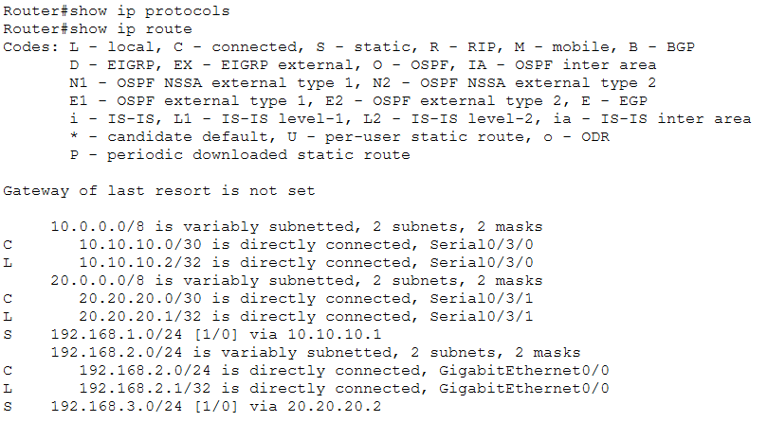
Router1# show ip route

Fig 4: Verification of DHCP and Static route configuration on router 1

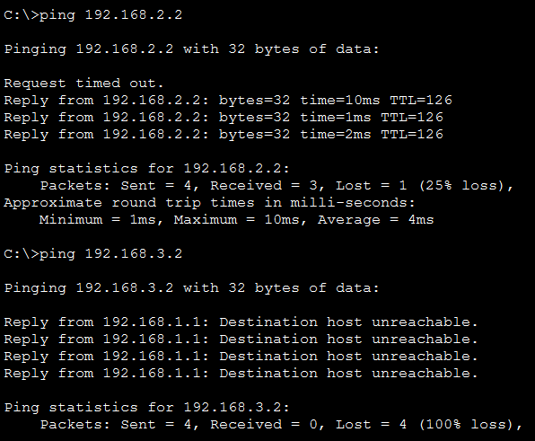
Ping Conformation
Fig 5: Ping from labtop0 to labtop3 and labtop6
DISCUSSION:
In this lab, static routing and DHCP configuration were implemented successfully in two-router and multi-router network architectures. Router interfaces were properly configured with IP addresses, and DHCP pools enabled automatic IP assignment to end devices, reducing manual configuration effort. Static and default routes allowed routers to correctly forward packets between different networks. Verification using routing tables and ping commands confirmed proper route installation and successful end-to-end connectivity. Although static routing is simple and reliable, it requires manual updates whenever network topology changes, making it less suitable for large or frequently changing networks.
CONCLUSION:
This experiment achieved its objectives by successfully configuring DHCP and static routing in a multi-router network environment. The lab provided practical understanding of router interface configuration, DHCP operation, and static route implementation using Cisco IOS commands. Successful ping results between hosts in different networks verified correct routing and network connectivity. Overall, the lab strengthened fundamental networking concepts and demonstrated that static routing is effective for small, stable networks.

