Computer Networks: Concept Mapping

1. Error Control Concept Map Analysis
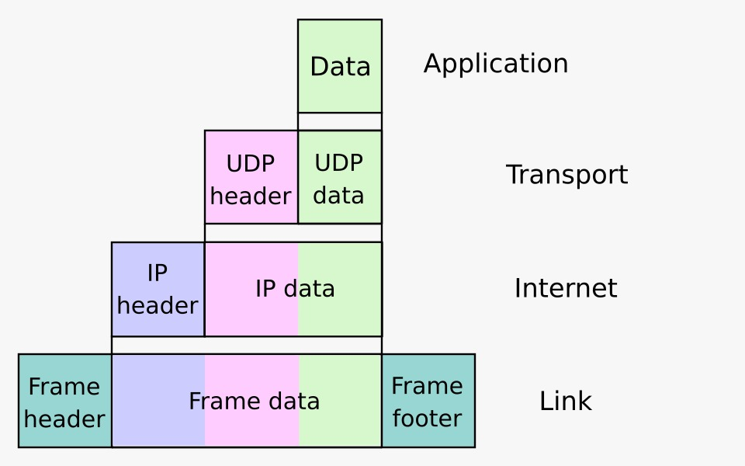
Analysis
- Error control ensures that data reaches the destination without corruption.
- The Data Link Layer detects errors in individual frames using methods such as CRC, checksum, and parity bits.
- When an error is detected, the receiver requests retransmission of the damaged frame.
- The Transport Layer provides end-to-end reliability between sender and receiver.
- It uses acknowledgments (ACK), sequence numbers, timeouts, and retransmissions to recover lost or corrupted packets.
- These two layers work together to reduce packet loss, improve data integrity, and ensure reliable communication.
- As a result, applications receive accurate and complete data.

2. Web Browsing Using OSI Layers
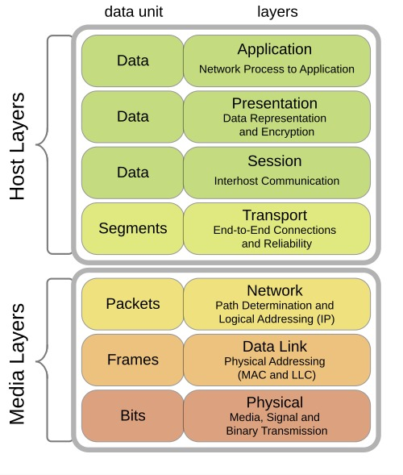
Analysis
- The Application Layer provides web services through HTTP or HTTPS.
- The Presentation Layer encrypts and decrypts data using SSL/TLS.
- The Session Layer establishes, maintains, and terminates communication sessions.
- The Transport Layer ensures reliable delivery of web data using TCP.
- The Network Layer routes packets from the client to the web server using IP addresses.
- The Data Link Layer transfers frames between devices on the local network.
- The Physical Layer transmits data as electrical, optical, or wireless signals.

Effect of Failure in One Layer
- If the Physical Layer fails, there is no network connection.
- If the Data Link Layer fails, frames cannot be transmitted correctly.
- If the Network Layer fails, packets cannot reach the destination.
- If the Transport Layer fails, reliable communication breaks and data may be lost.
- If the Application Layer fails, the web browser cannot display the requested webpage.

3. Network Issue Analysis
Analysis
- The Physical Layer is working correctly, so cables or Wi-Fi signals are functioning.
- The Data Link Layer is also working, meaning frames are successfully exchanged between nearby devices.
- The Network Layer has failed, preventing IP packets from being routed to the destination.
- Because the Network Layer fails, the Transport Layer cannot establish TCP or UDP communication.
- As a result, the Application Layer cannot access services such as web browsing, email, or file transfer.
- The concept map clearly shows that the problem starts at the Network Layer, making troubleshooting faster.
- Network administrators can focus on checking IP addresses, routing tables, gateways, or router configuration instead of inspecting every layer.

