**Xoriant Interview Questions**

**Web Services**

Which tool do you use to automate?

Which all tools do you use for manual testing WebServices (Soap and Rest both)

Which all methods are there? get,post,put,delete

When to use post and when to use put?

**Java**

Constructor, what is it and how it works?

Does constructor return anything at all?

Default values of data types.

this and super keyword explanation.

Can we have this() and super() together?

Nested classes?

Is Final a keyword?

HashMap v/s HashTable?

Collection v/s Collections

Lamda Expression?

**Programs**

1.

Given String s1 = "123456";

Output should be 1+2+3+4+5+6=21

2.

In a given file one line of sentence is present

How will you get the occurrence of any given character in that file.

**String concepts**

Way of creating string objects.

Immutability

String s1 = new String("Test");

String s1 = "Test");

s1= =s2, s1.equals(s2), s1.compareTo(s2)

**OOPS**

Inheritance

Multiple Inheritance, does Java support multiple inheritance at all?

Why don't Java support multiple inheritance through extending the multiple classes?

Abstraction as a concept?

what is Interface have you ever created interface and used it?

Can we have nested Interfaces?

**Selenium**

Verify v/s Assert?

what all assert have you used?

Is there any other assertion apart from TestNG ones which you have created or you have worked upon?

Right Click?

What all exception do you get in selenium?

Is there any way to come out of frame apart from defaultContent method?

Ans: Switch to current window handle.

Invalid Selector exception in selenium?

**TestNG**

Different Annotations?

What all parameters we can have in @Test(what all parameters could come here)?

Order of execution of annotations?

If BeforeClass is present in parent class also, then what would be sequence of execution?

**Framework**

Does your framework have interfaces or abstract classes?

About POM.

How do you initialised the elements?

**Altimetrik Interview Question**

**Collection Framework Hierarchy**

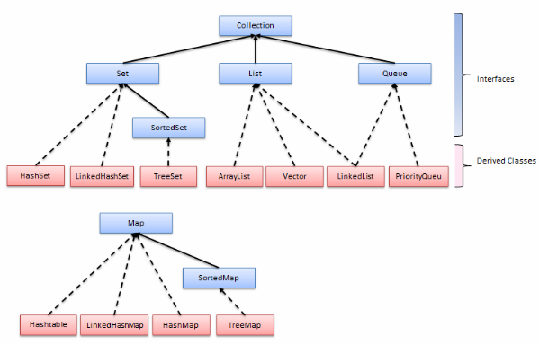

Given a class Person, how will you implement TreeSet with it?

Explanation of equals method of Comparator interface.

Which all Listeners you have worked with?

* IRetryAnalyzer, IAnnotationTransformer
* ITest
* IReporter

**Why do we need surefire plugin? Can we run testing.xml with maven without surefire plugin?**

**Implicit wait and explicit wait. Why shouldn’t we mix both?**

<http://stackoverflow.com/questions/29474296/clarification-on-the-cause-of-mixing-implicit-and-explicit-waits-of-selenium-doc>

**Product backlog and sprint backlog**

**Cucumber**:

* Feature file, scenario, scenario outline, parallel execution
* Difference between cucumber and jbehave
* Command for running cucumber test from cmd

**Exception throwing overridden method**

Subclass’s overridden method can’t throw broader exception. However it can throw same or narrowed exception than parent’s overriding method.

**Up casting and down casting in java**

Up-casting is casting to a supertype, while downcasting is casting to a subtype. Supercasting is always allowed, but subcasting involves a type check and can throw a ClassCastException.

Example: A parent class P has method m1() and child class C has one overridden method m1() and other normal method m2(). Then:

P p1 = new C();

P1.m1() is allowed.

P1.m2() is not allowed. ((C)p1).m2() need to be done.

C c1 = (C) P;

**Taking screenshot in selenium (Thorough explanation of each terms)**

<http://stackoverflow.com/questions/21877839/can-any-one-explain-screenshot-in-selenium>

**Iterating over Map* (see entryset)**

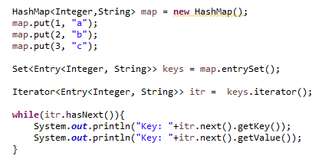

**Regex**

**Print something without main method.**

Using static block.

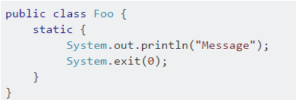

**Working**: Because the static initializer block is executed when the class is first loaded, we can print out “Hello World” without writing a main method. The execution is stopped using “System.exit()” command. So, we prevent “main method not found” error.

***Note****: It was possible till java 6 to use System.out.println(); without main(). From java 7 onwards, it is not possible to do it with static block. It will still ask for main method in main class.*

**RemoteWebdriver**

<http://www.myyesm.com/what-is-remotewebdriver/> 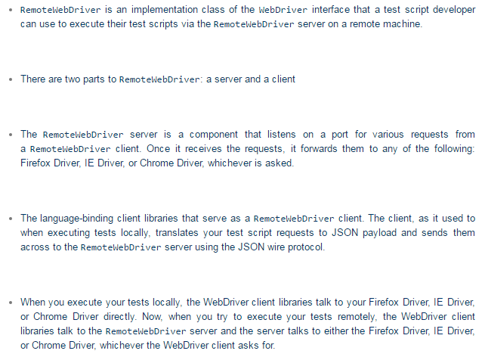

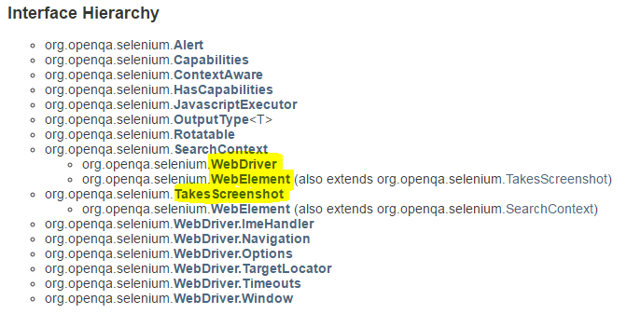

**Versions: Cucumber, Maven, TestNG, Selenium**

Maven: 3.3.9

TestNG: 6.8 (Latest is 6.9)

Selenium: 2.53

Cucumber: 1.2.4 (Latest is 1.2.5)

**HashMap vs HashTable**

<http://javahungry.blogspot.com/2014/03/hashmap-vs-hashtable-difference-with-example-java-interview-questions.html>

<http://javahungry.blogspot.com/2013/08/hashing-how-hash-map-works-in-java-or.html>

**Jenkins**

**TestPlan**

**App Direct Interview Question:**

**Barclays:**

Implement order by on objects of a given class

**Pramati**

Roles and responsibilities*

Cucumber JVM and JBehave difference

Glue in Cucumber

Run 5 feature file out of 10 feature files without using any tag

Synchronisation in Java

If 10 threads are waiting for an object, in what order it will be accessable to threads.

Difference between HashSet and TreeSet

Only 5 objects creation if allowed for a class, how to achieve this?

Selenium

Window switching

Alert switching

Return type of these switching

Screenshot

How you run test on remote machine

Saucelab configuration

Desired capabilities settings

Databases

Delete duplicate rows

API

Soap and Rest differences

Put and Patch difference