Post API for add book using **Post method** into database with image

URL: http://localhost:8888/addbook

Request Body

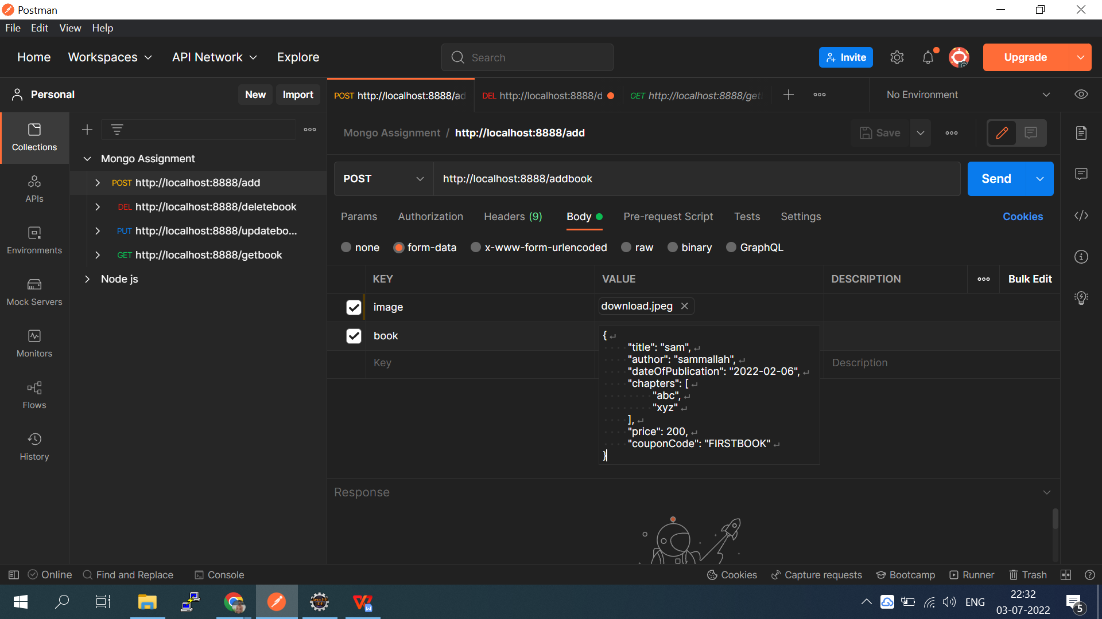

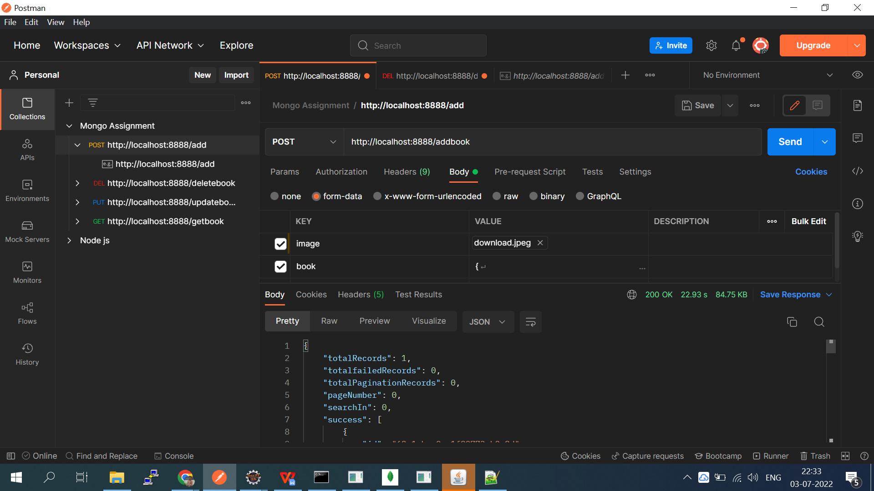

Response:

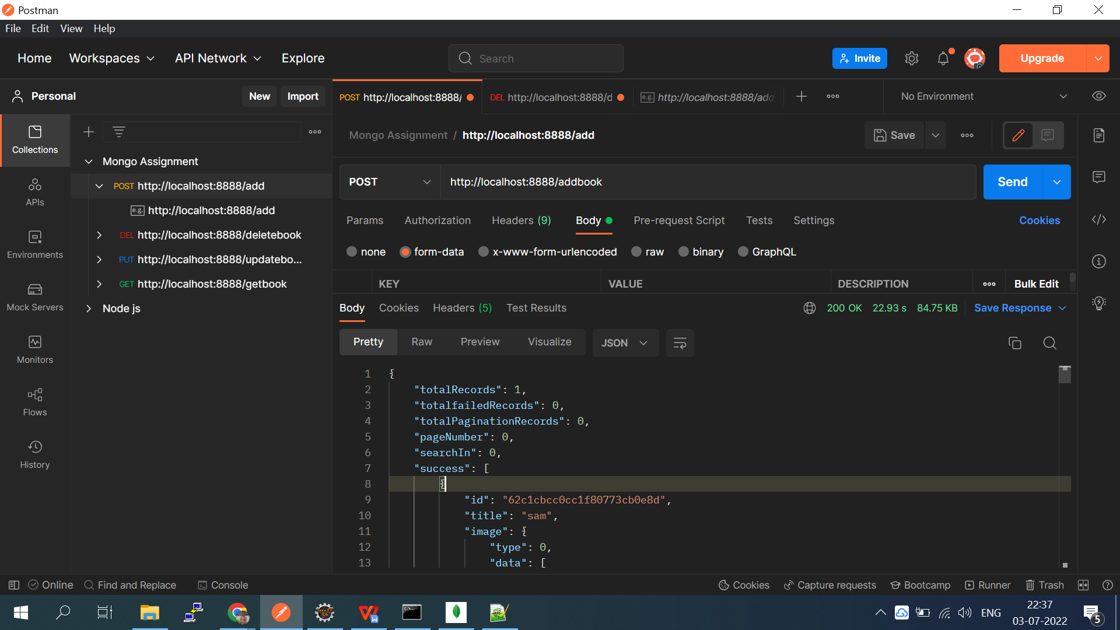

Delete API with **delete Method**

Delete book by Id

URL:-http://localhost:8888/deletebook

Request:

{

    "id":"62c182ec4a579a5e1c013f9b"

}

Response :

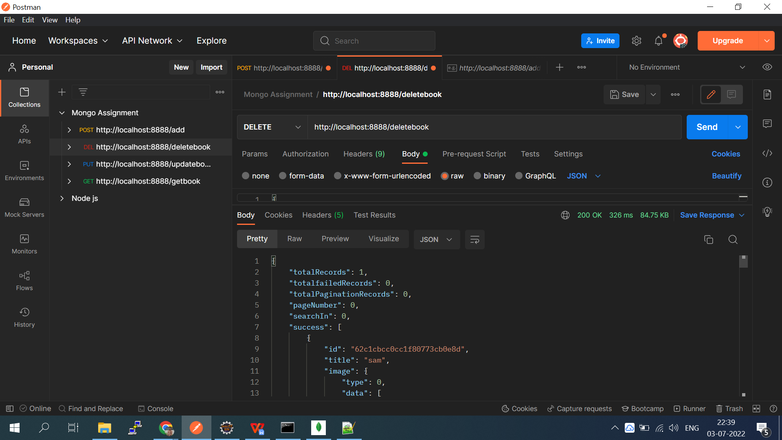

Update book API with **Put method**

URL: http://localhost:8888/updatebook

Request:

.{

    "id":"62bf3c4f1b30b63df3271428",

    "title": "mallah",

    "author": "santoshmallah",

    "dateOfPublication": "2022-02-06",

    "chapters": [

        "abc",

        "xyz"

    ],

    "price": 200

}

Resposne :

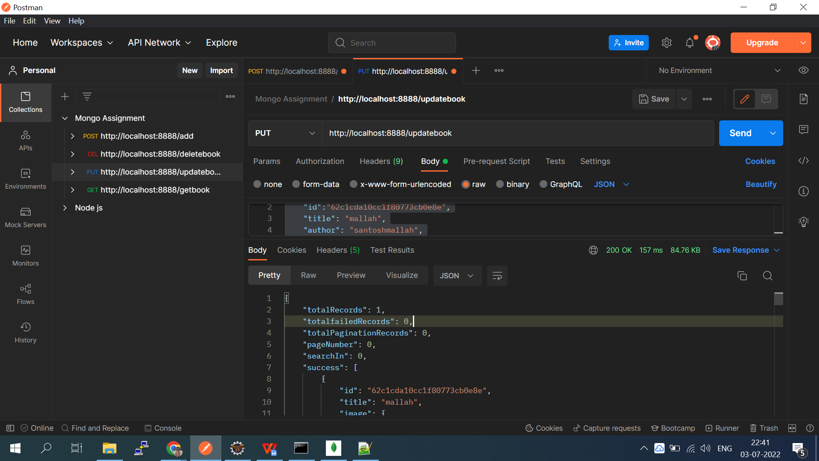

Get All book with **Get Method**

URL: http://localhost:8888/getbook

Response:

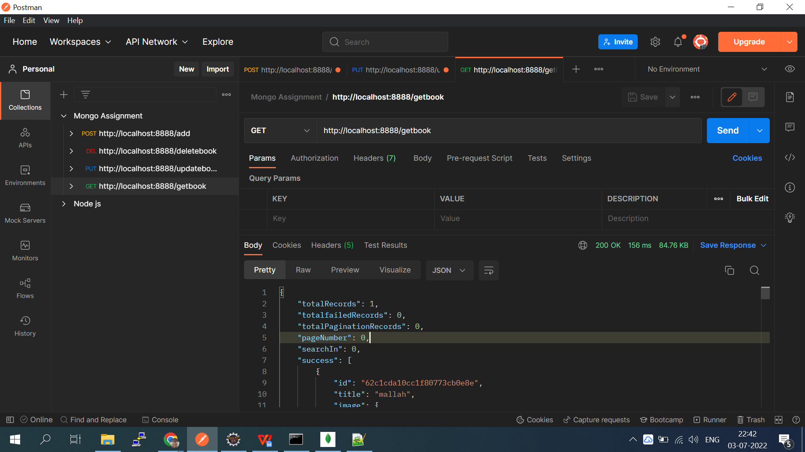

**Google Auth**

Google Auth will be using with domain url (http://localhost:8888/)

It will directly redirect to google auth login flow

After Successfully login username and email name will be save into mongo db in encrypted form

I have also included decryption utility method for decrypting response.

Here is screen shot of encrypted data

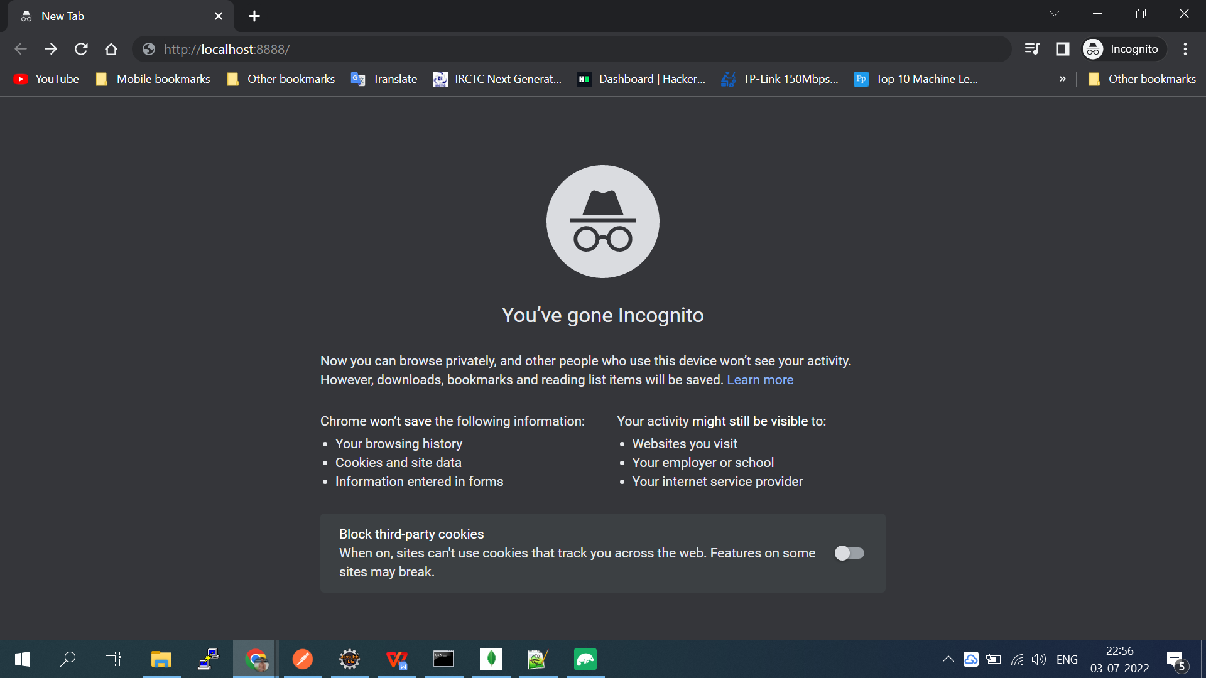

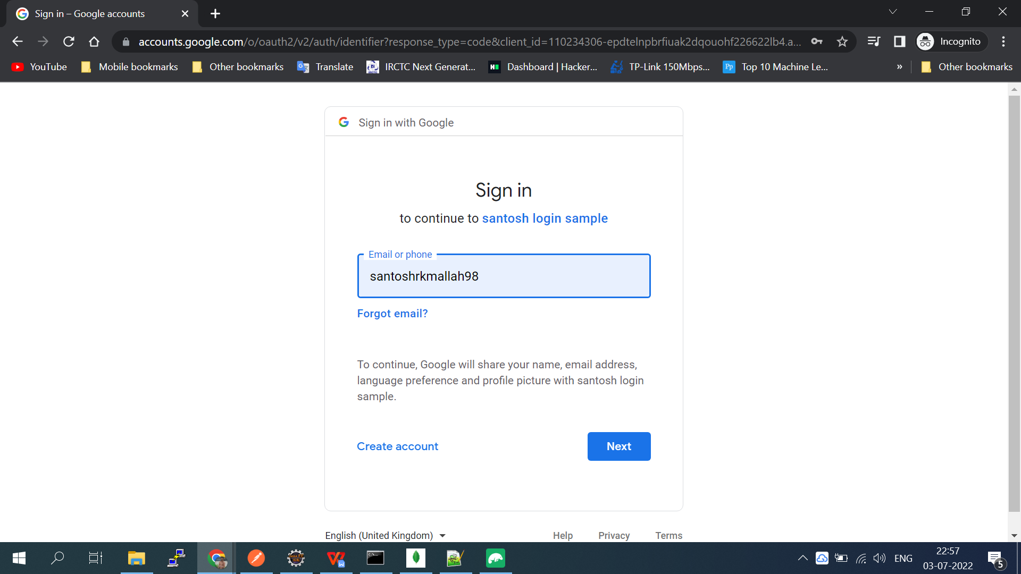

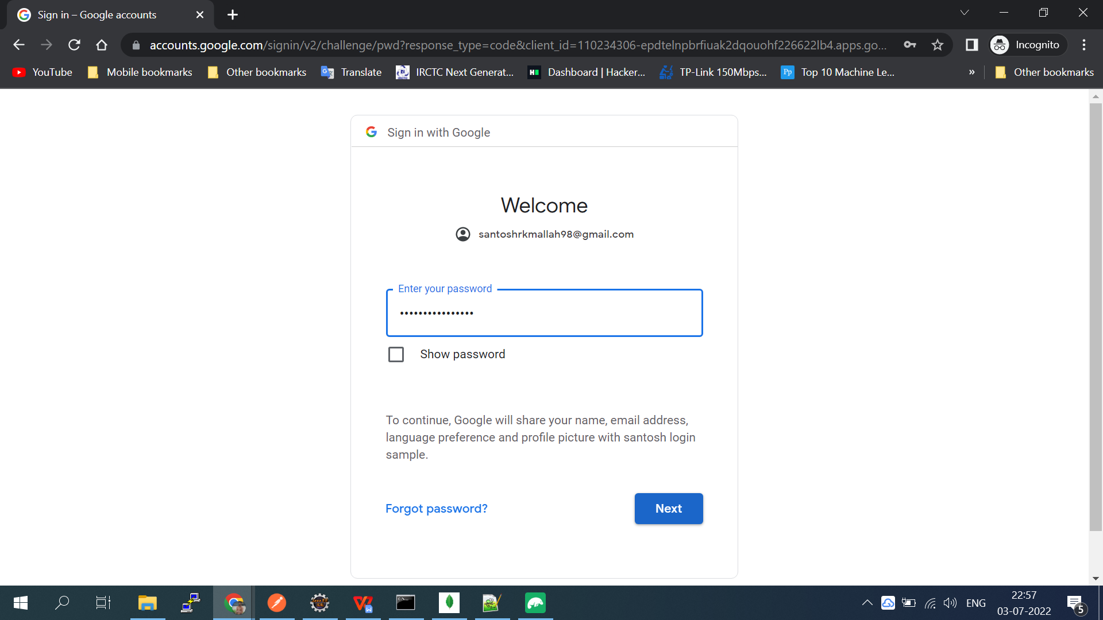

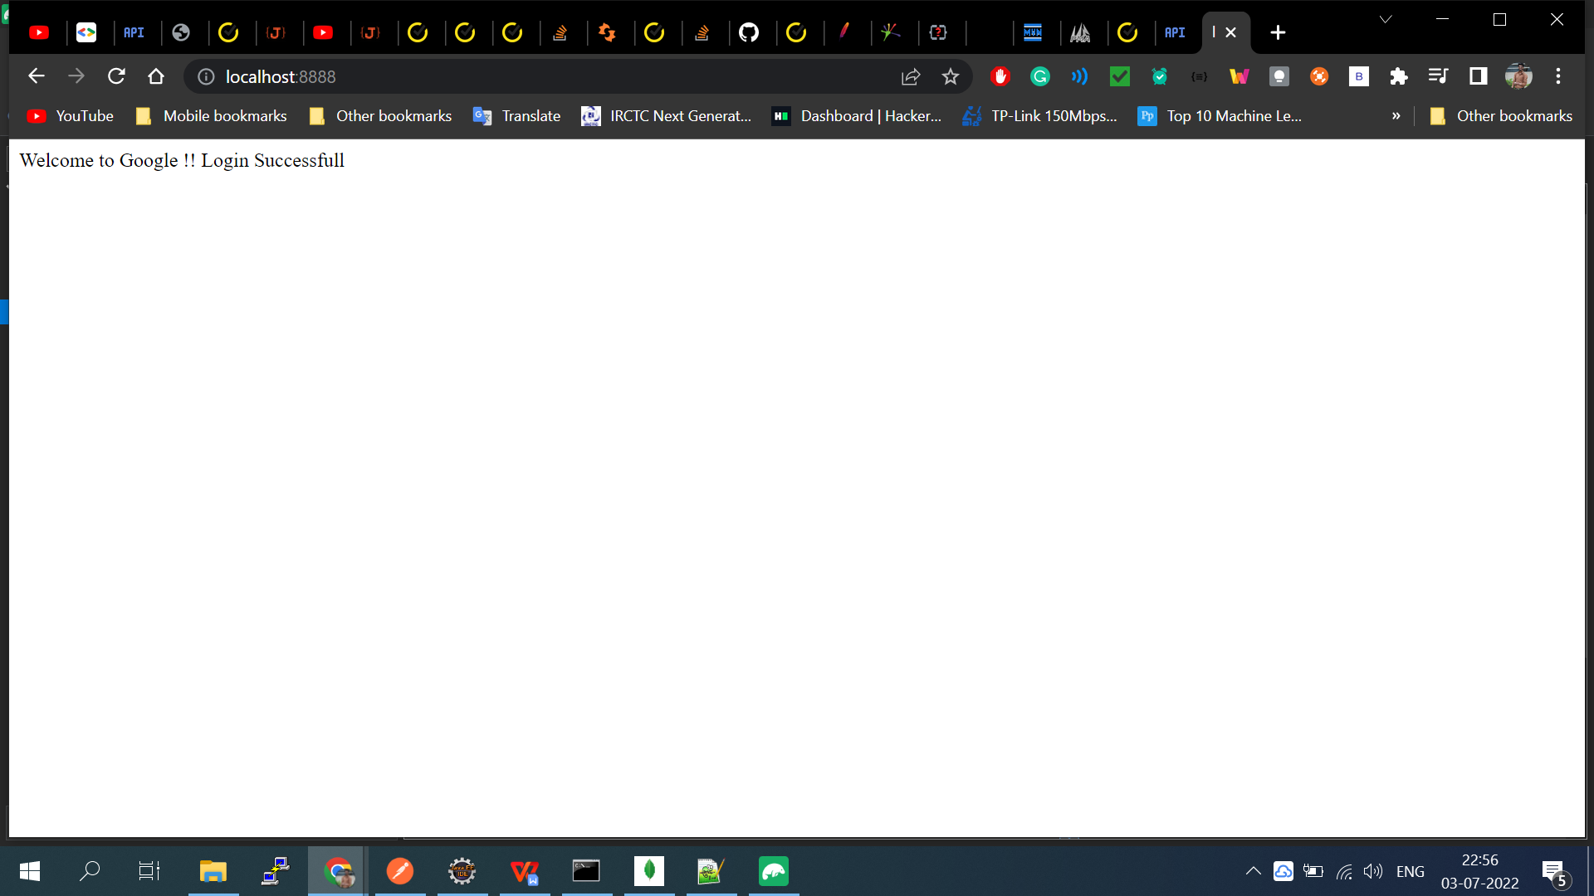

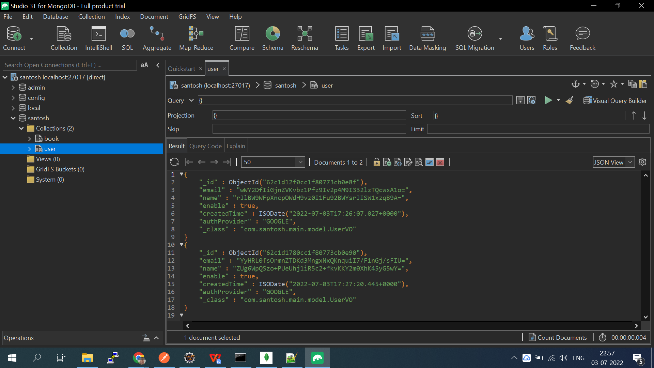

**Heroku**

I have deployed on heroku

Here is screen shot and url

URL:https://spring-boot-rest-api-assig.herokuapp.com/

