APIGEE Notes

[**Fundamentals of RESTful API Design**](https://academy.apigee.com/index.php/courses/elearning/fundamentals-restful-api-design)

**Foundation Training**

API Foundations

**Organization, Environments, and API Proxies**

* Apigee Edge enables us to expose APIs which can be easily consumed by Developers to build Apps.
* We expose APIs on Edge by building API profies that act as managed ‘facades’ for backend services

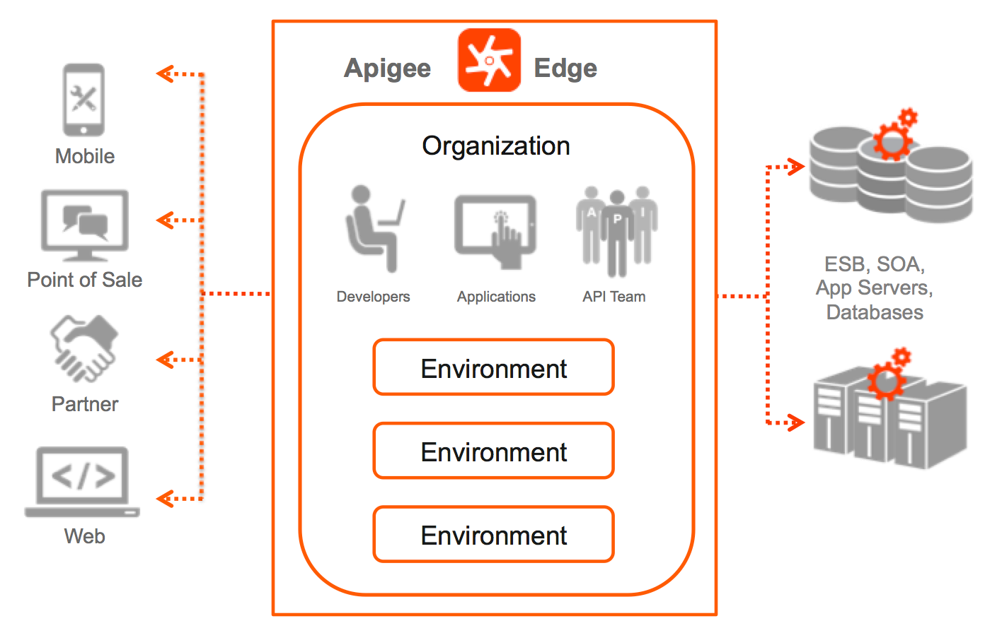

* An Organization is a collection of users, APIs and other resources
* An Environment is a subset of APIs in an Organization that are in a given deployment state
* The default environments are test and Production

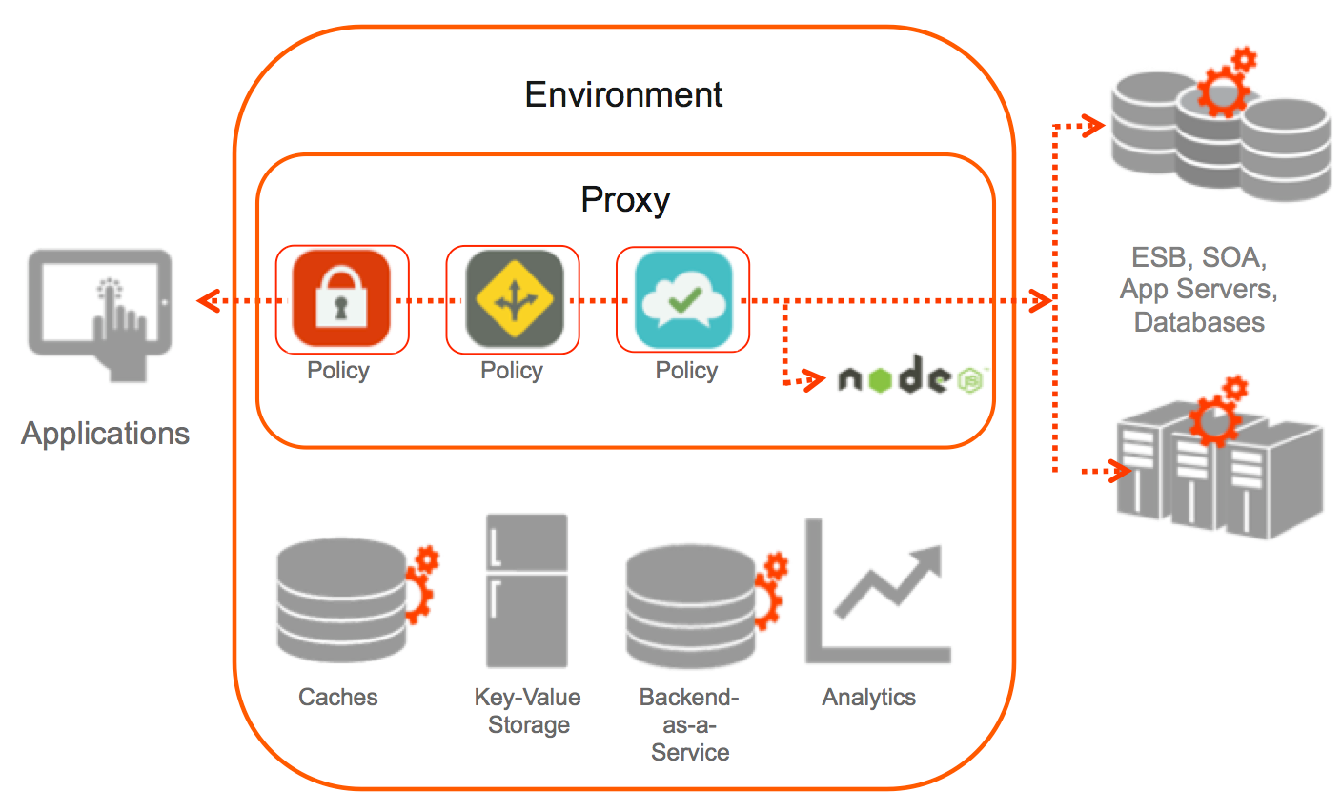

* An API Proxy is a set of configurable logic that handles API request.
* API Proxies decouple the app-facing API from your backend services